CALLMODEL Models a blue whale B call.
Uses a model of the form y = A.*y0 where A = A0*exp(-B*t).*sin(2*pi*fm*t) and y0 is a sum of harmonics yn = sin(2*pi*n*f0*t)
Create the time base for the signal. 1
Set the fundamental frequency of the call. 1
Create the harmonics. 1
Set the additional parameters in the model. 1
Plot the model call and listen to it. 2

Create the time base for the signal.
fs = 4000;
t = 0:(1/fs):1.5;

Set the fundamental frequency of the call.
f0 = 175;

Create the harmonics.
y0 = sin(2*pi*f0*t) + sin(2*pi*2*f0*t) + sin(2*pi*3*f0*t);

Set the additional parameters in the model.
A0 = 2; % Initial amplitude.
B = 1.5; % Amplitude decay rate.
fm = 0.65; % Frequency of the modulating envelope.
% Create the envelope
A = A0*exp(-B*t).*sin(2*pi*fm*t);
% Create the call.
call = A.*y0;

Plot the model call and listen to it.
figure
plot(t,call)
xlabel('Time')
ylabel('Amplitude')
title('{\bf Blue Whale B Call Model}')
soundsc(call,fs)
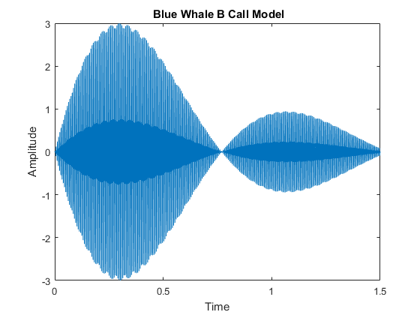
Published with MATLAB? R2016a

