ABSTRACT
Deeper neural networks are more difﬁcult to train. We present a residual learning framework to ease the training of networks that are substantially deeper than those used previously. We explicitly reformulate the layers as learning residual functions with reference to the layer inputs, instead of learning unreferenced functions. We provide comprehensive empirical evidence showing that these residual networks are easier to optimize, and can gain accuracy from considerably increased depth. On the ImageNet dataset we evaluate residual nets with a depth of up to 152 layers—8× deeper than VGG nets [41] but still having lower complexity. An ensemble of these residual nets achieves 3.57% error on the ImageNet test set. This result won the 1st place on the ILSVRC 2015 classiﬁcation task. We also present analysis on CIFAR-10 with 100 and 1000 layers.

1.INTRODUCTION
The introduction section of the academic paper delves into the significance of deep convolutional neural networks in achieving breakthroughs for image classification. It highlights the importance of network depth, as evidenced by leading results on the ImageNet dataset, which utilize very deep models. However, the paper identifies a critical issue: while stacking more layers seems like a straightforward way to improve networks, it is not as easy as it appears due to the problem of vanishing/exploding gradients. Although this issue has been largely addressed, a new degradation problem emerges as network depth increases, leading to a saturation and then a rapid decline in accuracy.

The authors propose a residual learning framework to tackle this degradation problem. They reformulate the layers to learn residual functions with reference to the layer inputs, instead of learning unreferenced functions. This approach is shown to ease the optimization process and allows the training of networks that are substantially deeper than those used previously. The paper aims to demonstrate that these residual networks are easier to optimize and can gain accuracy from increased depth.

The authors provide empirical evidence of the effectiveness of their method on the ImageNet dataset, where they achieve a depth of up to 152 layers, which is 8 times deeper than VGG nets but with lower complexity. An ensemble of these residual nets achieves a 3.57% error on the ImageNet test set, winning the 1st place on the ILSVRC 2015 classification task. The paper also presents analysis on CIFAR-10 with 100 and 1000 layers, further demonstrating the effectiveness of the proposed method.

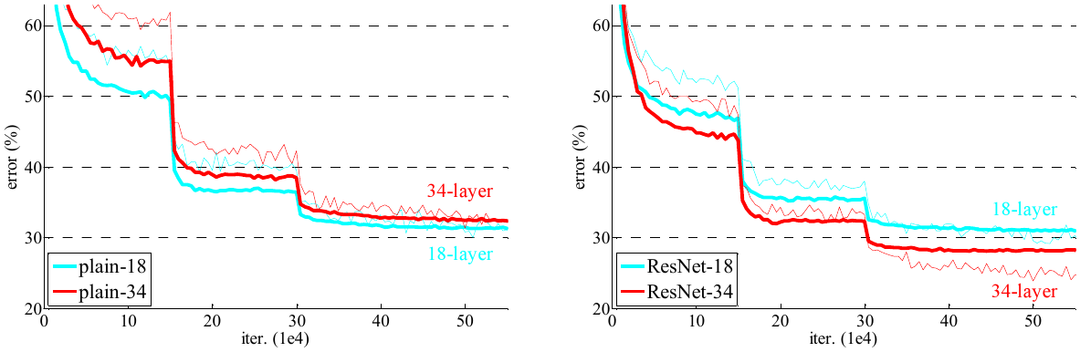

In conclusion, the authors argue that the residual learning principle is generic and can be applied to other vision and non-vision problems. They aim to show that their approach can address the degradation problem associated with increasing network depth and enable the training of deeper networks that are easier to optimize and more accurate.
2.RELATEDWORK
In the realm of deep learning, the quest for developing highly efficient and accurate neural networks has led to a plethora of research. The existing research can be broadly categorized into two areas: residual representations and shortcut connections.

Residual representations have been extensively used in image recognition, where VLAD and Fisher Vector are prominent examples. These methods encode residual vectors with respect to a dictionary, proving to be powerful shallow representations for image retrieval and classification. However, these methods do not delve into the optimization difficulties that arise with increasing network depth.

On the other hand, shortcut connections have been studied for a long time, with practices such as adding a linear layer from the network input to the output to address vanishing/exploding gradients. More recent approaches, such as "highway networks," introduce shortcut connections with gating functions. However, these methods have not demonstrated accuracy gains with extremely increased depth.

In this paper, the authors propose a novel learning framework that addresses the degradation problem by introducing deep residual networks. Instead of directly fitting a desired underlying mapping, the authors let the layers fit a residual mapping. This approach is hypothesized to be easier to optimize than the original, unreferenced mapping. The formulation of the residual mapping is realized by feedforward neural networks with "shortcut connections" that perform identity mapping.

The authors present comprehensive experiments on ImageNet and CIFAR-10 datasets, demonstrating that their deep residual nets are easier to optimize and can enjoy accuracy gains from greatly increased depth. The 152-layer residual net presented in this paper is the deepest network ever shown on ImageNet, achieving lower complexity than VGG nets and winning the 1st place on the ILSVRC 2015 classification task.

In conclusion, the proposed residual learning framework addresses the shortcomings of existing research by simplifying the optimization process and allowing the training of networks with increased depth. The authors demonstrate the effectiveness of their method through extensive experiments, suggesting that the residual learning principle is generic and can be applied to other vision and non-vision problems.
3.DEEPRESIDUALLEARNING
In the realm of deep learning, the challenge of training very deep neural networks has been a significant hurdle. However, a recent paper introduces a novel residual learning framework that addresses this issue effectively. The authors propose a reformulation of the layers to learn residual functions with reference to the layer inputs, rather than learning unreferenced functions. This innovative approach not only eases the optimization process but also enables the training of networks that are substantially deeper than those used previously.

The paper delves into the concept of residual learning, where the hypothesis is that multiple nonlinear layers can asymptotically approximate complicated functions. The authors argue that it is equivalent to hypothesize that these layers can asymptotically approximate the residual functions. This reformulation is particularly motivated by the counterintuitive phenomena about the degradation problem, where deeper models should ideally have training error no greater than their shallower counterparts.

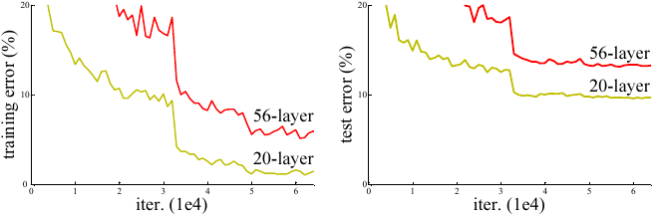

To implement this residual learning, the authors introduce identity mapping by shortcuts, which neither introduces extra parameters nor computation complexity. This is not only practical but also crucial for fair comparisons between plain and residual networks. The authors have tested various plain and residual networks and observed consistent phenomena.

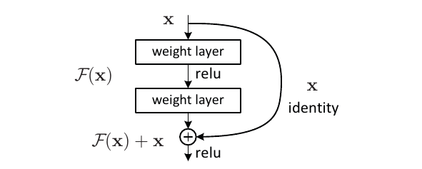

Two models for ImageNet are described in the paper, a plain network inspired by VGG nets and a residual network that inserts shortcut connections. The implementation for ImageNet follows standard practices, including batch normalization, weight initialization, and training from scratch using SGD. The models are trained for up to 60 epochs with a learning rate that starts from 0.1 and is divided by 10 when the error plateaus.

In testing, the authors adopt the standard 10-crop testing for comparison studies and the fully-convolutional form for the best results. The paper provides empirical evidence that these residual networks are easier to optimize and can gain accuracy from increased depth. The authors conclude that the residual learning principle is generic and can be applied to other vision and non-vision problems, marking a significant advancement in the field of deep learning.
4.EXPERIMENTS
In the experiments section of the paper, the authors evaluate their residual learning framework on the ImageNet dataset, demonstrating its effectiveness in training very deep neural networks. They compare plain networks with residual networks and observe that the deeper residual networks perform better and are easier to optimize. The authors also explore different shortcut connection options and find that identity shortcuts are particularly beneficial for the bottleneck architectures. They successfully train and evaluate 50-layer, 101-layer, and 152-layer residual networks, with the 152-layer network achieving a top-5 error of 4.49% on the ImageNet validation set. An ensemble of these networks achieves a 3.57% error on the ImageNet test set, winning the 1st place in the ILSVRC 2015 classification task.

The authors also conduct experiments on the CIFAR-10 dataset with networks having up to 1000 layers, further demonstrating the effectiveness of their method. They find that residual networks can overcome the optimization difficulties faced by plain networks and achieve accuracy gains from increased depth. Additionally, they explore the use of bottleneck architectures and identity shortcuts, which lead to more efficient models.

The paper also presents experiments on object detection tasks using the PASCAL VOC and MS COCO datasets, where the authors replace VGG-16 with ResNet-101 in the Faster R-CNN framework. They observe significant improvements in performance, particularly on the challenging COCO dataset, where they achieve a 6.0% increase in the standard metric (mAP@[.5, .95]), demonstrating the good generalization performance of their method on other recognition tasks.

Overall, the experiments in the paper provide strong empirical evidence supporting the effectiveness of the residual learning framework in training deep neural networks and its potential for other vision and non-vision problems.
Concept
Residual Learning Framework: This is a novel method for training deeper neural networks by reformulating the layers to learn residual functions with reference to the layer inputs, thereby easing the optimization process and enhancing accuracy with increased depth.

Deep Neural Networks: These are complex artificial neural networks with multiple layers, which are traditionally difficult to train, but the introduction of the residual learning framework has made their training more manageable.

Ensemble of Residual Nets: This refers to a group of residual networks working together, which, in this case, achieved a 3.57% error on the ImageNet test set, demonstrating the effectiveness of the residual learning framework.

ILSVRC 2015 Classification Task: This is a benchmark task in the ImageNet challenge that involves classifying images into a thousand categories, where the residual learning framework outperformed other methods.

CIFAR-10 Analysis: This is an evaluation of the residual learning framework on the CIFAR-10 dataset, a collection of images that are commonly used for machine learning and computer vision research. The analysis further validates the effectiveness of the proposed method.
Paper Recommend
1 :K. Simonyan and A. Zisserman. Very deep convolutional networks for large-scale image recognition. In ICLR, 2015.
2 :S. Ioffe and C. Szegedy. Batch normalization: Accelerating deep network training by reducing internal covariate shift. In ICML, 2015.
3 :C. Szegedy, W. Liu, Y. Jia, P. Sermanet, S. Reed, D. Anguelov, D. Er- han, V. Vanhoucke, and A. Rabinovich. Going deeper with convolu- tions. In CVPR, 2015.

