Author: Jiaan Randhawa-Heer
Gene Expression Analysis Report
Dataset Number: 6
Introduction
This output document is a summary of a differential expression report that used dataset 6 obtained from DESeq2 output data. The results in this include as following: summary of statistics, volcano plots, MA plots, histograms of p-values, a heatmap of the top 20 differentially expressed genes from both datasets and four tables that show some significantly upregulated and downregulated genes from both datasets.
Summary of Statistics
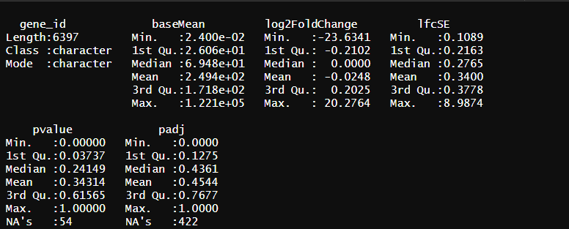
A vs C Statistics Summary- The following image shows the output from doing a summary of the A vs C data before it was cleaned to remove NA values from padj:

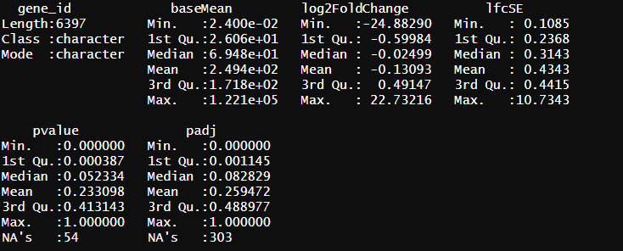
A vs E Statistics Summary- The following image shows the output from doing a summary of the A vs E data before it was cleaned to remove NA values from padj:

Volcano Plots
A vs C Volcano Plot- The following volcano plot is of A vs C data and shows the relationship between gene expression changes (log2 fold change) and their statistical significance. Additionally, it aids in the identification of upregulated, downregulated and non-significant genes:
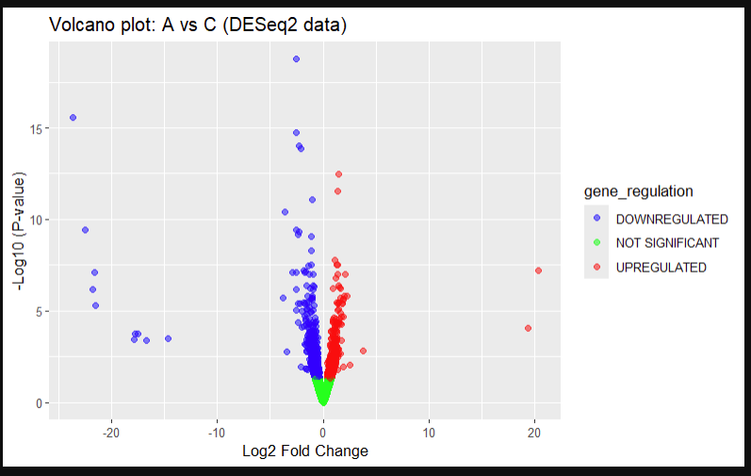
The volcano plot produced for A vs C shows a large quantity of upregulated and downregulated genes that fit the 0.05 padj threshold applied. Upregulated genes are shown in red, with the x-axis representing the positive log2 fold change. Downregulated genes are shown in blue, with the x-axis representing the negative log2 fold change. The y-axis shows -log10 p-values; genes higher on this have lower p-values, indicating higher statistical significance. Lower y-axis values are less statistically significant. If genes did not meet the threshold requirements (low log2foldchange around 0 and low-10padj), they were labelled as not significant and can be seen in green, clustered at the bottom, before the red and blue genes branch out. More downregulated genes in this appear to have lower log2 fold changes and -log10 p-values, suggesting slightly more downregulated gene expression and more statistical significance of downregulated genes.
A vs E Volcano Plot- The following volcano plot is of A vs E data and shows the relationship between gene expression changes (log2 fold change) and their statistical significance. Additionally, it aids in the identification of upregulated, downregulated and non-significant genes:
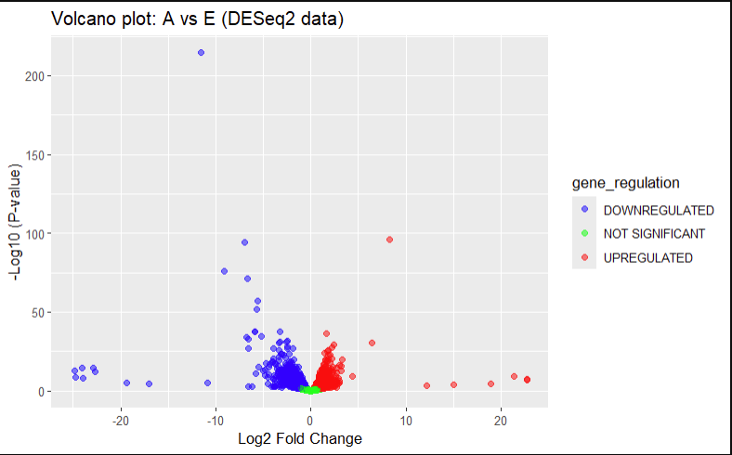
The volcano plot for A vs E also shows a spread of significantly upregulated and downregulated genes using the same 0.05 padj threshold as A vs C. Upregulated genes are shown in red, with the x-axis representing the positive log2 fold change. Downregulated genes are shown in blue, with the x-axis representing the negative log2 fold change. The y-axis shows -log10 p-values; genes higher on this have lower p-values, indicating higher statistical significance. Lower y-axis values are less statistically significant. If genes did not meet the threshold requirements (low log2foldchange around 0 and low-10padj), they were labelled as not significant and can be seen in green, clustered at the bottom, before the red and blue genes branch out. More downregulated genes in this appear to have lower log2 fold changes and -log10 p-values, suggesting slightly more downregulated gene expression and more statistical significance of downregulated genes. This average of downregulation genes having higher expression and statistical significance is similar to A vs C, which showed the same. Also, in comparison of A vs E to A vs C, there is a broader range of log2 fold changes, overall signifying more expression in this data. Additionally, the values of the y-axis of A vs E are, on average, much lower than A vs C, which indicates less statistical significance of the A vs E dataset.
MA plots
A vs C MA Plot- The following MA plot is of A vs C data and shows the relationship between average gene expression (log10 mean expression) and the log2 fold change. Additionally, it can be used to identify significantly differentially expressed genes:

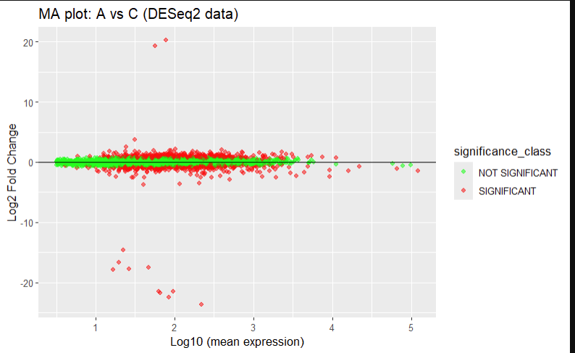
The MA plot for A vs C shows the relationship of log10 mean expression, on the x-axis, and log2 fold change on the y-axis. The horizontal line through the middle of the plot and the genes that cluster closely around it are in green, showing no significance as the threshold for the significance set was padj < 0.05. The non-significant genes that fall into this category essentially show very little change in gene expression. If these differentially expressed genes have surpassed the set threshold of padj, they are significant and shown as red on the plot. The mean expression of the x-axis indicates how much the average expression of a gene is, and the average plots of this appear to become lower as the mean expression values increase, which shows that high amounts of expression values are rarer. On the y-axis, positive log2 fold changes represent upregulated genes, and negative values of this axis represent downregulated genes. Overall, more downregulated genes, below the horizontal line, appear to have a stronger regulation compared to upregulation plots above the line. Additionally, stronger differential expression of both up- and down-regulated genes lies at lower values on the x-axis, indicating less variability of these stronger differentially expressed genes. The pattern seen in this plot with stronger downregulation aligns with the volcano plot for A vs C data, where downregulated genes had more negative log2 fold changes and a higher statistical significance.
A vs E MA Plot- The following MA plot is of A vs E data and shows the relationship between average gene expression (log10 mean expression) and the log2 fold change. Additionally, it can be used to identify significantly differentially expressed genes:

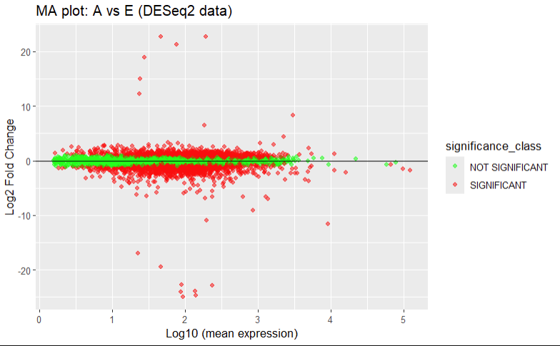
The MA plot for A vs E shows the relationship of log10 mean expression, on the x-axis, and log2 fold change on the y-axis (same 0.05 padj threshold). Similar to A vs C, this plot shows the majority of gene plots clustering around the horizontal line at 0. These genes are also coloured in green to signify no significance, as they do not break the threshold, meaning they have insignificant changes in expression. The red gene plots are significant genes due to their change in expression and have positive log2 fold change values, which indicate upregulated genes, and negative log2 fold change values, which indicate downregulated genes. On the plot, there appear to be more significant genes overall when compared to A vs C, which leads to more visible clusters in A vs E data. This also reflects the higher values obtained when both datasets were summarised previously, as the information from that appeared to have higher values. The volcano plot for A vs E showed slightly more differential expression in downregulated genes, which is reflected in this MA plot, which has more negative log2 fold changes than positive, indicating more differential expression of downregulated genes. Like A vs C data, the mean of the most differentially expressed genes sits at lower values on the x-axis, meaning there is less variability in them.
Histograms
A vs C Histogram- The following histogram is of A vs C data and shows how the frequency of p-values for each gene in the analysis is distributed. It is useful to assess the statistical significance of the genes:

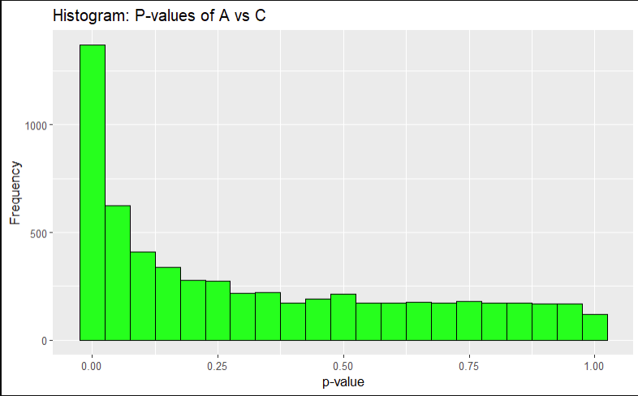
The histogram for A vs C has p-values on the x-axis and frequency of these values on the y-axis. The peaks vary, but the largest by far is a peak that is close to 0, which indicates a large number of genes had very small p-values. This is usually a sign of statistical significance, and this remained after the padj threshold of 0.05 was applied. Following the peak, the frequency across the rest of the p-values remains fairly evenly distributed, meaning these genes that are not significant fall under a null hypothesis. Overall, this histogram links strongly to the previous MA plot and volcano plot for A vs C data, due to the difference seen between significant and non-significant genes.
A vs E Histogram- The following histogram is of A vs E data and shows how the frequency of p-values for each gene in the analysis is distributed. It is useful to assess the statistical significance of the genes:
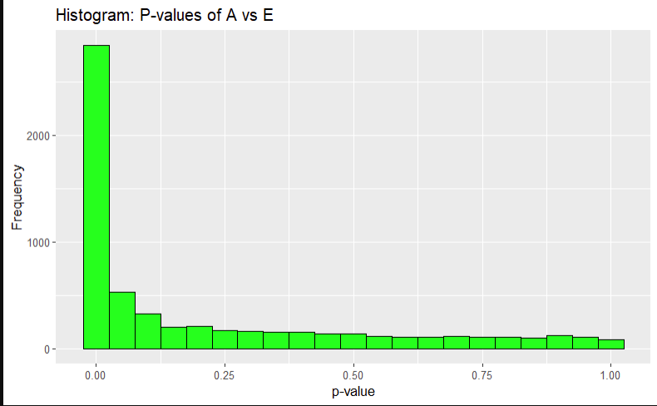
The histogram for A vs E has p-values on the x-axis and frequency of these values on the y-axis. Similar to A vs C, the peaks vary, but the largest by far is a peak that is close to 0, which indicates a large number of genes had very small p-values. This large peak close to 0 is much larger than A vs C’s peak, which links to the previous plots and summarisations that found more significant genes in A vs E data. Also, similar to A vs C is the fairly evenly spread of peaks after the large peak, which again supports non-significant gene behaviour of showing a null hypothesis in a histogram. Overall, this histogram links strongly to the previous Ma plot and volcano plot for A vs E data.

Heatmap
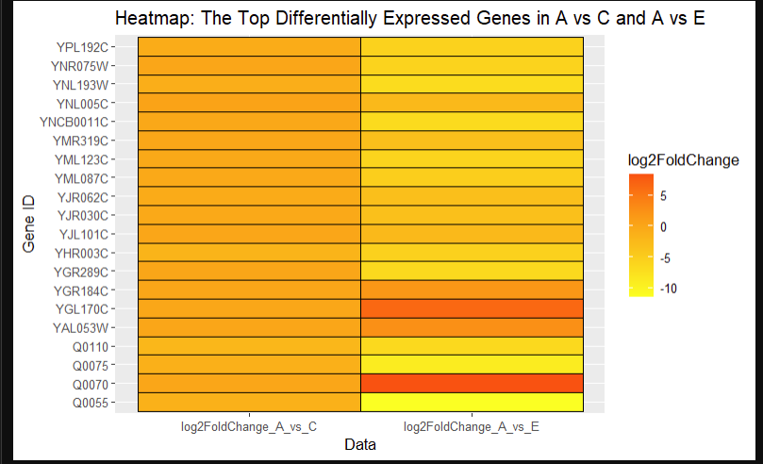
Heatmap of A vs C and A vs E- The following heatmap is of both A vs C and A vs E data that were merged together. It visualises the top 20 differentially expressed genes in these datasets that are ordered by smallest p-values and uses a colour gradient of log2 fold change to determine how strong differential expression is of the top 20 genes:

The heatmap shows the top 20 differentially expressed genes across A vs C and A vs E data, based on their lowest p-values. Each row contains a gene that was found as highly significant in either dataset, and the log2 fold change for each gene in both columns of data is measured by a colour gradient. The colour gradient ranges from yellow to orange to red, where yellow indicates lower log2 fold change values (low differential expression), orange change moderate (differential expression) and red indicates high value changes (high differential expression). While some columns of genes have similar expression patterns in both datasets, essentially all of A vs C’s columns are orange, indicating similar differential expression. A vs E’s has a lot more variability in colour gradient, with the highest value seen in the gene “Q0070”, indicating this is the gene with the most differential expression. Overall, this heatmap details certain genes that have the most influential and strong differential expression and can help to determine if gene expression is similar or different across the two datasets in this report.

Tables of Significant Genes
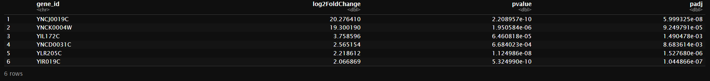
Table 1- This table shows the top upregulated genes in A vs C:

The first few rows of upregulated genes in A vs C data that have had the padj < 0.05 threshold applied. As these are upregulated genes, they show positive log2 fold change values. Genes at the top end of the table are strongest in expression and the smallest p-values, which indicates higher statistical significance associated with their differential expression.
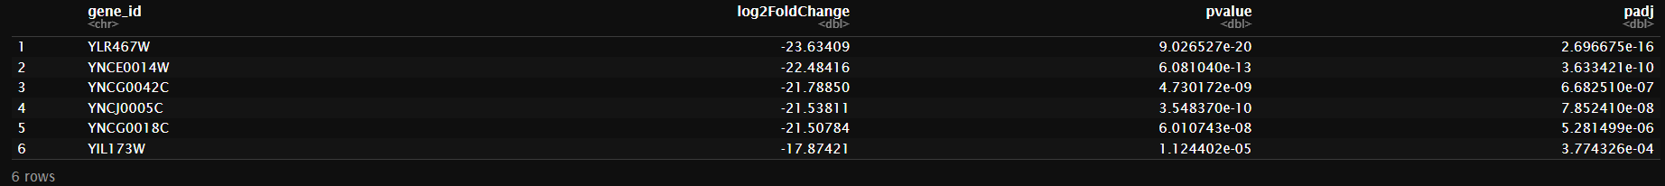
Table 2- This table shows the top downregulated genes in A vs C:

The first few rows of downregulated genes in A vs C data that have had the padj < 0.05 threshold applied. As these are downregulated genes, they show negative log2 fold change values. Genes at the top end of the table exhibit the strongest decrease in expression and the smallest p-values, which indicates higher statistical significance associated with their differential expression.
Table 3- This table shows the top upregulated genes in A vs E:

The first few rows of upregulated genes in A vs E data that have had the padj < 0.05 threshold applied. As these are upregulated genes, they show positive log2 fold change values. Genes at the top end of the table are strongest in expression and the smallest p-values, which indicates higher statistical significance associated with their differential expression.
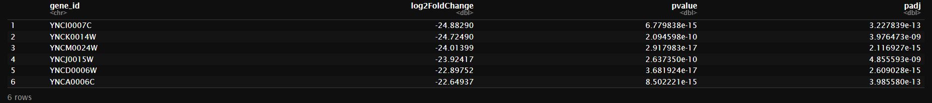
Table 4- This table shows the top downregulated genes in A vs E:

The first few rows of downregulated genes in A vs E data that have had the padj < 0.05 threshold applied. As these are downregulated genes, they show negative log2 fold change values. Genes at the top end of the table exhibit the strongest decrease in expression and the smallest p-values, which indicates higher statistical significance associated with their differential expression.

