Author: Jiaan Randhawa-Heer
Title: Pumpkin Data Analysis Report
Dataset Number: 6
Q1. Read in pumpkins.csv
The allocated pumpkins data was read into a pandas dataframe, and the first few rows were loaded to check it worked correctly.
Q2. Identify the heaviest pumpkin (variety, location, year)
The dataset was sorted by weight (lbs) to find the top heaviest one. Additionally, information including variety, city, state, province, country and the heaviest pumpkin was loaded. The heaviest pumpkin identified was 2888.2 lbs, was of champion variety, grown in Deurle, East Flanders, Belgium and in the year 2016.
Q3. Convert pounds -> kilograms (weight_kg column)
A function was created to convert weight in pounds to weight in kilograms, using the correct numerical formula and adding a new column for the weight in kilograms data.
Q4. Add a weight_class column (light/medium/heavy)
Weights in kilograms were sorted in order (lowest to highest) so the top and end of the data column could be viewed, and bands to sort weight classification into could be decided. Following this, a weight classification function was created and applied to separate them into light/medium/heavy and 20 of the results were loaded to ensure the classifcation column worked correctly.

Q5. Plot estimated vs actual weight (coloured by class)
Firstly, NA or missing values were dropped from the estimated weight column. Then a function was created to convert pounds into kilograms for estimated weights so that they would be usable with the actual kilogram weights for pumpkins. When the conversion column was checked, the scatterplot to show estimated vs actual weights, with weight classification colour-coding, was produced.
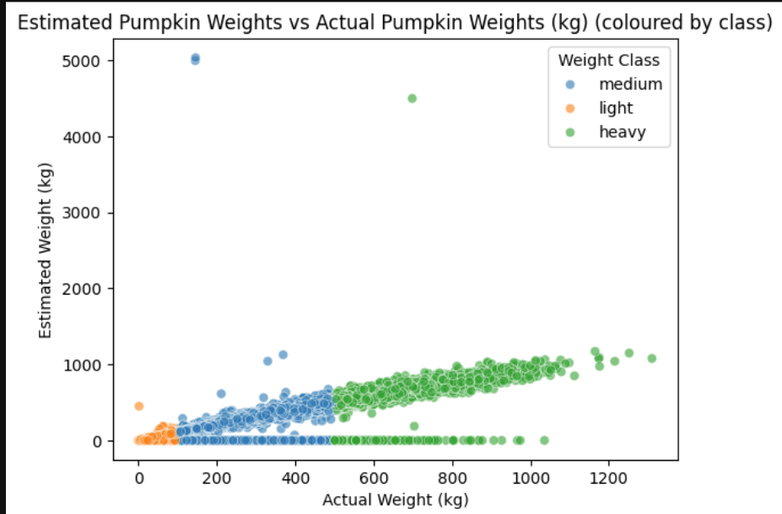
Q6. Filter for three countries and save (pumpkins_filtered.csv)
Firstly, all countries in the dataset were checked to find to choose from, then they were filtered into a new dataset. The countries selected for filtering were the United Kingdom, Canada and the United States of America
Q7. Summarise mean weights by country and variety
Q7A. Weight in kilograms was grouped with country from the filtered data, and the mean function was applied, which produced a list of the 3 filtered countries next to their corresponding means.
Q7B. Weight in kilograms was grouped from the pumpkin data with country and variety, then the mean function was applied. Then, the lowest mean was found in the United Kingdom for the “Connecticut Field” variety, displaying 168.160643kg as the average weight.

Q8. Create a boxplot for the three countries
A function to convert pounds to kilograms was repeated for the filter list so weight in kilograms could be used in the boxplot. Country was selected to be plotted against weight (kg) to show the difference between the countries via a boxplot
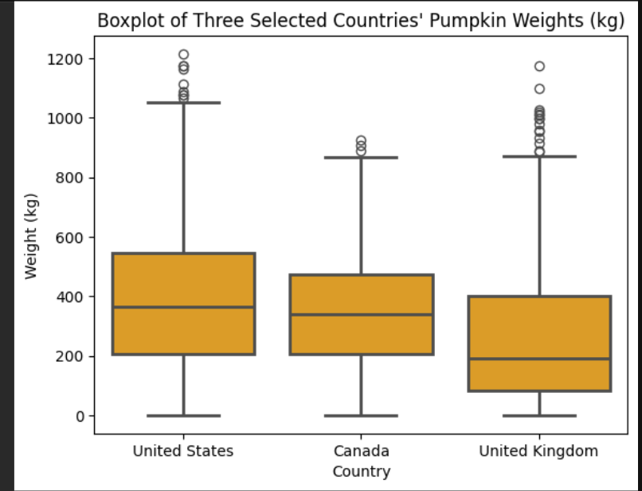
The boxplot displayed compares the weight distributions for pumpkins across the filtered countries (United States, Canada, United Kingdom). The horizontal line through each box represents the median weight (kg) of the pumpkins, and the United States can be seen to have the highest pumpkin weight on average when compared to the other countries.

Q9. Create a faceted plot by variety
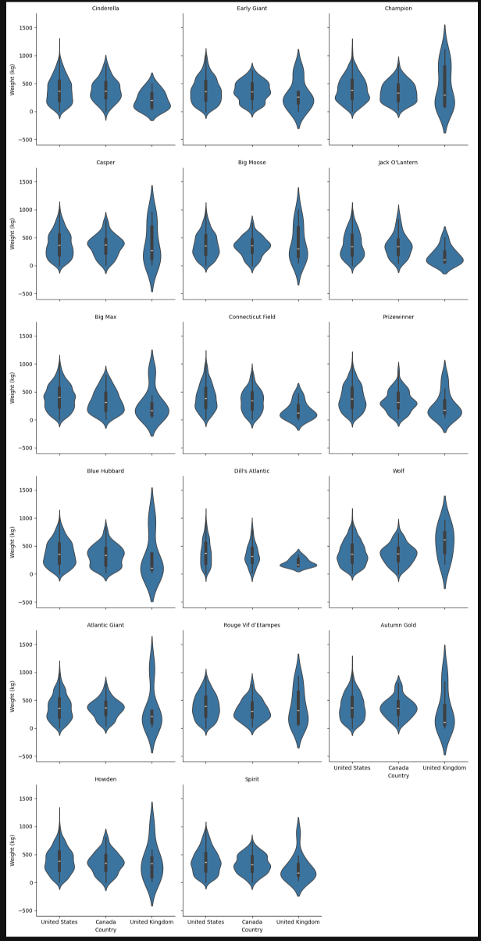
Country, weight (kg) and variety were selected to create a faceted violin plot for the pumpkins dataset, which allows for a comparison of each country's weight differences by their varieties

These faceted violin plots show the variation of pumpkin weights by variety across the filtered countries (United States, Canada, United Kingdom). The shapes of each violin plot entail information on the weight spread distributed across the varieties. For plots where the x-axis label has not printed country names, the United States is the most left plot, Canada is the middle plot, and the United Kingdom is the most right plot.

