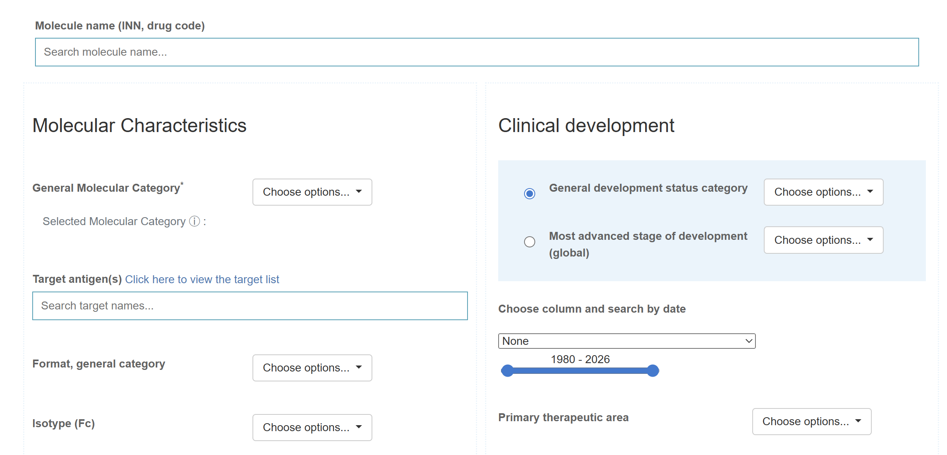

Fields like above based on column headers in my dataset.
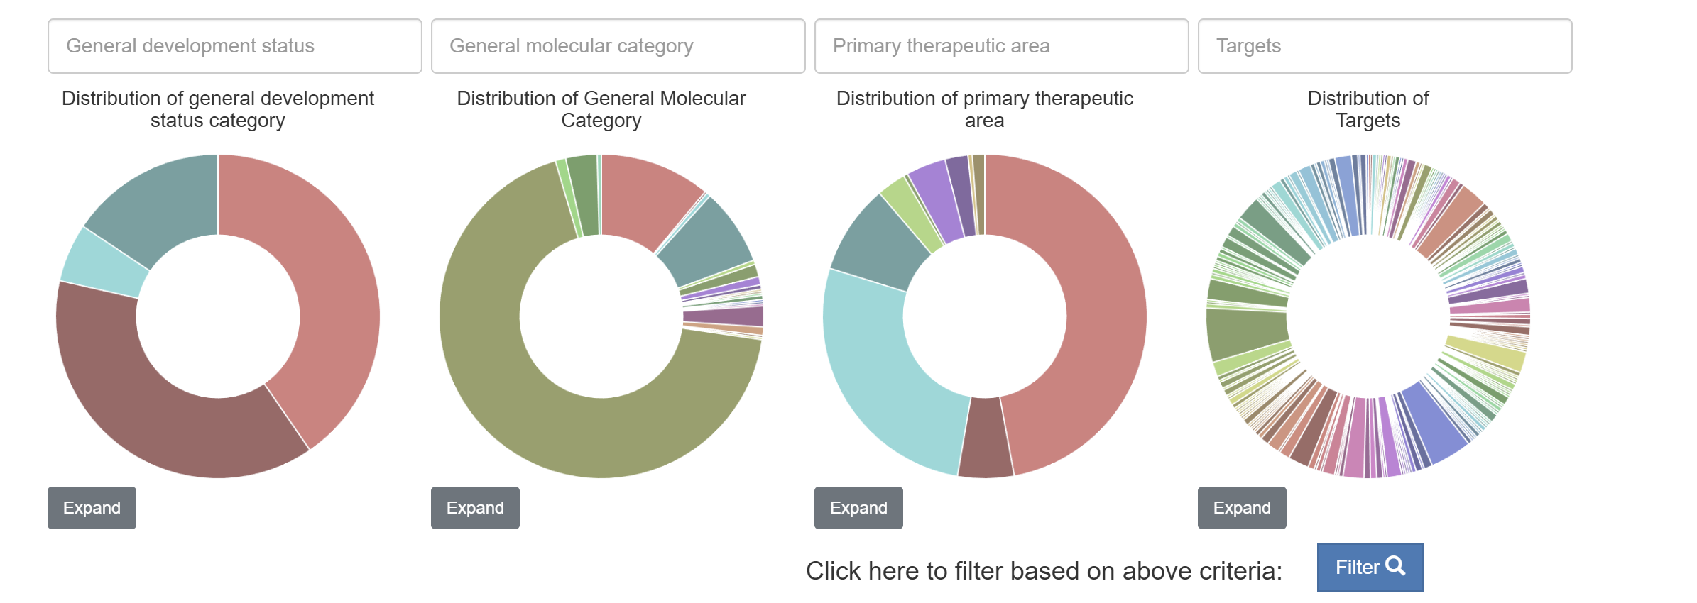
Visualizations like above based on filter criteria
Using n_ab and adverse event counts within rows, summarize using bar plots or other visualizations for proportions for different adverse events types, grouped at organ_system level or adverse_event_term levels
Do the same for comp_arm, if available…if comp_arm available then show side by side comparison within a specific combination, don’t aggregate multiple studies with different arms … potentially show a distribution if we decide to aggregate
Allow filtering by condition, target, antibody, Fc isotype, record category, general molecular category, source (FDA vs. CTGOV).

