Student Name：**Jiachen Luo (001061582)**

**INFO 6205**

**Program Structure & Algorithms**

**Spring 2021**

**Assignment4**

**Task:** For weighted quick union, store the depth rather than the size. For weight quick union with path compression, do two loops.

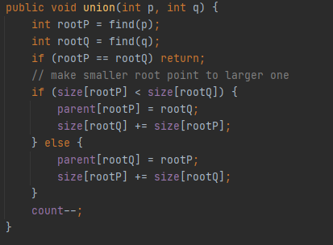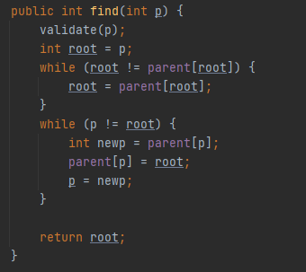

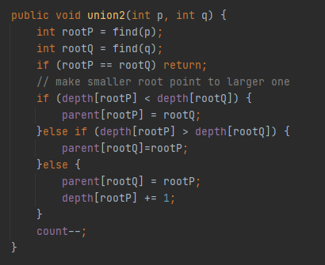

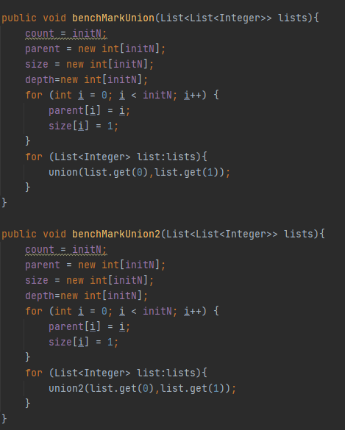

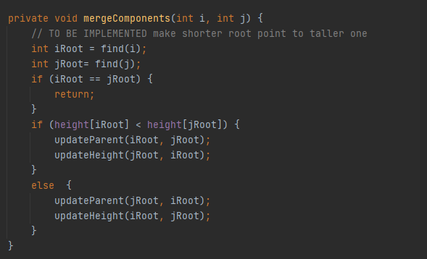

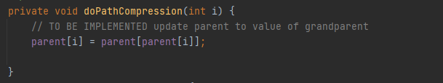

**Output:**

Depth2loop.csv

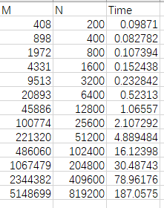

Size1loop.csv

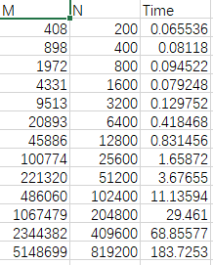

Size2loop.csv:

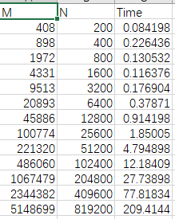

**Graphical representation:**

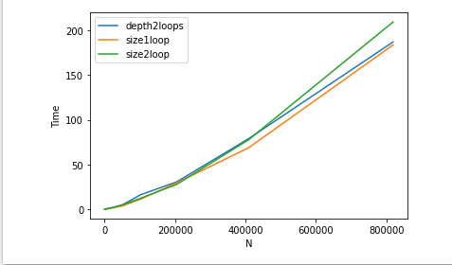

**Unit tests result:**

UF_HWQUPC_test

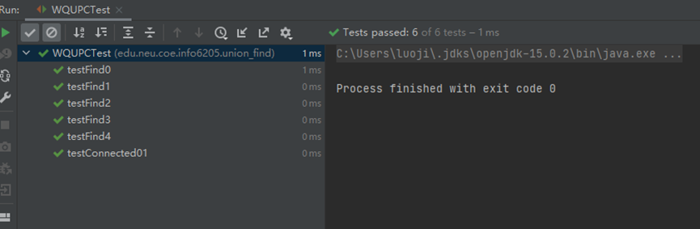

**Conclusion:** As can be seen from figure, the benchmark time of the size1loop algorithm is smaller than the nested loop (depth2loop and size2loop) and as the value of N increases, the benchmark time of size2loop should be gradually smaller than that of depth2loop. In short, the benchmark time of a single-layer loop is always less than multiple cycles