Predictive Authority Control: Learning How Much to Trust Each Controller, and Repairing That Trust Under Distribution Shift*
[Author names]
[Affiliations]
* The abbreviation PAC is unrelated to probably approximately correct learning.
Abstract
The ocean is warming and acidifying at rates that threaten marine ecosystems more severely than previously recognized [1], and autonomous underwater vehicles (AUVs) are the primary platform for the long-term observations needed to understand and mitigate these changes [2]. These vehicles must maintain precise trajectory tracking under ocean currents, parameter drift, and actuator degradation — conditions under which no single controller remains reliable. Sliding-mode control (SMC) is robust but coarse; model predictive control (MPC) is precise but collapses when its model is wrong — in our simulations, actuator degradation causes MPC to diverge to 0.822 m, nine times the nominal error and approaching the 1 m mission-failure threshold. Direct reinforcement learning can adapt to such shifts but produces policies that cannot be certified for deployment. Here we resolve this safety-robustness dilemma by restricting what the learning system controls: instead of generating thruster commands, it learns only a single bounded trust coefficient that continuously blends the two verified controllers. A 14,113-parameter Transformer encodes 0.16 s of closed-loop history to predict this coefficient; a 2,177-parameter residual head, zero-initialized and bounded by 0.1 per step, then refines it through constrained reinforcement learning on the frozen backbone — guaranteeing that the deployed system is numerically identical to the verified baseline at startup and can only deviate within a bounded envelope. In a pre-registered paired evaluation of 1,680 rollouts across 10 disturbance families, the residual policy reduces out-of-distribution tracking error by 28% (0.161 m to 0.116 m), confines the actuator-degradation failure from 0.822 m to 0.090 m, and achieves the lowest saturation and control cost among all six methods — at 16,290 parameters (63.6 KB), The gains carry disclosed costs: in-distribution error rises by 4.4%, heading error by 4.3%, and the solver deadline-miss fraction from 0.69 to 0.80.
This draft reports simulation evidence only; the planned hardware validation must be completed before submission.
1 Introduction
The ocean has absorbed more than 90% of the excess heat trapped by greenhouse gases, and the resulting warming and acidification are altering marine ecosystems more profoundly than previously recognized: a meta-analysis of hundreds of species reveals that combined warming and acidification affect twice as many biological traits as either stressor alone [1]. Understanding and mitigating these changes requires sustained, large-scale observation that exceeds the endurance, weather tolerance, and cost limits of ship-based campaigns [2]. Autonomous underwater vehicles are the established answer: a recent Science Robotics review argues for a paradigm shift toward autonomous robotic organizations capable of making ocean observations at large scale and low cost [2]. In both settings, the scientific value of each measurement depends on where the vehicle is when it is taken; tracking error misregisters observations, degrades image quality, narrows collision margins near fragile seabeds, and wastes limited propulsion energy.
Reliable tracking remains an unsolved control problem because the operating conditions are neither stationary nor fully known. Sliding-mode control rejects bounded disturbances through a transparent reaching-law structure [3], but its robustness is purchased with conservative gains and non-smooth action. Model predictive control anticipates motion and enforces actuator limits through online optimization [4,5], but its advantage evaporates when the internal model no longer represents the plant. Our simulations expose the severity of this failure: under actuator degradation, MPC alone diverges to 0.822 m — nearly an order of magnitude beyond nominal error, close to the 1 m threshold at which a mission is judged failedfailure threshold — because the optimizer acts confidently on wrong premises. Hybrid schemes that switch between the two controllers under fixed thresholds [8] cannot adapt to conditions that vary continuously within a single control step.
Adaptation to shifting conditions requires learning. Machine learning, however, introduces a verification problem that the underwater community has not resolved. End-to-end deep reinforcement learning has demonstrated strong results in six-degree-of-freedom AUV control [7,8], but the learned policy outputs six-dimensional thruster commands whose worst-case behavior cannot be bounded, audited, or certified. Residual reinforcement learning [11,12] superposes a learned correction on a scripted controller, reducing the learning burden but still perturbing the full actuation space without a safety envelope. Supervised learning — including our own prior work on temporal authority prediction — can imitate an oracle only where the oracle is well-defined (deterministic environments); under distribution shift, the learned coefficient degrades below a non-adaptive constant blend, because the training labels carry no information about conditions the oracle never encountered.
This paper resolves the safety-robustness dilemma by restricting what the learning system is allowed to control. Instead of generating thruster commands, the learned policy outputs a single scalar — the authority coefficient — that continuously blends the two verified controllers. The controllers remain explicit and inspectable; the learned output is one bounded number per step. We further constrain the adaptation through a zero-initialized residual head, bounded to perturb the coefficient by at most 0.1 per control step, so that the deployed system starts exactly at the verified baseline and can only deviate within a bounded envelope. The resulting architecture occupies 63.6 KB and runs at 100 Hz — small enough for embedded deployment on the vehicle itself.
In a pre-registered paired evaluation over 1,680 rollouts spanning 10 disturbance families, the constrained residual policy reduces out-of-distribution tracking error by 28% (0.161 m to 0.116 m, 95% CI [−0.074, −0.015] m), confines the actuator-degradation catastrophe from 0.822 m to 0.090 m, and achieves the lowest saturation fraction and control cost among all six methods. The gains carry disclosed costs: in-distribution error rises by 4.4% and the solver deadline-miss fraction from 0.69 to 0.80. This study makes four contributions:
(1) Continuous temporal authority allocation between two complete controllers, reducing the learned action space to one bounded variable that is directly auditable.
(2) A constrained residual reinforcement learning procedure on the frozen backbone, with the residual bounded by $|Δα_{t}|≤0.1$ and zero-initialized, so the worst-case behavior equals the deployed baseline.
(3) A pre-registered paired evaluation protocol covering 10 disturbance families, six methods, and 1,680 rollouts with seed-level confidence intervals.
(4) An extremely compact policy (16,290 parameters, 63.6 KB, 0.23M MACs at 100 Hz) that fits resource-constrained embedded processors.
2 Related Work
2.1 Underwater vehicle control
Marine vehicle control is developed from rigid-body dynamics with added mass, damping, and restoring forces [3,4]. Hybrid schemes combine nonlinear MPC with sliding-mode terms under threshold switching, retaining each expert in its favorable regime [17]; such switching surfaces are fixed at design time, whereas PAC answers the trust question online and continuously. Learning-based AUV control has advanced rapidly: improved TD3 path following [10] and six-degree-of-freedom control trained in parallel simulators with zero-shot transfer [8] learn commands directly. PAC instead learns a one-dimensional arbitration variable over complete structured controllers.
2.2 Learning with structured controllers
Residual reinforcement learning superposes a learned correction on a hand-designed base policy [5]. Actor-critic MPC embeds a differentiable optimizer in the actor [6], and learning-based MPC surveys data-driven refinement with safety considerations [4]. PAC differs in the interface: the residual applies to a bounded scalar authority rather than actuator commands, the supervisor is frozen rather than jointly trained, and zero initialization yields exact initial equivalence to the deployed system. Learned safety filters train barrier-like corrections [11]; the PAC safety filter instead composes fixed bounds with structured fallbacks and contains no learned component in the safety path. Embedded solvers such as TinyMPC [7] constrain what an onboard arbitration layer may assume computationally.
2.3 Temporal encoders for sequential decisions
Self-attention [17] and sequence-modeling formulations of control [18,19] scale with data and width. The PAC encoder deliberately occupies the opposite regime: one encoder layer over a 16-step history mapping to a single coefficient, which suffices for the arbitration interface and keeps edge deployment plausible. Diffusion policies [20] and imitation navigation [9] address different output spaces and are complementary.
3 Predictive Authority Control
3.1 Vehicle model and tracking objective
The vehicle pose and body velocity are η = [x, y, z, φ, θ, ψ]ᵀ and ν = [u, v, w, p, q, r]ᵀ. The simulator integrates the diagonalized six-degree-of-freedom model with added mass, linear and quadratic damping, and restoring stiffness by fourth-order Runge–Kutta at 100 Hz for 2,100 steps (21 s) per episode. Six thrusters in an X layout are limited to 35 N with magnitude and slew-rate constraints. The reference is a three-dimensional Lissajous path with desired yaw aligned to the horizontal tangent; initial pose and velocity are perturbed with standard deviations 0.03 m and 0.01 m/s.
3.2 Structured controller experts
The primary expert is an equivalent-control SMC whose translational sliding surface combines velocity error and pose error, with feedforward acceleration, damping compensation, and a bounded reaching term. The second expert is a receding-horizon linear-time-varying constrained MPC with a 20-step horizon (0.2 s), normalized thruster limits, warm-start smoothing, and an online solve-time limit of 7.5 ms with fallback to the previous plan. This expert replaces the one-step quadratic tracking law used in an earlier implementation of this framework; all results here use the constrained MPC.
3.3 History features and temporal encoder
At each step a 24-dimensional feature vector summarizes pose errors, body velocities, per-controller command statistics and disagreement, near-saturation fraction, horizontal current components, and trajectory phase. The most recent 16 vectors form the encoder input; one Transformer encoder layer (four heads, 128-unit feed-forward, 14,113 trainable parameters) maps the final token to α̂ₜ through a sigmoid head. At inference the prediction is scaled by 1.2, clipped, smoothed with coefficient 0.5, and rate-limited to 0.0125 per step.
3.4 Layered safety filter
Every learned contribution passes a fixed filter stack, in execution order: (i) the residual is bounded; (ii) the blended coefficient is clipped, smoothed, and rate-limited; (iii) expert failure forces primary control; and (iv) non-finite values fall back to the frozen supervised prediction. Because the residual head is zero-initialized, the composite policy reproduces the deployed baseline numerically at initialization, enforced by a unit test comparing full-episode rollouts to tight numerical tolerances. The worst case of the learning components is therefore the baseline policy itself. Figure 1 shows the complete architecture; Figure 2 details the network and two-phase training. Figure 2 details the two networks and the two-phase training procedure: the backbone is frozen throughout phase 2, and the residual head is zero-initialized, so the composite policy starts exactly at the supervised baseline.
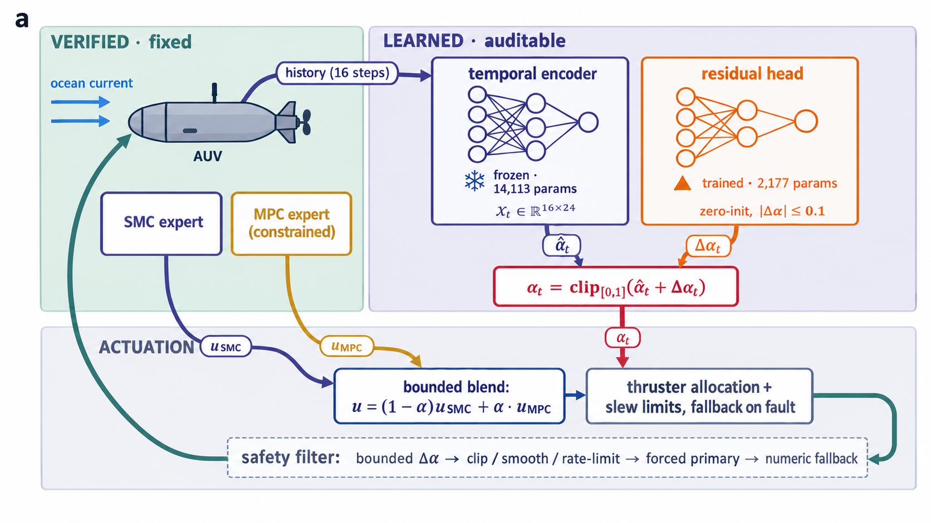
Figure 1. Predictive authority control architecture. (a) Closed loop: the experts generate commands blended by α; a frozen temporal encoder predicts the supervised coefficient and a bounded, zero-initialized residual head revises it. (b) Layered safety filter in execution order. (c) Two-phase training.
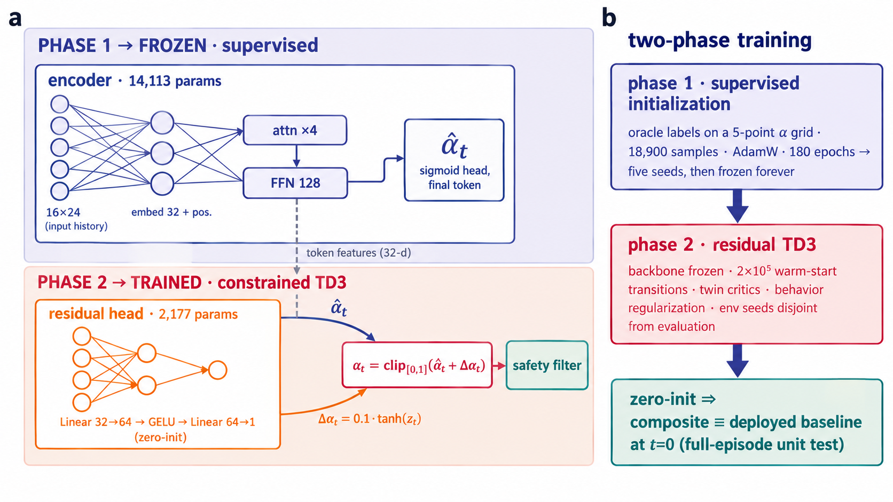
Figure 2. Network architectures and two-phase training. (a) The frozen temporal encoder (14,113 parameters) maps a 16×24 history through a 32-dimensional embedding and one Transformer encoder layer (four-head attention, 128-unit feed-forward) to the supervised authority; the trainable residual head (two linear layers, 2,177 parameters, zero-initialized final layer) revises it by at most 0.1 per step. (b) Phase 1 trains the backbone by imitation of the short-horizon oracle; phase 2 trains only the residual head with TD3 [13], behavior regularization, and a warm-start replay.
4 Learning the Authority Residual
4.1 Supervised initialization
The supervised PAC policy is trained by imitation of a short-horizon oracle: for each training state, candidate coefficients from a five-point grid are held for ten steps with the current frozen, and the label minimizes
$J(α)=‖e_{xy}‖^{2}+0.7e_{z}^{2}+0.08e_{ψ}^{2}+0.02mean([|u|−0.92]_{+}^{2})+0.01mean((u−u_{t−1})^{2})$ (2)
a cost combining horizontal and vertical position error, heading error, near-saturation magnitude, and command change. Training uses 18,900 labeled samples, AdamW for 180 epochs, and a weighted squared loss. Five model seeds are trained independently; these frozen policies supervise all later stages and are never retrained.
4.2 Constrained residual stage
The residual policy appends a two-layer head with 2,177 parameters to each frozen supervisor. The applied coefficient is
$α_{t}={clip}_{[0,1]}({\hat{α}}_{t}+Δα_{t}),Δα_{t}=0.1tanh(z_{t})$ (3)
where zₜ is the head output and the final layer is zero-initialized, so Δα ≡ 0 before training. Training uses TD3 (twin critics, target smoothing, delayed policy updates) over closed-loop episodes with environment seeds disjoint from all evaluation seeds, warm-started with 2×10⁵ offline transitions collected under the supervised policy, with a behavior-regularization term penalizing deviation from the supervisor. The reward combines position and heading error, command magnitude and rate, saturation, deadline flags, and constraint violations; all weights are frozen in a manifest before training. The learner emits Δα only: it cannot command thrusters and cannot alter the MPC schedule or solver budget.
5 Experimental Design
5.1 Registered protocol
All comparisons, seed partitions, and acceptance criteria were fixed and archived before residual training began. The evaluation grid comprises 120 paired episodes: 85 in-distribution (60 structured-current episodes under 20 held-out environment seeds, plus 25 episodes from five training-range disturbance families) and 35 out-of-distribution with respect to disturbance-family sampling (five test-range families, plus a fast time-scale current family and an estimation-delay family with sensor lag and noise). Each episode is shared across all methods: the same vehicle, current, and reference realization under every method and seed.
5.2 Methods and statistics
Six methods are compared: the experts alone (SMC, MPC), a constant blend (Fixed α = 0.5), a non-learning adaptive baseline searching window-level bias schedules by coordinate descent (SSPO, a coordinate-search ablation rather than an external baseline), and the two PAC variants (supervised and residual) each instantiated with the same five frozen supervised seeds. Fixed methods contribute one combination each, giving 14 method-seed combinations and 1,680 rollouts (about 3.53 million control steps).
Primary inference is at the model-seed level: per-seed paired effects are summarized with a t-distribution interval with four degrees of freedom. As a supplementary check, episode-level bootstrap intervals (resampling the paired episodes with replacement, 10,000 resamples, generator seed 0) are reported for the headline contrasts. No comparisons beyond the registered set are subjected to significance claims, and no multiple-comparison correction is applied: the registered set is reported in full rather than selected from.
6 Results
6.1 Closed-loop tracking: how the vehicle actually moves
Figure 3 shows representative paired episodes—an in-distribution sinusoidal current and the out-of-distribution actuator-degradation episode—as three-dimensional paths, horizontal projections, and vertical error. In-distribution, all learning and blending methods follow the Lissajous reference closely; SMC lags with a visible offset. Under actuator degradation the character changes: the MPC expert alone distorts the horizontal loop and drifts in depth (0.886 m episode RMSE), the supervised policy inherits part of that failure (0.206 m), and the residual policy stays on the reference (0.088 m), slightly better than the never-adapting constant blend (0.124 m).
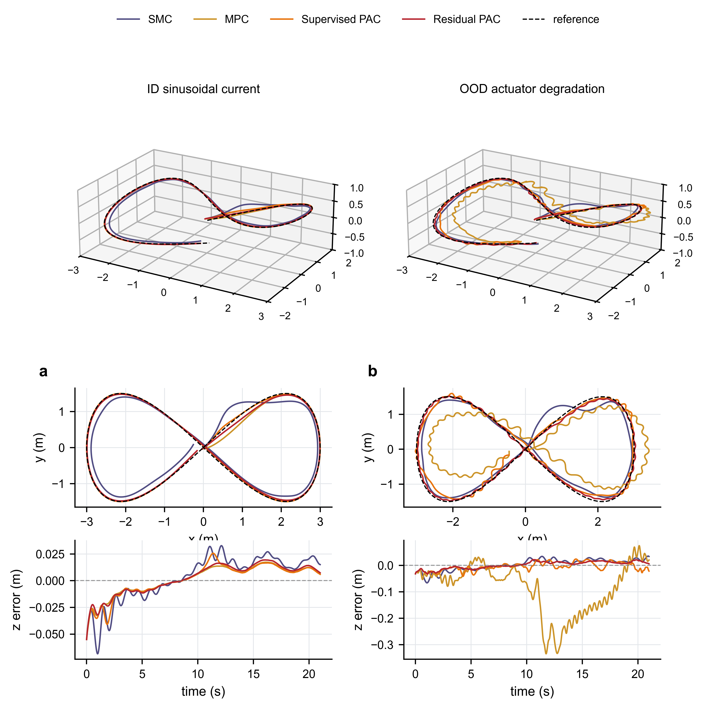
Figure 3. Representative closed-loop trajectories. Columns: in-distribution sinusoidal current and out-of-distribution actuator degradation (the lowest-numbered held-out seed of each block, fixed before inspection); both episodes are shared across methods and regenerated deterministically from the frozen checkpoints. Rows: three-dimensional path, horizontal projection, z-axis tracking error (dashed line, zero). The fixed blend is omitted for legibility; its values appear in Table 1.
Figure 4 resolves the same episodes in time. The position-error row shows the MPC divergence under degradation growing through the episode rather than spiking, consistent with a steadily wrong internal model rather than a transient. Heading error and pitch remain small for residual PAC in both regimes, while the degraded MPC episode carries visible attitude excursions. Table 1 aggregates the full grid.
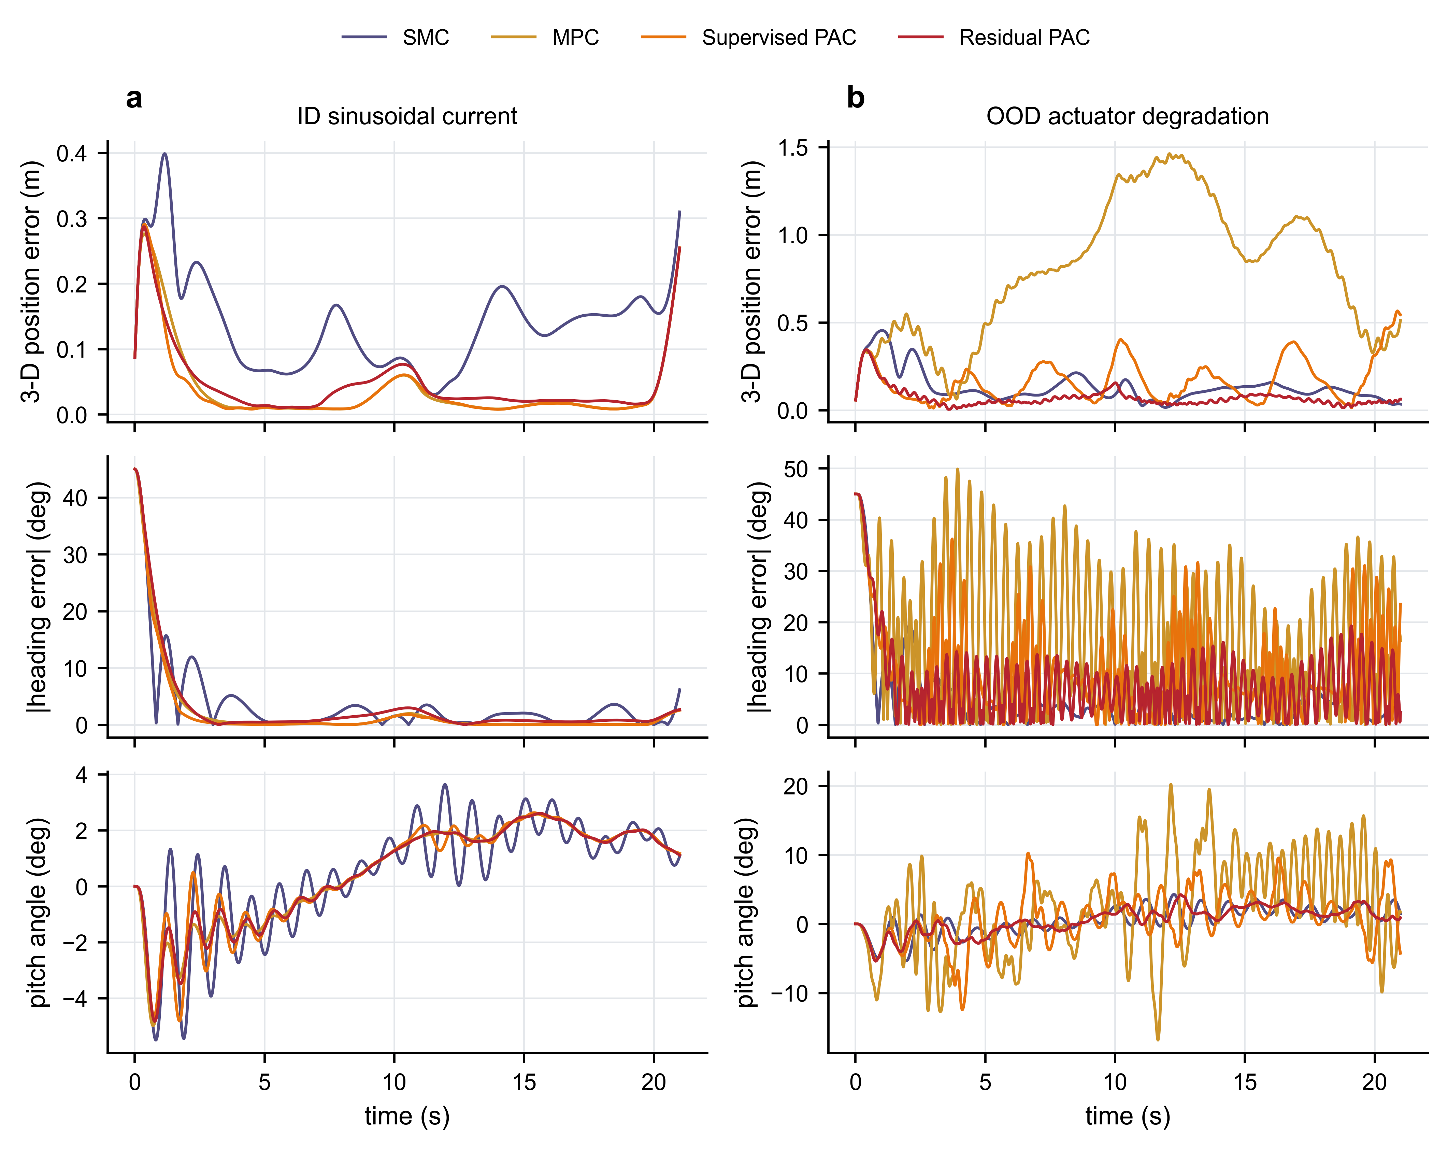
Figure 4. Time-resolved motion errors for the two episodes of Fig. 3. Rows: three-dimensional position error, absolute heading error, pitch angle. The MPC divergence under actuator degradation grows through the episode; residual PAC remains close to the reference in both regimes. Single episodes; block-level aggregates appear in Table 1 and Fig. 7.
Residual training is stable across seeds. Figure 5 shows the per-seed mean episode reward during phase 2, collected under exploration noise on the rotating training-family schedule; the trend therefore reflects the changing episode mix rather than greedy-policy performance, and no seed diverges. All five seeds yield policies with consistent closed-loop behavior in the registered evaluation (Fig. 6, Table 1), which is the performance measure of record.
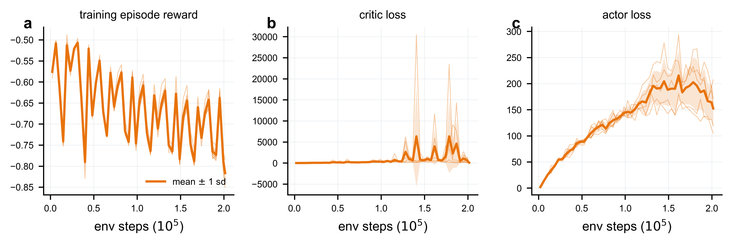
Figure 5. Residual training across the five model seeds. (a) Episode reward, (b) critic loss, (c) actor loss. Thin lines: per-seed values; bold line and shaded band: five-seed mean $±$ 1 sd. All metrics are collected under exploration noise on the rotating training-family schedule, so trends reflect the changing episode mix rather than greedy-policy performance; no seed diverges. The losses are regressions onto a moving TD target that is recomputed from tracking networks at every update, so their magnitudes track the growing value scale of that target rather than divergence; the actor loss is dominated by the negative action value, whose scale inflates with the critic. Greedy closed-loop performance is the registered evaluation of Fig. 6 and Table 1.
Table 1. Paired evaluation over 120 episodes per method-seed combination (means over five model seeds for learned methods; ID, in-distribution; OOD, out-of-distribution with respect to disturbance-family sampling). Five-seed dispersion is reported as confidence intervals in Fig. 6a.
Method | ID RMSE (m) | OOD RMSE (m) | OOD max err (m) | OOD heading (°) | OOD deadline miss | OOD mean α
SMC | 0.162 | 0.248 | 0.601 | 10.65 | 0.69 | 0.00
MPC | 0.071 | 0.221 | 0.575 | 9.46 | 0.69 | 1.00
Fixed α = 0.5 | 0.066 | 0.120 | 0.412 | 8.66 | 0.69 | 0.59
SSPO | 0.062 | 0.136 | 0.448 | 9.11 | 0.69 | 0.87
Supervised PAC | 0.064 | 0.160 | 0.495 | 9.20 | 0.69 | 0.82
Residual PAC | 0.066 | 0.116 | 0.414 | 8.46 | 0.80 | 0.54

6.2 Where the residual earns its value
Across the OOD block, the residual policy reduces tracking RMSE from 0.161 m (supervised) to 0.116 m. The registered model-seed paired effect is −0.0445 m with a 95% t(4) interval of [−0.0737, −0.0154] m (28% relative reduction); the episode-level bootstrap over the 35 OOD episodes is [−0.0759, −0.0167] m, consistent with the seed-level analysis. Maximum error falls from 0.495 m to 0.414 m (five-seed means) and OOD heading error improves by 0.73°.
The sharpest reading of Table 1 is unfavorable to us: a constant α = 0.5 reaches 0.120 m OOD, within 3% of the residual policy. That comparison was not registered and we make no significance claim; the honest summary is that the residual's overall advantage over never adapting is small, and its value is concentrated where adaptation is hardest (−28% versus the constant blend in the actuator-degradation family, Table 2). The in-distribution effect is +0.0028 m [+0.0009, +0.0047] (+4.4%) and in-distribution heading error rises by 0.32° [+0.29, +0.35] (+4.3%).
The family decomposition in Fig. 6b locates the gain, and the registered paired effects in Fig. 6a quantify it. The SSPO versus residual PAC contrast is not included in the archived paired-effects summary; it is recomputed from raw episode metrics with the same seed-level procedure: OOD −0.0198 m [−0.0211, −0.0185] in favor of the residual policy, ID +0.0043 m [+0.0033, +0.0053] in favor of SSPO.
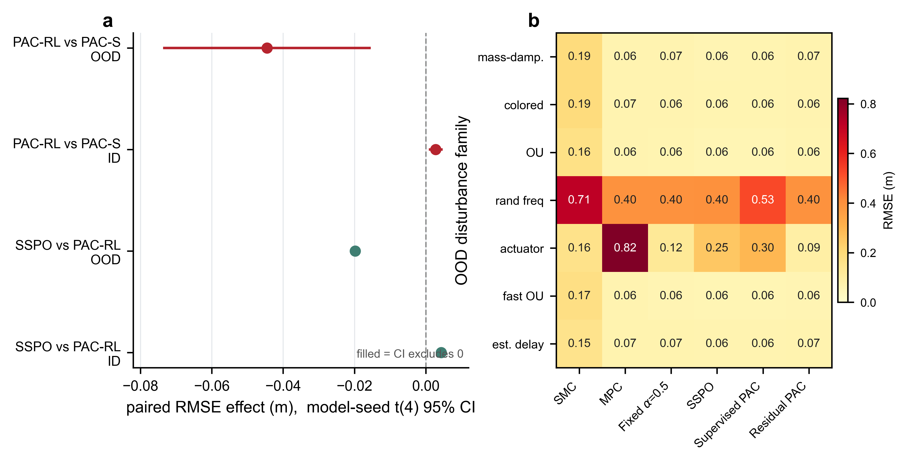
Figure 6. Registered paired effects and family decomposition. (a) RMSE paired effects with model-seed t(4) 95% intervals by block (OOD, ID); filled markers denote intervals excluding zero; the SSPO versus supervised contrast is as archived; the SSPO contrast is recomputed from raw episode metrics. (b) OOD RMSE by disturbance family and method. Gains concentrate in the actuator-degradation family; in the mild stochastic and estimation-delay families the supervised policy and SSPO remain marginally better. The panel does not support uniform superiority.
Table 2. Actuator-degradation family (response lag with measurement noise): paired family means.
Method | ID RMSE (m) | OOD RMSE (m) | vs supervised PAC
SMC | 0.142 | 0.156 | -47%
MPC | 0.089 | 0.822 | +179%
Fixed α = 0.5 | 0.056 | 0.125 | -58%
SSPO | 0.074 | 0.252 | -15%
Supervised PAC | 0.069 | 0.295 | —
Residual PAC | 0.056 | 0.090 | -69%

6.3 How does the residual act?
The mechanism is visible in Fig. 7b. Within seconds of degraded-thruster onset, the supervised policy drives α above 0.9 and oscillates there for much of the episode (31.2% of steps above 0.9; standard deviation 0.331); the residual policy never exceeds 0.69 and holds [0.4, 0.6] on 97.0% of steps. The residual has not learned a new schedule—it has learned to veto the supervisor's excursions. We read this as conservatism under distribution shift, a single-family observation we do not extrapolate.
The stabilization generalizes beyond the single episode: across all 35 OOD episodes and five seeds (175 episodes per method), the per-episode mean authority is 0.82 ± 0.14 for the supervised policy (10th–90th percentile 0.62–0.93) and 0.54 ± 0.03 for the residual policy, with every residual episode inside [0.48, 0.62] (Fig. 7c).
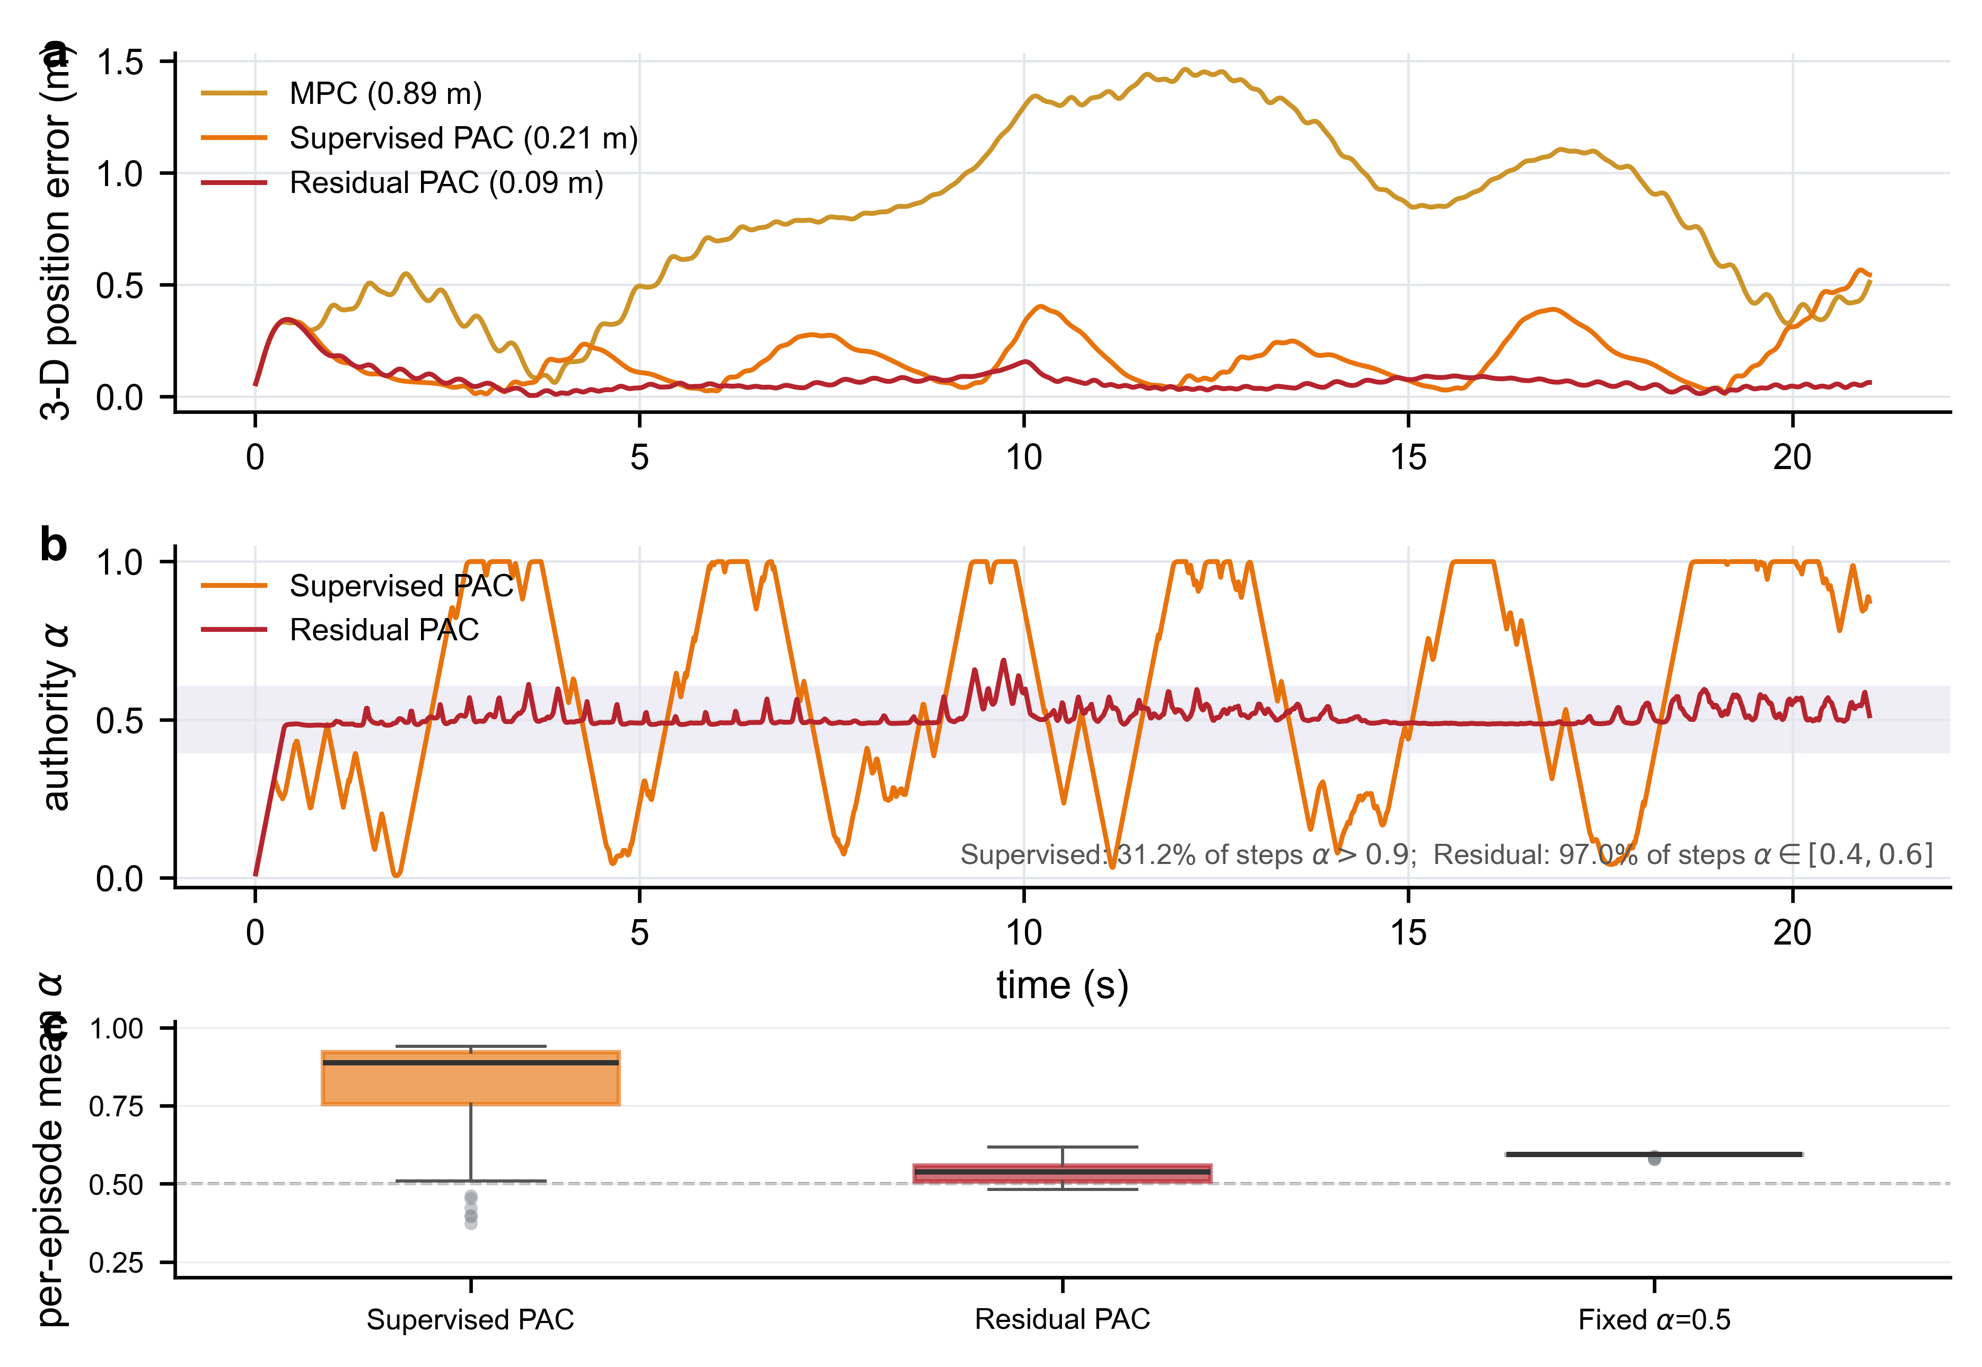
Figure 7. Actuator-degradation episode (held-out seed 43000, fixed before inspection; family means superposed as text). (a) Position error. (b) Authority coefficient in the representative episode. (c) Box plots of per-episode mean authority over all 35 OOD episodes and five seeds (175 points per method; boxes: IQR, whiskers: range, line: median). Family-mean coefficients: 0.63 (supervised) versus 0.50 (residual).
6.4 Control quality: the gain is not purchased with actuator abuse
On the OOD block the residual policy attains the lowest saturation-step fraction of all six methods (0.126, versus 0.134 for the fixed blend and 0.168 for the supervised policy), the lowest applied control cost (31.9 versus 33.7), and a rate-limit activation of 0.039 below both experts. The paired effect on control cost is −1.78 [−2.31, −1.26] OOD and −0.52 [−0.56, −0.48] ID: the residual policy is in fact cheaper to run than its supervisor while tracking better OOD. This substantiates the registered criterion that gains must not be purchased with heading, saturation, or constraint degradation (Fig. 8).
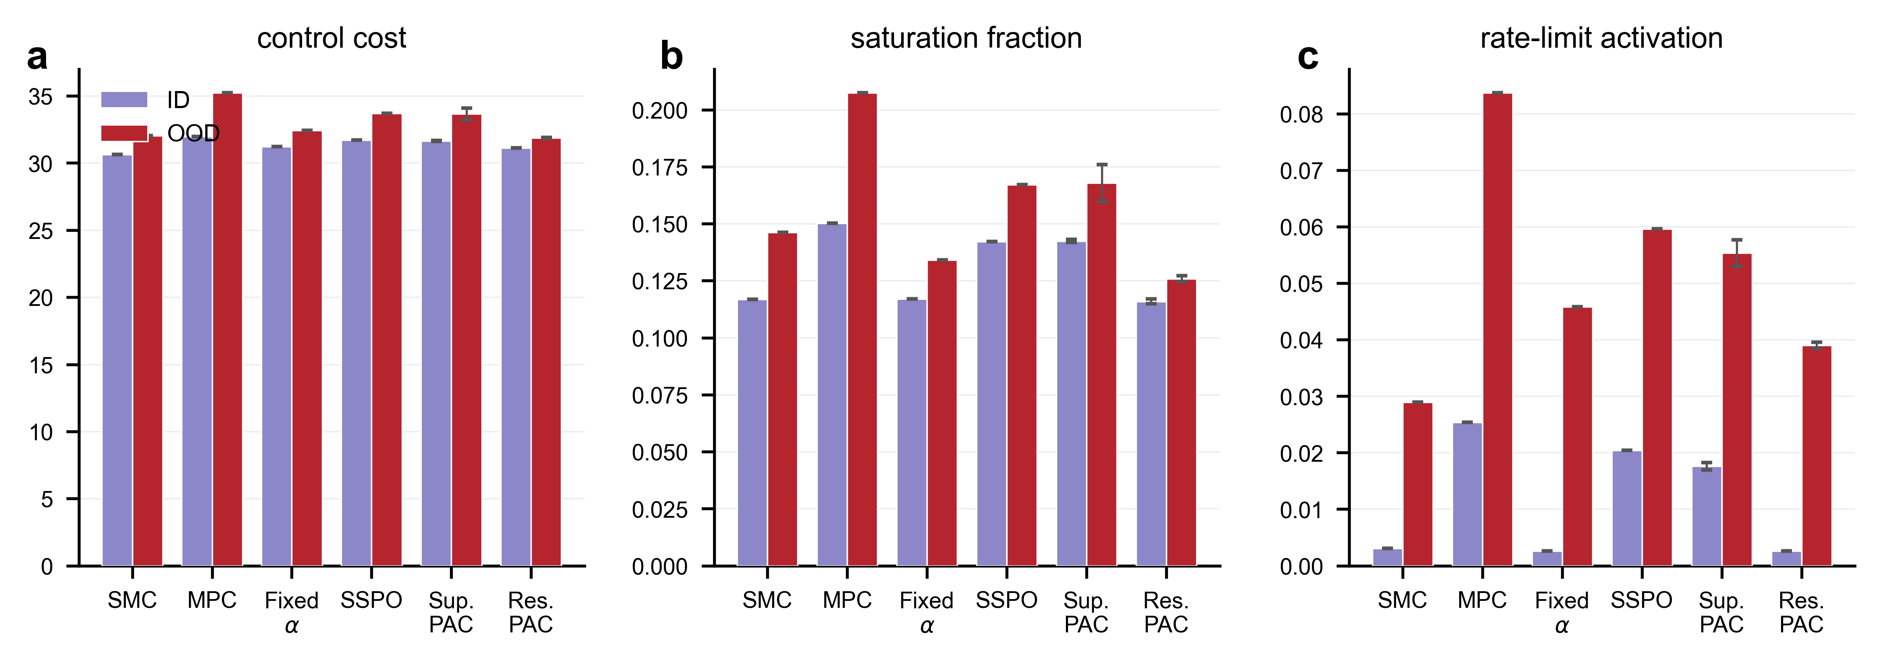
Figure 8. Control quality by method and block (bars: five-seed means $±$ sd). (a) Applied control cost. (b) Saturation-step fraction. (c) Rate-limit activation. The residual policy attains the lowest OOD saturation and control cost of all methods.
6.5 The price of the gain
Two costs accompany the OOD gain. In-distribution position and heading error increase as quantified above. And the solver deadline-miss fraction—steps on which the harness MPC instance exceeds the 10 ms period, measured identically for every method—rises from a common 0.69 baseline to 0.80 under the residual policy (+0.107 [+0.094, +0.120] OOD; +0.028 [+0.010, +0.047] ID). The constant blend leaves the metric unchanged, so the coefficient value itself is not the cause; a candidate explanation is trajectory-dependent solver conditioning, flagged as a hypothesis rather than a conclusion. Deployed safeguards are unaffected: fallback to the previous plan triggers on 0.3–0.5% of steps for all methods, success at the one-metre threshold is unchanged (0.988 ID / 0.943 OOD), and OOD maximum error improves.
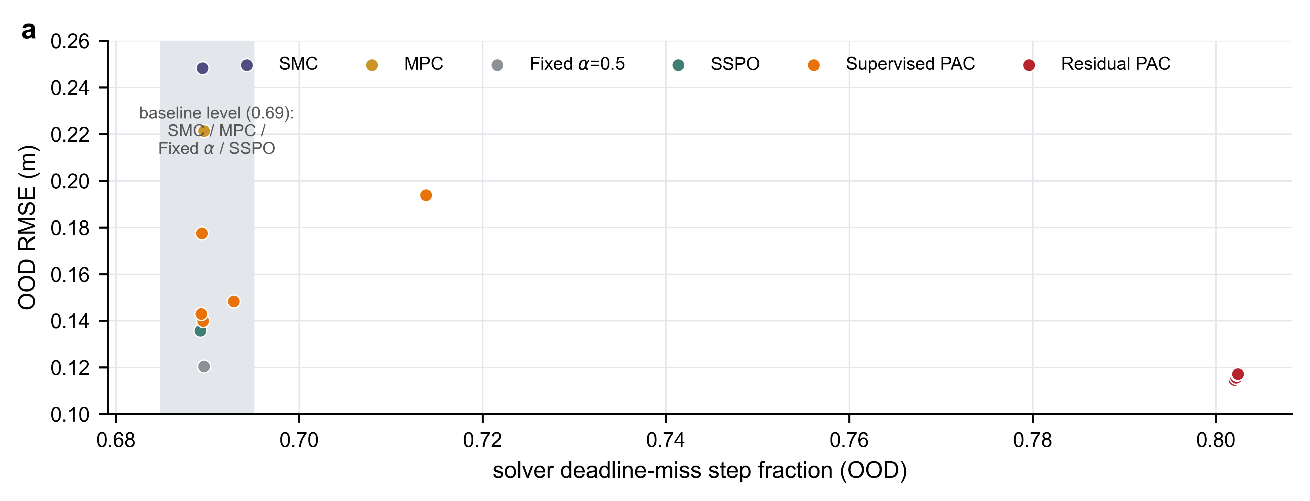
Figure 9. Cost accounting. OOD RMSE versus solver deadline-miss fraction for every method-seed combination; the metric counts steps on which the shared-harness MPC instance exceeds the 10 ms period, collected identically for all methods. Shaded band: common baseline level (0.69; SMC / MPC / Fixed α / SSPO).
Table 3. Registered paired effects of the residual policy versus the supervised baseline across all reported metrics (model-seed t(4) 95% intervals). The SSPO contrast, recomputed from raw episode metrics, is RMSE OOD −0.0198 [−0.0211, −0.0185] in favor of the residual policy and ID +0.0043 [+0.0033, +0.0053] in favor of SSPO.
Metric | ID effect [95% CI] | OOD effect [95% CI]
RMSE (m) | +0.0028 [+0.0009, +0.0047] | −0.0445 [−0.0737, −0.0154]
Heading error (deg) | +0.32 [+0.29, +0.35] | −0.73 [−1.41, −0.06]
Applied control cost | −0.52 [−0.56, −0.48] | −1.78 [−2.31, −1.26]
Deadline-miss fraction | +0.028 [+0.010, +0.047] | +0.107 [+0.094, +0.120]

Against the six registered criteria concerning the residual stage, three pass (gains not purchased with heading, saturation, or constraint violations; ablation separability; stable direction across five seeds), two fail (overall non-inferiority, through the in-distribution +4.4% effect; deadline-miss non-worsening), and one—deployment inference time within the control period—was not evaluated and is the first gate of the hardware stage. The criteria are translated verbatim from the registered Chinese original.
7 Limitations and Discussion
The central result is that a two-thousand-parameter residual, acting only on a bounded authority coefficient, converts a supervised arbitration policy that fails under distribution shift into one that matches a strong constant blend overall and exceeds it mainly where adaptation is hardest. The safety argument is architectural: zero initialization guarantees numerical equivalence to the deployed baseline at deployment, bounded output limits every perturbation, and fixed fallbacks bound the worst case by the baseline itself. This positions the contribution against residual reinforcement learning [5], which perturbs actuator commands, and learned safety filters [11], which place a learned component in the safety path.
Six boundaries qualify these claims. First, all evidence is simulation-level. Second, the feature set receives exact current information, which hardware must estimate. Third, out-of-distribution means disturbance-family sampling, not arbitrary field conditions. Fourth, in-distribution non-inferiority failed (+4.4% position, +4.3% heading). Fifth, the deadline-miss increase (+0.107) has no established cause. Sixth, deployment latency of the composite policy is unmeasured.
These boundaries define the registered next experiments. First, a direct-RL arm—an end-to-end TD3 policy emitting thruster commands on the same grid—completes the comparison hierarchy that residual-RL studies expect. Second, a constant-authority sweep over α ∈ {0, 0.25, 0.5, 0.75, 1} exposes the trust landscape that the policy navigates. Both require new registered runs. Third, a second residual round with the final encoder block unfrozen targets the in-distribution effect. Fourth, isolation of the deadline mechanism. Fifth, the hardware protocol of Section 8, whose first gate is deployment latency.
8 Planned Hardware Validation
The paper is not submission-ready without physical experiments. The planned study deploys the same SMC, MPC expert, supervised PAC, and residual PAC checkpoints on the 10-kg six-thruster vehicle. The protocol includes at least ten independent trials per method and disturbance condition, randomized controller order, a fixed battery-voltage acceptance window, and identical trajectory and actuator limits. Disturbances progress from quiescent water to steady cross-flow, a repeatable step-like disturbance from a tethered pull or calibrated flow source, and—specific to this paper's claims—an injected actuator-degradation condition realized by a validated first-order command lag plus noise on a subset of thrusters.
The onboard estimator must provide pose, body velocity, and a causal current estimate from IMU, depth, DVL, and localization; the exact simulator current must not be exposed. Beyond position and attitude RMSE, the hardware section reports maximum error, success rate, measured electrical energy, per-step inference latency, end-to-end control-loop latency (the unevaluated criterion), saturation duration, and emergency interventions. Placeholder items (platform dimensions, sensor suite, test-site calibration, trial counts) must be filled with measured values only; they must not be replaced with simulated or expected data.
9 Future Directions
The immediate extension is a second residual round under a registered rule: unfreeze the final encoder block, target the in-distribution regressions (+4.4% position, +4.3% heading), and decide in advance that both rounds are reported whichever way the comparison ends. The bounded-residual interface makes this an incremental step rather than a redesign—the worst case of the new round is still the deployed baseline of the current one.
The world-model route has concrete, separable levers. Calibration comes first, because a rank-valid but miscalibrated signal (14.5% and 32.8% empirical coverage at 68% and 95% nominal) cannot be gated safely; conformal or ensemble-recalibration methods apply directly. Gate policy and refresh interval come second: the current gate opens on only 4–5% of steps, so raising engagement where advice can change outcomes is a design variable, not a property of the model. Joint training comes third, letting world-model predictions participate in the residual objective rather than entering only as input features. The promotion rule is fixed in advance: a closed-loop gain under the registered evaluation promotes the world model into the method; otherwise it remains an ablation.
The hardware campaign of Section 8 executes the protocol as written, with two additions informed by this study: the injected actuator-degradation condition is the primary OOD test, and the causal current estimator replaces the privileged simulator input so that authority decisions are made on the same information a fielded vehicle would have. Before the campaign, an isolation experiment should separate the two candidate mechanisms behind the deadline-miss increase—trajectory-dependent solver conditioning and advisory-computation wall-time—because the answer determines what the hardware logging must instrument.
Two further directions are open. On theory, the time-varying convex blend lacks a formal stability argument; a common-Lyapunov or dwell-time and rate condition for the switched structure would complement the architectural safety argument with an analytical one. On generality, the authority interface extends beyond two experts—per-axis coefficients, larger expert sets, and experts added or removed at run time—and the certification structure developed here (zero initialization, bounded residual, fixed fallbacks) is a candidate template for other learned components in safety-relevant loops.
10 Conclusion
PAC reframes learned underwater control as a trust question between structured controllers, and the residual stage repairs that trust under distribution shift: the OOD tracking error falls by 28% with intervals excluding zero at both seed and episode level, the degradation failure of the optimizer is confined to 0.090 m, and every cost is measured against criteria fixed before training. The learned component remains bounded, auditable as a single coefficient trajectory, and worst-case equivalent to the deployed baseline. Hardware validation, causal current estimation, latency measurement, and stability analysis of the time-varying blend remain required before any fielded-robustness claim.
Data Availability
All reported quantities derive from hash-frozen archives (configuration, dataset, and checkpoint digests with per-file checksums) covering the supervised and residual training stages and the paired evaluation. Source data for every figure and table are regenerated from these archives by the repository build scripts; the trajectory figures replay the archived episodes deterministically from the frozen checkpoints.
References
[1] K. Alter, J. Jacquemont, J. Claudet, et al., “Hidden impacts of ocean warming and acidification on biological responses of marine animals revealed through meta-analysis,” Nature Communications, vol. 15, art. 2885, 2024.
[2] K. Skaugset, J. Borges de Sousa, and A. J. Sørensen, “Autonomous robotic organizations for marine operations,” Science Robotics, vol. 10, no. 100, eadl2976, 2025.
[3] T. I. Fossen, Handbook of Marine Craft Hydrodynamics and Motion Control, 2nd ed. Wiley, 2021.
[4] G. Antonelli, Underwater Robots: Motion and Force Control of Vehicle-Manipulator Systems, 3rd ed. Springer, 2014.
[5] V. I. Utkin, Sliding Modes in Control and Optimization. Springer, 1992.
[6] E. F. Camacho and C. Bordons Alba, Model Predictive Control, 2nd ed. Springer, 2013.
[7] L. Hewing, K. P. Wabersich, M. Menner, and M. N. Zeilinger, “Learning-based model predictive control: Toward safe learning in control,” Annual Review of Control, Robotics, and Autonomous Systems, vol. 3, pp. 269–296, 2020.
[8] Z. Zhao, X. Liu, T. Wang, Z. Zhou, and M. Zhang, “Hybrid control scheme of nonlinear model prediction and adaptive terminal sliding mode for underwater vehicles based on threshold switching,” ISA Transactions, vol. 176, pp. 580–590, 2026.
[9] Y. Fan, H. Dong, X. Zhao, and P. Denissenko, “Path-following control of unmanned underwater vehicle based on an improved TD3 deep reinforcement learning,” IEEE Transactions on Control Systems Technology, vol. 32, no. 5, pp. 1904–1919, 2024.
[10] L. Cai, K. Chang, and Y. Girdhar, “Learning to swim: Reinforcement learning for 6-DOF control of thruster-driven autonomous underwater vehicles,” in Proc. IEEE ICRA, 2025, pp. 11286–11293.
[11] T. Johannink, S. Bahl, A. Nair, et al., “Residual reinforcement learning for robot control,” in Proc. IEEE ICRA, 2019, pp. 6023–6029.
[12] T. Silver, K. Allen, A. Tenenbaum, and J. Koltun, “Residual policy learning,” arXiv preprint arXiv:1812.06298, 2018.
[13] S. Fujimoto, H. van Hoof, and D. Meger, “Addressing function approximation error in actor-critic methods,” in Proc. ICML, 2018, pp. 1587–1596.
[14] A. Romero, Y. Song, and D. Scaramuzza, “Actor-critic model predictive control,” in Proc. IEEE ICRA, 2024, pp. 14777–14784.
[15] K. Nguyen, S. Schoedel, A. Alavilli, B. Plancher, and Z. Manchester, “TinyMPC: Model-predictive control on resource-constrained microcontrollers,” in Proc. IEEE ICRA, 2024.
[16] O. So, Z. Serlin, M. Mann, et al., “How to train your neural control barrier function: Learning safety filters for complex input-constrained systems,” in Proc. IEEE ICRA, 2024, pp. 11532–11539.
[17] A. Vaswani, N. Shazeer, N. Parmar, et al., “Attention is all you need,” in Advances in Neural Information Processing Systems, vol. 30, 2017, pp. 5998–6008.
[18] L. Chen, K. Lu, A. Rajeswaran, et al., “Decision Transformer: Reinforcement learning via sequence modeling,” in Advances in Neural Information Processing Systems, vol. 34, 2021, pp. 15084–15097.
[19] M. Janner, Q. Li, and S. Levine, “Offline reinforcement learning as one big sequence modeling problem,” in Advances in Neural Information Processing Systems, vol. 34, 2021, pp. 1273–1286.
[20] C. Chi, S. Feng, Y. Du, et al., “Diffusion policy: Visuomotor policy learning via action diffusion,” in Robotics: Science and Systems, 2023.
[21] D. Liberzon, Switching in Systems and Control. Birkhäuser, 2003.

