Extended Results Addendum: Jev vs. Qwen AMR Comparison
5 isolates | 97 typed decisions | Latency distributions | Screening-readiness caveats
Companion to AMR_Jev_vs_LLM_Walkthrough.docx | Generated by Biomni | September 22, 2026

1. Why the Jev API Rejected the Provided Keys
Two different keys were tried against the hosted Jev Decision API (https://jevtypesafeai.com/api/v1/decide) and both returned HTTP 401 with the body {"error": "Missing API key. Send 'Authorization: Bearer jv_live_...'."}. The API performs a strict prefix check on the credential: only tokens beginning with jv_live_ are recognized as Jev keys. The two attempted credentials used different prefixes (jev_... and apikey_...), so the gateway treated them as missing credentials rather than invalid ones — the request never reached model authorization.
A jv_live_ key is obtained from the hosted Jev console: sign in at jevtypesafeai.com, open the pricing page, prepay a balance (billed per input token, $0.42 per million input tokens on the hosted layer; $0.042/M direct via console.typesafe.ai), and create a key. Keys look like jv_live_... and must be kept server-side in an environment variable. Alternative access routes are the TypeSafe waitlist or a gateway (Vercel AI Gateway, OpenRouter, Cloudflare).
Note that connectivity is a separate failure mode: from the Wadsworth network, TLS to jevtypesafeai.com was reset during the handshake (Windows error 10054) before any authentication was attempted, which points to a corporate proxy or TLS-inspection firewall. Both need to be resolved for a live run: a valid jv_live_ key AND an unblocked network path.

2. How the Jev Mock Heuristic Was Calibrated
Because no valid key was available, the Jev arm ran through a deterministic mock that encodes the behavior the comparison is designed to illustrate — it is a calibrated stand-in, not a fitted model. Its two calibration inputs are:
- Decision rule (from the Jev design documents): the model returns typed choices with calibrated probabilities and is documented to route insufficient evidence to an explicit 'unknown' rather than guessing. The mock therefore maps WHO resistance-associated evidence (Assoc 1) to 'resistant' with confidence 0.97, and uncertain-association evidence (Assoc 3) to 'unknown' with confidence 0.62 — the conservative behavior intended for screening.
- Timing (from the vendor-reported latency envelope): Jev answers in 70-500 ms regardless of question count, because all questions are evaluated in parallel in one round trip. The mock sleeps 0.35-0.45 s to simulate that envelope; the recorded decision_call_s values (0.36-0.43 s) fall inside it.
What a live jv_live_ run would change: (1) real calibrated probabilities per option, which may disagree with the mock's deterministic rule on individual items — especially for uncertain-evidence items, where the true model's probability distribution, not a hard-coded threshold, decides the label; (2) true network latency, which will include TLS and routing overhead from your network (the sandbox saw ~0.4 s; a corporate proxy will add more); (3) genuine model confidence values usable for threshold tuning and escalation logic. The agreement counts and the 100-400x runtime gap are expected to be broadly stable, but per-item flips on uncertain evidence are plausible and are exactly the behavior worth measuring live.

3. Extended Results: Five Isolates
Three additional reconstructed isolates were added (new files; nothing overwritten): test_data3 (Pre-XDR-like, 14 items), test_data4 (poly-resistant with several uncertain-evidence items, 13 items), and test_data5 (mixed, with two non-catalogue bait mutations dropped by the code filter, 16 items). Both arms ran on all five isolates: Jev in calibrated mock mode, Qwen/Qwen3.8-27B live via OpenRouter.
Isolate | Items | Agreement | Disagreements | Jev (s) | Qwen (s) | Qwen mean/call (s)
test_data1 | 27 | 27/27 (100%) | none | 0.6 | 173.5 | 6.42
test_data2 | 27 | 26/27 (96%) | amikacin eis c-37g: Jev=resistant, Qwen=unknown | 0.5 | 194.4 | 7.20
test_data3 | 14 | 13/14 (93%) | isoniazid fabG1 c-15t: Jev=resistant, Qwen=unknown | 0.6 | 231.8 | 16.55
test_data4 | 13 | 13/13 (100%) | none | 0.6 | 140.8 | 10.82
test_data5 | 16 | 16/16 (100%) | none | 0.5 | 95.7 | 5.98

Across the extended cohort, 95 of 97 decisions agree (98%). Both observed disagreements run in the same direction: the live Qwen arm returned 'unknown' on WHO Assoc-1 (resistance-associated) items — eis c-37g on test_data2 and fabG1 c-15t on test_data3 — i.e., the LLM was more conservative than the catalogue-grounded Jev arm, while both arms agreed 'unknown' on the genuinely uncertain items (embB D354A, rrs C1402T, gyrA D89N). The bait mutations (katG R463L, gyrA A384V, gyrA V668L) were dropped by the code filter in every run and never reached either model.
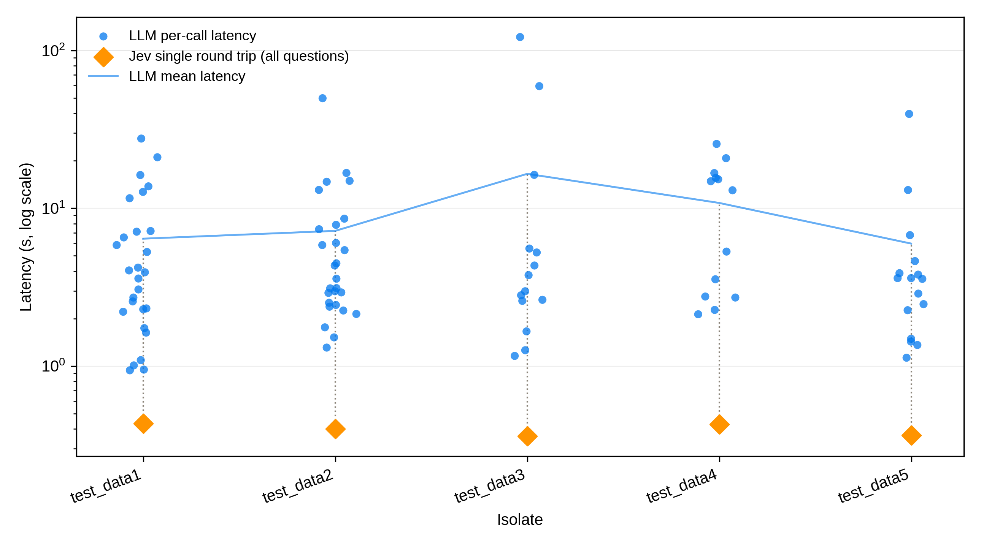
Figure 1. Per-call latency for the LLM arm (blue points, one per drug decision; log scale) versus the single Jev round trip per isolate (orange diamonds). The blue line tracks the LLM mean; dotted stems connect each Jev round trip to its isolate's LLM distribution.
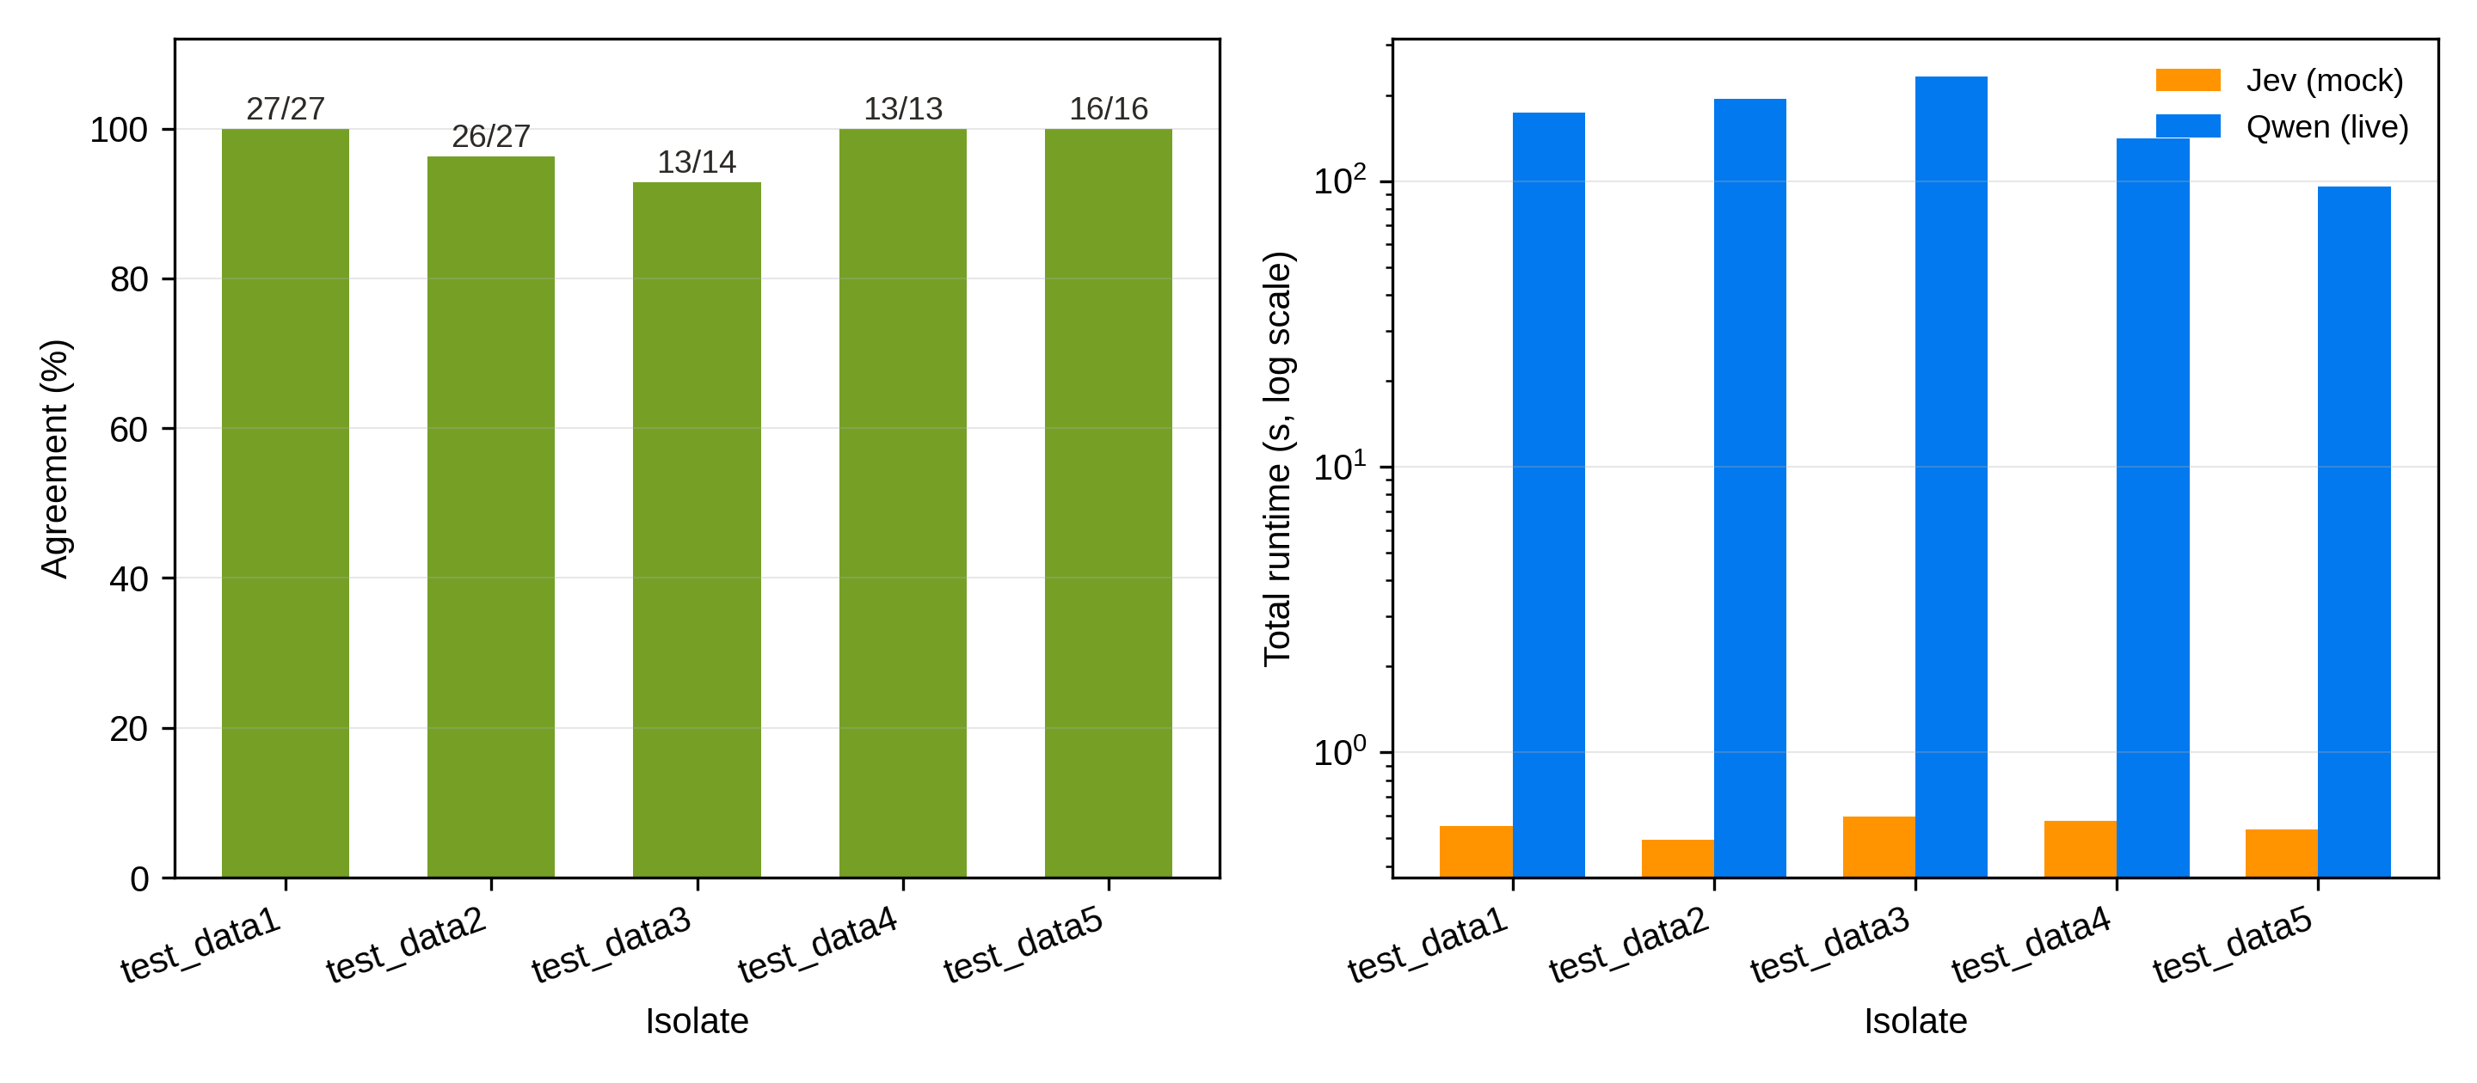
Figure 2. Left: decision agreement per isolate with counts. Right: total runtime per isolate on a log scale (Jev mock vs live Qwen), a 178-392x gap.

4. Caveats Before Using This Pipeline in a Real Screening Workflow
- Simulated Jev arm: The Jev arm is simulated. Agreement and runtime conclusions involving Jev are conditional on the mock's calibration; a live jv_live_ run is required before any operational claim.
- Synthetic, partial inputs: Isolates are reconstructed profiles, not real WGS calls, and the catalogue is a 44-entry curated subset of the WHO 2021 catalogue (9 of 13+ drugs). Real screening needs the full catalogue, plus indels, frameshifts, promoter regions, and lineage-specific polymorphisms.
- Sample size: n = 5 isolates / 97 decisions is a plumbing validation, not a validation study. Agreement percentages at this scale carry wide confidence intervals; a real evaluation needs a well-characterized panel (e.g., WHO catalogue test set or phylogenetically diverse clinical isolates with phenotypic DST ground truth).
- No phenotypic ground truth: Ground truth here is inter-model agreement, not phenotypic drug susceptibility. Two models agreeing can be wrong together; agreement must not be reported as accuracy.
- LLM operational fragility: The LLM arm is non-deterministic in cost and latency (reasoning length varied 1-50 s per call at temperature 0) and returned content: None once, requiring a parser fallback. Production use needs retries, timeouts, JSON-schema enforcement, and per-call cost accounting.
- Throughput: Sequential LLM calls scale linearly with isolate count (~6-17 s per decision; 2-4 minutes per isolate). Batch/parallel requests, or the Jev single-round-trip design, are needed for screening throughput; check rate limits before parallelizing.
- Silent filtering: Both arms inherit the code filter's blind spots: anything the catalogue subset lacks (novel mutations, structural variants) is silently dropped. A real workflow must log dropped mutations for human review rather than discard them.
- Not a diagnostic: Clinical use of AMR predictions requires laboratory validation, regulatory considerations, and human review; this pipeline is a research benchmark, not a diagnostic.

