SUPPLEMENTARY MATERIALS
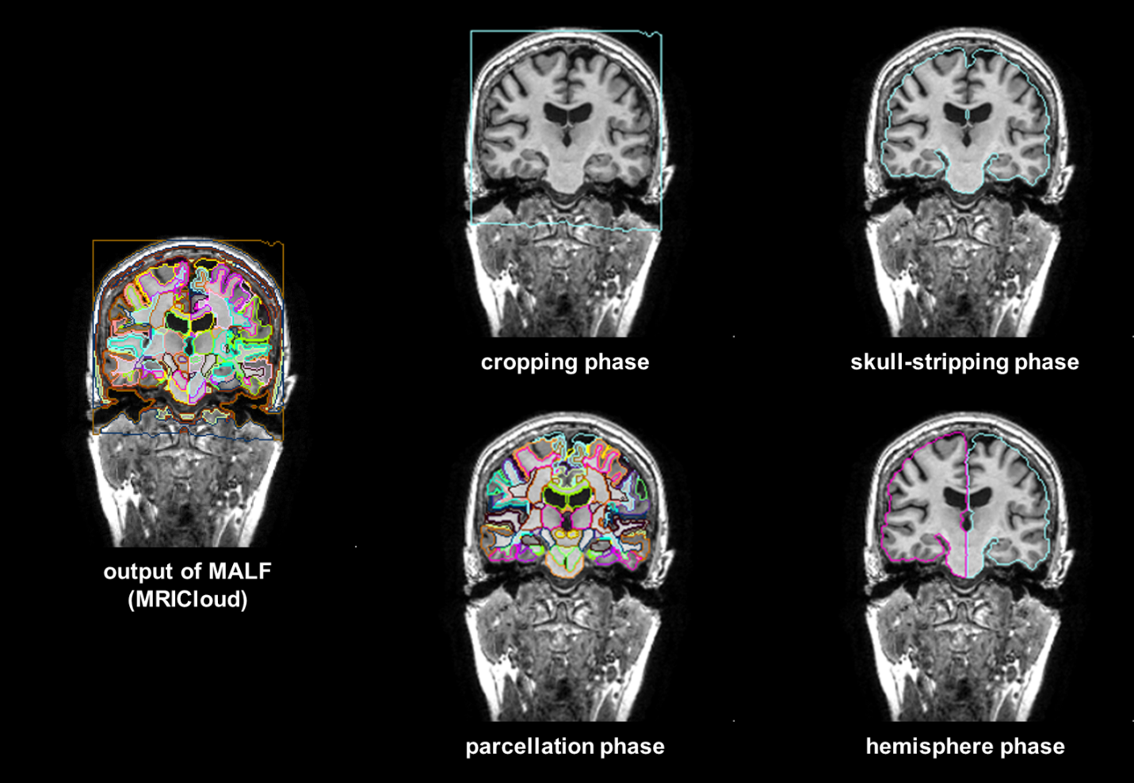
Supplementary Figure A. The procedure used to create training labels. The training labels for OpenMAP-T1 were generated by combining parcellation maps created by MALF (MRICloud).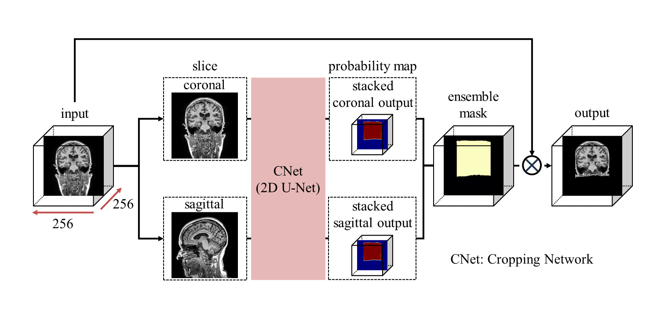
Supplementary Figure B. Overview of the cropping phase.

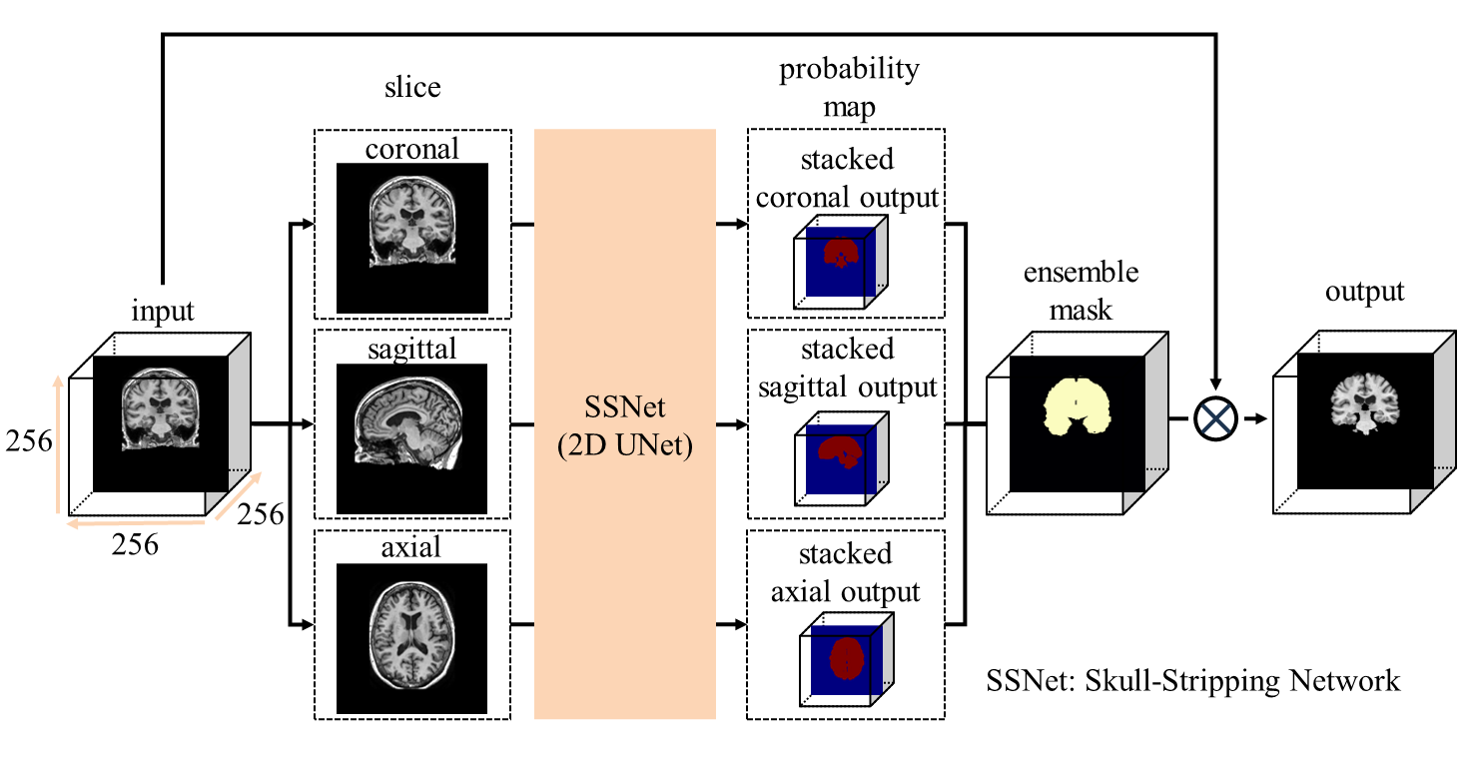
Supplementary Figure C. Overview of the skull-stripping phase.

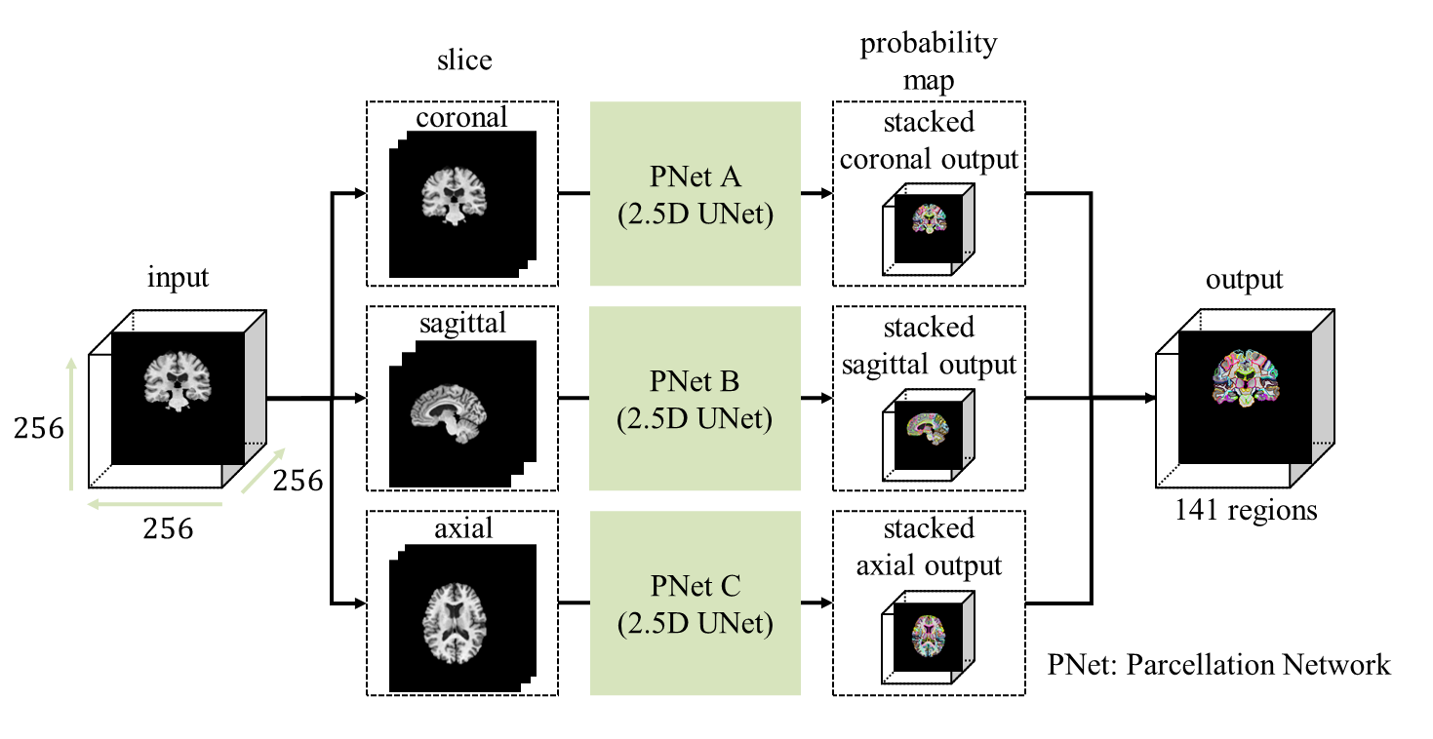
Supplementary Figure D. Overview of the parcellation phase.

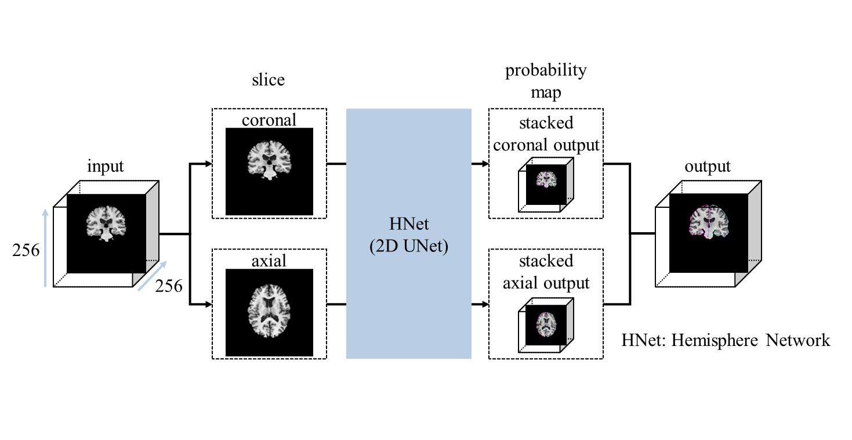
Supplementary Figure E. Overview of the hemisphere phase.

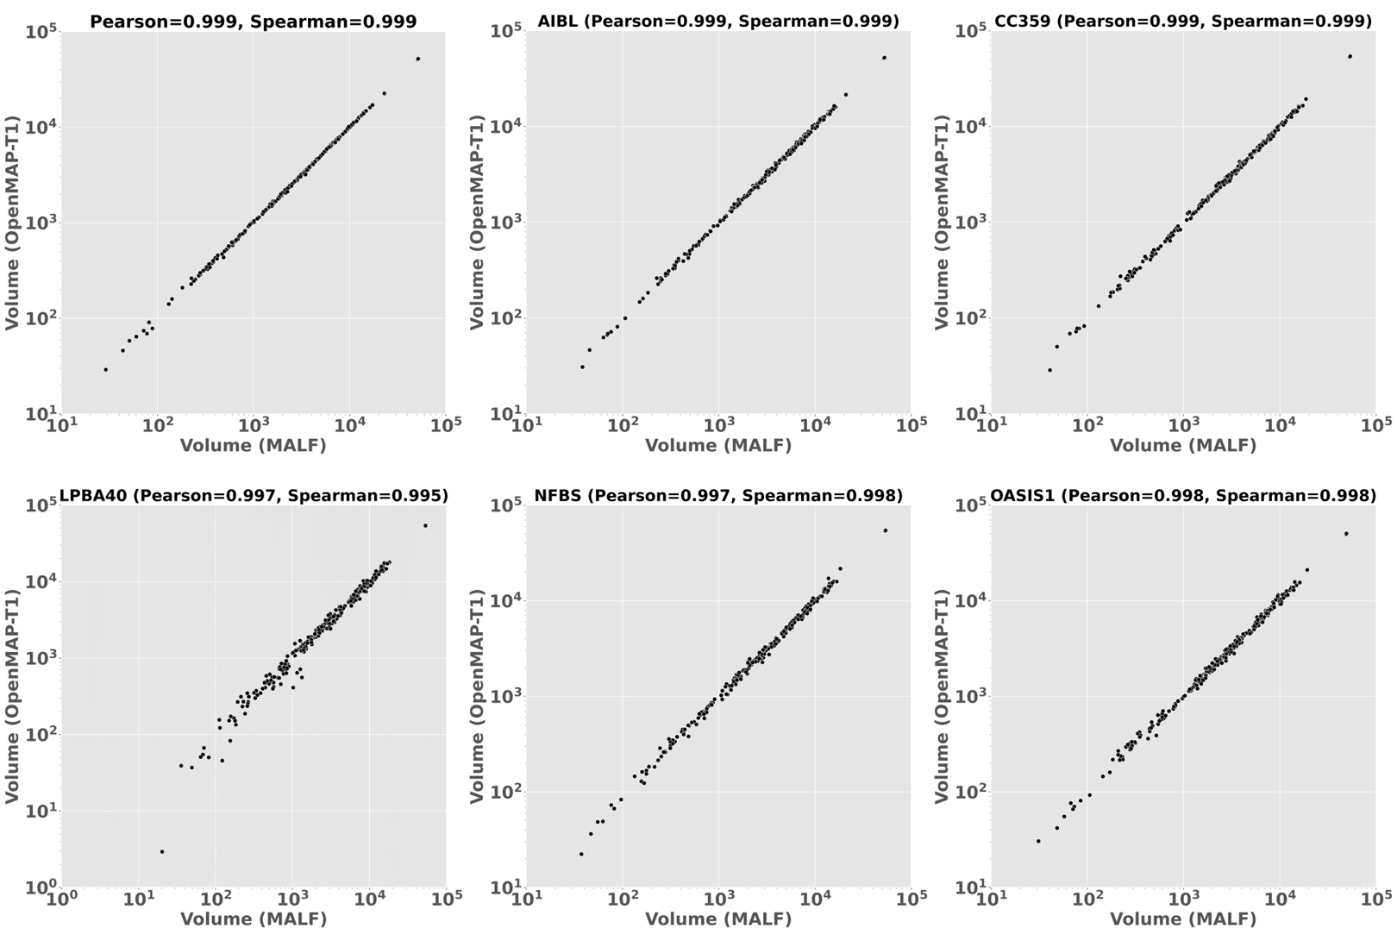
Supplementary Figure F. Correlation between the predicted volumes obtained using MALF and OpenMAP-T1 in ADNI2, AIBL, CC359, LPBA40, NFBS, and OASIS1.

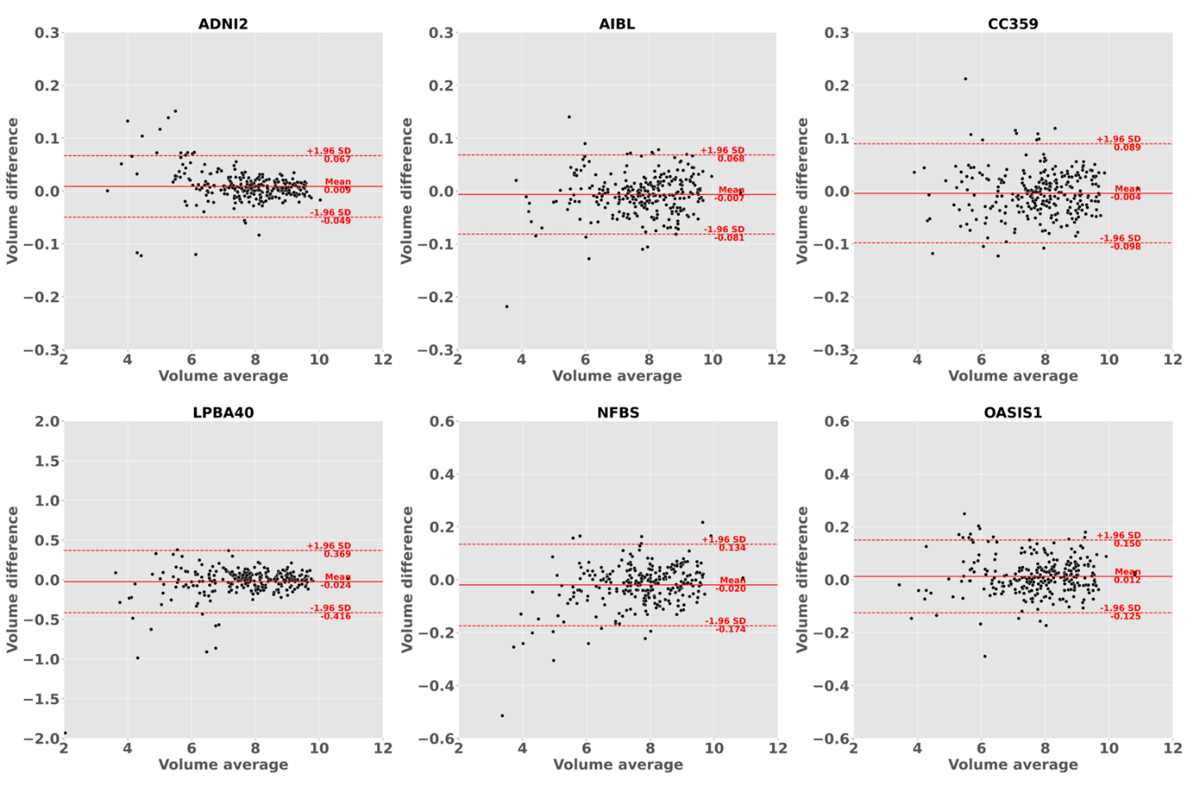
Supplementary Figure G. Bland-Altman plot demonstrates agreement between regional volumes predicted by MALF and OpenMAP-T1 in ADNI2, AIBL, CC359, LPBA40, NFBS, and OASIS1. The volume measurements were transformed using a base-2 logarithmic scale.
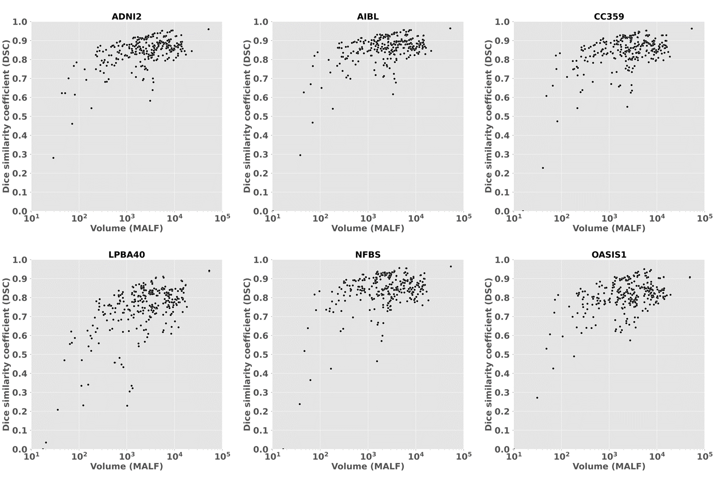
Supplementary Figure H. Relationship between the predicted volumes by MALF and the Dice similarity coefficient (DSC) in ADNI2, AIBL, CC359, LPBA40, NFBS, and OASIS1.

Supplementary Table A. Regions of interest defined in OMAP-T1.
No. | ROI | ROI (FULL)
0 | Background | Background
1 | SFG_L | Superior Frontal Gyrus (Posterior Segment) Left
2 | SFG_R | Superior Frontal Gyrus (Posterior Segment) Right
3 | SFG_PFC_L | Superior Frontal Gyrus (Prefrontal Cortex) Left
4 | SFG_PFC_R | Superior Frontal Gyrus (Prefrontal Cortex) Right
5 | SFG_pole_L | Superior Frontal Gyrus (Frontal Pole) Left
6 | SFG_pole_R | Superior Frontal Gyrus (Frontal Pole) Right
7 | MFG_L | Middle Frontal Gyrus (Posterior Segment) Left
8 | MFG_R | Middle Frontal Gyrus (Posterior Segment) Right
9 | MFG_DPFC_L | Middle Frontal Gyrus (Dorsal Prefrontal Cortex) Left
10 | MFG_DPFC_R | Middle Frontal Gyrus (Dorsal Prefrontal Cortex) Right
11 | IFG_opercularis_L | Inferior Frontal Gyrus Pars Opercularis Left
12 | IFG_opercularis_R | Inferior Frontal Gyrus Pars Opercularis Right
13 | IFG_orbitalis_L | Inferior Frontal Gyrus Pars Orbitalis Left
14 | IFG_orbitalis_R | Inferior Frontal Gyrus Pars Orbitalis Right
15 | IFG_triangularis_L | Inferior Frontal Gyrus Pars Triangularis Left
16 | IFG_triangularis_R | Inferior Frontal Gyrus Pars Triangularis Right
17 | LFOG_L | Lateral Fronto Orbital Gyrus Left
18 | LFOG_R | Lateral Fronto Orbital Gyrus Right
19 | MFOG_L | Middle Fronto Orbital Gyrus Left
20 | MFOG_R | Middle Fronto Orbital Gyrus Right
21 | RG_L | Gyrus Rectus Left
22 | RG_R | Gyrus Rectus Right
23 | PoCG_L | Postcentral Gyrus Left
24 | PoCG_R | Postcentral Gyrus Right
25 | PrCG_L | Precentral Gyrus Left
26 | PrCG_R | Precentral Gyrus Right
27 | SPG_L | Superior Parietal Gyrus Left
28 | SPG_R | Superior Parietal Gyrus Right
29 | SMG_L | Supramarginal Gyrus Left
30 | SMG_R | Supramarginal Gyrus Right
31 | AG_L | Angular Gyrus Left
32 | AG_R | Angular Gyrus Right
33 | PrCu_L | PrecCuneus Left
34 | PrCu_R | Precuneus Right
35 | STG_L | Superior Temporal Gyrus Left
36 | STG_R | Superior Temporal Gyrus Right
37 | STG_pole_L | Pole of Superior Temporal Gyrus Left
38 | STG_pole_R | Pole of Superior Temporal Gyrus Right
39 | MTG_L | Middle Temporal Gyrus Left
40 | MTG_R | Middle Temporal Gyrus Right
41 | MTG_pole_L | Pole of Middle Temporal Gyrus Left
42 | MTG_pole_R | Pole of Middle Temporal Gyrus Right
43 | ITG_L | Inferior Temporal Gyrus Left
44 | ITG_R | Inferior Temporal Gyrus Right
45 | PHG_L | Parahippocampal Gyrus Left
46 | PHG_R | Parahippocampal Gyrus Right
47 | ENT_L | Entorhinal Area Left
48 | ENT_R | Entorhinal Area Right
49 | FuG_L | Fusiform Gyrus Left
50 | FuG_R | Fusiform Gyrus Right
51 | SOG_L | Superior Occipital Gyrus Left
52 | SOG_R | Superior Occipital Gyrus Right
53 | MOG_L | Middle Occipital Gyrus Left
54 | MOG_R | Middle Occipital Gyrus Right
55 | IOG_L | Inferior Occipital Gyrus Left
56 | IOG_R | Inferior Occipital Gyrus Right
57 | Cu_L | Cuneus Left
58 | Cu_R | Cuneus Right
59 | LG_L | Lingual Gyrus Left
60 | LG_R | Lingual Gyrus Right
61 | rostral_ACC_L | Rostral Anterior Cingulate Gyrus Left
62 | rostral_ACC_R | Rostral Anterior Cingulate Gyrus Right
63 | subcallosal_ACC_L | Subcallosal Anterior Cingulate Gyrus Left
64 | subcallosal_ACC_R | Subcallosal Anterior Cingulate Gyrus Right
65 | subgenual_ACC_L | Subgenual Anterior Cingulate Gyrus Left
66 | subgenual_ACC_R | Subgenual Anterior Cingulate Gyrus Right
67 | dorsal_ACC_L | Dorsal Anterior Cingulate Gyrus Left
68 | dorsal_ACC_R | Dorsal Anterior Cingulate Gyrus Right
69 | PCC_L | Posterior Cingulate Gyrus Left
70 | PCC_R | Posterior Cingulate Gyrus Right
71 | Insula_L | Insula Left
72 | Insula_R | Insula Right
73 | Amyg_L | Amygdala Left
74 | Amyg_R | Amygdala Right
75 | Hippo_L | Hippocampus Left
76 | Hippo_R | Hippocampus Right
77 | Caud_L | Caudate Nucleus Left
78 | Caud_R | Caudate Nucleus Right
79 | Put_L | Putamen Left
80 | Put_R | Putamen Right
81 | GP_L | Globus Pallidus Left
82 | GP_R | Globus Pallidus Right
83 | Thalamus_L | Thalamus Left
84 | Thalamus_R | Thalamus Right
85 | HypoThalamus_L | Hypothalamus Left
86 | HypoThalamus_R | Hypothalamus Right
87 | AnteriorBasalForebrain_L | Anterior Basal Forebrain Left
88 | AnteriorBasalForebrain_R | Anterior Basal Forebrain Right
89 | NucAccumbens_L | Nucleus Accumbens Left
90 | NucAccumbens_R | Nucleus Accumbens Right
91 | RedNc_L | Red Nucleus Left
92 | RedNc_R | Red Nucleus Right
93 | Snigra_L | Substantia Nigra Left
94 | Snigra_R | Substantia Nigra Right
95 | CerebellumGM_R | Cerebellum Right
96 | CerebellumGM_L | Cerebellum Left
97 | CP_L | Cerebral Peduncle Left
98 | CP_R | Cerebral Peduncle Right
99 | Midbrain_L | Midbrain Left
100 | Midbrain_R | Midbrain Right
101 | CST_L | Corticospinal Tract Left
102 | CST_R | Corticospinal Tract Right
103 | SCP_L | Superior Cerebellar Peduncle Left
104 | SCP_R | Superior Cerebellar Peduncle Right
105 | MCP_L | Middle Cerebellar Peduncle Left
106 | MCP_R | Middle Cerebellar Peduncle Right
107 | PCT_L | Pontine Crossing Tract (A Part Of MCP) Left
108 | PCT_R | Pontine Crossing Tract (A Part Of MCP) Right
109 | ICP_L | Inferior Cerebellar Peduncle Left
110 | ICP_R | Inferior Cerebellar Peduncle Right
111 | ML_L | Medial Lemniscus Left
112 | ML_R | Medial Lemniscus Right
113 | Pons_L | Pons Left
114 | Pons_R | Pons Right
115 | Medulla_L | Medulla Left
116 | Medulla_R | Medulla Right
117 | ACR_L | Anterior Corona Radiata Left
118 | ACR_R | Anterior Corona Radiata Right
119 | SCR_L | Superior Corona Radiata Left
120 | SCR_R | Superior Corona Radiata Right
121 | PCR_L | Posterior Corona Radiata Left
122 | PCR_R | Posterior Corona Radiata Right
123 | GCC_L | Genu of Corpus Callosum Left
124 | GCC_R | Genu of Corpus Callosum Right
125 | BCC_L | Body of Corpus Callosum Left
126 | BCC_R | Body of Corpus Callosum Right
127 | SCC_L | Splenium of Corpus Callosum Left
128 | SCC_R | Splenium of Corpus Callosum Right
129 | PVWl_L | Periventricular White Matter Posterior Lateral Left
130 | PVWl_R | Periventricular White Matter Posterior Lateral Right
131 | ALIC_L | Anterior Limb of Internal Capsule Left
132 | ALIC_R | Anterior Limb of Internal Capsule Right
133 | PLIC_L | Posterior Limb of Internal Capsule Left
134 | PLIC_R | Posterior Limb of Internal Capsule Right
135 | RLIC_L | Retrolenticular Part of Internal Capsule Left
136 | RLIC_R | Retrolenticular Part of Internal Capsule Right
137 | EC_L | External Capsule Left
138 | EC_R | External Capsule Right
139 | CGC_L | Cingulum (Cingulate Gyrus) Left
140 | CGC_R | Cingulum (Cingulate Gyrus) Right
141 | CGH_L | Cingulum (Hippocampus) Left
142 | CGH_R | Cingulum (Hippocampus) Right
143 | Fx/ST_L | Fornix Cres (Cres) / Stria Terminalis (cannot be resolved with current resolution) Left
144 | Fx/ST_R | Fornix Cres (Cres) / Stria Terminalis (cannot be resolved with current resolution) Right
145 | Fx_L | Fornix (Column and Body of Fornix) Left
146 | Fx_R | Fornix (Column and Body of Fornix) Right
147 | IFO_L | Inferior Fronto-Occipital Fasciculus Left
148 | IFO_R | Inferior Fronto-Occipital Fasciculus Right
149 | PTR_L | Posterior Thalamic Radiation (Include Optic Radiation) Left
150 | PTR_R | Posterior Thalamic Radiation (Include Optic Radiation) Right
151 | SS_L | Sagittal Stratum (Include Inferior Longitudinal Fasciculus and Inferior Fronto Occipital Fasciculus) Left
152 | SS_R | Sagittal Stratum (including Inferior Longitudinal Fasciculus and Inferior Fronto Occipital Fasciculus) Right
153 | SFO_L | Superior Fronto-Occipital Fasciculus (could be a part of anterior internal capsule) Left
154 | SFO_R | Superior Fronto-Occipital Fasciculus (could be a part of anterior internal capsule) Right
155 | SLF_L | Superior Longitudinal Fasciculus Left
156 | SLF_R | Superior Longitudinal Fasciculus Right
157 | Cl_L | Claustrum Complex Left
158 | Cl_R | Claustrum Complex Right
159 | PosteriorBasalForebrain_L | Posterior Basal Forebrain Left
160 | PosteriorBasalForebrain_R | Posterior Basal Forebrain Right
161 | Mammillary_R | Mammillary Body Right
162 | Mammillary_L | Mammillary Body Left
163 | LV_Frontal_L | Lateral Ventricle_Frontal Left
164 | LV_body_L | Lateral Ventricle_Body Left
165 | LV_atrium_L | Lateral Ventricle_Atrium Left
166 | LV_Occipital_L | Lateral Ventricle_Occipital Left
167 | LV_Inferior_L | Lateral Ventricle_Inferior Left
168 | LV_Frontal_R | Lateral Ventricle_Frontal Right
169 | LV_body_R | Lateral Ventricle_Body Right
170 | LV_atrium_R | Lateral Ventricle_Atrium Right
171 | LV_Occipital_R | Lateral Ventricle_Occipital Right
172 | LV_Inferior_R | Lateral Ventricle_Inferior Right
173 | III_ventricle | Third Ventricle
174 | PVWa_L | Periventricular White Matter Frontal Left
175 | PVWa_R | Periventricular White Matter Frontal Right
176 | PVWp_L | Periventricular White Matter Posterior Left
177 | PVWp_R | Periventricular White Matter Posterior Right
178 | SFWM_L | Superior Frontal WM (Posterior Segment) Left
179 | SFWM_R | Superior Frontal WM (Posterior Segment) Right
180 | SFWM_PFC_L | Superior Frontal WM (Prefrontal Cortex) Left
181 | SFWM_PFC_R | Superior Frontal WM (Prefrontal Cortex) Right
182 | SFWM_pole_L | Superior Frontal WM (Frontal Pole) Left
183 | SFWM_pole_R | Superior Frontal WM (Frontal Pole) Right
184 | MFWM_L | Middle Frontal WM (Posterior Segment Left
185 | MFWM_R | Middle Frontal WM (Posterior Segment Right
186 | MFWM_DPFC_L | Middle Frontal WM (Dorsal Prefrontal Cortex) Left
187 | MFWM_DPFC_R | Middle Frontal WM (Dorsal Prefrontal Cortex) Right
188 | IFWM_opercularis_L | Inferior Frontal WM Pars Opercularis Left
189 | IFWM_opercularis_R | Inferior Frontal WM Pars Opercularis Right
190 | IFWM_orbitalis_L | Inferior Frontal WM Pars Orbitalis Left
191 | IFWM_orbitalis_R | Inferior Frontal WM Pars Orbitalis Right
192 | IFWM_triangularis_L | Inferior Frontal WM Pars Triangularis Left
193 | IFWM_triangularis_R | Inferior Frontal WM Pars Triangularis Right
194 | LFOWM_L | Lateral Fronto Orbital WM Left
195 | LFOWM_R | Lateral Fronto Orbital WM Right
196 | MFOWM_L | Middle Fronto Orbital WM Left
197 | MFOWM_R | Middle Fronto Orbital WM Right
198 | RGWM_L | Gyrus Rectus Left
199 | RGWM_R | Gyrus Rectus Right
200 | PoCWM_L | Postcentral WM Left
201 | PoCWM_R | Postcentral WM Right
202 | PrCWM_L | Precentral WM Left
203 | PrCWM_R | Precentral WM Right
204 | SPWM_L | Superior Parietal WM Left
205 | SPWM_R | Superior Parietal WM Right
206 | SMWM_L | Supramarginal WM Left
207 | SMWM_R | Supramarginal WM Right
208 | AGWM_L | Angular Gyrus WM Left
209 | AGWM_R | Angular Gyrus WM Right
210 | PrCuWM_L | Pre-Cuneus WM Left
211 | PrCuWM_R | Pre-Cuneus WM Right
212 | STWM_L | Superior Temporal WM Left
213 | STWM_R | Superior Temporal WM Right
214 | STWM_pole_L | Pole of Superior Temporal WM Left
215 | STWM_pole_R | Pole of Superior Temporal WM Right
216 | MTWM_L | Middle Temporal WM Left
217 | MTWM_R | Middle Temporal WM Right
218 | MTWM_pole_L | Pole of Middle Temporal WM Left
219 | MTWM_pole_R | Pole of Middle Temporal WM Right
220 | ITWM_L | Inferior Temporal WM Left
221 | ITWM_R | Inferior Temporal WM Right
222 | FuWM_L | Fusiform WM Left
223 | FuWM_R | Fusiform WM Right
224 | SOWM_L | Superior Occipital WM Left
225 | SOWM_R | Superior Occipital WM Right
226 | MOWM_L | Middle Occipital WM Left
227 | MOWM_R | Middle Occipital WM Right
228 | IOWM_L | Inferior Occipital WM Left
229 | IOWM_R | Inferior Occipital WM Right
230 | CuWM_L | Cuneus WM Left
231 | CuWM_R | Cuneus WM Right
232 | LGWM_L | Lingual WM Left
233 | LGWM_R | Lingual WM Right
234 | rostralWM_ACC_L | Rostral Anterior Cingulate WM Left
235 | rostralWM_ACC_R | Rostral Anterior Cingulate WM Right
236 | subcallosalWM_ACC_L | Subcallosal Anterior Cingulate WM Left
237 | subcallosalWM_ACC_R | Subcallosal Anterior Cingulate WM Right
238 | subgenualWM_ACC_L | Subgenual Anterior Cingulate WM Left
239 | subgenualWM_ACC_R | Subgenual Anterior Cingulate WM Right
240 | dorsalWM_ACC_L | Dorsal Anterior Cingulate WM Left
241 | dorsalWM_ACC_R | Dorsal Anterior Cingulate WM Right
242 | PCCWM_L | Posterior Cingulate WM Left
243 | PCCWM_R | Posterior Cingulate WM Right
244 | CerebellumWM_R | Cerebellum WM Right
245 | CerebellumWM_L | Cerebellum WM Left
246 | MCP_cb_L | Middle Cerebellar Peduncle Cerebellar Part Left
247 | MCP_cb_R | Middle Cerebellar Peduncle Cerebellar Part Right
248 | ICP_cb_L | Inferior Cerebellar Peduncle Cerebellar Part Left
249 | ICP_cb_R | Inferior Cerebellar Peduncle Cerebellar Part Right
250 | FrontSul_L | Frontal Lobe Sulcus Left
251 | FrontSul_R | Frontal Lobe Sulcus Right
252 | CentralSul_L | Central Sulcus Left
253 | CentralSul_R | Central Sulcus Right
254 | SylFrontSul_L | Sylvian Fissure Frontal Lobe Part Left
255 | SylFrontSul_R | Sylvian Fissure Frontal Lobe Part Right
256 | SylTempSul_L | Sylvian Fissure Temporal Lobe Part Left
257 | SylTempSul_R | Sylvian Fissure Temporal Lobe Part Right
258 | SylParieSul_L | Sylvian Fissure Parietal Lobe Part Left
259 | SylParieSul_R | Sylvian Fissure Parietal Lobe Part Right
260 | ParietSul_L | Parietal Lobe Sulcus Left
261 | ParietSul_R | Parietal Lobe Sulcus Right
262 | CinguSul_L | Cingular Cortex Sulcus Left
263 | CinguSul_R | Cingular Cortex Sulcus Right
264 | OcciptSul_L | Occipital Lobe Sulcus Left
265 | OcciptSul_R | Occipital Lobe Sulcus Right
266 | TempSul_L | Temporal Lobe Sulcus Left
267 | TempSul_R | Temporal Lobe Sulcus Right
268 | Caudate_tail_L | Caudate Tail Left
269 | Fimbria_L | Fimbria Left
270 | Caudate_tail_R | Caudate Tail Right
271 | Fimbria_R | Fimbria Right
272 | Chroid_LVetc_L | Choroid Plexus within the Lateral Ventricle Left
273 | Chroid_LVetc_R | Choroid Plexus within the Lateral Ventricle Right
274 | IV_ventricle | Fourth_Ventricle
275 | ECCL_L | External Capsule / Claustrum Left
276 | ECCL_R | External Capsule / Claustrum Right
277 | ECSAnterior_L | Extracranial Space Anterior Left
278 | ECSAnterior_R | Extracranial Space Anterior Right
279 | ECSPosterior_L | Extracranial Space Posterior Left
280 | ECSPosterior_R | Extracranial Space Posterior Right

Table B. Dice similarity coefficient (DSC), 95th percentile Hausdorff distance (HD), and P value of ANOVA, for each effect in all datasets.
DSC | Age |  |  | ANOVA | P-value (Bonferroni corrected)
 | 8-19 | 22-50 | 50-90 |  | 8-19 vs. 22-50 | 22-50 vs. 50-90 | 8-19 vs. 50-90
Cortical | 0.740 (±0.027) | 0.767 (±0.027) | 0.794 (±0.033) | P<0.001 | P<0.001 | P=0.003 | P<0.001
Deep  gray matter | 0.817 (±0.027) | 0.855 (±0.010) | 0.847 (±0.030) | P<0.001 | P<0.001 | P=0.197 | P<0.001
White matter | 0.727 (±0.027) | 0.760 (±0.022) | 0.774 (±0.032) | P<0.001 | P<0.001 | P=0.080 | P<0.001
Others | 0.623 (±0.031) | 0.701 (±0.032) | 0.748 (±0.037) | P<0.001 | P<0.001 | P<0.001 | P<0.001
DSC | Sex |  | ANOVA |  | Diagnosis (only 50-90) |  | ANOVA
 | F | M |  |  | CN | AD
Cortical | 0.768 (±0.037) | 0.752 (±0.033) | P=0.045 | Cortical | 0.806 (±0.026) | 0.758 (±0.020) | P<0.001
Deep  gray matter | 0.840 (±0.027) | 0.830 (±0.032) | P=0.149 | Deep  gray matter | 0.861 (±0.018) | 0.808 (±0.023) | P<0.001
White matter | 0.751 (±0.032) | 0.742 (±0.033) | P=0.241 | White matter | 0.786 (±0.026) | 0.740 (±0.022) | P<0.001
Others | 0.688 (±0.065) | 0.665 (±0.060) | P=0.119 | Others | 0.758 (±0.037) | 0.720 (±0.017) | P=0.025
HD | Age |  |  | ANOVA | P-value (Bonferroni test)
 | 8-19 | 22-50 | 50-90 |  | 8-19 vs. 22-50 | 22-50 vs. 50-90 | 8-19 vs. 50-90
Cortical | 3.83 (±0.54) | 2.97 (±0.33) | 2.73 (±0.44) | P<0.001 | P<0.001 | P=0.037 | P<0.001
Deep  gray matter | 1.65 (±0.28) | 1.37 (±0.10) | 1.40 (±0.26) | P<0.001 | P<0.001 | P=0.619 | P＝0.001
White matter | 3.83 (±0.54) | 2.97 (±0.33) | 2.73 (±0.44) | P<0.001 | P<0.001 | P=0.200 | P<0.001
Others | 5.29 (±0.71) | 4.50 (±0.58) | 4.08 (±0.91) | P<0.001 | P<0.001 | P=0.060 | P<0.001
HD | Sex |  | ANOVA |  | Diagnosis (only 50-90) |  | ANOVA
 | F | M |  |  | CN | AD
Cortical | 3.21 (±0.64) | 3.45 (±0.68) | P=0.105 | Cortical | 2.57 (±0.33) | 3.18 (±0.41) | P=0.001
Deep  gray matter | 1.48 (±0.24) | 1.55 (±0.30) | P=0.21 | Deep  gray matter | 1.29 (±0.18) | 1.71 (±0.21) | P<0.001
White matter | 3.21 (±0.64) | 3.45 (±0.68) | P=0.105 | White matter | 2.57 (±0.33) | 3.18 (±0.41) | P=0.001
Others | 4.59 (±0.96) | 4.96 (±0.83) | P=0.070 | Others | 3.83 (±0.86) | 4.80 (±0.70) | P=0.021

Table C. Dice similarity coefficient (DSC) and P value of ANOVA for each effect in all datasets.
 |  |  |  |  | ADNI2 |  |  | ADNI3 |  |  | AIBL
 |  |  |  | Subjects |  | DSC | Subjects |  | DSC | Subjects |  | DSC
Age |  | <40 |  | - |  | - | - |  | - | - |  | -
 |  | 40s |  | - |  | - | - |  | - | - |  | -
 |  | 50s |  | 11 |  | 0.850±0.010 | 40 |  | 0.856±0.009 | 2 |  | 0.858±0.002
 |  | 60s |  | 134 |  | 0.841±0.020 | 260 |  | 0.859±0.014 | 112 |  | 0.852±0.016
 |  | 70s |  | 258 |  | 0.843±0.015 | 351 |  | 0.857±0.015 | 169 |  | 0.856±0.012
 |  | 80s |  | 122 |  | 0.838±0.019 | 148 |  | 0.853±0.019 | 89 |  | 0.849±0.085
 |  | 90< |  | 10 |  | 0.829±0.017 | 17 |  | 0.849±0.020 | 4 |  | 0.851±0.018
 |  | P-value |  | P=0.001 |  |  | P=0.002 |  |  | P=0.793
Sex |  | Female |  | 247 |  | 0.841±0.014 | 431 |  | 0.857±0.012 | 198 |  | 0.855±0.014
 |  | Male |  | 288 |  | 0.841±0.020 | 385 |  | 0.856±0.019 | 178 |  | 0.852±0.061
 |  | P-value |  | P=0.9468 |  |  | P=0.308 |  |  | P=0.518
Manufacturer |  | GE |  | 170 |  | 0.834±0.016 | 184 |  | 0.850±0.019 | - |  | -
 |  | PHILIPS |  | 89 |  | 0.847±0.013 | 123 |  | 0.859±0.016 | - |  | -
 |  | SIEMENS |  | 276 |  | 0.844±0.018 | 509 |  | 0.859±0.012 | 376 |  | 0.853±0.043
 |  | P-value |  | P<0.001 |  |  | P<0.001 |  |  | -
Field Strength |  | 1.5T |  | 110 |  | 0.830±0.015 | - |  | - | 102 |  | 85.10±1.48
 |  | 3.0T |  | 425 |  | 0.844±0.017 | - |  | - | 274 |  | 85.46±4.99
 |  | P-value |  | P<0.001 |  |  | - |  |  | P=0.471
Diagnosis |  | CN |  | 136 |  | 0.840±0.019 | 463 |  | 0.857±0.015 | 268 |  | 0.856±0.012
 |  | MCI |  | 229 |  | 0.841±0.018 | 261 |  | 0.857±0.015 | 64 |  | 0.854±0.013
 |  | AD |  | 170 |  | 0.842±0.016 | 92 |  | 0.855±0.017 | 44 |  | 0.837±0.121
 |  | P-value |  | P=0.465 |  |  | P=0.585 |  |  | P=0.023
 |  |  |  | CC359 |  |  | OASIS1 |  |  | OASIS4
 |  |  |  | Subjects |  | DSC | Subjects |  | DSC | Subjects |  | DSC
Age |  | <40 |  | 18 |  | 0.838±0.016 | 2 |  | 0.655±0.075 | 3 |  | 0.820±0.013
 |  | 40s |  | 80 |  | 0.834±0.018 | 13 |  | 0.812±0.031 | 5 |  | 0.828±0.009
 |  | 50s |  | 185 |  | 0.843±0.022 | 22 |  | 0.796±0.049 | 29 |  | 0.835±0.012
 |  | 60s |  | 72 |  | 0.838±0.016 | 40 |  | 0.817±0.026 | 169 |  | 0.831±0.021
 |  | 70s |  | 3 |  | 0.807±0.064 | 83 |  | 0.811±0.054 | 237 |  | 0.832±0.020
 |  | 80s |  | 1 |  | 0.857 | 62 |  | 0.792±0.092 | 111 |  | 0.831±0.017
 |  | 90< |  | - |  | - | 13 |  | 0.805±0.084 | 16 |  | 0.818±0.020
 |  | P-value |  | P=0.002 |  |  | P=0.016 |  |  | P=0.153
Sex |  | Female |  | 183 |  | 0.842±0.018 | 156 |  | 0.807±0.070 | 303 |  | 0.832±0.018
 |  | Male |  | 176 |  | 0.837±0.023 | 79 |  | 0.798±0.054 | 267 |  | 0.831±0.021
 |  | P-value |  | P=0.031 |  |  | P=0.300 |  |  | P=0.495
Manufacturer |  | GE |  | 120 |  | 0.849±0.014 | - |  | - | - |  | -
 |  | PHILIPS |  | 119 |  | 0.830±0.017 | - |  | - | - |  | -
 |  | SIEMENS |  | 120 |  | 0.838±0.025 | 235 |  | 0.804±0.065 | - |  | -
 |  | P-value |  | P<0.001 |  |  | - |  |  | -
Field Strength |  | 1.5T |  | 179 |  | 0.839±0.023 | 235 |  | 0.804±0.065 | 29 |  | 0.819±0.017
 |  | 3.0T |  | 180 |  | 0.839±0.018 | - |  | - | 541 |  | 0.832±0.019
 |  | P-value |  | P=0.878 |  |  | - |  |  | P<0.001
Diagnosis |  | CN |  | 359 |  | 0.839±0.021 | 135 |  | 0.803±0.069 | ※
 |  | MCI |  | - |  | - | - |  | -
 |  | AD |  | - |  | - | 100 |  | 0.805±0.060
 |  | P-value |  | - |  |  | P=0.759

Table D. Dice similarity coefficient (DSC) and p value of ANOVA for diagnosis in OASIS4.
 |  | OASIS4
 |  | Subjects | DSC
※Diagnosis | AD Variant | 10 | 0.838±0.010
 | AD+Non Neurodegenerative | 8 | 0.844±0.008
 | AD / Vascular | 38 | 0.828±0.020
 | Alzheimer Disease Dementia | 189 | 0.832±0.018
 | CN | 39 | 0.833±0.017
 | Dementia with Lewy Bodies (DLB) | 11 | 0.833±0.018
 | Early Onset AD | 23 | 0.832±0.023
 | Frontotemporal Dementia (FTD) | 15 | 0.822±0.025
 | Mild Cognitive Impairment (MCI) | 41 | 0.832±0.017
 | Mood / polypharmacy / sleep | 29 | 0.832±0.016
 | Non-Neurodegenerative Neurologic Disease | 19 | 0.824±0.019
 | Other - Miscellaneous | 15 | 0.830±0.018
 | Other Non-AD Neurodegenerative Disorder | 7 | 0.8117±0.040
 | Primary Progressive Aphasia (PPA) | 7 | 0.840±0.010
 | Uncertain - AD possible | 105 | 0.834±0.020
 | Vascular Cognitive Impairment (VCI) | 14 | 0.813±0.024
 | p-value | P=0.003

