**The template for Program 2 has been updated as below. And highlighted part is new added, which is for signal processing.**



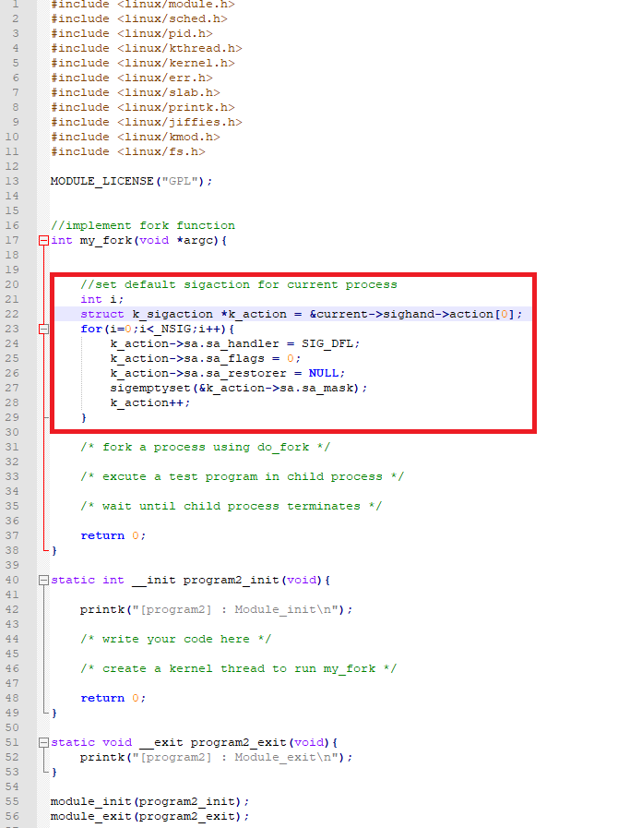

**If you have already updated the template with your own codes, you only need to add following codes before forking a process.**

//set default sigaction for current process

int i;

struct k_sigaction *k_action = &current->sighand->action[0];

for(i=0;i<_NSIG;i++){

k_action->sa.sa_handler = SIG_DFL;

k_action->sa.sa_flags = 0;

k_action->sa.sa_restorer = NULL;

sigemptyset(&k_action->sa.sa_mask);

k_action++;

}

**Tips for struct wait_opts parameter setting: (using in do_wait())**

wo_type: PIDTYPE_PID

wo_flags: WEXITED

wo_pid: child process’s pid, use “find_get_pid()” to converting type

wo_info: NULL

wo_stat: pointing to child process’ state. (For example: (int __user *)&state)

wo_rusage: NULL