**Project Report**

List of features:

1. Draw shapes on the canvas. Before drawing shapes you need to specify the features of the graph including: types of shapes, types of shading types and types and colors.
2. Undo: undo the current state and go back to the previous state.
3. Redo: Redo the next step and go to the next state.
4. Delete: you can delete any shape shown on the canvas. To delete a shape you first need to go to the select mode and then click one shape or drag to select multiple shapes and then hit delete button.
5. Copy and paste: You can copy and paste shapes. Before you paste shapes you need to select the shapes you want to copy and paste under the select mode. After that you need to copy the selected shapes then hit the paste buttons to paste the shapes.
6. Move shapes: First you need to select the shapes under the select mode then go to the move mode to move the shapes. **Note: after you move the shapes if you want to make another move you need to go back to the select mode to select the shapes and then repeat the previous steps.**

**The Steps that support redo and undo: Draw,Delete,Paste,move.**

Design patterns: the design patterns I currently used are adapter pattern, static factory, strategy pattern and command pattern.

Adapter pattern, Static factory:

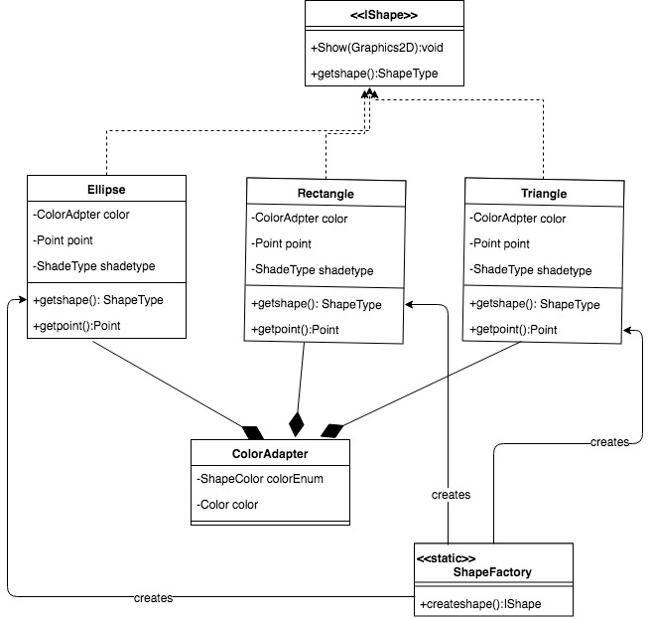

Explanation: use adapter pattern to adapt third party library to something that fits our purpose. Use static factory to draw shape.

Strategy Pattern

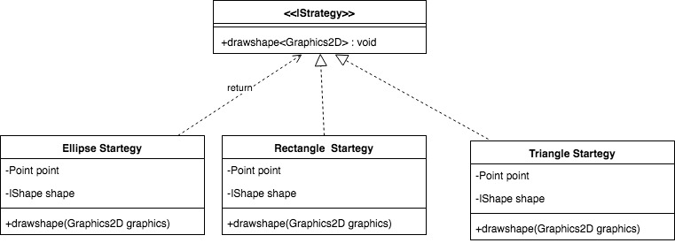

Explanation:

Because different shapes should be drawn differently, to differentiate them we use strategy pattern

Command pattern

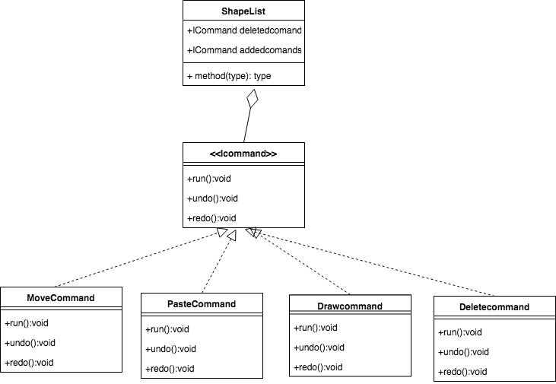

We use the command pattern to track the command we have added and undoed. The shapelist has fields to store the passed commands for future use. By using the command patterns, it will hide many details for users and will be easier for future maintaining.

Things went right:

1. In this project, all major functionalities specified in the requirements are implemented.
2. Units are run and passed. All implementations are correct.
3. The design patterns I picked really help my development process especially the command patterns.

Things went wrong

1. Although the moving shape functions can move the shapes successfully without interruption. However you cannot not continuously move the shapes without going back to the select mode. Once you move the shapes, if you want to move the shapes again you need to select them under the select mode again.