**Report for Project 1**

**Task 1**

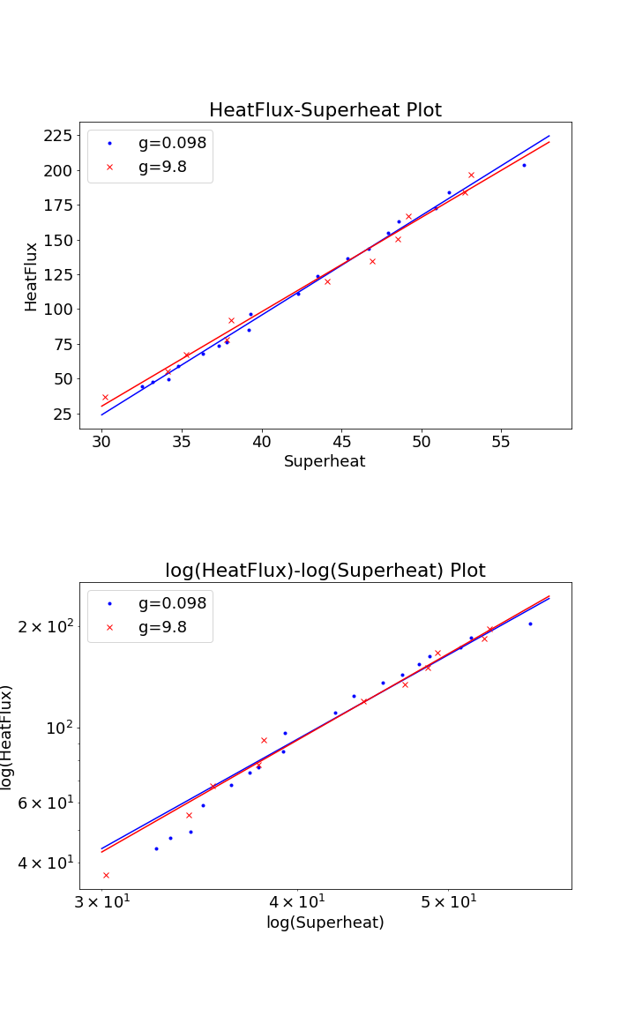

The figure above includes a HeatFlux-Superheat plot and a HeatFlux-Superheat log-log plot. Blue dots and lines represent the data and regression under the condition of micro gravity (0.098), while the red ones represent the condition of regular gravity (9.8).

As shown in the figure, heat flux is positively correlated with superheat, and the relationship varied little in different gravity conditions.

It seems that there could be a linear relationship between heat flux and superheat, so linear regression is applied to the data. (As for the log-log plot, linear relationship should be transferred into exponential relationship according to simple math calculations.) The result is shown in the table below. Mean Square Error (MSE) is used to decide whether the regression is good or not.

|  |  |  |
| --- | --- | --- |
| g | Lin. Regression | Exp. Regression |
| 0.098 | y = 7.167503 * x + -191.125966  MSE = 15.158677 | y = 0.006760 * x ^(2.581364)  MSE = 72.352377 |
| 9.8 | y = 6.785368 * x + -173.429351  MSE = 38.131234 | y = 0.005384 * x ^(2.641377)  MSE = 32.514733 |

Therefore, linear regression has a better performance when gravity is low, while exponential regression works better under a regular-gravity condition. However, the conclusion isn’t accurate enough because of inadequacy of data.

Code Modified:

* Save the data as a csv file, so that the reading process will look concise.
* The data type is changed to pandas.DataFrame, also to make the code concise.
* Linear and exponential regression added.
* Plot the scatter data and the regression graph and save it.

Task 2