Ourselves

|  |  |  |  |  |  |  |
| --- | --- | --- | --- | --- | --- | --- |
| Name | Age | Location | Skills | Knowledge | Websites | Goals |
| Qihan | 21 | Sydney | Java/HTML | Algorithm/Database | Forum for NGO Shanghai Jungle | Get HD for INFO2222 |
| Alan | 20 | Sydney | Java/python | Java/python |  | HD |
| JIAHAO | 21 | Sydney | Java/Python | Java/Python |  | Get knowledge of web |
| Alison/Yisheng | 20 | Sydney | Java/python/cooking | Java/python/language |  | HD |
| Vincent | 20 | Sydney | coding bilingual | art  sports  social -science | none | HD |

Persona

|  |  |  |
| --- | --- | --- |
| **Persona:** | USYD 2nd year computer science students |  |
| **Photo:** |  |  |
| **Fictional name:** | Daniel Wu |  |
| **Job title/major responsibilities:** | College Student |  |
| **Demographics:** | * 20.4 years old * Single * Single child * High School graduate |  |
| **Goals and tasks:** | He is focused, goal-oriented within a strong leadership role. One of his concerns is maintaining quality across all output of programs.  Spends his work time:   * Requesting and reviewing research reports, * preparing memos and briefs for agency heads, and * learning programming knowledge to prepare for further studies and work | |
| **Environment:** | He is suitable for simple programming and computer tasks. He enjoys social media and other mobile phone entertainments. | |
| **Quote:** | “Can you get me that code work by Tuesday?” | |

Project Brief

1. Login
2. Register
3. Knowledge Base
4. Admin role
5. User role
6. Discussion forum

PACT Analysis

People

**Who are the people involved?**

|  |  |
| --- | --- |
| **People** | **Description** |
| Students | * 1. limited skills on HTML/CSS, web development and Computer Science in general   2. have interests in Web   3. want to gain more knowledge about the web and learn about web development skills |
| Admins | 1. professors in the area of web development 2. passionate tutors who would like to offer help 3. Members get real time response from the user about the website |
| Software developers | * 1. develop and design a comfortable and easy environment for users to learn web development   2. maintains the usability of the website and improves it according to users’ preferences and advices |

Activity

* **How regular are the activities**

once to twice per week

* **When do people do the activities**

anytime when they have access to internet and computer

* **Does the activity require contiguous set of actions?**

Yes, it requires constant self-learning for two months

* **Can the activity be done alone?**

Yes

* **Are people allowed to make mistakes?**

Yes

* **What are the consequences of mistakes?**

Unable to login

Lost the ability to reply the post

Get muted by the admin

need  to report to admin/website authorities to retrieve information

* **What type of the information needed for the activity?**

Username and password

Understand buttons and links on the website

example and demonstrations for actual website development

simple and individual practice for area of knowledge

Context

* **Physical**

Anywhere with a computer: home, Internet bar, in the office, etc

* **Social**

Group up with other people interested in learning web development on the

            Internet

interact with professors of web development

* **Organization**

User base is usyd students

Technology

* **What type of data do users input into the system**

Users’ basic personal information, account number, password, comments     and other possible data

* **What type of data do users view from the system**

Pictures (jpg, png files)

Codes

Links

Texts

* **Where do the contents of the system come from**

Knowledge and resources of the designers

Other websites’ resources

Users’ thoughts, posts and comments

Questions

**a. Identify the users and their characteristics.**

Usyd students, basic knowledge of the internet, proficient understanding of the web system

People who are interested in the web.

**b. What kind of tasks will your users do with the website? If possible, list out the steps that users will take to perform each task.**

Learn how to create a website

1. Register
2. Login
3. Read content on the Knowledge Base
4. Post content on the forum
5. Online weekly tasks

**c. Will the website be officially affiliated to University of Sydney e.g. students gain actual credits from completing assessments on the website? If so, list the implications of this affiliation to your design.**

The website will not be affiliated to the university.

**d. What type of information does your user expect to view on the website?**

1. the knowledge of how the web works
2. how to use HTML, CSS, JavaScript, Web application frameworks
3. Some exercises
4. Some example of website created
5. Other users’ posts and comments on the discussion forum

**e. Review your answers from (a) to (d), do you have all the information that you need?**

No.

1. Survey to students to know the approximate number of target audience
2. Ask the tutor for extra information to know the size and depth of the information required.

Data collected about your target user group

* Young 18-24 students, online
* Interested in computer, web and programming
* Little to intermediate skill of HTML/CSS
* Some understanding of the internet, www
* Would like to share thoughts with other learners
* 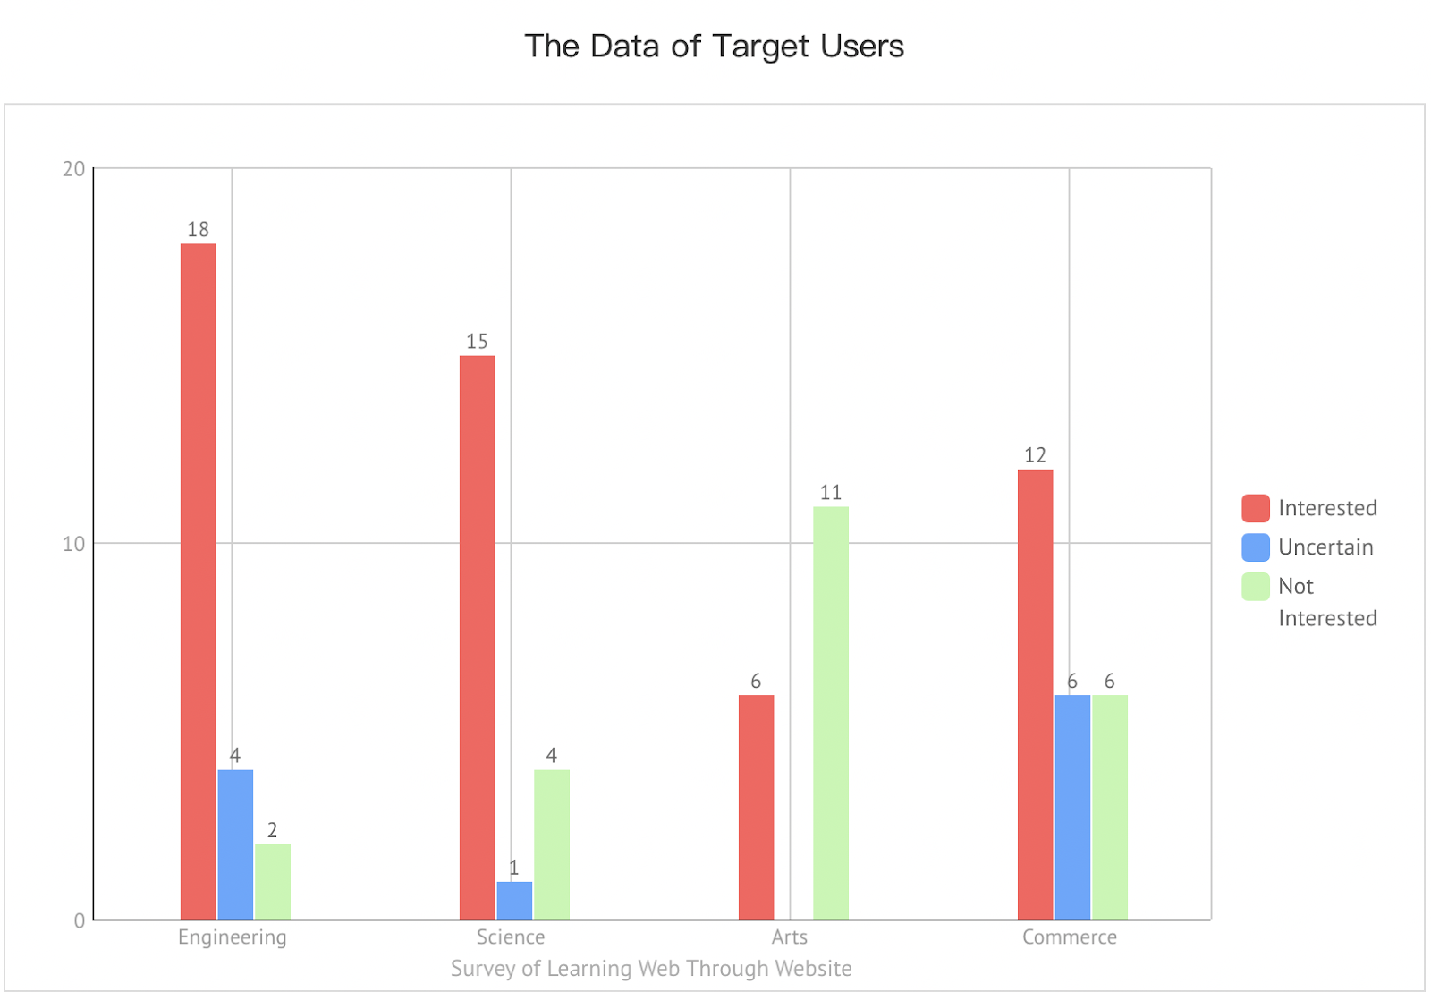

Personas for your website

|  |  |  |
| --- | --- | --- |
| **Persona:** | USYD student |  |
| **Photo:** |  |  |
| **Fictional name:** | Jack Lee |  |
| **Job title/Major**  **responsibilities:** | As a student, he learns knowledge as well as gets a better understanding of the society and industries. |  |
| **Demographics:** | * 18-24 years old * Married/Single * Has graduated from the senior high school * Has a Bachelor or Master in any degree |  |
| **Goals and tasks:** | He is passionate to learn about web development skills so that he can use it to communicate his idea to the wider society. He is also focused, goal-oriented within a strong desire to self-success and social responsibilities. One of his concerns is maintaining quality across all output of programs. The desired further career of him would be a software developer and web developer.  Spends his work time:   * studying for his university degree * actively participating in internet industries * paying close attention to the social issues * learning the web-develop skill by himself * socializing and sporting sufficiently | |
| **Environment:** | He comes to campus several days a week or studies remotely. He keeps the computer and phone with him almost all of the time. He has basic computer skills and knowledge about the Internet at least. He uses the web more than 1 hour every day. He meets with other students/tutors or communicates with peers/tutors through the Internet from Monday to Friday. He has some free time after finishing his study task from Monday to Friday and is more available on weekends. | |
| **Quote:** | “It’s a good day to learn something new!” | |
| **Frustration:** | Can not get things done by schedule. | |

Contents for your group’s web page

|  |  |
| --- | --- |
| **Basic Functions** | **Description** |
| Register | Register with phone number and or email address and the user can retrieve the password according to the registration information |
| Login | Username and Password, captcha. |
| Knowledge Base | Edited by admin, the user can only view them |
| Admin role | Add, delete and mute users |
| User role | Message other users, add friends. |
| Discussion forum | Users and admin add, delete, modify and search posts. |
| Possible extra | 1. Some university tutors are available to answer some challenging questions 2. Challenges to answer question online 3. The user can supplement test cases after being checked by a tutor in our website |
| Contents | 1. Complete knowledge about web 2. Some good YouTube videos about web 3. Online Compiler, practise what you have learned at any time |

Pages

Index page - Title, introduction of the website to attract user, hyperlink to knowledge base and forum

Knowledge base - List of post related to html/css and other web design basics

Forum - Post and reply to other people’s posts

Personal - Register, login to account, set and modify user information

Source code for About Us Page

<!DOCTYPE html>

<html>

<head>

<title>

About Us</title>

<meta name="viewport" content="width=device-width, initial-scale=1">

<meta name="keywords" content="web design">

<meta name="description" content="Meet the Excelsiors, web design database for Sydney students. ">

<style>

body {background-color:#ffffff;background-repeat:no-repeat;background-position:top left;background-attachment:fixed;}

h1{font-family:Arial, sans-serif;color:#000000;background-color:#ffffff;}

p {font-family:Georgia, serif;font-size:14px;font-style:normal;font-weight:normal;color:#000000;background-color:#ffffff;}

</style>

</head>

<body>

<h1>About Us</h1>

<h2>Alan - CEO</h2>

<p>Alan is highly motivated in the web development course. He has a strong coding background and is suitable for answering hard questions related to JavaScript, React, Vue. </p>

<p></p>

<h2>Alison - President</h2>

<p>Alison is an expert on the JVM system. She is suitable for answering questions related to Java/Maven/Spring. </p>

<p></p>

<h2>Jiahao - Editor-in-Chief</h2>

<p>Jiahao is very suitable to develop the state-of-the-art backend system. He is remarkably familiar with modern languages like Go/Rust and is suitable to develop high performance backends. His favorite hobby is cooking. </p>

<p></p>

<h2>Vincent - Publisher</h2>

<p>As a publisher, Vincent is good at frontend, he is the designer of our website. He would be glad to answer questions related to website aesthetics. </p>

<p></p>

<h2>Qihan - Engineer</h2>

<p>Qihan is highly motivated on Python. He is currently struggling to understand the C language. </p>

</body>

</html>