
Code Quality Report

Prime Software
University of Regina
2020

Version | Description of Change | Author | Date
1 | Document Creation | McKenzie Busenius | 01/26/20
2 | Code Revision, adding functional comments of swift classes, functions | Jiahao Li | 02/18/2020
2.1 | Document complete, Code Revision, writing more code flow details for each file | Jiahao Li | 04/02/2020

**** Edit Color ****
Mckenzie Busenius - Black
Jinkai Fan - Red
Jiahao Li – Green

- Development Environment
Our capstone project named Serdachny Hockey IOS mobile app is built in MacOS Xcode development tool with Swift 5 language. By exploring Xcode and Swift language as we were developing this app, our team took advantage of kind of aspects. For example, Xcode tool provides opportunities of files structures layers navigation as shown as Figure 1, development screen color themes, code character colors and intuitive tool icons. Swift 5 language provides great powerful libraries and good defined naming conventions of functions.
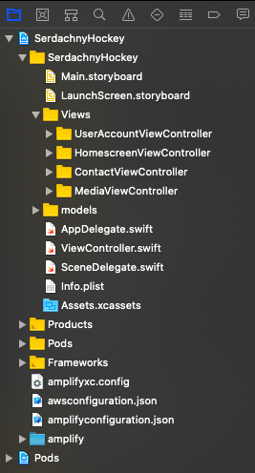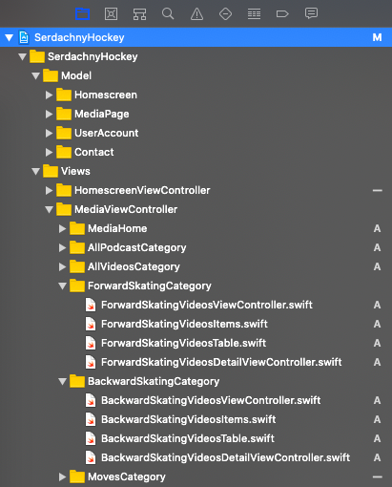
Figure 1. Xcode File Navigation Figure 2. Source Files and Order

- Code Formatting
It’s important for well-developed application that formatting code work should be always done during or after building codes. As programs get more complex, they get harder and harder to understand by others and even the personal who wrote the codes cannot understand and be able to re-read it.
Good layout has been proven time after time to make code more readable and the time it takes to do it nearly always repays itself many times over in the future. After reviewing all codes from the app, we ensured that each class file name has meaningful or intuitive meaning because we are developing a marketing video categories hockey app that requires clear categorized sources file names. Therefore my teammates are capable to modify and even future developers can easily pick up, read and write. We have created appropriately folders location that contains related source files and the right order. For example, as shown as above Figure 2, based on the Media Page Views navigation part , there are ForwardSkatingCategory, BackwardSkatingCategory folders as an example. Each folder represents one type of hockey sport skills. Expending one of them, it is clearly see that it has consistent related name and order. Inside ForwardSkatingCategory folder, there are ForwardSkatingVideosViewController.swift that is a controller function to display all contents in the screen, ForwardSkatingVideosItems.swift that is an instance class to initialize all variables/objects, ForwardSkatingVideosTable.swift that is a helper function to pass and update current video’s variables being modified and lastly ForwardSkatingVideosDetailViewController.swift that is a sub controller function to pass data to anther screen for showing a video details when user taps one of video contents.

- Architecture
MVC pattern is good at handling model, view, controller patterns during the development. There is also a strong reason to use MVC that we can have total separation in programming logic and the interface code. Therefore, it provides an effective way to design, implement, add, and debug/test functionalities. In this app, we are using MVC design pattern. The Serdachny app is all about video-based with marketing services that means it requires a lot of demands on querying, displaying processes. In the Model state, our backend configuration files which are connected to AWS S3 Bucket server side are in the model folder. In the View state, it was designed to contains storyboard where contains UI designs and have the parallel relationship with Controller state that contains manipulation files. Our team exactly followed all the way of MVC pattern to build, modify and test codes from the beginning to the end.

- Coding Best Practices
The coding best practices is essential for developers or company with the respect to benefits such that efficient and productive workflow improvement within a team and costs reduction. When we reviewed all codes, we focused on questions regarding as coding best practices about do we write appropriate and right comments about why we are doing with code blocks, what is the complexity of logical blocks, whether we use framework features instead of writing custom code. For instance, as shown as screenshots of part of codes below, we wrote engineering practical comment on the each top of file for telling what is functionality and team name which is shown as Figure 3. With the respect to framework modular, we used built-in functions via import Foundation or import UIKit from library. In the Figure 4, all func tableview(…) functions are required to deal with interaction between View state and Controller state, in other words, way of storing and displaying contents. And the benefit is we can view these functions’ definition and usage within the Xcode Swift 5 library or research online IOS Swift 5 reference manual.
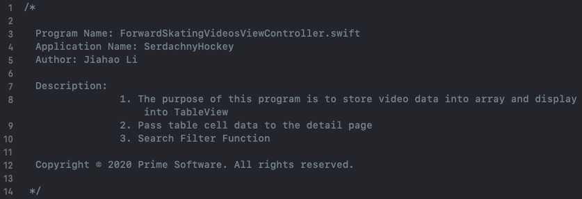
Figure 3. Top File Comments
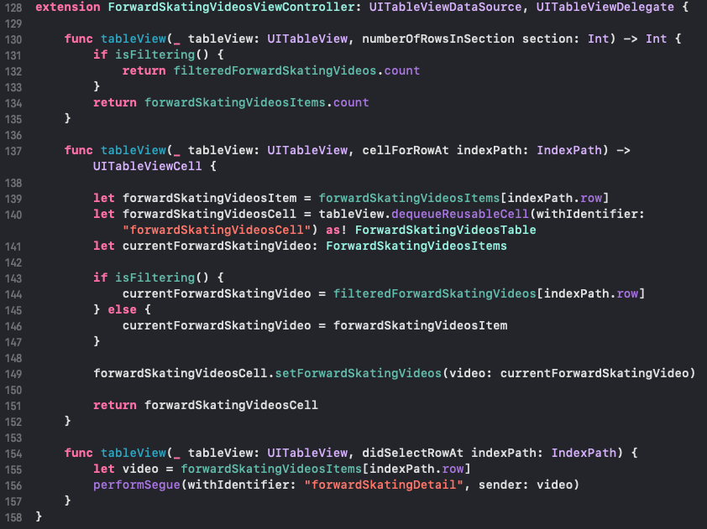
Figure 4. func tableview() structure
- Non Functional Requirements
  - Maintainability
Our team has three members and each one has own individual coding parts. Afterwards, we need to do integration part such that combining and testing features. So that requires code’s readability, testability from anyone. It would save time to understand codes. From the code review perspective, we ensured that we used appropriate name for variables, functions and classes. Moreover, the code can be easily tested with existing refactoring classes.
  - Reusability
“Do not repeat yourself”. We were trying to eliminate duplicate logic codes(classes, functions) via abstraction method in separate location and call it logically if necessary. It also can be reused when it is called. Recalling layout in our app, each video category folder contains a source file that initializes Swift UI components such as UIImage, UILabel, UIText.
  - Reliability
Based on the User Account page, we used AWS S3 Bucket authentication credentials for login, signup. We designed exception handling for each case such as login failure, signup failure and user invalid input. The purpose is to save user from failures.
  - Extensibility
We used abstraction method to reduce complexity of logical code as much as we can. It is easy to make minimal changes to existing code without breaking codes.
  - Security
Since we applied AWS S3 bucket authentication credentials method to process login, signup. The backend will handle/provide user data security, input data validation etc.
  - Scalability
The scalability standard of application is critical to deployment such that it can handle numbers processes of requesting or querying user data. However, based on our app testing, we just had added small sample contents/data because we realized that it depends on whether you purchase relative serveries from AWS bucket if you want to handle a large data.
  - Usability
As we started on user interface design, there were Swift 5 language UI components design documentations that we could refer to. And we made a nice design layout for each part. The user interface should easily to be understood and used.

- Object-Oriented Analysis and Design(OOAD) Principles
During app development, our team started with carefulness of writing simple and clean(single responsibility principle) for each function. As more logical things being added, we had tried to reduce complexity within a function(separation if necessary). With respect to open closed principle, new features can be easily added without modifying existing code. For instance, as shown as below, on the left, this is the ForwardSkatingCategory of Media Page UI design in Xcode. There is a TableView that contains Image View, Title Label, Description Label. If I want to add another feature to display what is the date of content creation like Date Label. I need to find and add another label icon from library. The last thing is to add another instance of Date Label into the class – ForwardSkatingCategory(). Also it is also convenient for code debugging.
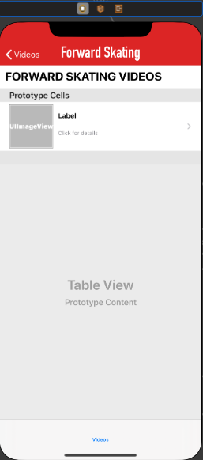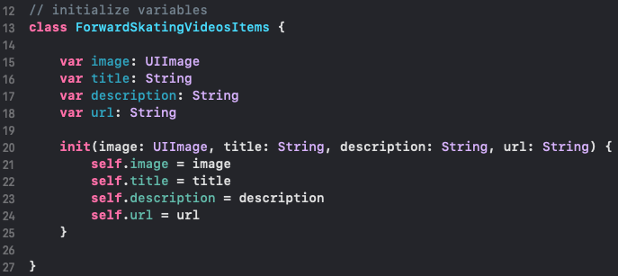
Left Right

- Tools for Code Reviews
Currently our team still check/review codes manually but we are planning to use kind of technologies/tools in the feature version(future MVPs).

- Reference
Code Review Checklist. https://www.evoketechnologies.com/blog/code-review-checklist-perform-effective-code-reviews/

