


- RESUME
User Guide
Catalog
1. Operating Environment 1
2. Definitions and Abbreviations 1
3. System Launch Instructions 1
4. Interface Description 1
5. Operation Instructions 2
5.1. Step 1: Input/Output Settings 2
Figure 2. Input/Output Module 2
5.2. Step 2: Running Parameter Settings 3
(2) Selecting Covariates 3
(4) Setting the Time Sequence 4
(6) Setting Reproducibility 5
(7) Executing the Matching 6
5.3. Step 3: Balance Test 6
5.4. Step 4: Parallel Trend Test 6

- Operating Environment
Supports Windows 7 and above (including Windows 10 and Windows 11). It is recommended to use Windows 10 or a higher version to achieve better compatibility and performance.

- Definitions and Abbreviations
This section will introduce all the specialized terms used in the software to help users better understand and operate the software.

table 1. Definitions and Abbreviations
Terms in the Software | Explanation
Covarate File | The file that users need to input, which stores the covariate data.
Panel File | The file that users need to input, which stores the panel data of crime rates.
Output Path | The output address for the matching result files generated by the software.
Geoid | The unique identifier for samples.
Treatment Variable | A variable with a value of 0 or 1, where 1 indicates that the sample has received treatment, and 0 indicates that it has not received treatment.
K Clusters | The k value that needs to be set when performing the k-means clustering algorithm, specifying the number of clusters to divide the samples into.
Iter | The maximum number of iterations for the k-means algorithm, indicating the maximum number of times the algorithm can be executed in a single run.
Tol | Tol is the relative tolerance for convergence, used to measure whether the change in cluster centers between two consecutive iterations is small enough to determine if the algorithm has converged.
Lag-1 Pre | The time period immediately preceding the implementation of the intervention.
Lag-2 Pre | The time period two periods before the implementation of the intervention.
Lag-3 Pre | The time period three periods before the implementation of the intervention.
SB | Standardized Bias
VR | Variance Ratio
MSD | Mean of Squared Differences
MDBT | Mean Distance Between Trends

- System Launch Instructions
Double-click the executable file “MatchingTool.exe” to open the software. When the software is launched, a Command-Line Terminal and the software interface will appear. Do not close the Command-Line Terminal at this time, as it will terminate the program.
- Interface Description
The software interface consists of four modules: Input/Output Settings, Running Parameter Settings, Balance Test and Parallel Trend Test.

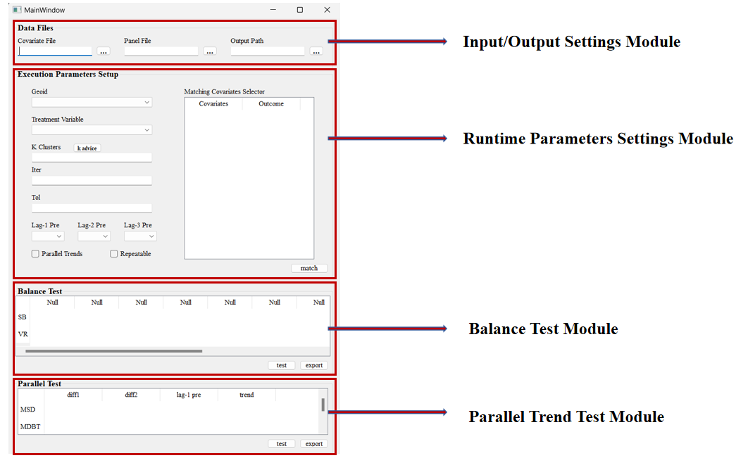
Figure 1. Software Interface

- Operation Instructions
The software requires four steps to perform matching: Input/Output Settings, Running Parameter Settings, Balance Test, and Parallel Trend Test.

5.1. Step 1: Input/Output Settings
In the Input/Output Settings module, by clicking the button“”, you can open the File Explorer to select the corresponding file path (only data in csv and xlsx formats are supported).

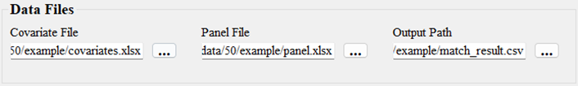

Figure 2. Input/Output Module

It should be noted that the first row of the covariate file and the panel file (in csv or xlsx format) must contain column names, and the covariate file must include the treatment variable (as shown in Figure 3).

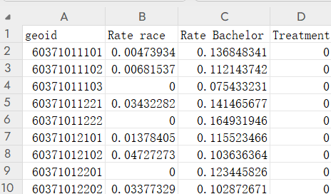 | 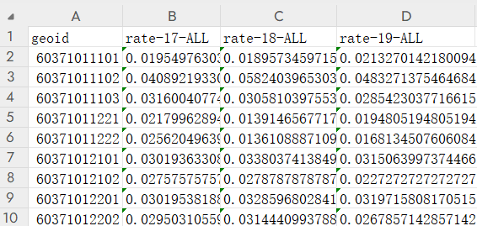
(a) Covariate File | (b) Panel File
Figure 3. File Input Example

5.2. Step 2: Running Parameter Settings
(1) Selecting the Treatment Variable and Geoid
After completing the input/output settings, the Running Parameter Settings module will be updated. The interface will refresh the options for Geoid and Treatment Variable. At this point, users can select the correct Geoid and treatment variable from the drop-down menus (as shown in Figure 4).

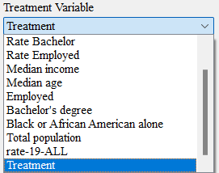 | 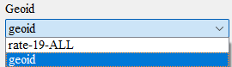
(a) Treatment Variable Option | (b) Geoid Option
Figure 4. Select Treatment Variable and Geoid

(2) Selecting Covariates
The covariate selector will display the covariates from the covariate file and the variables from the panel data. Users can select the covariates needed for matching by clicking on the cells in the covariate selector. The selected cells will turn green. Users can deselect a covariate by clicking on the same cell again (as shown in Figure 5).

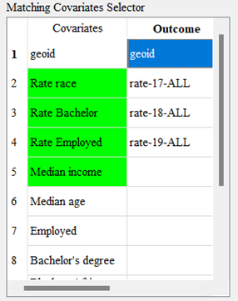
Figure 5. Select Covariates

(3) Setting k-Means Algorithm Parameters
There are three parameters for the k-means algorithm in the software: "K Clusters," "Iter," and "Tol" (for specific meanings, refer to the Definitions and Abbreviations section). For the parameter "K Clusters," please enter an integer greater than 0. If you are unable to determine the specific value, you can click the button“”. The software will then generate and display an elbow plot (as shown in Figure 6). By identifying the elbow point, users can determine the value for "K Clusters."For the parameter "Iter," users can select an integer greater than 0. The larger the value, the more iterations the k-means algorithm will perform.For the parameter "Tol," users can choose a positive number greater than 0. The smaller the value, the smaller the relative tolerance for convergence.

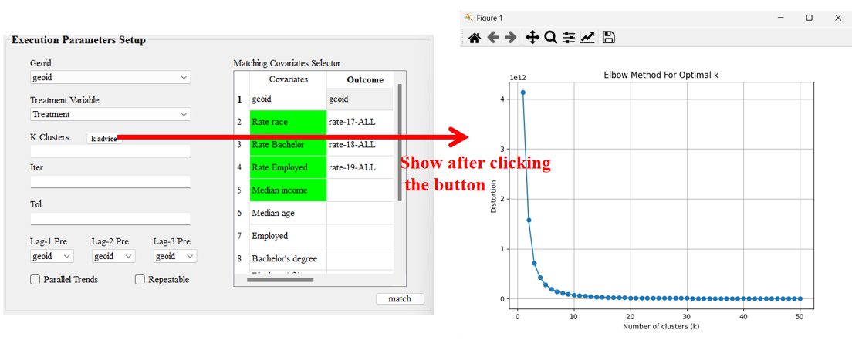
Figure 6. Elbow Plot

(4) Setting the Time Sequence
Users can select the options for "Lag-1 Pre," "Lag-2 Pre," and "Lag-3 Pre" (for specific meanings, refer to the Definitions and Abbreviations section) through the drop-down menu. After selection, the chosen options will be highlighted in yellow in the matching covariate selector (as shown in Figure 7).

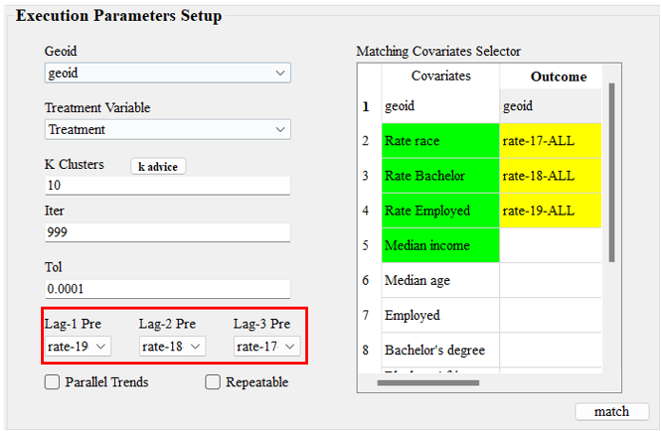
Figure 7. Set Time Sequence

(5) Setting Parallel Trend Matching
Users need to check the box“” to perform parallel trend matching (as shown in Figure 8). If this box is not checked, the software will only match samples that have similar covariates and comparable baseline crime rate levels.

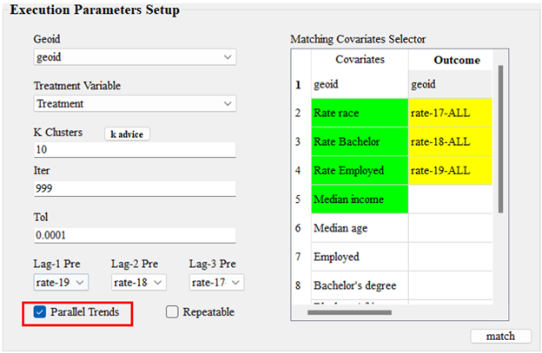
Figure 8. Set Parallel Trend Matching

(6) Setting Reproducibility
Users need to check the box“” to ensure that the matching results are consistent each time the software is run with the same parameters.

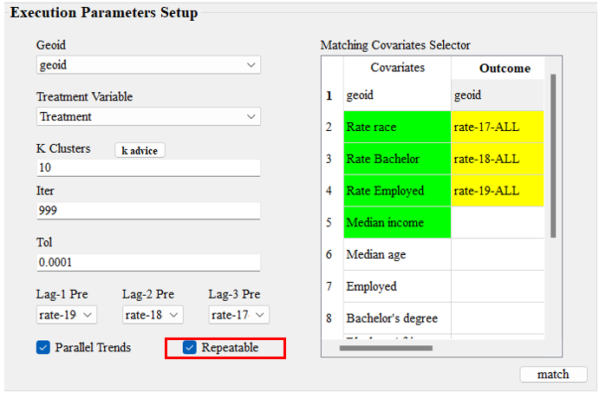
Figure 9. Set Reproducibility

(7) Executing the Matching
After all parameters have been set, click the button“”to initiate the matching process. The final matching results will be saved to the output path previously specified.

5.3. Step 3: Balance Test
After obtaining the matching results, users can check the balance of covariates between the treatment group and the control group. In the Balance Test module, clicking the button “”will display the SB and VR (for specific meanings, refer to the Definitions and Abbreviations section) for each covariate . Users can click the button “” to export the test results in xlsx format(as shown in Figure 10).

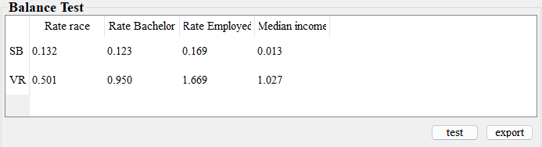
Figure 10. Example of Balance Test

5.4. Step 4: Parallel Trend Test
After obtaining the matching results, users can check the parallel trend of the outcome variables between the treatment group and the control group. In the Parallel Trend Check module, clicking the button “” will display the MSD for diff1, diff2, Lag-1 Pre, and Trend, as well as the MDBT for Trend (for specific meanings, refer to the Definitions and Abbreviations section). Users can click the button“”again to export the test results in xlsx format (as shown in Figure 13).

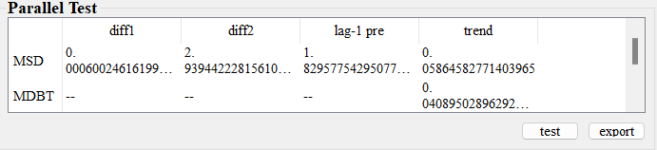
Figure 11. Example of Parallel Test

