DSCI 551 Lab 4

Jiahao Sun

Screenshot of the contents of the item:

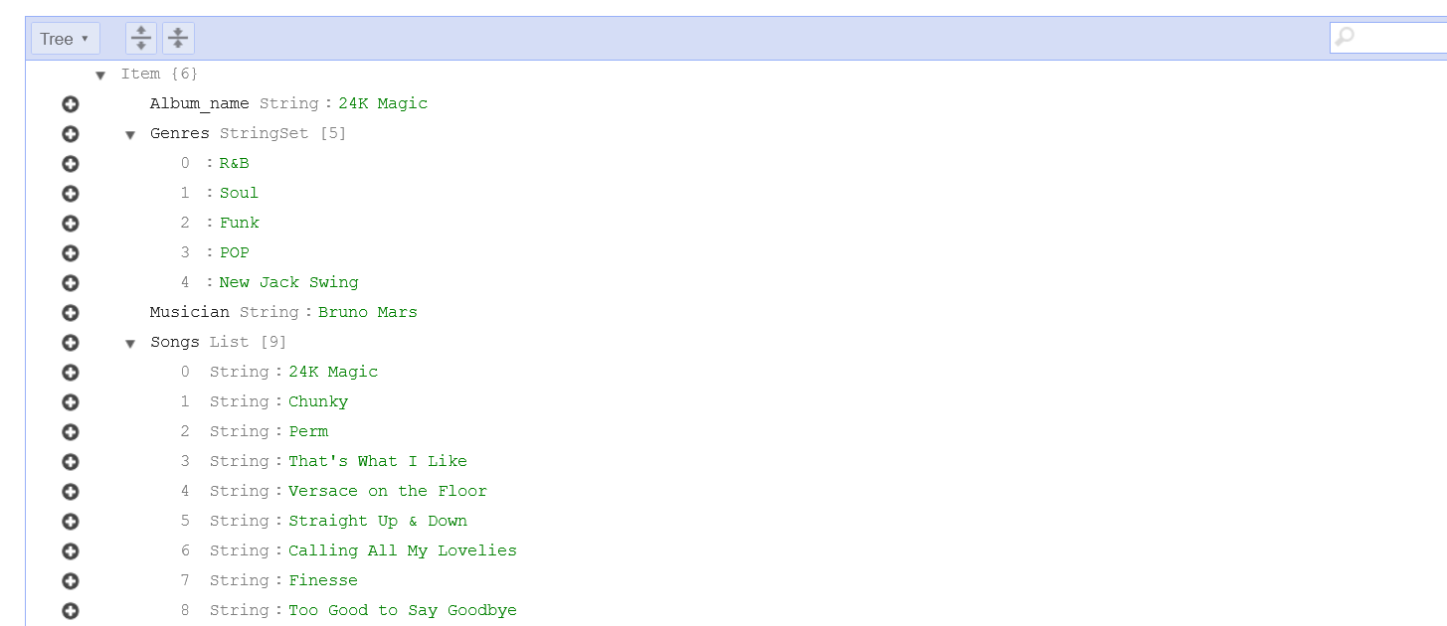

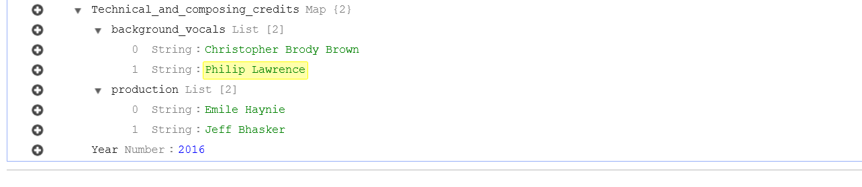

Screenshot of an example of searching using “scan” and “query”:

Scan:

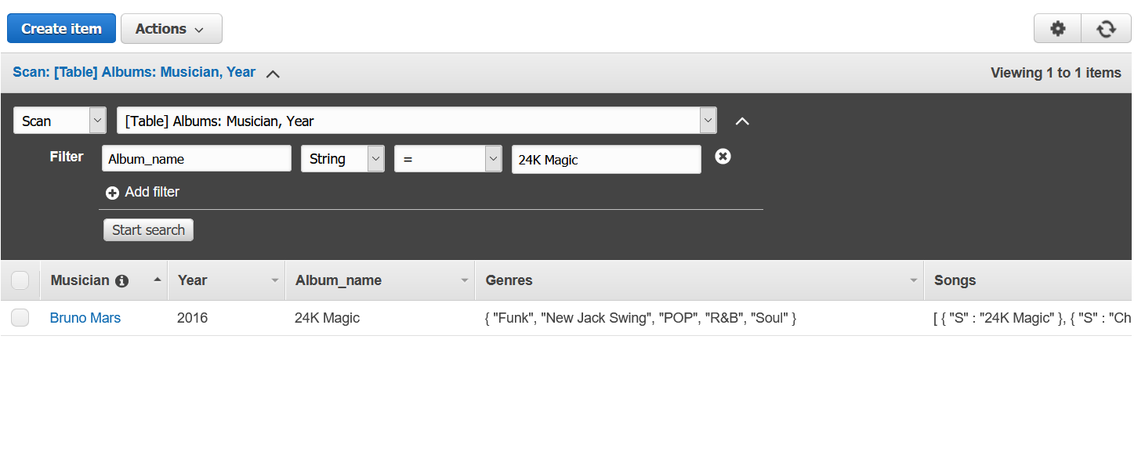

Query:

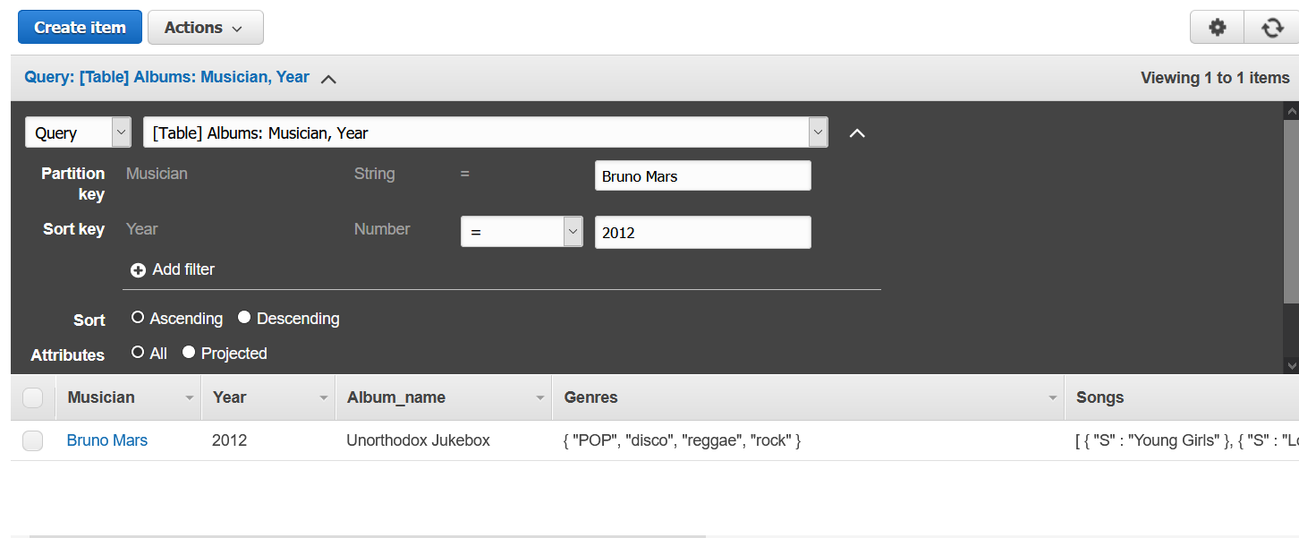

Contents of an item in Json format:

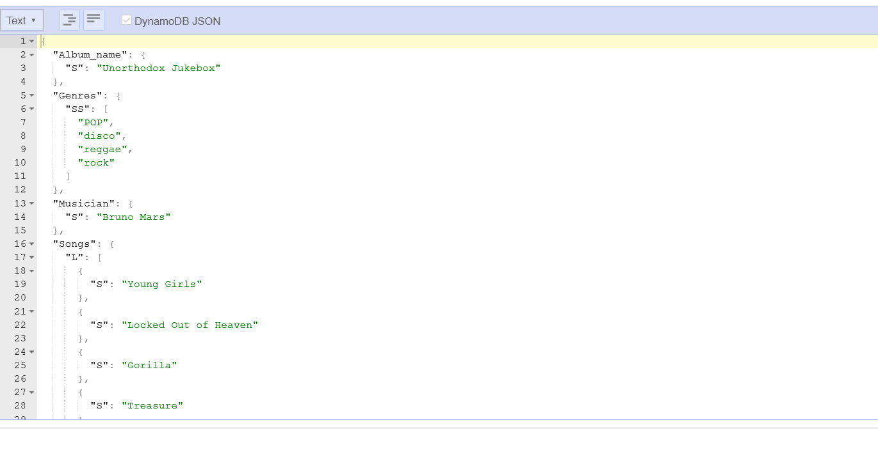

{

"Album_name": {

"S": "Unorthodox Jukebox"

},

"Genres": {

"SS": [

"POP",

"disco",

"reggae",

"rock"

]

},

"Musician": {

"S": "Bruno Mars"

},

"Songs": {

"L": [

{

"S": "Young Girls"

},

{

"S": "Locked Out of Heaven"

},

{

"S": "Gorilla"

},

{

"S": "Treasure"

},

{

"S": "Moonshine"

},

{

"S": "When I Was Your Man"

},

{

"S": "Natalie"

},

{

"S": "Show Me"

},

{

"S": "Money Make Her Smile"

},

{

"S": "If I Knew"

}

]

},

"Technical_and_composing_credits": {

"M": {

"background_vocals": {

"L": [

{

"S": "Jeff Bhasker"

},

{

"S": "Mark Ronson"

}

]

},

"production": {

"L": [

{

"S": "The Smeezingtons"

},

{

"S": "Benny Blanco "

}

]

}

}

},

"Year": {

"N": "2012"

}

}

Explanation on the difference between “scan” and “query”:

Using query, we need to specify the key. Both the partition key and the sort key need to be specified. However, scanning does not need to enter keys. We can use scanning by entering any filter of the attributes.