**LAB 3**

**Jiahao Sun**

Upload two json file into EC2

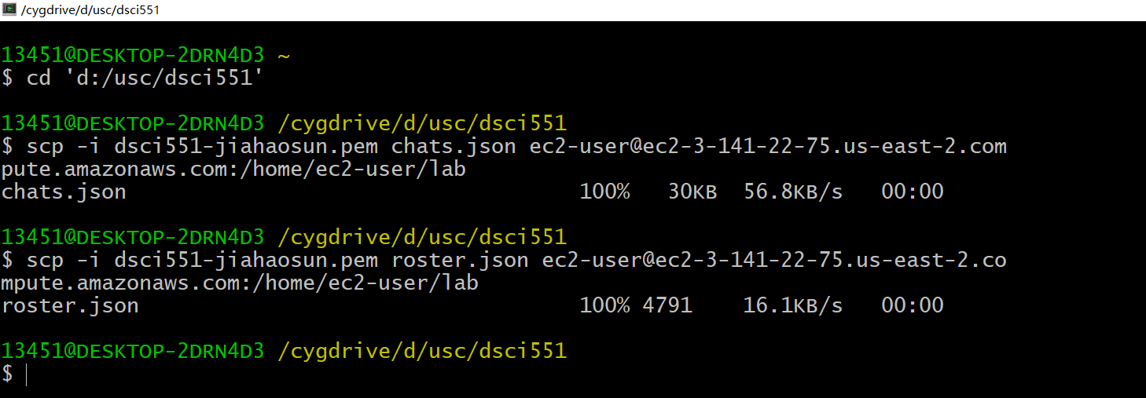

Load two json file into MongoDB

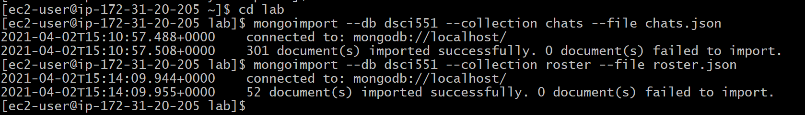

1.Find out the number of people who made at least one chat

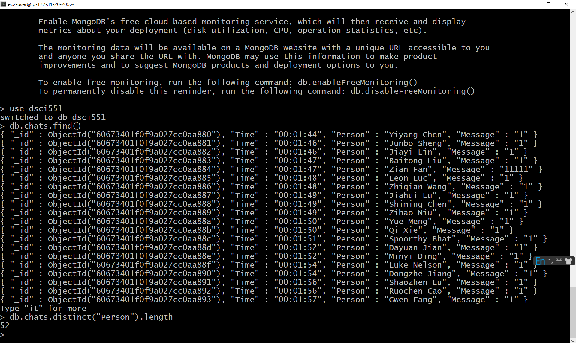

2. Find out the names of students (from roster) whose name contains "li" (case insensitive). Output the names in the ascending order.

db.roster.find({"Name":/li/i}, {"Name":1,"_id":0}).sort({Name:1})

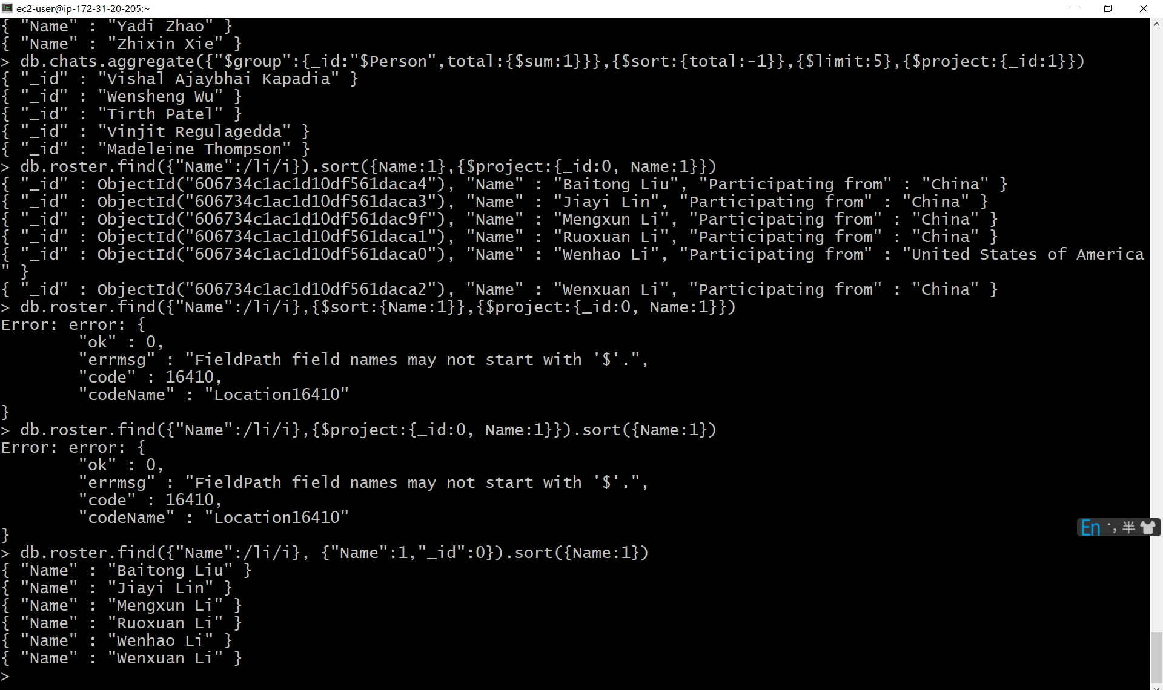

3. Find out the names of top-5 students ranked by the number of chats they have made.

db.chats.aggregate({"$group":{_id:"$Person",total:{$sum:1}}},{$sort:{total:-1}},{$limit:5},{$project:{_id:1}})

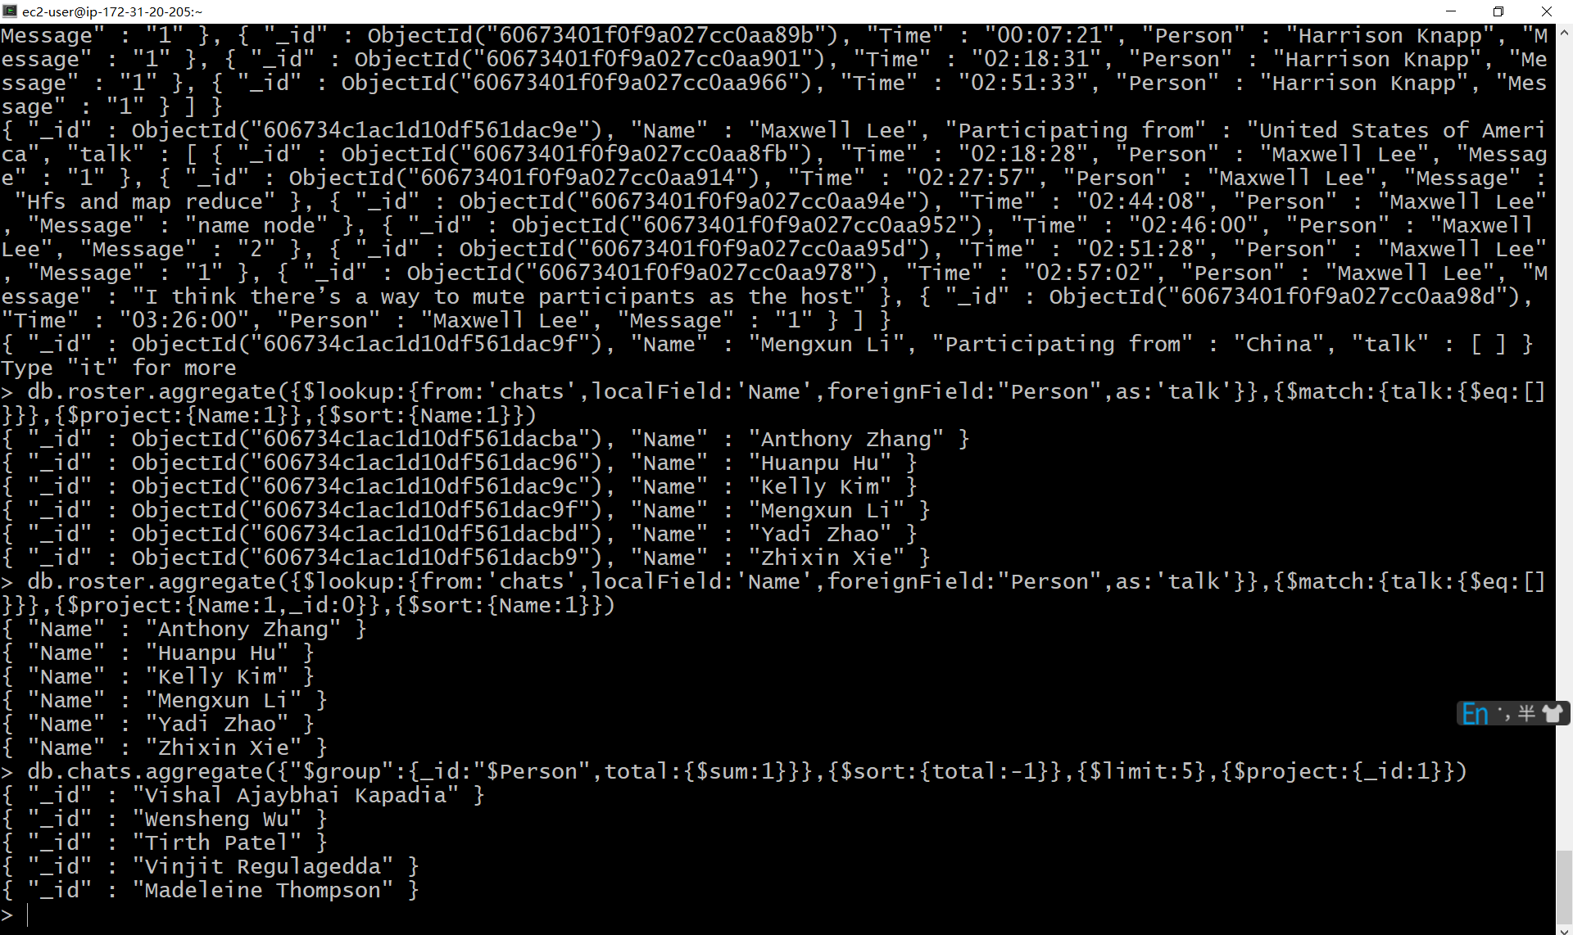

4. Find out the names of students who did not make any chats. Return names only, sorted (ascending order)

db.roster.aggregate({$lookup:{from:'chats',localField:'Name',foreignField:"Person",as:'talk'}},{$match:{talk:{$eq:[]}}},{$project:{Name:1,_id:0}},{$sort:{Name:1}})

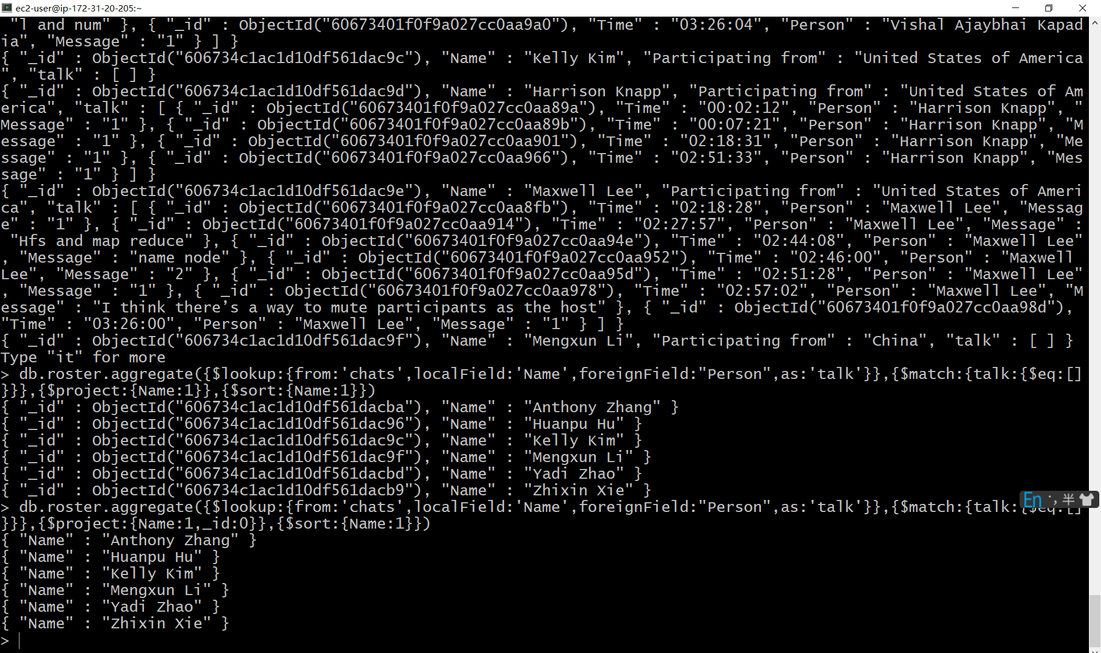

5. Add a new student "John Smith", participating from "United States of America" to the roster, with age = 25

db.roster.insert({"_id":ObjectId(),"Name":"John Smith","Participating from":"United States of America","age":25})

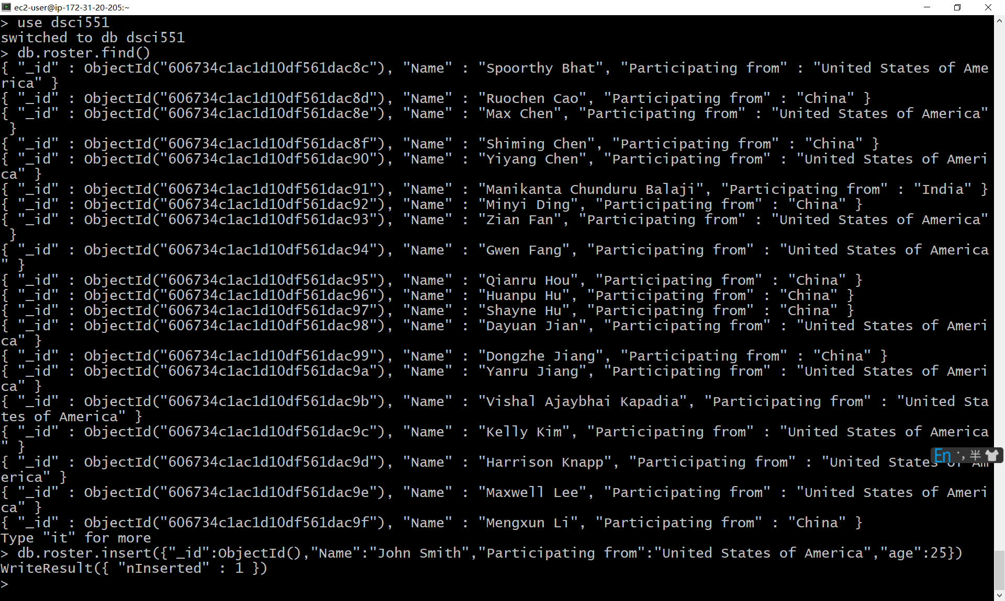

6. Add a new student "Mary Smith" with "Age" = 30 (no need to add participation info) and query it by name.

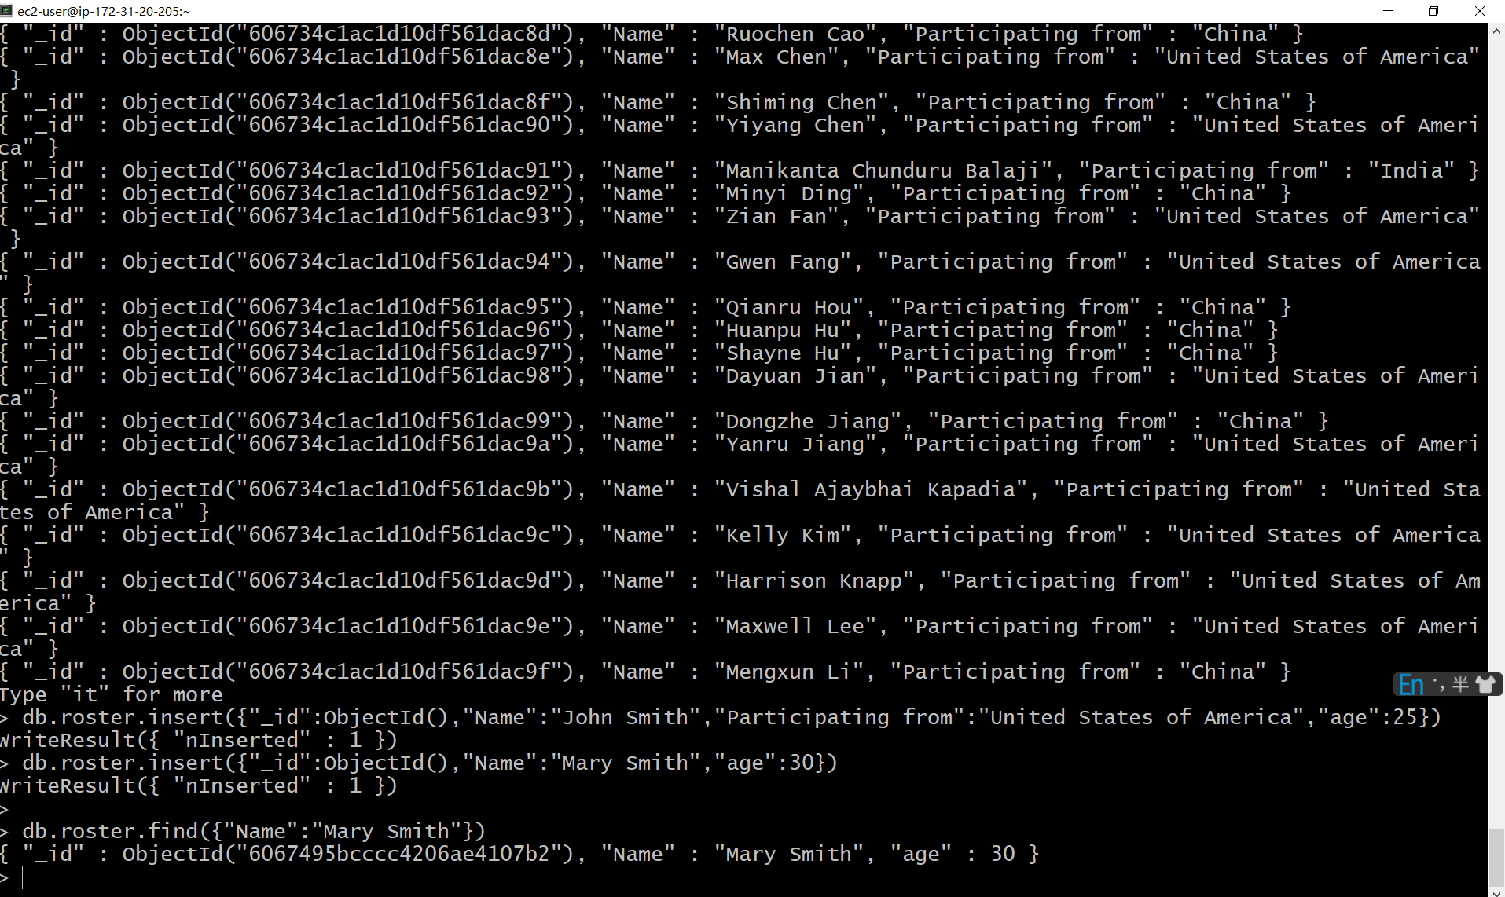

7. Change the name of student John Smith to Jonny Smith and age to 36 and query it by age equal to 36

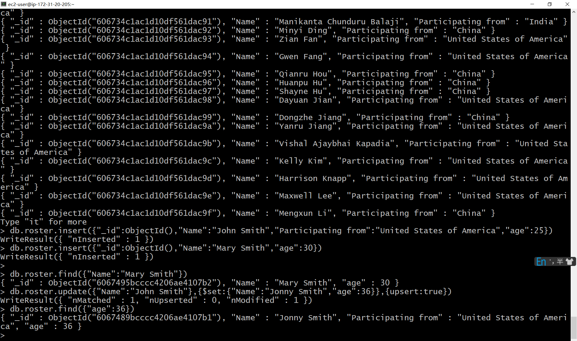

8. Add a new attribute "Program" and set its value to "ADS" for all students whose names contain Smith (case sensitive). And then query these students

