广东电信故障工单月度管控通报

一、重复派单网元TOP10统计

|  |  |  |  |  |  |  |  |  |
| --- | --- | --- | --- | --- | --- | --- | --- | --- |
| **4G网络** | | | |  | **直放站** | | | |
| **排名** | **地市** | **网元名称** | **故障单数** |  | **排名** | **地市** | **网元名称** | **故障单数** |
| {%tr for i in G4_Repeater %} | | | | | | | | |
| {{ i.index_Net_4G }} | {{ i.city_Net_4G }} | {{ i.ne_Net_4G }} | {{ i.amount_Net_4G }} |  | {{ i.index_Repeater }} | {{ i.city_Repeater }} | {{ i.ne_Repeater }} | {{ i.amount_Repeater }} |
| {%tr endfor %} | | | | | | | | |

|  |  |  |  |  |  |  |  |  |
| --- | --- | --- | --- | --- | --- | --- | --- | --- |
| **CDMA网络** | | | |  | **传输专业** | | | |
| **排名** | **地市** | **网元名称** | **故障单数** |  | **排名** | **地市** | **网元名称** | **故障单数** |
| {%tr for i in CDMA_Transmission %} | | | | | | | | |
| {{ i.index_Net_CDMA }} | {{ i.city_Net_CDMA }} | {{ i.ne_Net_CDMA }} | {{ i.amount_Net_CDMA }} |  | {{ i.index_Transmission }} | {{ i.city_Transmission }} | {{ i.ne_Transmission }} | {{ i.amount_Transmission }} |
| {%tr endfor %} | | | | | | | | |

|  |  |  |  |  |  |  |  |  |
| --- | --- | --- | --- | --- | --- | --- | --- | --- |
| **光网络** | | | |  | **动力专业** | | | |
| **排名** | **地市** | **网元名称** | **故障单数** |  | **排名** | **地市** | **网元名称** | **故障单数** |
| {%tr for i in Optical_Dynamics %} | | | | | | | | |
| {{ i.index_Net_Optical }} | {{ i.city_Net_Optical }} | {{ i.ne_Net_Optical }} | {{ i.amount_Net_Optical }} |  | {{ i.index_Dynamics }} | {{ i.city_Dynamics  }} | {{ i.ne_Dynamics }} | {{ i.amount_Dynamics }} |
| {%tr endfor %} | | | | | | | | |

|  |  |  |  |  |  |  |  |  |
| --- | --- | --- | --- | --- | --- | --- | --- | --- |
| **交换专业** | | | |  | **数据专业** | | | |
| **排名** | **地市** | **网元名称** | **故障单数** |  | **排名** | **地市** | **网元名称** | **故障单数** |
| {%tr for i in Exchange_Data %} | | | | | | | | |
| {{ i.index_Exchange }} | {{ i.city_Exchange }} | {{ i.ne_Exchange }} | {{ i.amount_Exchange }} |  | {{ i.index_Data }} | {{ i.city_Data }} | {{ i.ne_Data }} | {{ i.amount_Data }} |
| {%tr endfor %} | | | | | | | | |

二、故障单分布情况

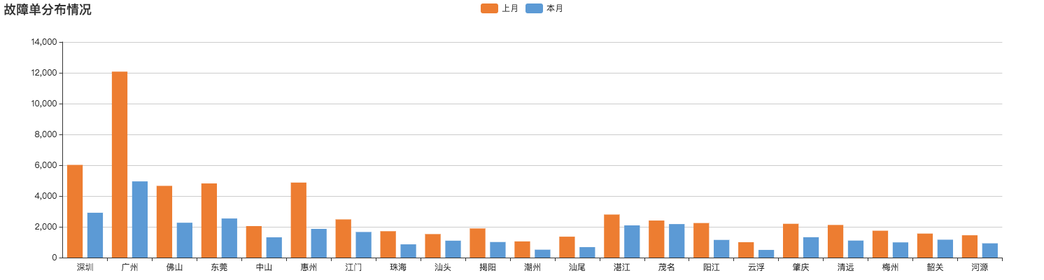

三、故障原因分析

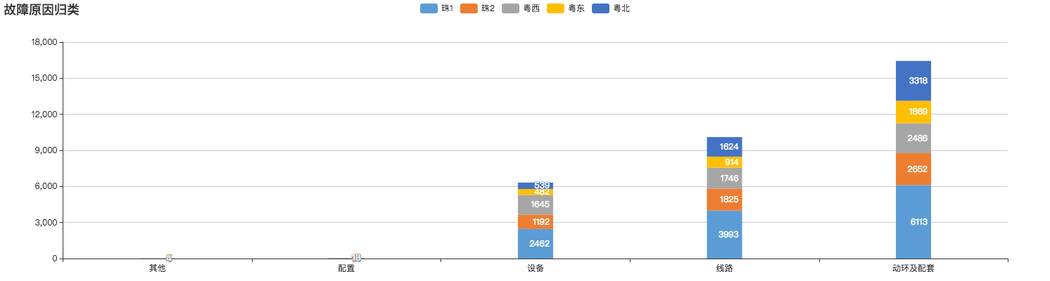

四、指标分析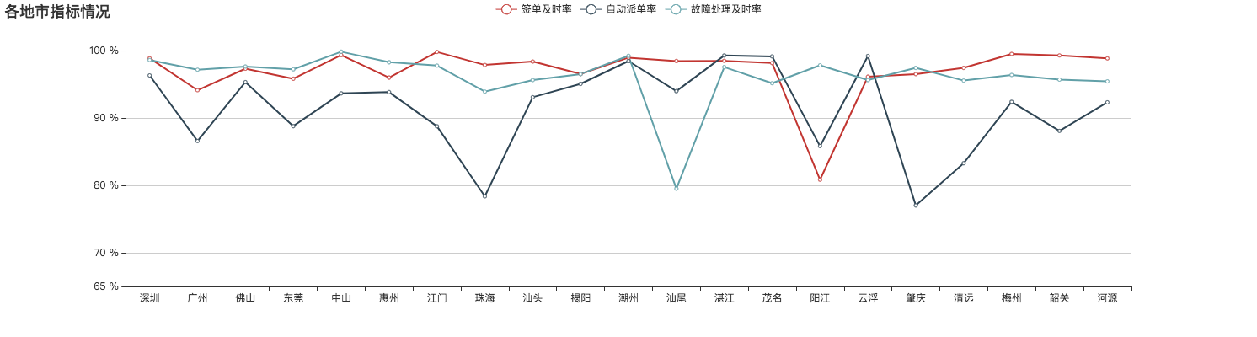五、处理及时率差的维护部门

|  |  |  |  |  |
| --- | --- | --- | --- | --- |
| **处理部门** | **处理总单量** | **处理及时单量** | **处理不及时单量** | **处理及时率(%)** |
| {%tr for i in departments %} | | | | |
| {{i.department}} | {{i.totalAmount}} | {{i.intimeAmount}} | {{i.overtimeAmount}} | {{i.intimeRate}} |
| {%tr endfor %} | | | | |