广东电信故障工单季度管控通报

## 一、 全省网络故障单量情况统计

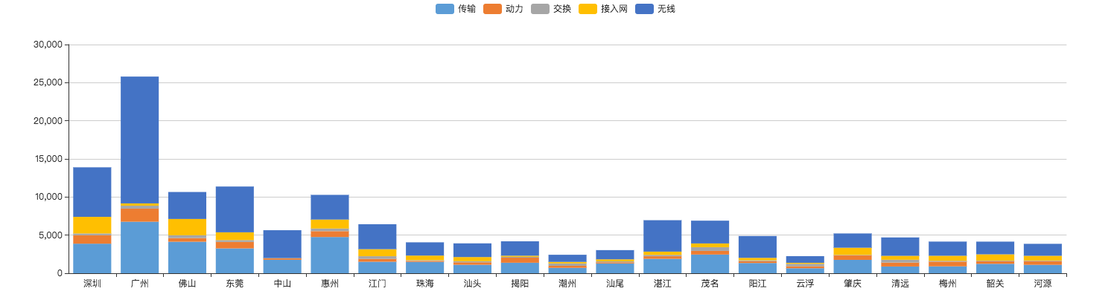

|  |  |  |  |  |  |  |  |
| --- | --- | --- | --- | --- | --- | --- | --- |
| **区域** | **地市** | **专业** | | | | | **合计** |
| 传输 | 动力 | 交换 | 接入网 | 无线 |
| {%tr for i in AmountArea1 %} | | | | | | | |
| {%vm%} {{district1}} | {%cellbg i.bg%}{{i.city}} | {%cellbg i.bg%}{{i.transmission}} | {%cellbg i.bg%}{{i.dynamics}} | {%cellbg i.bg%}{{i.exchange}} | {%cellbg i.bg%}{{i.AN}} | {%cellbg i.bg%}{{i.wireless}} | {%cellbg i.bg%}{{i.sum}} |
| {%tr endfor %} | | | | | | | |
| {%tr for i in AmountArea2 %} | | | | | | | |
| {%vm%} {{district2}} | {{i.city}} | {{i.transmission}} | {{i.dynamics}} | {{i.exchange}} | {{i.AN}} | {{i.wireless}} | {{i.sum}} |
| {%tr endfor %} | | | | | | | |
| {%tr for i in AmountArea3 %} | | | | | | | |
| {%vm%} {{district3}} | {{i.city}} | {{i.transmission}} | {{i.dynamics}} | {{i.exchange}} | {{i.AN}} | {{i.wireless}} | {{i.sum}} |
| {%tr endfor %} | | | | | | | |
| {%tr for i in AmountArea4 %} | | | | | | | |
| {%vm%} {{district4}} | {{i.city}} | {{i.transmission}} | {{i.dynamics}} | {{i.exchange}} | {{i.AN}} | {{i.wireless}} | {{i.sum}} |
| {%tr endfor %} | | | | | | | |
| {%tr for i in AmountArea5 %} | | | | | | | |
| {%vm%} {{district5}} | {{i.city}} | {{i.transmission}} | {{i.dynamics}} | {{i.exchange}} | {{i.AN}} | {{i.wireless}} | {{i.sum}} |
| {%tr endfor %} | | | | | | | |
| 合计 | | {{total_transmission}} | {{total_dynamics}} | {{total_exchange}} | {{total_AN}} | {{total_wireless}} | {{total}} |

## 二、全省故障工单处理质量情况分析

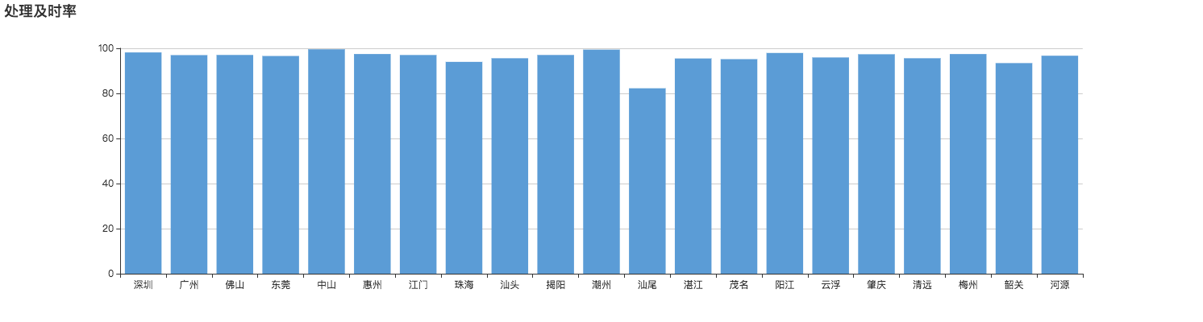

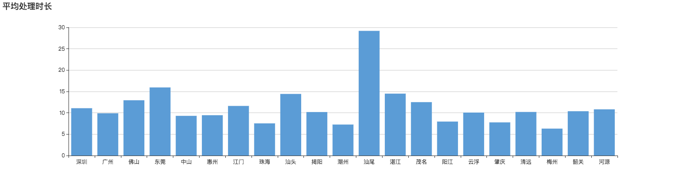

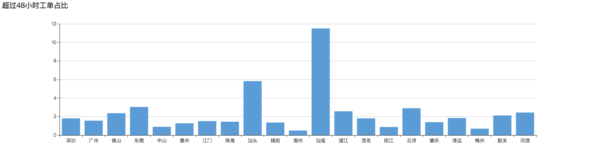

|  |  |  |  |  |  |  |
| --- | --- | --- | --- | --- | --- | --- |
| **区域** | **地市** | | **签单及时率（%）** | **处理及时率（%）** | **平均处理时长（小时）** | **超48小时工单占比（%）** |
| {%tr for i in QualityArea1 %} | | | | | | |
| {%vm%} {{district1}} | {{i.city}} | | {{i.SignRate}} | {{i.IntimeRate}} | {{i.AverageTime}} | {{i.Over48Rate}} |
| {%tr endfor %} | | | | | | |
| {%tr for i in QualityArea2 %} | | | | | | |
| {%vm%} {{district2}} | {{i.city}} | | {{i.SignRate}} | {{i.IntimeRate}} | {{i.AverageTime}} | {{i.Over48Rate}} |
| {%tr endfor %} | | | | | | |
| {%tr for i in QualityArea3 %} | | | | | | |
| {%vm%} {{district3}} | {{i.city}} | | {{i.SignRate}} | {{i.IntimeRate}} | {{i.AverageTime}} | {{i.Over48Rate}} |
| {%tr endfor %} | | | | | | |
| {%tr for i in QualityArea4 %} | | | | | | |
| {%vm%} {{district4}} | {{i.city}} | | {{i.SignRate}} | {{i.IntimeRate}} | {{i.AverageTime}} | {{i.Over48Rate}} |
| {%tr endfor %} | | | | | | |
| {%tr for i in QualityArea5 %} | | | | | | |
| {%vm%} {{district5}} | {{i.city}} | | {{i.SignRate}} | {{i.IntimeRate}} | {{i.AverageTime}} | {{i.Over48Rate}} |
| {%tr endfor %} | | | | | | |
| 平均 | | {{avg_signRate}} | | {{avg_intimeRate}} | {{avg_dealTime}} | {{avg_over48Rate}} |

## 三、全省网络故障原因分析

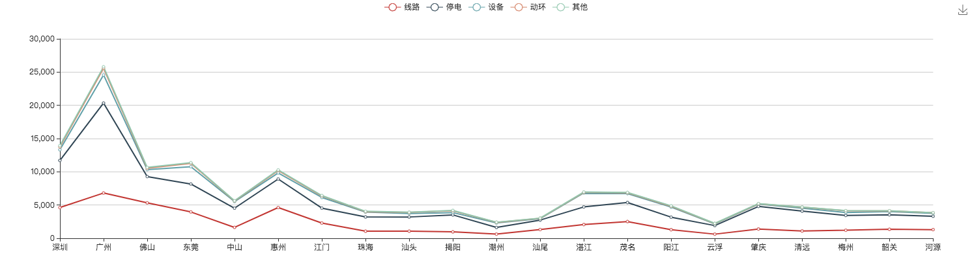

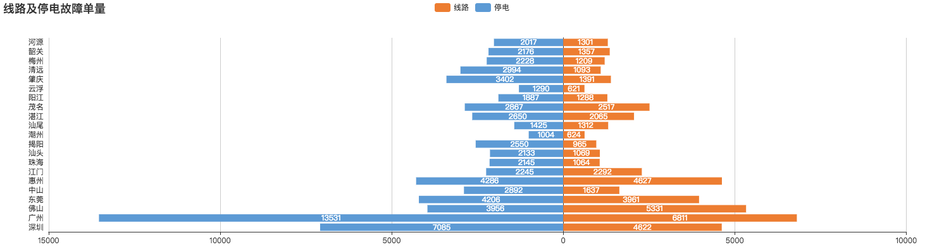

|  |  |  |  |  |  |  |
| --- | --- | --- | --- | --- | --- | --- |
| **区域** | **地市** | **线路（张）** | **停电（张）** | **设备（张）** | **动环（张）** | **其他（张）** |
| {%tr for i in SpecificDealtimeAmount1 %} | | | | | | |
| {%vm%} {{district1}} | {{i.city}} | {{i.line_amount}} | {{i.power_amount}} | {{i.equipment_amount}} | {{i.environment_amount}} | {{i.other_amount}} |
| {%tr endfor %} | | | | | | |
| {%tr for i in SpecificDealtimeAmount2 %} | | | | | | |
| {%vm%} {{district2}} | {{i.city}} | {{i.line_amount}} | {{i.power_amount}} | {{i.equipment_amount}} | {{i.environment_amount}} | {{i.other_amount}} |
| {%tr endfor %} | | | | | | |
| {%tr for i in SpecificDealtimeAmount3 %} | | | | | | |
| {%vm%} {{district3}} | {{i.city}} | {{i.line_amount}} | {{i.power_amount}} | {{i.equipment_amount}} | {{i.environment_amount}} | {{i.other_amount}} |
| {%tr endfor %} | | | | | | |
| {%tr for i in SpecificDealtimeAmount4 %} | | | | | | |
| {%vm%} {{district4}} | {{i.city}} | {{i.line_amount}} | {{i.power_amount}} | {{i.equipment_amount}} | {{i.environment_amount}} | {{i.other_amount}} |
| {%tr endfor %} | | | | | | |
| {%tr for i in SpecificDealtimeAmount5 %} | | | | | | |
| {%vm%} {{district5}} | {{i.city}} | {{i.line_amount}} | {{i.power_amount}} | {{i.equipment_amount}} | {{i.environment_amount}} | {{i.other_amount}} |
| {%tr endfor %} | | | | | | |
| 合计 | | {{sum_line}} | {{sum_power}} | {{sum_equipment}} | {{sum_environment}} | {{sum_other}} |

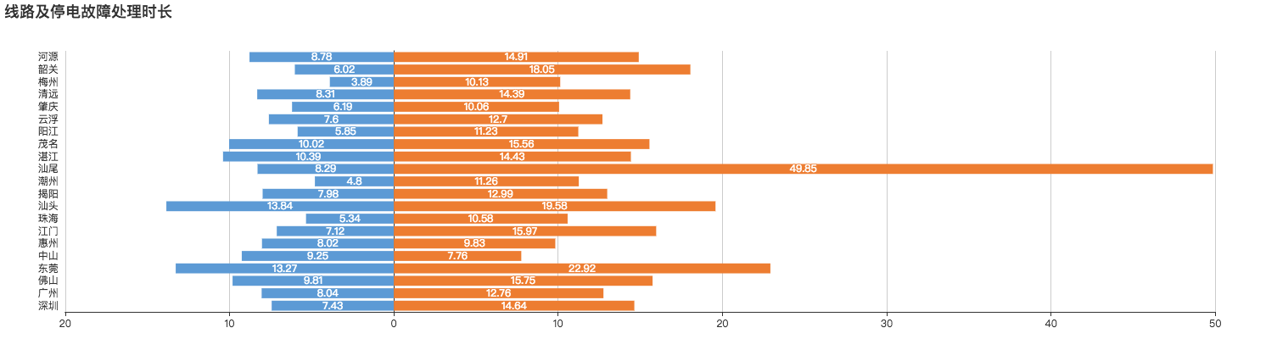

|  |  |  |  |  |  |  |
| --- | --- | --- | --- | --- | --- | --- |
| **区域** | **地市** | **线路故障 平均处理时长（小时）** | **停电故障 平均处理时长（小时）** | **设备故障 平均处理时长（小时）** | **动环故障 平均处理时长（小时）** | **其他故障 平均处理时长（小时）** |
| {%tr for i in SpecificDealtimeAmount1 %} | | | | | | |
| {%vm%} {{district1}} | {{i.city}} | {{i.line_time }} | {{i.power_time }} | {{i.equipment_time }} | {{i.environment_time}} | {{i.other_time}} |
| {%tr endfor %} | | | | | | |
| {%tr for i in SpecificDealtimeAmount2 %} | | | | | | |
| {%vm%} {{district2}} | {{i.city}} | {{i.line_time }} | {{i.power_time }} | {{i.equipment_time }} | {{i.environment_time}} | {{i.other_time}} |
| {%tr endfor %} | | | | | | |
| {%tr for i in SpecificDealtimeAmount3 %} | | | | | | |
| {%vm%} {{district3}} | {{i.city}} | {{i.line_time }} | {{i.power_time }} | {{i.equipment_time }} | {{i.environment_time}} | {{i.other_time}} |
| {%tr endfor %} | | | | | | |
| {%tr for i in SpecificDealtimeAmount4 %} | | | | | | |
| {%vm%} {{district4}} | {{i.city}} | {{i.line_time }} | {{i.power_time }} | {{i.equipment_time }} | {{i.environment_time}} | {{i.other_time}} |
| {%tr endfor %} | | | | | | |
| {%tr for i in SpecificDealtimeAmount5 %} | | | | | | |
| {%vm%} {{district5}} | {{i.city}} | {{i.line_time }} | {{i.power_time }} | {{i.equipment_time }} | {{i.environment_time}} | {{i.other_time}} |
| {%tr endfor %} | | | | | | |
| 合计 | | {{avg_line}} | {{avg_power}} | {{avg_equipment}} | {{avg_environment}} | {{avg_other}} |