广东电信故障工单周度管控通报

**一、遗留跟踪单**

|  |  |  |  |  |  |  |  |
| --- | --- | --- | --- | --- | --- | --- | --- |
| **处理部门** | **在途遗留跟踪单(张)** | **本周新增在途(张)** | **本周新增占比(%)** | **本周完成(张)** | **本周完成占比(%)** | **处理时间超1个月(张)** | **处理时间超3个月(张)** |
| {%tr for i in weeklyTrack %} | | | | | | | |
| {{i.city}} | {{i.sum_amount}} | {{i.new_amount}} | {{i.new_rate}} | {{i.finish_amount}} | {{i.finish_rate}} | {{i. over1_amount }} | {{i. over3_amount }} |
| {%tr endfor %} | | | | | | | |

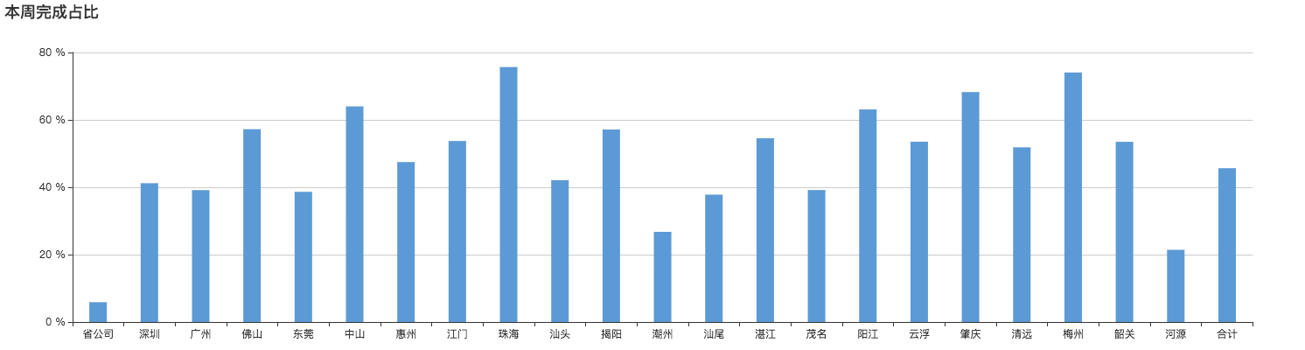

**二、超长历时在途工单**

|  |  |  |  |  |  |
| --- | --- | --- | --- | --- | --- |
| **工单停留单位** | **在途网络单总数** | **故障历时72-168小时(张)** | **占比(%)** | **故障历时>168小时(张)** | **占比(%)** |
| {%tr for i in weeklyLongtime%} | | | | | |
| {{i.city}} | {{i.sum_amount}} | {{i.amount_3_7}} | {{i.amount_3_7_rate}} | {{i.amount_over_7}} | {{i.amount_over_7_rate}} |
| {%tr endfor %} | | | | | |

