广东电信故障工单周度管控通报

**一、遗留跟踪单**

|  |  |  |  |  |  |  |  |
| --- | --- | --- | --- | --- | --- | --- | --- |
| **处理部门** | **在途遗留跟踪单(张)** | **本周新增在途(张)** | **本周新增占比(%)** | **本周完成(张)** | **本周完成占比(%)** | **处理时间超1个月(张)** | **处理时间超3个月(张)** |
| 省公司 | 126 | 15 | 11.9 | 13 | 9.35 | 79 | 54 |
| 深圳 | 844 | 22 | 2.61 | 460 | 35.28 | 171 | 84 |
| 广州 | 402 | 7 | 1.74 | 341 | 45.9 | 86 | 55 |
| 佛山 | 78 | 5 | 6.41 | 105 | 57.38 | 6 | 3 |
| 东莞 | 383 | 15 | 3.92 | 177 | 31.61 | 169 | 104 |
| 中山 | 67 | 0 | 0.0 | 81 | 54.73 | 5 | 2 |
| 惠州 | 79 | 1 | 1.27 | 89 | 52.98 | 16 | 11 |
| 江门 | 36 | 1 | 2.78 | 28 | 43.75 | 5 | 2 |
| 珠海 | 52 | 0 | 0.0 | 63 | 54.78 | 1 | 0 |
| 汕头 | 175 | 1 | 0.57 | 160 | 47.76 | 36 | 24 |
| 揭阳 | 26 | 0 | 0.0 | 20 | 43.48 | 1 | 1 |
| 潮州 | 42 | 2 | 4.76 | 13 | 23.64 | 12 | 3 |
| 汕尾 | 108 | 0 | 0.0 | 114 | 51.35 | 14 | 1 |
| 湛江 | 81 | 0 | 0.0 | 93 | 53.45 | 15 | 4 |
| 茂名 | 56 | 1 | 1.79 | 31 | 35.63 | 14 | 11 |
| 阳江 | 30 | 0 | 0.0 | 42 | 58.33 | 6 | 6 |
| 云浮 | 29 | 1 | 3.45 | 41 | 58.57 | 1 | 0 |
| 肇庆 | 40 | 0 | 0.0 | 90 | 69.23 | 2 | 0 |
| 清远 | 47 | 1 | 2.13 | 37 | 44.05 | 27 | 16 |
| 梅州 | 5 | 0 | 0.0 | 26 | 83.87 | 2 | 1 |
| 韶关 | 47 | 0 | 0.0 | 44 | 48.35 | 9 | 3 |
| 河源 | 14 | 0 | 0.0 | 11 | 44.0 | 3 | 3 |
| 合计 | 2767 | 72 | 2.6 | 2079 | 42.9 | 680 | 388 |

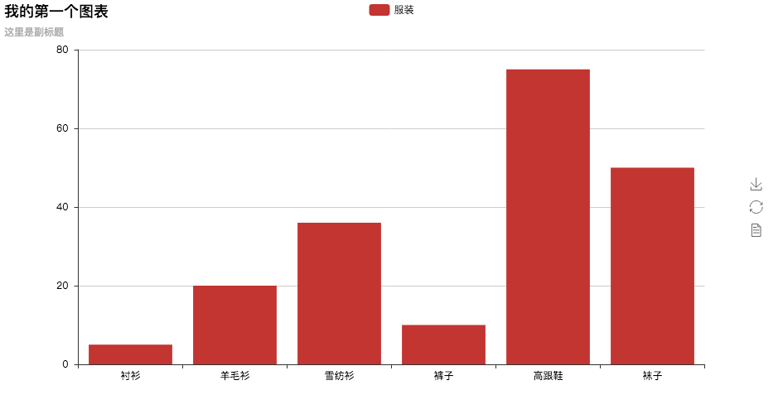

**二、超长历时在途工单**

|  |  |  |  |  |  |
| --- | --- | --- | --- | --- | --- |
| **工单停留单位** | **在途网络单总数** | **故障历时72-168小时(张)** | **占比(%)** | **故障历时>168小时(张)** | **占比(%)** |
| 省公司 | 142 | 44 | 30.99 | 62 | 43.66 |
| 深圳 | 521 | 49 | 9.4 | 157 | 30.13 |
| 广州 | 1371 | 172 | 12.55 | 484 | 35.3 |
| 佛山 | 192 | 21 | 10.94 | 16 | 8.33 |
| 东莞 | 468 | 56 | 11.97 | 218 | 46.58 |
| 中山 | 112 | 10 | 8.93 | 13 | 11.61 |
| 惠州 | 210 | 27 | 12.86 | 27 | 12.86 |
| 江门 | 91 | 10 | 10.99 | 6 | 6.59 |
| 珠海 | 34 | 0 | 0.0 | 5 | 14.71 |
| 汕头 | 269 | 30 | 11.15 | 126 | 46.84 |
| 揭阳 | 83 | 9 | 10.84 | 6 | 7.23 |
| 潮州 | 203 | 33 | 16.26 | 112 | 55.17 |
| 汕尾 | 103 | 14 | 13.59 | 35 | 33.98 |
| 湛江 | 56 | 9 | 16.07 | 2 | 3.57 |
| 茂名 | 134 | 12 | 8.96 | 10 | 7.46 |
| 阳江 | 221 | 13 | 5.88 | 93 | 42.08 |
| 云浮 | 65 | 17 | 26.15 | 3 | 4.62 |
| 肇庆 | 171 | 21 | 12.28 | 17 | 9.94 |
| 清远 | 118 | 10 | 8.47 | 54 | 45.76 |
| 梅州 | 52 | 5 | 9.62 | 4 | 7.69 |
| 韶关 | 119 | 20 | 16.81 | 45 | 37.82 |
| 河源 | 79 | 6 | 7.59 | 15 | 18.99 |
| 合计 | 4814 | 588 | 12.21 | 1510 | 31.37 |

