Project Proposal: Soft Robotic Fish via Beam Model
Jiajin Cui

Problem and motivation
Soft robotic fishes are important in terms of underwater exploration. Although rigid propellers have been widely used nowadays, they generate unwanted noises and turbulent flow. However, flexible robotic fish can adapt to the fluid forces, providing a safer and quieter actuation. However, the complex relationship between the stiffness, actuation frequency, and effectiveness has been an unsolved problem. This project focuses on modeling the robotic fish as a flexible node-spring network to simulate how different key parameters affect the bending behavior.

Background and literature review

Finite-Element-Based Structure Modeling

Katzshman et al. (2018) brought up the idea of robotic fish ‘SoFi. In the paper, he demonstrated a modeling of underwater exploration using different materials and finite element analysis. Their work described the process starting from design to a control planner and testing under water at depths around 18 meters. Utilizing the water-driven actuators, the robot produces motions very similar to a biological fish. The application of a modern modem allows the robot to accept commands such as adjusting speed, angles and depth. Their experiments have shown the capacity of the fish to swim in three dimensions while maintaining low disturbance and noise level. Their physical modeling emphasizes complex hardware design and FEA-based modeling, which extensively increases the complexity of the robot tail.

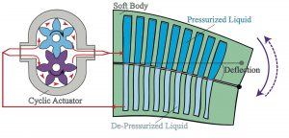
Figure 1: The internal structure of a robotic fish

Stiffness, Actuation Frequency and Locomotor Thrust

Esposito et al. (2012), on the other hand, focused on the study of stiffness and actuation of the soft robot fins. They have revealed a strong relationship between stiffness and thrust effectiveness. They work showcased a robotic fish inspired by a bluegill sunfish, with six fin rays being individually actuated. This also enables their fish to be able to swim in three dimensions. They have adjusted parameters such as fin-ray stiffness, flapping frequency, motion control programs studied from biological fish. They have applied sensors to measure forces to show that different values of stiffness produce different thrusts, while the intermediate stiffness produced the largest thrust. They have provided evidence that stiffness is a key variable that determines the locomotor performance.

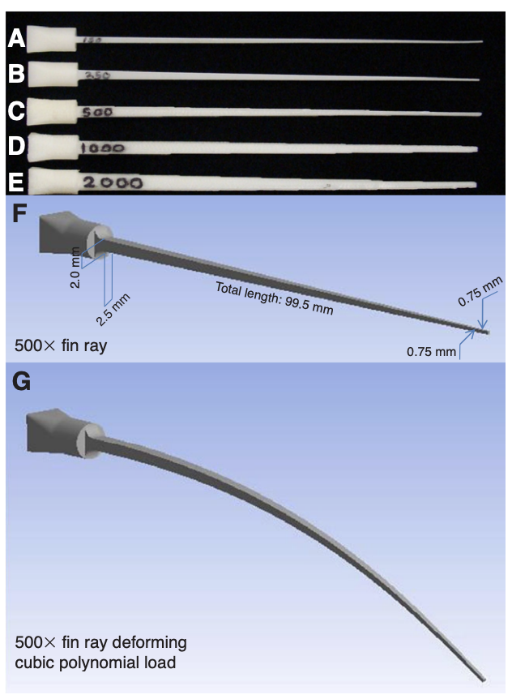

Adjustable Stiffness
In one of the recent papers by Zhong et al. (2021), the team has shown that swimming efficiency highly depends on stiffness of the material by applying tunable stiffness. The team has combined a biomechanical model of a tuna tail and a robotic setup where stiffness can be adjusted to study the relationship between swimming efficiency and tail stiffness. Their study shows that the tail stiffness, representing muscle tension in biological term, should be linearly scaled with the square of swimming speed. They have shown that swimming efficiency could be doubled by finding the ideal stiffness compared to a fixed-stiffness design given certain frequency and speed range. The purpose of the paper is to address the importance of adjust stiffness for different operation conditions.
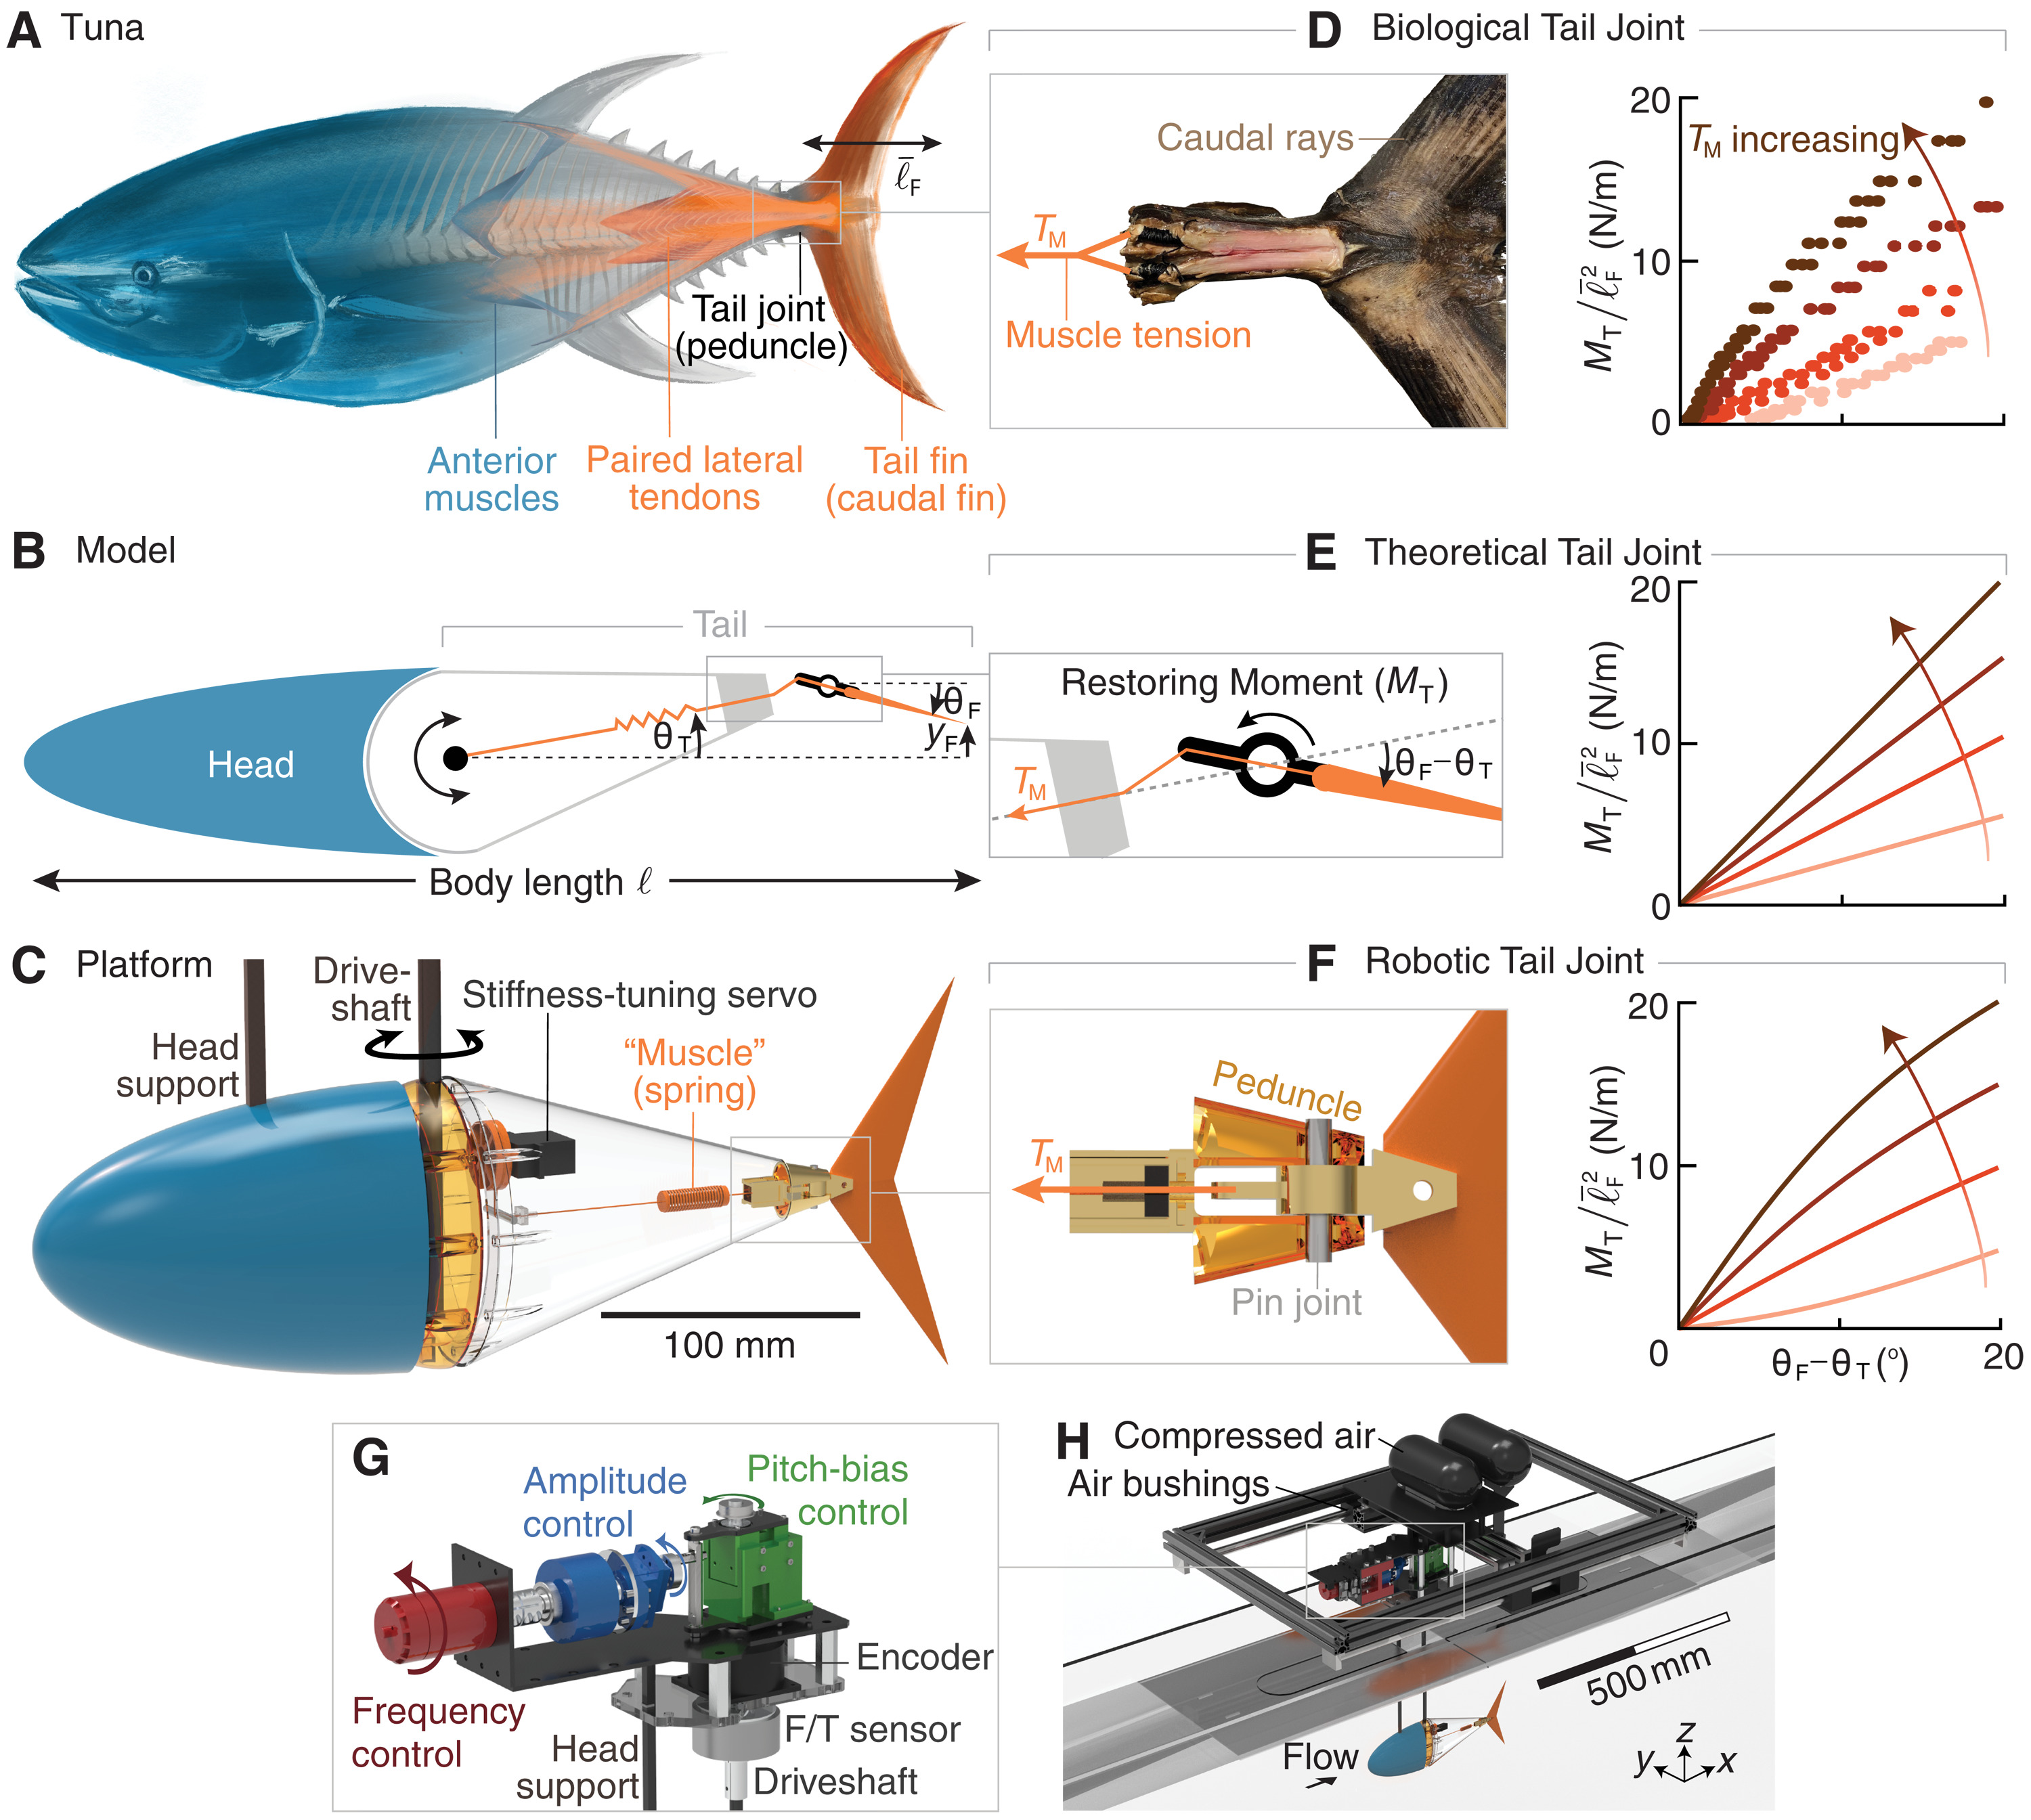

Multiphase Hydrodynamics on Various Platforms
Lauder’s team has developed various fish-like robotics and conducted hydrodynamic experiments. They have utilized multiphase hydrodynamics, plastic foils and fish bodies actuated at the leading edge to reproduce the undulatory swimming. Force sensors and flow visualization are also used to determine thrust and efficiency. With all these individual models, the team was able to conduct independent control of different parameters including body length, stiffness, etc. to determine how different deformation, fin shape influence the propulsive force. However, the coupling of a deformable structure and realistic hydrodynamics makes the whole simulation computationally expensive very quickly.

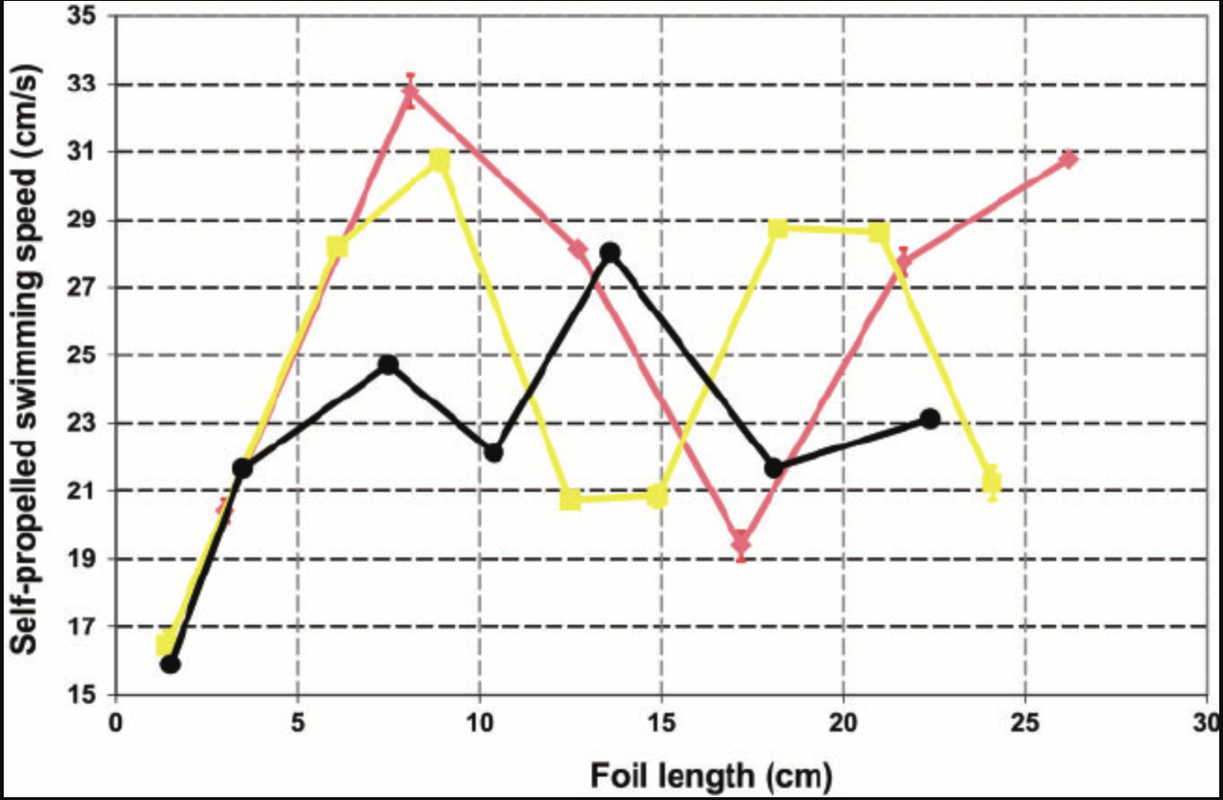

The Optimal Strouhal Number
Eloy (2012) has studied the Strouhal Number for swimming animals. The Strouhal Number is defined as St = f A/U, where f is the tail actuating frequency, A is the oscillation amplitude, and U is the swimming speed of the fish. With Lighthill’s elongated-body theory, the team has calculated how the optimal Strouhal number for propulsive efficiency depends on the size, and other kinematic parameters by studying over 53 different aquatic species. They have discovered the optimal range of the number for most species they studied to be around 0.2-0.4. The purpose of the study is to provide an interpretation of the swimming efficiency of the natural species, which is a Strouhal number within 0.2-0.4.

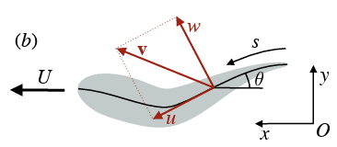

These prior works have implemented complex analysis/ modeling of the soft fin behaviors. They have utilized different sophisticated frameworks such as fluid-structure interaction, computational fluid mechanics, etc. They demonstrate different designs such as tunable stiffness, optimal stiffness distribution and actuation frequency, etc. are essential to swimming efficiency. However, most such studies require heavy computation for multiple experimental platforms or coupled fluid-structure simulations involving Finite Element Analysis and Computational Fluid Dynamics. Considering the scope of this course, this project will model the soft robotic fish an Euler-Bernoulli beam discretized into a node-spring network actuated by curvature as a function of time along the body other than explicit loads. This simplified framework will isolate key parameters such as stiffness, actuation amplitude, and frequency and study how they affect the pattern and bending deformation of the fish.

Propose Approach
This project models the soft robotic fish as a classic Euler-Bernoulli beam with bending stiffness. Actuation will be represented by a time-varying curvature instead of a distributed load. These replicates bending like an actual fish. Like the previous homework, the beam will be modeled as a discretized spring-node network. The integration would be implicit Euler method. To isolate and study how key parameters such as stiffness, actuation amplitude and frequency affect the pattern and bending deformation of the fish, different values of each parameter would be used to simulate the motion.

Expected Contribution
The goal of this project is to provide a straightforward, lightweight model of a soft robotic fish. Key parameters such as stiffness and actuation variables would be studied to reproduce the motion. With contents from M263F, this project will focus on using Euler-Bernoulli, implicit Euler and analysis of bending and stretching energy instead of full fluid computation requirement.

Implementation

Overview
A 2D robotic fish swimming simulation is implemented using Euler-Bernoulli Beam simulation with time-varying actuation to generate fish-like motion. This fish is modeled as an elastic beam with spring-node networks consisting of 11 nodes undergoing deformation in a viscous fluid environment.

Geometry
Rod length: L = 0.1m

Number of nodes nv = 11

Discrete segment length: deltaL = 0.01m

Cross-sectional radius r_0 = 1mm

Node radii R = deltaL/10 = 1mm

Middle node radius R_mid = 25mm

Material Properties
Young’s Modulus: Y = 1Gpa

Bending Stiffness EI. = 7.85*10e-7N/m^2

Axial Stiffness EA = 3.14*10^3N

Metal density rho_metal = 7000kg/m^3

Fluid Property
Fluid density rho_fluid = 1000kg/m^3

Fluid viscosity mu = 5000 Pas

Curvature Control
Swimming of the robotic fish is modeled as a time-varying of the natural curvature. The wave pattern is described as the function below:

where
- s is the arc length coordinate along the fish body
- t is time
- A is the amplitude of the motion
- r is the smooth ramp-up function
- f is the tail-beat frequency
- k is the spatial wavenumber

The amplitude increases from head to tail as the envelope below:

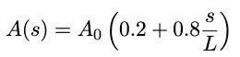,
which mimics the biological fish where the tail has larger motion than the head.

Main Algorithm

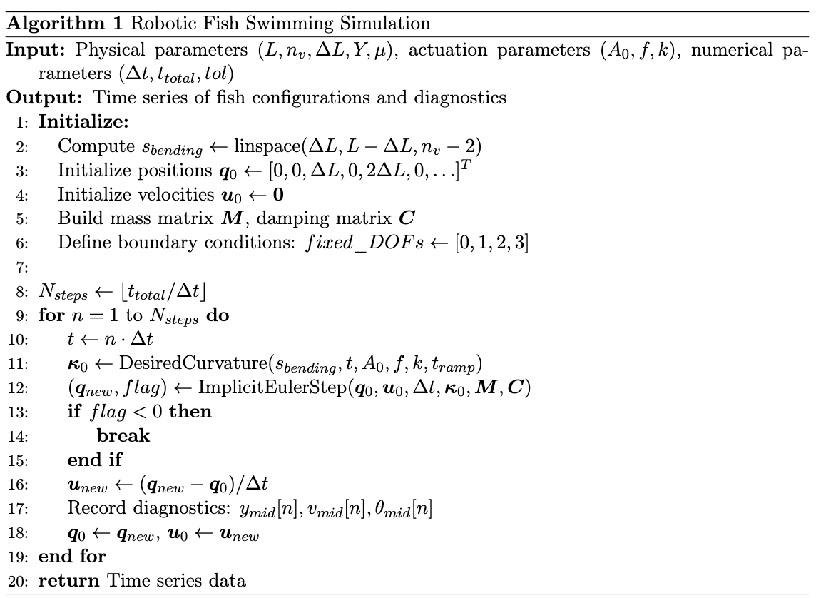

Results and Findings
At this stage, the simulation demonstrates swimming motion characteristic of the robotic fish. Major observations include that

- the traveling wave of curvature travels successfully from head to tail.

- The amplitude increases as the wave travels down the tail.

References
- Eloy, C. (2012). Optimal Strouhal number for swimming animals. Journal of Theoretical Biology, 324, 41–49.
- Esposito, C. J., Tangorra, J. L., Flammang, B. E., & Lauder, G. V. (2012). A robotic fish caudal fin: Effects of stiffness and kinematics on locomotor performance. Journal of Experimental Biology, 215(1), 56–67.
- Katzschmann, R. K., DelPreto, J., MacCurdy, R., & Rus, D. (2018). Exploration of underwater life with an acoustically controlled soft robotic fish. Science Robotics, 3(16), eaar3449.
- Lauder, G. V., Madden, P. G., Mittal, R., Jones, E. A., & Baker, T. V. (2012). Fish-inspired robotics: Multi-phase hydrodynamics. Integrative and Comparative Biology, 52(6), 891–896.
- Zhong, J., Wang, T., Li, G., & Zhu, J. (2021). Tunable stiffness swimming robots. Science Robotics, 6(54), eabd2971.
[6]https://www.researchgate.net/publication/228082613_Passive_Robotic_Models_of_Propulsion_by_the_Bodies_and_Caudal_Fins_of_Fish

[7] https://journals.biologists.com/jeb/article/215/1/56/10790/A-robotic-fish-caudal-fin-effects-of-stiffness-and

