e) The equivalence between (G) and (M) is contingent upon the accuracy of the quadrature. The effect of numerical quadrature is discussed in Hughes's book p.191.

Run the code with the element of degree 3 (i.e. cubic element). Experiment the code with 1,2,3,4,5,6 quadrature points, respectively. Report your observations and make comments.

In the problem definition part, the chosen function f is sin(x).

The element is cubic(element of degree 3), the polyshape function is shown below and attached in the submitted code.

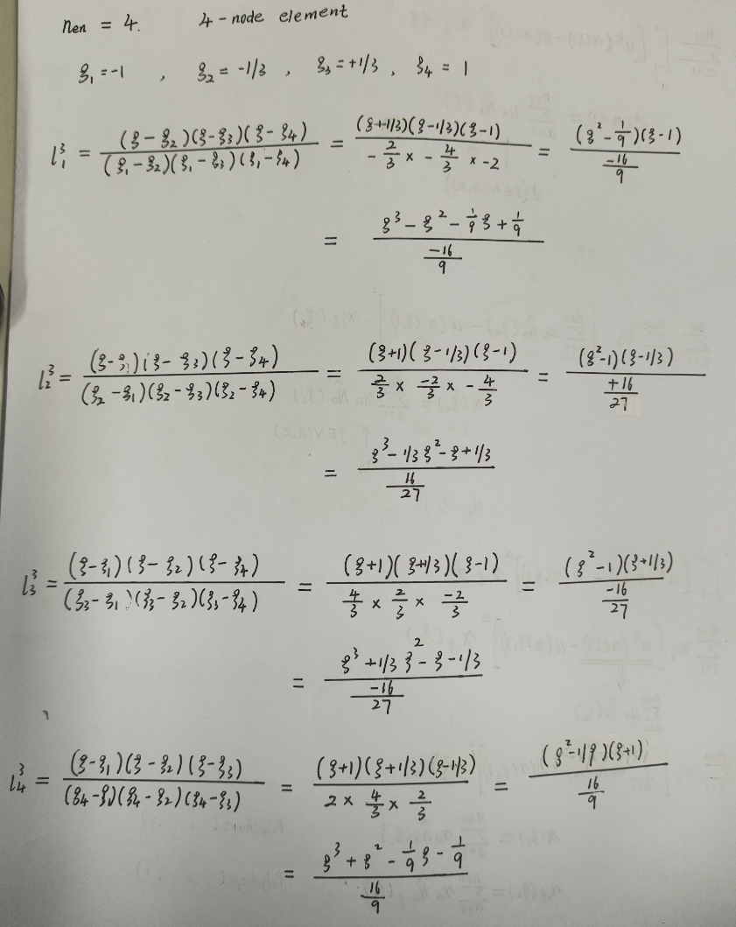

PolyShape Function in this Case

Solving the problem of Kd=F with different numbers of quadrature points,

the solutions (d = [uh; g])are listed as follows:

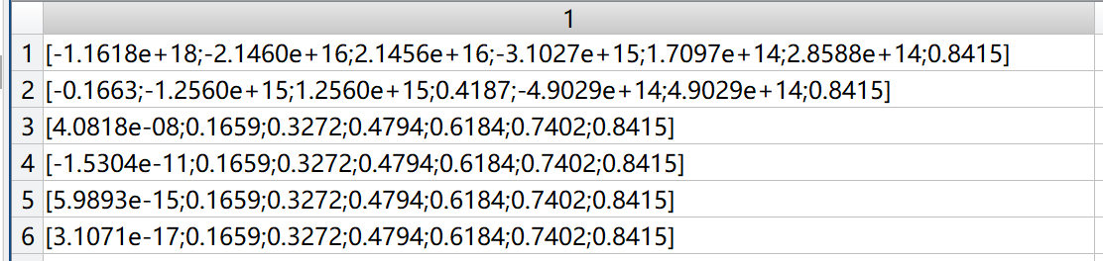

The six rows correspond to the cases with 1 to 6 quadrature points.

The first two rows correspond to the 1 and 2 quadrature points cases, which result in one warning that “警告: 矩阵接近奇异值，或者缩放错误。结果可能不准确”.

The following is the reason for this phenomenon.

We solve the matrix problem using the Matlab code in the element view.

Gaussian quadrature is needed to calculate the integral.

For the element stiffness:

Similarly:

The -point Gaussian quadrature can integrate polynominals with degrees up to

The degrees of and are 3 and 2.

The degree of is same to , which is 2. ( is a mapping from to x)

Note that:

So the degree of is 2, which can be obtained through **2 quadrature points**.

We choose f to be sin(x), and the degree of is 5, which can be obtained through **3 quadrature points**.

In conclusion, we need at least 3quadrature points to integrate the above two polynominals, which can explain the warning that occurs in the case with only 1 and 2 quadrature points.

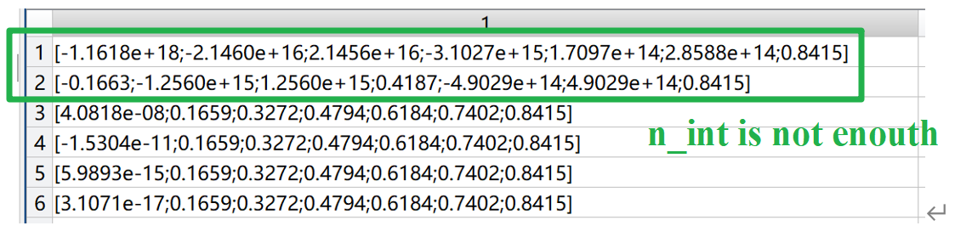

Solutions with different number of quadrature points

With increasing the number of quadrature points, the values of the results are nearly the same with very small tolerances, increasing accuracy.