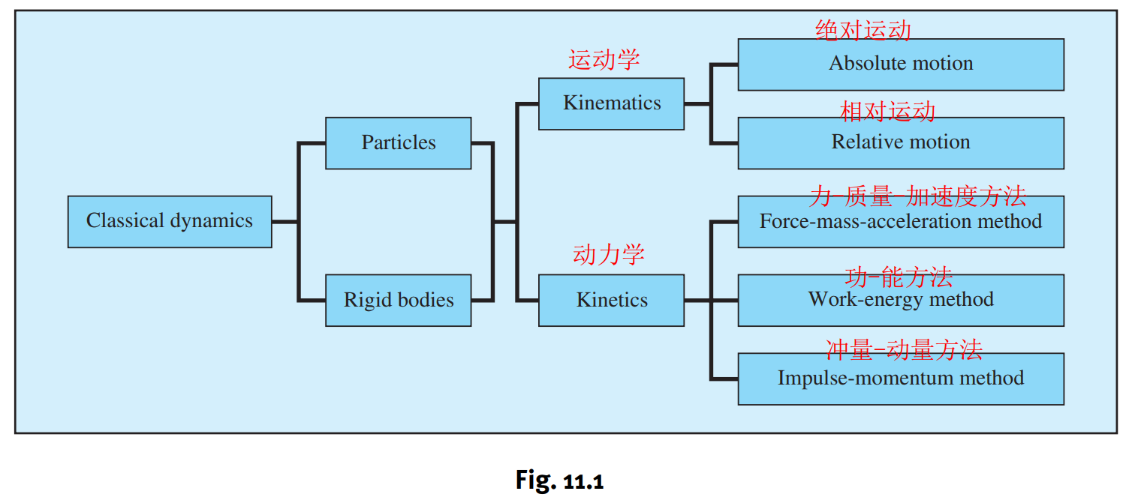

**Kinematics运动学**

|  |  |  |  |  |
| --- | --- | --- | --- | --- |
|  | **Single particle单个质点** | **System of particles质点系** | **Single rigid body单个刚体** | **System of rigid bodies多刚体系统** |
| **Kinematics运动学** | Ch11. Vector calculus矢量微积分:    Ch12. Kinematics in rectangular coordinates直角坐标系的运动学:    Rectilinear motion (直线运动):      Ch13.1-ch13.3曲线坐标系中的运动学  Kinematics in normal-tangential coordinates法向-切向坐标系中的运动学:      Kinematics of motion along a circular path    Kinematics in polar and cylindrical coordinates | Motion of the mass center of a particle system      下面的图是给左边一列的单个质点的实例（借用这一column的空白空间）  固定路劲的曲线坐标系：    极坐标下运动学的应用： | Plane angular motion of a rigid body    Rotation about a fixed axis, The velocity and acceleration components of a point in a body are: |  |
| **Relative motion相对运动** |  | Ch 15.2 Relative motion between two particles  these formula are for the translating reference frame 相对一个平动参考系的运动 | **1Relative motion**, Points A and B are in the same rigid body. The relative velocity and acceleration are:    上面这些公式中的定义相对运动的参考系是平动还是转动？  16.10    Instant center瞬心法:  16.13 | 1相对一个转动参考系的运动    (16.42) |
| **Special problems:**  **Rolling without slipping特殊问题：纯滚动** |  |  | Rolling without slipping, The velocity and acceleration of the center of a disk are: |  |
| **Equations of constraint约束方程** |  |  |  |  |

**Kinetics动力学**

|  |  |  |  |  |
| --- | --- | --- | --- | --- |
|  | **Single particle单个质点** | **System of particles质点系** | **Single rigid body单个刚体** | **System of rigid bodies多刚体系统** |
| **Newton’s equation** |  | Equation of motion of the mass center    Force-momentum relationships |  |  |
| **Angular momentum** | 14.45 | (15.33) | A is arbitrary (17.5)  Angular momentum of a rigid body in plane motion    刚体上的空间的固定点  空间的固定点  If for the instant center, then for the fixed point in the body  d = moment arm of the momentum vector mv¯ about A |  |
| **Euler’s equation** | A is an arbitrary point，A可以是任意点  （14.49）  A为固定点时：  (14.50) | moment-angular momentum relationship  A is an arbitrary point (15.34)任意点  (A: fixed point or mass center) | （17.10）A is arbitrary  Plane motion:      注意：上面的公式中，A不仅仅是固定点，还得是刚体上的点 | 3D motion, A is arbitrary:    Plane motion, A is arbitrary:    If A is a fixed point: |
| **Work-energy method功能方法** | Work and potential energy of conservative forces保守力的功和势能 | Principle of work and kinetic energy | Work of a couple (plane motion) The work of the couple C is  (constant *C*)  Kinetic energy of a rigid body in plane motion  (A is the fixed point in the body, or the instant center)  Principle of work and kinetic energy |  |
| **Conservation of mechanical energy机械能守恒** | Conservation of mechanical energy: | Conservation of mechanical energy | Conservation of mechanical energy | Conservation of mechanical energy |
| **Linear Impulse-momentum method线冲量-动量定理** | Impulse and momentum | Impulse-momentum equations |  |  |
| **线动量守恒** |  |  |  |  |
| **Angular impulse-momentum principle角动量-冲量定理** | Angular impulse and angular momentum    (14.51) | Impulse-momentum equations    (A: fixed point or mass center) |  | 多刚体系统，要选固定点，质心不是好的选择，why? |
| **角动量守恒** | Conservation of angular momentum | Conservation of angular momentum  (A: fixed point or mass center) | Conservation of angular momentum  (A: fixed point or mass center) | Conservation of angular momentum  (A: fixed point or mass center) |

**分析力学初步**

|  |  |  |
| --- | --- | --- |
|  | **定义和公式** | **实例** |
| **Equations of constraint约束方程** | 15.3: Kinematics of Constrained Motion  16.10: Method of Constraints  10.1: Introduction  10.2: Virtual Displacements  10.3: Virtual Work  10.4: Method of Virtual Work |  |
| **Principle of virtual work (or displacement) 虚功(虚位移)原理** | 适用于多刚体系统    “If a system of rigid bodies is in equilibrium, then the virtual work of all forces acting on the system is zero for all kinematically admissible virtual displacements of the system from the equilibrium position.”  “如果一个多刚体系统处于平衡状态，则所有力在满足运动约束条件下的所有的可能虚位移上的虚功之和为零” |  |
| **（参考资料，不在考试范围）**  **虚功原理推广到动力学情形：达朗贝尔原理**  **（注：中文的哈工大理论力学教材中的达朗贝尔原理指的是动静法）** | 下面的截图来自于Goldstein et al的classical mechanics书 |  |