Solution for HW1

**S1.1**

Since the velocity distribution is not linear, the velocity gradient varies with y.

$$u=12y^{1/4}$$

$$\frac{du}{dy}=3y^{-3/4}$$

The velocity gradient is smallest when y=16mm. Thus,

$$τ_{min}=μ\frac{du}{dy}=\left(0.5×{10}^{-3}N∙s /m^{2}\right)\left(3×{16}^{-\frac{3}{4}}s^{-1}\right)=1.875×{10}^{-4}Pa$$

Note: When y=0, $\frac{du}{dy}→0,$ so $τ→∞$. Hence the equation can not be used at this point.

**S1.2**

Water is a Newtonian fluid.

Applying Newton’s law of viscosity

$${τ_{A}}_{y=0}=0.02875π N/m^{2}$$

$${τ_{B}}_{y=0.1}=0.188 N/m^{2}$$

Here, the area per unit length of plate is A=3m. Thus,

$$F=\left(τ_{A}+τ_{B}\right)A=\left(0.02875π+0.188\right)×3=0.835N/m$$

**S1.3**

$$T=2.402×{10}^{-6} N∙m$$

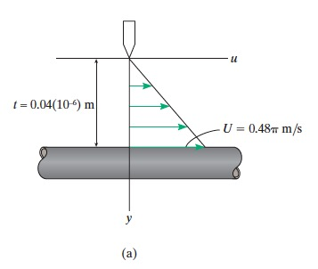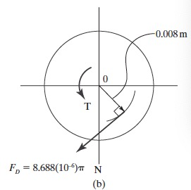

**S1.4**

Writing the force equation of equilibrium along the vertical by referring to the FBD of the droplet in Fig. a

$$σ=0.158 N/m$$

