Solution for HW3

**S3.1**

As indicated in Fig. a, the velocity V of a particle on the streamline is always directed along the tangent of the streamline. Therefore,

$$\frac{dy}{dx}=tanθ$$

$$\frac{dy}{dx}=\frac{v}{u}=\frac{6y}{3x}$$

$$\int{\frac{dy}{2y}}=\int{\frac{dx}{x}}$$

$$\frac{1}{2}\ln{y=\ln{x+C}}$$

At $x=3ft, y=1ft$. Then

$$\frac{1}{2}\ln{y=\ln{x-\ln{3}}}$$

$$\frac{1}{2}\ln{y=\ln{\frac{x}{3}}}$$

$$y=\frac{x^{2}}{9}$$

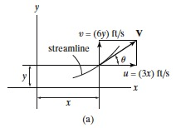

**S3.2**

For two dimensional flow, the Eulerian description gives

$$a=\frac{∂V}{∂t}+u\frac{∂V}{∂x}+v\frac{∂V}{∂y}$$

When $t=1s, x=1 ft$ and $y=2 ft$ then

$$a_{x}=13ft/s^{2}$$

$$a_{y}=28ft/s^{2}$$

Thus, the magnitude of the acceleration is

$$a=\sqrt{a_{x}^{2}+a_{y}^{2}}=30.9 ft/s^{2}$$

**S3.3**

$$Q=\frac{wU_{max}h}{2}$$

Therefore,

$$V=\frac{Q}{A}=\frac{U_{max}}{2}$$

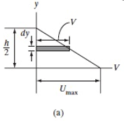

**S3.4**

The control volume is fixed since it contains the air in the tunnel. Since the flow is steady, no local changes take place. Also, the density of air is constant (incompressible) and the average velocities will be used.

Thus,

$$V_{c}=20.4m/s$$