Solution for HW4

**S4.1**

We consider steady flow of an ideal fluid.

Take the control volume as the plate and a portion of water striking it.

**Continuity Equation.**

$$V_{B}=22.22 m/s$$

**Relative Velocity.**

Relative to the control volume, the velocity at B is $\underset{→}{+}{(V_{f/cs})}_{B}=V_{f}-V_{cs}= 22.22 m/s - (-2 m/s)= 24.22 m/s$

Thus, the relative flow onto the plate is

$$Q_{f/cs}={(V_{f/cs})}_{C}A_{B}=24,22×π×{0.0075}^{2}=0.004280 m^{3}/s$$

**Linear Momentum.**

Referring to the free-body diagram of the control volume in Fig. a,

$$F=104 N$$

**S4.2**

$$F_{x}=1.21 kN$$

$$F_{y}=697 kN$$

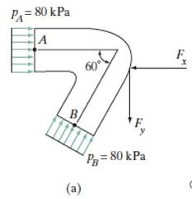

**S4.3**

The maximum force developed in the tie rope occurs when the velocity $V$ ofthe flow is maximum. This happens when the flow achieves the maximum range, ie, $S_{x}= 10 m$. Consider the vertical motion by referring to Fig. a.

$$V_{A}=15.66 m/s$$

$$T=2.31 kN$$

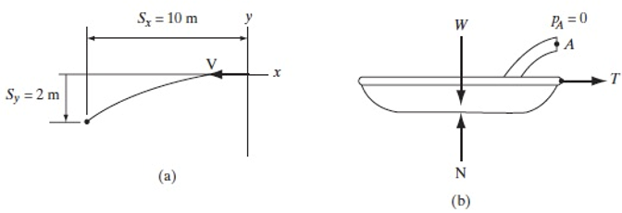

**S4.4**

The flow is steady and the water can be considered as an ideal fluid (incompressible and inviscid). Hence Average velocities are used and $P_{w}=1000 kg/m^{3}$. The control volume contains the water in the pipe and the tank and it is fixed instantaneously, Fig. a.

Equilibrium of the FBD of the tank, Fig. b, requires

$$+↑ \sum{F_{y}}=0$$

Thus, the compression of the spring is

$$F_{sp}=kx$$

$$x=0.1169m$$

