Solution for HW2

**S2.1**

The imaginary surface of milk in the accelerated tank is shown in Fig. a.

$$∆P_{AB}=4.12kPa$$

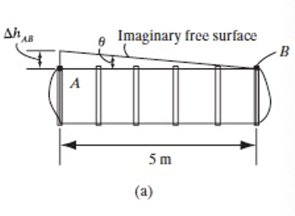

**S2.2**

When the tank accelerates, the water spill from the left side wall. The surface of the water under this condition is shown in Fig. a.

$$tanθ=\frac{1}{2.5}=\frac{a_{c}}{9.81}$$

$$a_{c}=3.92m/s^{2}$$

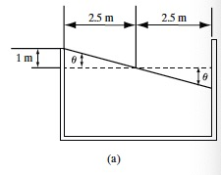

**S2.3**

From Fig. a, we observe that

$$h^{'}=0.1+\frac{H}{2}=0.132m$$

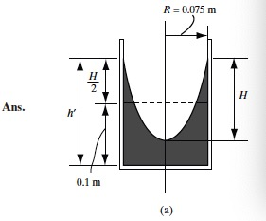

**S2.4**

The horizontal component of the resultant force is equal to the pressure force acting on the vertically projected area of the gate. Referring to Fig. a.

$$F_{h}=49.994kN$$

The vertical component of the resultant force is equal to the weight of the imaginarycolumn of water above the gate (shown shaded in Fig.a) but acts upward.

$$F_{v}=19.825kN$$

The magnitude of the resultant force is

$$F_{R}=\sqrt{F_{h}^{2}+F_{v}^{2}}=\sqrt{{49.994}^{2}+{19.825}^{2}}=53.8kN$$

Referring to the FBD of the gate shown in fig d,

$$T=42.29kN∙m$$

Also the $F_{R}$ acts toward the point O, so it doesn’t provide torque

$$T=42.29kN∙m$$

