Solution for HW6

**S6.1**

$$f=2ω$$

Thus,

$$f=2（ω_{x}i+ω_{y}j+ω_{z}k）=3xy^{2}k$$

Since $f$ is not zero everywhere the flow is not irrotational.

**S6.2**

$$u=\frac{∂ψ}{∂y}=\frac{∂ϕ}{∂x}$$

Similarly,

$$v=-\frac{∂ψ}{∂x}$$

To satisfy both equation

$$ψ=axy+C$$

For a given a, the streamline pattern is obtained by setting $ψ$ equal to various constant. For $ψ=0$ the x and y axes are streamlines and for other values of $ψ$ the streamline are rectangular hyperbolas as shown in Fig.

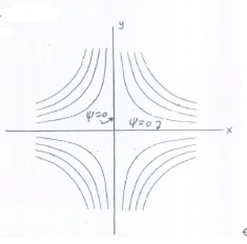

**S6.3**

**Fluid Description.** Since the velocity is not a function of time, the flow is steady. The fluid is an ideal fluid.

**Volumetric Dilatation.**

$$\frac{∂u}{∂x}+\frac{∂v}{∂y}+\frac{∂w}{∂z}=0$$

**Rotation.** The angular velocity of the fluid element at B is defined by Equation.

$$ω_{z}=\frac{1}{2}\left(\frac{∂v}{∂x}-\frac{∂u}{∂y}\right)=0$$

Therefore, the fluid element will not rotate about the z axis. Actually, the above two results apply at all points in the fluid, since they are independent of x and y. In other words, an ideal fluid is incompressible and produces irrotational flow.

**Pressure.** Since the flow is irrotational and steady, we can apply the Bernoulli equation at two points not located on the same streamline.

$$\frac{P_{A}}{ρg}+\frac{{V_{A}}^{2}}{2g}+y_{A}=\frac{P_{B}}{ρg}+\frac{{V_{B}}^{2}}{2g}+y_{B}$$

$$P_{B}=173 kPa$$