Network Assignment Report

Executive Summary

This comprehensive report details a secure, and scalable network infrastructure for a multi-site
Enterprise (HQ Singapore, Jakarta/Tokyo branches, DMZ/Intranet) using VLSM IP design,
OSPF routing with MD5 authentication, IPSec VPNs, AAA/RADIUS central auth, NTP sync,
port-security, and granular firewall ACLs - with the achievement of CIA triad compliance with
minimal IP address wastage and defence-in-depth. All requirements function seamlessly via
the Cisco Packet Tracer Simulation, verified by DNS resolution to accounting.qwerty.com
across sites.

VLSM was used over FLSM to allocate variable subnet sizes matching host needs and
minimizing any waste of Ip address (e.g /28 for 14 hosts in HQ LAN vs /25 for larger Jakarta
LAN). Private IP addresses all range in the class C in order to enable efficient carving; public
/29 for WAN links support 6 hosts each (2 used for point-to-point). Sequential numbering aids
management; masks chosen as smallest power-of-2 exceeding required hosts +2
(network/broadcast addresses).

Security Implementation Highlights:

Central Auth/Time: Usage of RADIUS + NTP on all routers; SSH-only through vty 0 1, no Telnet/Con/Aux.

Routing: OSPF Area 0 MD5 with a tuned hello/dead intervals for faster convergence and trust.

Encryption: IPSec site-to-site Tokyo-Jakarta (AES/SHA-HMAC, ACL 111 HTTPS to Jakarta Server, usage of vpnkey)

Access Control: Switch port-security and Firewall inbound ACLs for NTP, RADIUS, DNS, HTTP, HTTPS services for respective networks
Inspection: Stateful HTTP/ICMP deep checks; DNS records enable secure resolution

Usage of NAT for translation between Ip addresses in the site of connection to the internet (HQ
Router)

Key Benefits & Verification
Includes Least-privilege blocks spoofing/DoS (no use of any ip any any), IPSec protects sensitive HTTPS over WAN. Verification of browser access to accounting.qwerty.com from branches/HQ; usage of OSPF neighbours full.

Network IP addressing and FLSM/VLSM Design

Device | Interface | IP Address | Subnet Mask | Default Gateway
HQ_Firewall  H | Gig1/4 | 192.168.1.1/28 | 255.255.255.240 | NA
 | Gig1/3 | 192.168.2.1/29 | 255.255.255.248 | NA
 | Gig1/2 | 192.168.3.1/27 | 255.255.255.224 | NA
 | Gig1/1 | 209.165.200.225/29 | 255.255.255.248 | NA
Singapore (HQ) Router | FA0/0 | 209.165.200.226/29 | 255.255.255.248 | NA
 | Se0/0/0 | 192.168.4.1/30 | 255.255.255.252 | NA
 | Se0/0/1 | 192.168.5.1/30 | 255.255.255.252 | NA
 | Se0/1/0 | 209.165.200.2 | 255.255.255.248 | NA
Server-PT www.qwerty.com | Fa0 | 192.168.2.2/29 | 255.255.255.248 | 192.168.2.1
Server-PT dns.qwerty.com | Fa0 | 192.168.2.3/29 | 255.255.255.248 | 192.168.2.1
PC-PT HQ_Intranet_User | Fa0 | 192.168.3.2/27 | 255.255.255.224 | 192.168.3.1
Server-PT  NTP Server | Fa0 | 192.168.1.2/28 | 255.255.255.240 | 192.168.1.1
Server-PT  Accounting.qwerty.com | Fa0 | 192.168.1.3/28 | 255.255.255.240 | 192.168.1.1
Server-PT  RADIUS Server | Fa0 | 192.168.1.4/28 | 255.255.255.240 | 192.168.1.1
Jakarta (Branch) | Se0/0/0 | 192.168.4.2/30 | 255.255.255.252 | NA
 | Fa0/0 | 192.168.6.1/25 | 255.255.255.128 | NA
 | Fa0/1 | 192.168.6.129/25 | 255.255.255.128 | NA
Server-PT Jakarta.qwerty.com | Fa0 | 192.168.6.130/25 | 255.255.255.128 | 192.168.6.129
Laptop-PT Jakarta Laptop | Fa0 | 192.168.6.2/25 | 255.255.255.128 | 192.168.6.1
Tokyo (Branch) | Se0/0/1 | 192.168.5.2/30 | 255.255.255.252 | NA
 | Fa0/1 | 192.168.7.1/29 | 255.255.255.248 | NA
Laptop-PT Tokyo Laptop | Fa0 | 192.168.7.2/29 | 255.255.255.248 | 192.168.7.1
SP Router | Se0/1/0 | 209.165.200.1 | 255.255.255.248 | NA
 | Fa0/1 | 209.165.200.236 | 255.255.255.248 | NA
Server-PT www.internet.com | Fa0/2 | 209.165.200.234 | 255.255.255.248 | 209.165.200.236
Laptop-PT Internet User | Fa0/24 | 209.165.200.235 | 255.255.255.248 | 209.165.200.236

All Devices:
Enable password : 242100Q_enable
Service password-encryption: Enabled
Shutdown all unused ports
All routers, switches, firewalls are named to the requirements of 242100Q_device(location)

For Tokyo Router,

NTP Time-Synchronize and password encryption
NTP Time-Synchronization

ntp authentication-key 1 md5 SITNetSec
ntp authenticate
ntp trusted-key 1
ntp server 192.168.1.2
ntp update-calendar

Servicing of Password-Encryption

service password-encryption

- Configured to prevent any spoofing, tampering and Man-in-the-Middle (MitM) attacks.
- Ensures Accurate time, critical for security compliance and using authentication key for trusted NTP sources

AAA through Radius server
Configuration of Radius server and AAA

Enable
Config t
Username Tokyo_Admin privilege 15 secret 242100Q
Ip domain-name cisco.com
Aaa new-model
Radius-server host 192.168.1.4 auth-port 1645
Radius-server key 242100Q
aaa authentication login default group radius local
crypto key generate rsa
1024

SSH connection and disable other connection (Aux, Con, Tel)
line vty 0 1
transport input ssh
login authentication default
line vty 2 15
transport input none
line con 0
exec-timeout 0 0
line aux 0
exec-timeout 0 0
exit

AAA used for centralization of authentication across routers(HQ, Jakarta, Tokyo); Ensuring:
- Verification of user identities and determines authorized configuration of network services
- Configuration of SSH connection only through vty 0 1 to limit and prevent any unauthorized connection through other protocols (e.g telnet, auxiliary, console)

OSPF Routing and Hello and Dead intervals
Router ospf 1
area 0 authentication message-digest
network 192.168.5.0 0.0.0.3 area 0
network 192.168.7.0 0.0.0.7 area 0

interface serial 0/0/1
ip ospf message-digest-key 1 md5 242100Q_md5
ip ospf hello-interval 10
ip ospf dead-interval 15

interface fa0/1
ip ospf message-digest-key 1 md5 242100Q_md5
ip ospf hello-interval 10
ip ospf dead-interval 15

OSPF MD5 authentication using key (242100Q_md5) and configuring hello and dead intervals
of 10 and 15 respectively to:
- Authentication Type 2 to ensure secure OSPF routing exchanges and only trusted routers can participate in the network
- Similar dead and hello intervals for maintaining neighbour relationships and ensuring quick network convergence

IPSec site-to-site with Jakarta
Parameters | Tokyo | Jakarta
Transform Set Name | VPN-SET | VPN-SET
ESP Transform Encryption | esp-aes | esp-aes
ESP Transform Authentication | esp-sha-hmac | esp-sha-hmac
Peer IP Address | 192.168.4.2 | 192.168.5.2
Traffic to be Encrypted | access-list 111 (source 192.168.7.0 dest 192.168.6.0) | access-list 111 (source 192.168.6.0 dest 192.168.7.0)
Crypto Map Name | VPN-MAP | VPN-MAP
SA Establishment | ipsec-isakmp | ipsec-isakmp

With the diagram at the top for referencing the IPSec parameters used to configure IPSec direct connectivity between Tokyo and Jakarta.

Access list used to permit any HTTPS traffic sent by Tokyo subnet as interesting traffic

access-list 111 permit tcp 192.168.7.0 0.0.0.7 host 192.168.6.130 eq 443

Creation of ISAKMP Policy

crypto isakmp policy 10
encryption aes
hash sha
authentication pre-share
group 2
exit

Setting Pre-shared key

crypto isakmp key vpnkey address 192.168.4.2

Creation of Transform Set

crypto ipsec transform-set VPN-SET esp-aes esp-sha-hmac

Create and Map the Crypto Map

crypto map VPN-MAP 10 ipsec-isakmp
set peer 192.168.4.2
set transform-set VPN-SET
match address 111
exit

Applying Map to Interface facing connection

interface serial 0/0/1
crypto map VPN-MAP

The IPSec VPN Site-to-Site Implementation between Tokyo and Jakarta Router to encrypt
traffic going to the Jakarta Server over HTTPS only.
- This ensures that this connection is able to connect securely over the public internet without the internet users being able to connect to it over HTTPS.
- It also ensures that the HTTPS request is protected as sensitive data so that it will not be intercepted nor tampered during the transmission through cryptographic services.

Port Security on Switch 4
Configuring maximum of 3 MAC addresses connected to Switch
Enable
Config t
Interface range fa 0/1-2
Switchport port-security maximum 3
Exit

Shutdown all unused ports on switch

Interface range fa 0/3-24
Shutdown

Interface range gig 0/1-2
Shutdown

Interface vlan 1
Shutdown

Configuration of switch to ensure:
- Maximum number of MAC addresses (end devices) to connect to the switch are limited to three
- Unused ports /interfaces are shutdown to prevent any unauthorized connection to the network

For Jakarta Router

NTP Time-Synchronize and password encryption
NTP Time-Synchronization

ntp authentication-key 1 md5 SITNetSec
ntp authenticate
ntp trusted-key 1
ntp server 192.168.1.2
ntp update-calendar

Servicing of Password-Encryption

service password-encryption

- Configured to prevent any spoofing, tampering and Man-in-the-Middle (MitM) attacks.
- Ensures Accurate time, critical for security compliance and using authentication key for trusted NTP sources

AAA through Radius Server

Configuration of Radius server and AAA

Enable
Config t
Username Jakarta_Admin privilege 15 secret 242100Q
Ip domain-name cisco.com
Aaa new-model
Radius-server host 192.168.1.4 auth-port 1645
Radius-server key 242100Q
aaa authentication login default group radius local
crypto key generate rsa
1024

SSH connection and disable other connection (Aux, Con, Tel)
line vty 0 1
transport input ssh
login authentication default
line vty 2 15
transport input none
line con 0
exec-timeout 0 0
line aux 0
exec-timeout 0 0
exit

AAA used for centralization of authentication across routers(HQ, Jakarta, Tokyo); Ensuring:
- Verification of user identities and determines authorized configuration of network services
- Configuration of SSH connection only through vty 0 1 to limit and prevent any unauthorized connection through other protocols (e.g telnet, auxiliary, console)

OSPF Routing and Hello and Dead Intervals
Router ospf 1
area 0 authentication message-digest
network 192.168.4.0 0.0.0.3 area 0
network 192.168.6.0 0.0.0.127 area 0
network 192.168.6.128 0.0.0.127 area 0

interface serial 0/0/0
ip ospf message-digest-key 1 md5 242100Q_md5
ip ospf hello-interval 10
ip ospf dead-interval 15

interface fa0/0
ip ospf message-digest-key 1 md5 242100Q_md5
ip ospf hello-interval 10
ip ospf dead-interval 15

interface fa0/1
ip ospf message-digest-key 1 md5 242100Q_md5
ip ospf hello-interval 10
ip ospf dead-interval 15

OSPF MD5 authentication using key (242100Q_md5) and configuring hello and dead intervals
of 10 and 15 respectively to:
- Authentication Type 2 to ensure secure OSPF routing exchanges and only trusted routers can participate in the network
- Similar dead and hello intervals for maintaining neighbour relationships and ensuring quick network convergence

IPSec site-to-site with Tokyo
Mirror ACL from reverse destination (Tokyo)

access-list 111 permit tcp host 192.168.6.130 eq 443 192.168.7.0 0.0.0.7

Phase 1 Policy (Must match Tokyo)
crypto isakmp policy 10
encryption aes
hash sha
authentication pre-share
group 2
exit

Set the Pre-Shared Key
crypto isakmp key vpnkey address 192.168.5.2

Define Phase 2 (Transform Set)
crypto ipsec transform-set VPN-SET esp-aes esp-sha-hmac

Create Crypto Map
crypto map VPN-MAP 10 ipsec-isakmp
set peer 192.168.5.2
set transform-set VPN-SET
match address 111
exit

Apply to the Outgoing Interface (facing the other IPSec implementation)
interface Serial 0/0/0
crypto map VPN-MAP

The IPSec VPN Site-to-Site Implementation between Tokyo and Jakarta Router to encrypt
traffic going to the Jakarta Server over HTTPS only.
- This ensures that this connection is able to connect securely over the public internet without the internet users being able to connect to it over HTTPS.
- It also ensures that the HTTPS request is protected as sensitive data so that it will not be intercepted nor tampered during the transmission through cryptographic services.

Port Security on Switch 3
Configuring maximum of 2 MAC addresses connected to Switch
Enable
Config t
Interface range fa 0/1-2
Switchport port-security maximum 2
Exit

Shutdown all unused ports on switch

Interface range fa 0/3-24
Shutdown

Interface range gig 0/1-2
Shutdown

Interface vlan 1
Shutdown

Configuration of switch to ensure:
- Maximum number of MAC addresses (end devices) to connect to the switch are limited to two
- Unused ports /interfaces are shutdown to prevent any unauthorized connection to the network

HQ @Singapore Router

NTP Time-Synchronize and password encryption
NTP Time-Synchronization

ntp authentication-key 1 md5 SITNetSec
ntp authenticate
ntp trusted-key 1
ntp server 192.168.1.2
ntp update-calendar

Servicing of Password-Encryption

service password-encryption

- Configured to prevent any spoofing, tampering and Man-in-the-Middle (MitM) attacks.
- Ensures Accurate time, critical for security compliance and using authentication key for trusted NTP sources

AAA through Radius Server

Configuration of Radius server and AAA

Enable
Config t
Username HQ_Admin privilege 15 secret 242100Q
Ip domain-name cisco.com
Aaa new-model
Radius-server host 192.168.1.4 auth-port 1645
Radius-server key 242100Q
aaa authentication login default group radius local
crypto key generate rsa
1024

SSH connection and disable other connection (Aux, Con, Tel)
line vty 0 1
transport input ssh
login authentication default
line vty 2 15
transport input none
line con 0
exec-timeout 0 0
line aux 0
exec-timeout 0 0
exit

AAA used for centralization of authentication across routers(HQ, Jakarta, Tokyo); Ensuring:
- Verification of user identities and determines authorized configuration of network services
- Configuration of SSH connection only through vty 0 1 to limit and prevent any unauthorized connection through other protocols (e.g telnet, auxiliary, console)

OSPF Routing, Default routing and Hello and Dead Intervals
ip route 0.0.0.0 0.0.0.0 Serial0/1/0

Router ospf 1
area 0 authentication message-digest
network 192.168.4.0 0.0.0.3 area 0
network 192.168.5.0 0.0.0.3 area 0
network 209.165.200.224 0.0.0.7 area 0
default-information originate

interface s 0/0/0
ip ospf message-digest-key 1 md5 242100Q_md5
ip ospf hello-interval 10
ip ospf dead-interval 15

interface s0/0/1
ip ospf message-digest-key 1 md5 242100Q_md5
ip ospf hello-interval 10
ip ospf dead-interval 15

interface fa0/0
ip ospf message-digest-key 1 md5 242100Q_md5
ip ospf hello-interval 10
ip ospf dead-interval 15

OSPF MD5 authentication using key (242100Q_md5) and configuring hello and dead intervals
of 10 and 15 respectively to:
- Authentication Type 2 to ensure secure OSPF routing exchanges and only trusted routers can participate in the network
- Similar dead and hello intervals for maintaining neighbour relationships and ensuring quick network convergence
Static Routing towards the Internet Subnet to ensure:
- Saving CPU and bandwidth
- Specifying the gateway to ensure the internet connection only through this link for all networks

NAT Configuration
Ip access-list standard INSIDE-LOCAL
permit 192.168.3.0 0.0.0.31

ip nat inside source static tcp 192.168.2.2 80 209.165.200.2 80
ip nat inside source static tcp 192.168.2.2 443 209.165.200.2 443
ip nat inside source static udp 192.168.2.3 53 209.165.200.2 53
ip nat inside source list INSIDE-LOCAL interface Serial0/1/0 overload
int fa 0/0
ip nat inside

int s0/1/0
ip nat outside

exit

Used to configure static NAT to allow consistent access to the specific subnet servers (DMZ)
Through the translation of public subnetting in the same VLSM for better security and better access.

Used NAT overload to allow inside connection (Intranet user) to the outside server (Internet.com) for private IP translation to public IP translation.

For ISP Router

Routing

Default routing to the internet subnet
Enable
Config t
ip route 0.0.0.0 0.0.0.0 FastEthernet0/1

Configuration of a static routing:
- To ensure that a gateway to the internet subnet through the router is created and the only path to the network with no restrictions

For Firewall

OSPF Routing and hello and dead interval
Router ospf 1
area 0 authentication message-digest
network 209.165.200.224 255.255.255.248 area 0
network 192.168.1.0 255.255.255.240 area 0
network 192.168.2.0 255.255.255.248 area 0
network 192.168.3.0 255.255.255.224 area 0

interface gig 1/1
ospf message-digest-key 1 md5 242100Q_md5
ospf hello-interval 10
ospf dead-interval 15
OSPF MD5 authentication using key (242100Q_md5) and configuring hello and dead intervals
of 10 and 15 respectively to:
- Authentication Type 2 to ensure secure OSPF routing exchanges and only trusted routers can participate in the network
- Similar dead and hello intervals for maintaining neighbour relationships and ensuring quick network convergence

ACLs Implemented on firewall
Enable
Config t

Tokyo ACLs

NTP Service
Access-list ALL-IN Permit udp 192.168.5.0 255.255.255.252 host 192.168.1.2 eq 123

AAA Service
Access-list ALL-IN Permit udp 192.168.5.0 255.255.255.252 host 192.168.1.4 eq 1645
Access-list ALL-IN Permit udp 192.168.5.0 255.255.255.252 host 192.168.1.4 eq 1646

DNS, HTTPS, and HTTP Service
Access-list ALL-IN Permit udp 192.168.7.0 255.255.255.248 any eq 53
Access-list ALL-IN Permit tcp 192.168.7.0 255.255.255.248 any eq 443
Access-list ALL-IN Permit tcp 192.168.7.0 255.255.255.248 any eq 80

Jakarta ACLs

NTP Service
Access-list ALL-IN Permit udp 192.168.4.0 255.255.255.252 host 192.168.1.2 eq 123

AAA Service
Access-list ALL-IN Permit udp 192.168.4.0 255.255.255.252 host 192.168.1.4 eq 1645
Access-list ALL-IN Permit udp 192.168.4.0 255.255.255.252 host 192.168.1.4 eq 1646

DNS, HTTPS, HTTP Service for Jakarta Subnet
Access-list ALL-IN Permit udp 192.168.6.0 255.255.255.128 any eq 53
Access-list ALL-IN Permit tcp 192.168.6.0 255.255.255.128 any eq 443
Access-list ALL-IN Permit tcp 192.168.6.0 255.255.255.128 any eq 80

DNS, HTTPS Service for Intranet Subnet
Access-list ALL-IN Permit udp 192.168.6.128 255.255.255.128 any eq 53
access-list ALL-IN extended permit tcp host 192.168.6.130 eq 443 192.168.3.0
255.255.255.224

HQ@Singapore ACLs

NTP Service
access-list ALL-IN extended permit udp 209.165.200.224 255.255.255.248 host 192.168.1.2
eq 123

AAA Service
access-list ALL-IN extended permit udp 209.165.200.224 255.255.255.248 host 192.168.1.4
eq 1645
access-list ALL-IN extended permit udp 209.165.200.224 255.255.255.248 host 192.168.1.4
eq 1646

Internet ACLs

Permit Access to only HTTP, DNS, HTTPS to DMZ Area(Web server, DNS server) only
access-list ALL-IN extended permit udp 209.165.200.232 255.255.255.248 192.168.2.0
255.255.255.248 eq domain
access-list ALL-IN extended permit tcp 209.165.200.232 255.255.255.248 192.168.2.0
255.255.255.248 eq www
access-list ALL-IN extended permit tcp 209.165.200.232 255.255.255.248 192.168.2.0
255.255.255.248 eq 443

Permit HTTPS back into Intranet Users
access-list ALL-IN extended permit tcp host 192.168.6.130 eq 443 192.168.3.0
255.255.255.224

Apply ACLs on interface outside to allow one way in and out methods
Access-group ALL-IN in interface outside

All on one ACLs to permit through one interface only instead of multiple to prevent over complication of activity

Additional Security Implementations to Firewall
Provide Firewall ability to inspect http and https pings made by server

Enable
Config t
Class inspection-default
Inspect http
Inspect icmp

- Inspection of HTTP/HTTPS and ICMP packets to ensure deep packet checks and allow permission for HTTP and HTTPS

DMZ Subnet

Verification access to HTTP and HTTPS of web access
Ensure end-devices (PC, Laptops) have a DNS server gateway (192.168.2.3).

In the DNS server (192.168.2.3), ensure to add account.qwerty.com (192.168.1.3) as “record
A” to the DNS records in the server services. To allow NAT public address to access DMZ web server, the public address added in as well for access.
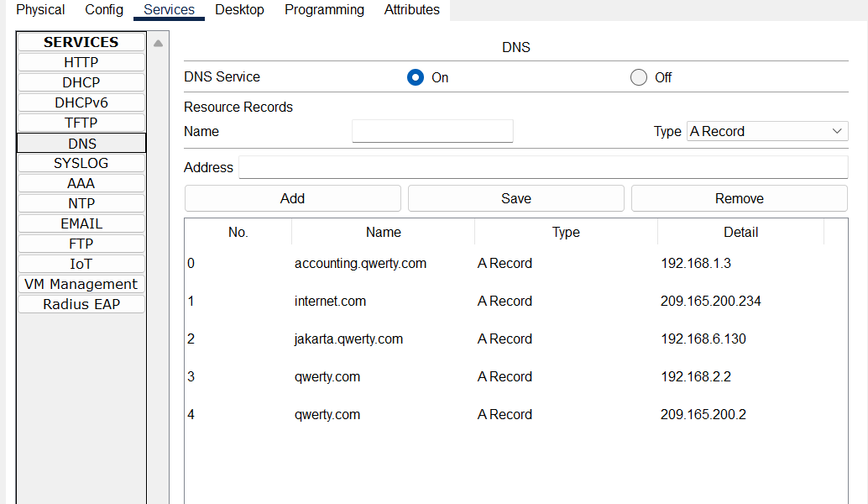

To verify results, go to any end device in the any subnet (Tokyo, Jakarta, Intranet)and enter the
web browser in desktop tab “accounting.qwerty.com” and the following page should show up.
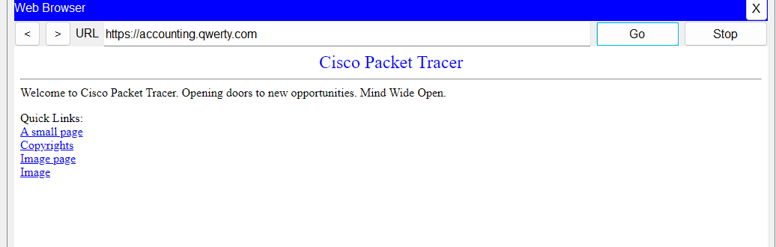

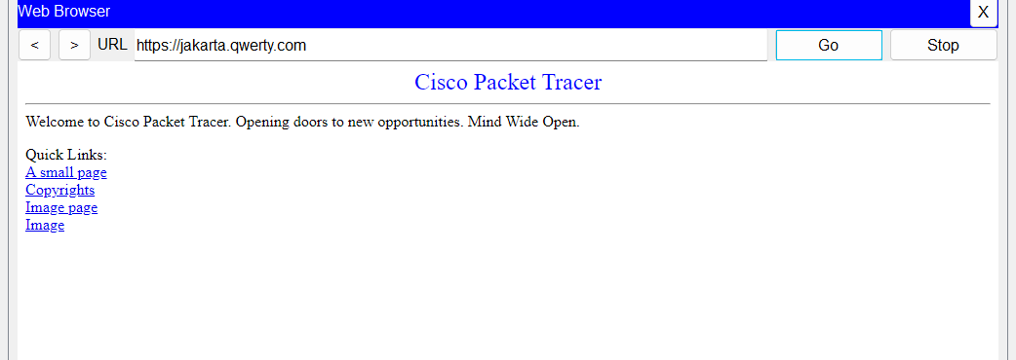

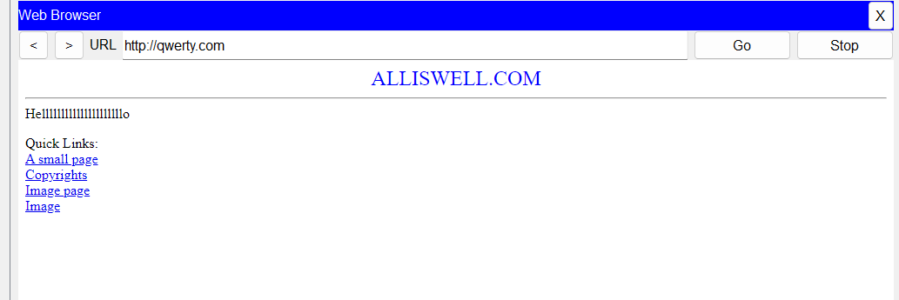

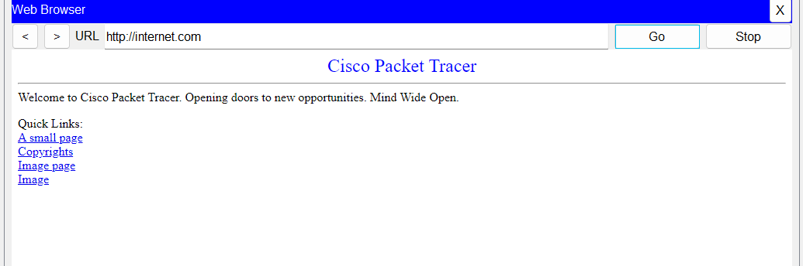

Server Farm

Radius Server
On the Radius Server services of AAA, ensuring to put in all client information (router
information) and the user set-up of “Radius_Admin” with password as “242100Q”.
- Enable authentication of routers using the AAA through Radius_Server
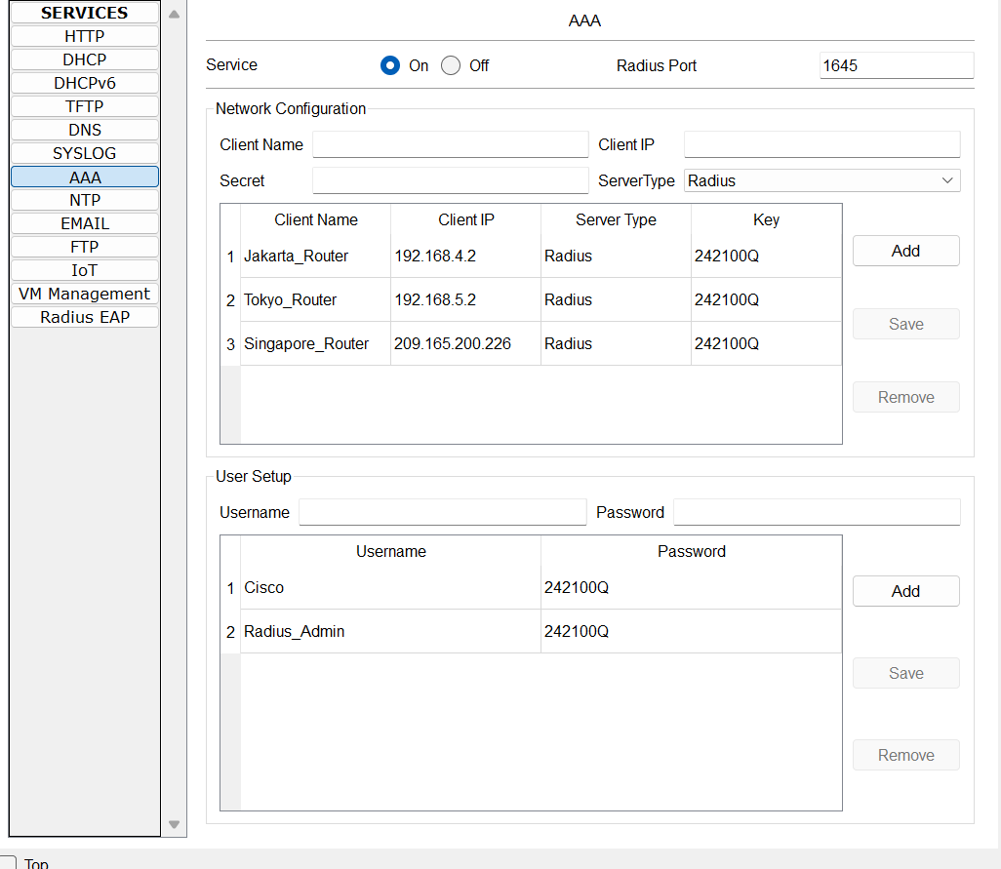

NTP Server
On the NTP Server on the services of NTP, ensure to “On” NTP and Enable Authentication
and enter in the respective values (Key = 1, Password = SITNetSec) to ensure that routers with
the authentication key 1 with password of SITNetSec can be authenticated over the NTP
service.

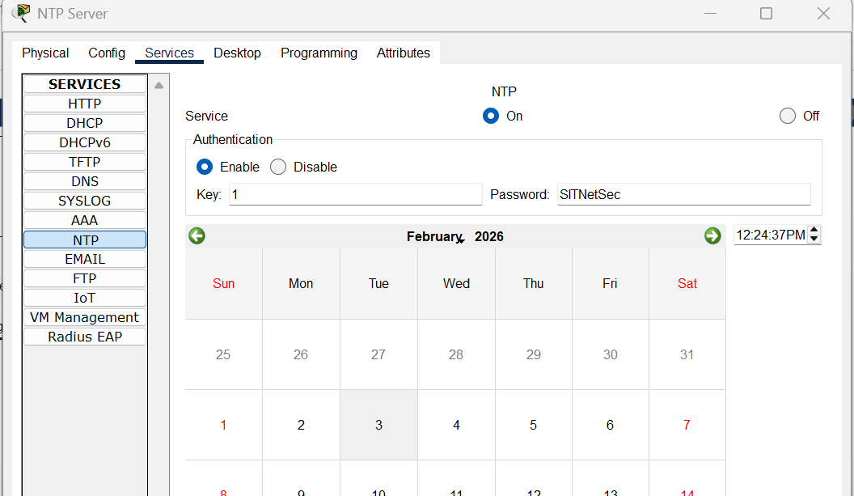

Assumptions
Jakarta Subnetting shares with the HQ subnet users, hence /25 to accommodate for the HQ
users + Jakarta users.

Simulated environment: NAT already configured for the translation of private to public
addressing

Annex

Tokyo Router
Current configuration : 2106 bytes
!
version 12.4
no service timestamps log datetime msec
no service timestamps debug datetime msec
service password-encryption
!
hostname 242100Q_Tokyo
!
!
!
enable secret 5 $1$mERr$7QVi9O/SygRnlYHzfjQbC.
!
!
!
!
!
aaa new-model
!
aaa authentication login default group radius local
!
!
!
!
!
!
!
ip cef
no ipv6 cef
!
!
!
username Tokyo_Admin privilege 15 secret 5 $1$mERr$qIuQAvEBEHQIpDl3eqvYs.
!
!
crypto isakmp policy 10
encr aes 256
authentication pre-share
group 2
!
crypto isakmp key 242100Q address 192.168.4.2
!
!
!
crypto ipsec transform-set VPN-SET esp-aes esp-sha-hmac
!
crypto map VPN-MAP 10 ipsec-isakmp
set peer 192.168.4.2
set transform-set VPN-SET
match address 111
!
!
!
!
ip domain-name cisco.com
!
!
spanning-tree mode pvst
!
!
!
!
!
!
interface FastEthernet0/0
no ip address
duplex auto
speed auto
shutdown
!
interface FastEthernet0/1
ip address 192.168.7.1 255.255.255.248
ip ospf message-digest-key 1 md5 242100Q_md5
duplex auto
speed auto
!
interface Serial0/0/0
no ip address
clock rate 2000000
shutdown
!
interface Serial0/0/1
ip address 192.168.5.2 255.255.255.252
ip ospf message-digest-key 1 md5 242100Q_md5
ip ospf dead-interval 15
clock rate 2000000
crypto map VPN-MAP
!
interface Serial0/1/0
no ip address
clock rate 2000000
shutdown
!
interface Serial0/1/1
no ip address
clock rate 2000000
shutdown
!
interface Vlan1
no ip address
shutdown
!
router ospf 1
log-adjacency-changes
area 0 authentication message-digest
network 192.168.5.0 0.0.0.3 area 0
network 192.168.7.0 0.0.0.7 area 0
!
ip classless
!
ip flow-export version 9
!
!
access-list 111 permit tcp 192.168.7.0 0.0.0.7 host 192.168.6.130 eq 443
!
no cdp run
!
!
radius-server host 192.168.1.4 auth-port 1645
radius-server key 242100Q
!
!
!
!
line con 0
exec-timeout 0 0
!
line aux 0
exec-timeout 0 0
!
line vty 0 1
login authentication default
transport input ssh
line vty 2 4
transport input none
line vty 5 15
transport input none
!
!
ntp authentication-key 1 md5 0812657A271C11241708 7
ntp authenticate
ntp trusted-key 1
ntp server 192.168.1.2
ntp update-calendar
!
end

Jakarta Router
Current configuration : 2172 bytes
!
version 12.4
no service timestamps log datetime msec
no service timestamps debug datetime msec
service password-encryption
!
hostname 242100Q_Jakarta
!
!
!
enable secret 5 $1$mERr$7QVi9O/SygRnlYHzfjQbC.
!
!
!
!
!
aaa new-model
!
aaa authentication login default group radius local
!
!
!
!
!
!
!
no ip cef
no ipv6 cef
!
!
!
username Jakarta_Admin privilege 15 secret 5 $1$mERr$qIuQAvEBEHQIpDl3eqvYs.
!
!
crypto isakmp policy 10
encr aes 256
authentication pre-share
group 2
!
crypto isakmp key 242100Q address 192.168.5.2
!
!
!
crypto ipsec transform-set VPN-SET esp-aes esp-sha-hmac
!
crypto map VPN-MAP 10 ipsec-isakmp
set peer 192.168.5.2
set transform-set VPN-SET
match address 111
!
!
!
!
ip domain-name cisco.com
!
!
spanning-tree mode pvst
!
!
!
!
!
!
interface FastEthernet0/0
ip address 192.168.6.1 255.255.255.128
duplex auto
speed auto
!
interface FastEthernet0/1
ip address 192.168.6.129 255.255.255.128
ip ospf message-digest-key 1 md5 242100Q_md5
duplex auto
speed auto
!
interface Serial0/0/0
ip address 192.168.4.2 255.255.255.252
ip ospf message-digest-key 1 md5 242100Q_md5
ip ospf dead-interval 15
clock rate 2000000
crypto map VPN-MAP
!
interface Serial0/0/1
no ip address
clock rate 2000000
shutdown
!
interface Serial0/1/0
no ip address
clock rate 2000000
shutdown
!
interface Serial0/1/1
no ip address
clock rate 2000000
shutdown
!
interface Vlan1
no ip address
shutdown
!
router ospf 1
log-adjacency-changes
area 0 authentication message-digest
network 192.168.4.0 0.0.0.3 area 0
network 192.168.6.0 0.0.0.127 area 0
network 192.168.6.128 0.0.0.127 area 0
!
ip classless
!
ip flow-export version 9
!
!
access-list 111 permit tcp host 192.168.6.130 eq 443 192.168.7.0 0.0.0.7
!
no cdp run
!
!
radius-server host 192.168.1.4 auth-port 1645
radius-server key 242100Q
!
!
!
!
line con 0
exec-timeout 0 0
!
line aux 0
exec-timeout 0 0
!
line vty 0 1
login authentication default
transport input ssh
line vty 2 4
transport input none
line vty 5 15
transport input none
!
!
ntp authentication-key 1 md5 0812657A271C11241708 7
ntp authenticate
ntp trusted-key 1
ntp server 192.168.1.2
ntp update-calendar
!
end

HQ@Singapore Router
Current configuration : 2262 bytes
!
version 12.4
no service timestamps log datetime msec
no service timestamps debug datetime msec
service password-encryption
!
hostname 242100Q_HQ
!
!
!
enable secret 5 $1$mERr$7QVi9O/SygRnlYHzfjQbC.
!
!
!
!
!
aaa new-model
!
aaa authentication login default group radius local
!
!
!
!
!
!
!
ip cef
no ipv6 cef
!
!
!
username HQ_Admin privilege 15 secret 5 $1$mERr$qIuQAvEBEHQIpDl3eqvYs.
!
!
!
!
!
!
!
!
ip domain-name cisco.com
!
!
spanning-tree mode pvst
!
!
!
!
!
!
interface FastEthernet0/0
ip address 209.165.200.226 255.255.255.248
ip ospf message-digest-key 1 md5 242100Q_md5
ip nat inside
duplex auto
speed auto
!
interface FastEthernet0/1
no ip address
duplex auto
speed auto
shutdown
!
interface Serial0/0/0
ip address 192.168.4.1 255.255.255.252
ip ospf message-digest-key 1 md5 242100Q_md5
ip ospf dead-interval 15
!
interface Serial0/0/1
ip address 192.168.5.1 255.255.255.252
ip ospf message-digest-key 1 md5 242100Q_md5
ip ospf dead-interval 15
!
interface Serial0/1/0
ip address 209.165.200.2 255.255.255.248
ip nat outside
clock rate 2000000
!
interface Serial0/1/1
no ip address
clock rate 2000000
shutdown
!
interface Vlan1
no ip address
shutdown
!
router ospf 1
log-adjacency-changes
area 0 authentication message-digest
network 192.168.4.0 0.0.0.3 area 0
network 192.168.5.0 0.0.0.3 area 0
network 209.165.200.224 0.0.0.7 area 0
default-information originate
!
ip nat inside source list INSIDE-LOCAL interface Serial0/1/0 overload
ip nat inside source static tcp 192.168.2.2 80 209.165.200.2 80
ip nat inside source static tcp 192.168.2.2 443 209.165.200.2 443
ip nat inside source static udp 192.168.2.3 53 209.165.200.2 53
ip classless
ip route 0.0.0.0 0.0.0.0 Serial0/1/0
!
ip flow-export version 9
!
!
ip access-list standard INSIDE-LOCAL
permit 192.168.3.0 0.0.0.31
!
no cdp run
!
!
radius-server host 192.168.1.4 auth-port 1645
radius-server key 242100Q
!
!
!
!
line con 0
exec-timeout 0 0
!
line aux 0
exec-timeout 0 0
!
line vty 0 1
login authentication default
transport input ssh
line vty 2 4
transport input none
line vty 5 15
transport input none
!
!
ntp authentication-key 1 md5 0812657A271C11241708 7
ntp authenticate
ntp trusted-key 1
ntp server 192.168.1.2
ntp update-calendar
!
end

ISP Router
Current configuration : 1073 bytes
!
version 12.4
no service timestamps log datetime msec
no service timestamps debug datetime msec
service password-encryption
!
hostname 242100Q_ISP
!
!
!
enable password 7 0873181C584955262D0E0205282721
!
!
!
!
!
!
ip cef
no ipv6 cef
!
!
!
!
!
!
!
!
!
!
!
!
spanning-tree mode pvst
!
!
!
!
!
!
interface FastEthernet0/0
no ip address
duplex auto
speed auto
shutdown
!
interface FastEthernet0/1
ip address 209.165.200.236 255.255.255.248
duplex auto
speed auto
!
interface Serial0/0/0
no ip address
clock rate 2000000
shutdown
!
interface Serial0/0/1
no ip address
clock rate 2000000
shutdown
!
interface Serial0/1/0
ip address 209.165.200.1 255.255.255.248
!
interface Serial0/1/1
no ip address
clock rate 2000000
shutdown
!
interface Vlan1
no ip address
shutdown
!
router ospf 1
log-adjacency-changes
default-information originate
!
ip classless
ip route 0.0.0.0 0.0.0.0 FastEthernet0/1
!
ip flow-export version 9
!
!
!
no cdp run
!
!
!
!
!
!
line con 0
!
line aux 0
!
line vty 0 4
login
!
!
!
end

Firewall ASA 5506
ASA Version 9.6(1)
!
hostname 242100QFirewall
enable password lgwuysk3tYU3Risq encrypted
names
!
interface GigabitEthernet1/1
nameif outside
security-level 0
ip address 209.165.200.225 255.255.255.248
ospf message-digest-key 1 md5 *****
!
interface GigabitEthernet1/2
nameif INTRANET
security-level 100
ip address 192.168.3.1 255.255.255.224
!
interface GigabitEthernet1/3
nameif DMZ
security-level 70
ip address 192.168.2.1 255.255.255.248
!
interface GigabitEthernet1/4
nameif INTRANET_SERVER_FARM
security-level 100
ip address 192.168.1.1 255.255.255.240
!
interface GigabitEthernet1/5
no nameif
no security-level
no ip address
shutdown
!
interface GigabitEthernet1/6
no nameif
no security-level
no ip address
shutdown
!
interface GigabitEthernet1/7
no nameif
no security-level
no ip address
shutdown
!
interface GigabitEthernet1/8
no nameif
no security-level
no ip address
shutdown
!
interface Management1/1
management-only
no nameif
no security-level
no ip address
shutdown
!
!
!
access-list ALL-IN extended permit udp 192.168.5.0 255.255.255.252 host 192.168.1.2 eq 123
access-list ALL-IN extended permit udp 192.168.5.0 255.255.255.252 host 192.168.1.4 eq 1645
access-list ALL-IN extended permit udp 192.168.5.0 255.255.255.252 host 192.168.1.4 eq 1646
access-list ALL-IN extended permit udp 192.168.7.0 255.255.255.248 any eq domain
access-list ALL-IN extended permit tcp 192.168.7.0 255.255.255.248 any eq 443
access-list ALL-IN extended permit tcp 192.168.7.0 255.255.255.248 any eq www
access-list ALL-IN extended permit udp 192.168.4.0 255.255.255.252 host 192.168.1.2 eq 123
access-list ALL-IN extended permit udp 192.168.4.0 255.255.255.252 host 192.168.1.4 eq 1645
access-list ALL-IN extended permit udp 192.168.4.0 255.255.255.252 host 192.168.1.4 eq 1646
access-list ALL-IN extended permit udp 192.168.6.0 255.255.255.128 any eq domain
access-list ALL-IN extended permit tcp 192.168.6.0 255.255.255.128 any eq 443
access-list ALL-IN extended permit tcp 192.168.6.0 255.255.255.128 any eq www
access-list ALL-IN extended permit udp 192.168.6.128 255.255.255.128 any eq domain
access-list ALL-IN extended permit udp 209.165.200.224 255.255.255.248 host 192.168.1.2 eq 123
access-list ALL-IN extended permit udp 209.165.200.224 255.255.255.248 host 192.168.1.4 eq 1645
access-list ALL-IN extended permit udp 209.165.200.224 255.255.255.248 host 192.168.1.4 eq 1646
access-list ALL-IN extended permit udp 209.165.200.232 255.255.255.248 192.168.2.0 255.255.255.248 eq domain
access-list ALL-IN extended permit tcp 209.165.200.232 255.255.255.248 192.168.2.0 255.255.255.248 eq www
access-list ALL-IN extended permit tcp 209.165.200.232 255.255.255.248 192.168.2.0 255.255.255.248 eq 443
access-list ALL-IN extended permit tcp host 192.168.6.130 eq 443 192.168.3.0 255.255.255.224
!
!
access-group ALL-IN in interface outside
!
!
class-map inspection_default
match default-inspection-traffic
class-map inspection-default
match default-inspection-traffic
!
policy-map type inspect dns preset_dns_map
parameters
message-length maximum 512
policy-map global_policy
class inspection_default
inspect dns preset_dns_map
inspect ftp
inspect tftp
class inspection-default
inspect http
inspect icmp
!
service-policy global_policy global
!
telnet timeout 5
ssh timeout 5
!
!
!
!
router ospf 1
log-adjacency-changes
area 0 authentication message-digest
network 209.165.200.224 255.255.255.248 area 0
network 192.168.1.0 255.255.255.240 area 0
network 192.168.2.0 255.255.255.248 area 0
network 192.168.3.0 255.255.255.224 area 0
!

DNS Server
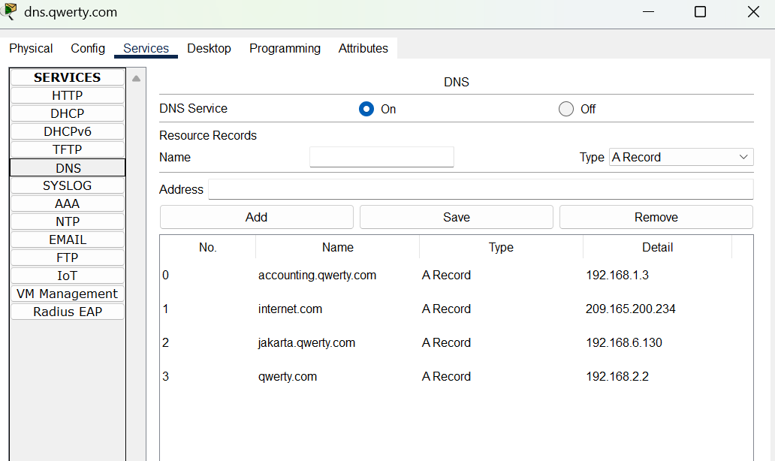

NTP Server
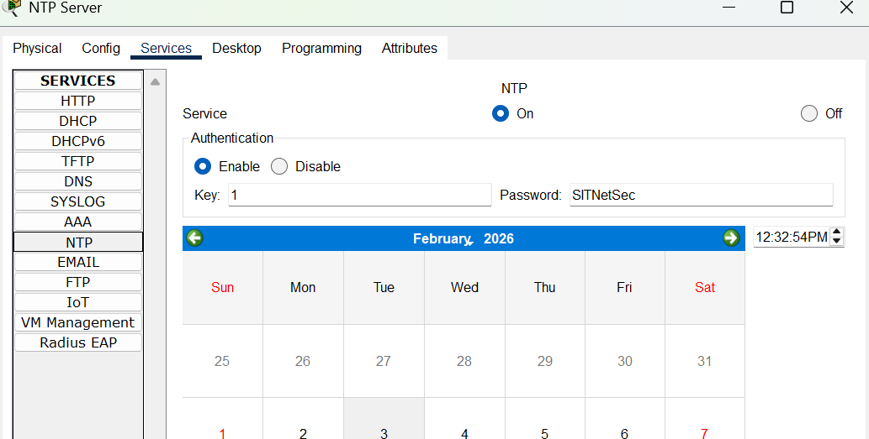

RADIUS Server
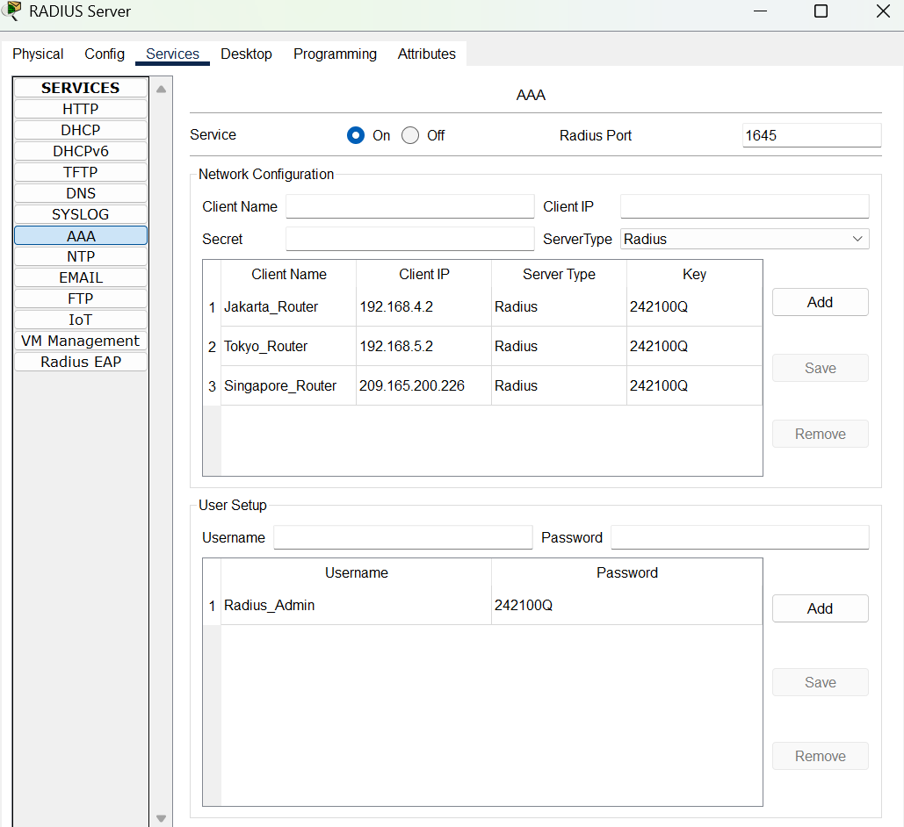

Switch 0
Current configuration : 1374 bytes
!
version 15.0
no service timestamps log datetime msec
no service timestamps debug datetime msec
service password-encryption
!
hostname 242100Q_InternetSwitch
!
enable password 7 0873181C584955262D0E0205282721
!
!
!
!
!
!
spanning-tree mode pvst
spanning-tree extend system-id
!
interface FastEthernet0/1
!
interface FastEthernet0/2
!
interface FastEthernet0/3
shutdown
!
interface FastEthernet0/4
shutdown
!
interface FastEthernet0/5
shutdown
!
interface FastEthernet0/6
shutdown
!
interface FastEthernet0/7
shutdown
!
interface FastEthernet0/8
shutdown
!
interface FastEthernet0/9
shutdown
!
interface FastEthernet0/10
shutdown
!
interface FastEthernet0/11
shutdown
!
interface FastEthernet0/12
shutdown
!
interface FastEthernet0/13
shutdown
!
interface FastEthernet0/14
shutdown
!
interface FastEthernet0/15
shutdown
!
interface FastEthernet0/16
shutdown
!
interface FastEthernet0/17
shutdown
!
interface FastEthernet0/18
shutdown
!
interface FastEthernet0/19
shutdown
!
interface FastEthernet0/20
shutdown
!
interface FastEthernet0/21
shutdown
!
interface FastEthernet0/22
shutdown
!
interface FastEthernet0/23
shutdown
!
interface FastEthernet0/24
!
interface GigabitEthernet0/1
shutdown
!
interface GigabitEthernet0/2
shutdown
!
interface Vlan1
no ip address
shutdown
!
!
!
!
line con 0
!
line vty 0 4
login
line vty 5 15
login
!
!
!
!
end

Switch 1 (Server Farm)
Current configuration : 1366 bytes
!
version 15.0
no service timestamps log datetime msec
no service timestamps debug datetime msec
service password-encryption
!
hostname 242100Q_ServerFarmSwitch
!
enable password 7 0873181C584955262D0E0205282721
!
!
!
!
!
!
spanning-tree mode pvst
spanning-tree extend system-id
!
interface FastEthernet0/1
!
interface FastEthernet0/2
!
interface FastEthernet0/3
!
interface FastEthernet0/4
!
interface FastEthernet0/5
shutdown
!
interface FastEthernet0/6
shutdown
!
interface FastEthernet0/7
shutdown
!
interface FastEthernet0/8
shutdown
!
interface FastEthernet0/9
shutdown
!
interface FastEthernet0/10
shutdown
!
interface FastEthernet0/11
shutdown
!
interface FastEthernet0/12
shutdown
!
interface FastEthernet0/13
shutdown
!
interface FastEthernet0/14
shutdown
!
interface FastEthernet0/15
shutdown
!
interface FastEthernet0/16
shutdown
!
interface FastEthernet0/17
shutdown
!
interface FastEthernet0/18
shutdown
!
interface FastEthernet0/19
shutdown
!
interface FastEthernet0/20
shutdown
!
interface FastEthernet0/21
shutdown
!
interface FastEthernet0/22
shutdown
!
interface FastEthernet0/23
shutdown
!
interface FastEthernet0/24
shutdown
!
interface GigabitEthernet0/1
shutdown
!
interface GigabitEthernet0/2
shutdown
!
interface Vlan1
no ip address
shutdown
!
!
!
!
line con 0
!
line vty 0 4
login
line vty 5 15
login
!
!
!
!
end

Switch 1 (DMZ)
Current configuration : 1369 bytes
!
version 15.0
no service timestamps log datetime msec
no service timestamps debug datetime msec
service password-encryption
!
hostname 242100Q_DMZSwitch
!
enable password 7 0873181C584955262D0E0205282721
!
!
!
!
!
!
spanning-tree mode pvst
spanning-tree extend system-id
!
interface FastEthernet0/1
!
interface FastEthernet0/2
!
interface FastEthernet0/3
!
interface FastEthernet0/4
shutdown
!
interface FastEthernet0/5
shutdown
!
interface FastEthernet0/6
shutdown
!
interface FastEthernet0/7
shutdown
!
interface FastEthernet0/8
shutdown
!
interface FastEthernet0/9
shutdown
!
interface FastEthernet0/10
shutdown
!
interface FastEthernet0/11
shutdown
!
interface FastEthernet0/12
shutdown
!
interface FastEthernet0/13
shutdown
!
interface FastEthernet0/14
shutdown
!
interface FastEthernet0/15
shutdown
!
interface FastEthernet0/16
shutdown
!
interface FastEthernet0/17
shutdown
!
interface FastEthernet0/18
shutdown
!
interface FastEthernet0/19
shutdown
!
interface FastEthernet0/20
shutdown
!
interface FastEthernet0/21
shutdown
!
interface FastEthernet0/22
shutdown
!
interface FastEthernet0/23
shutdown
!
interface FastEthernet0/24
shutdown
!
interface GigabitEthernet0/1
shutdown
!
interface GigabitEthernet0/2
shutdown
!
interface Vlan1
no ip address
shutdown
!
!
!
!
line con 0
!
line vty 0 4
login
line vty 5 15
login
!
!
!
!
end

Switch 2
Current configuration : 1384 bytes
!
version 15.0
no service timestamps log datetime msec
no service timestamps debug datetime msec
service password-encryption
!
hostname 242100Q_IntranetSwitch
!
enable password 7 0873181C584955262D0E0205282721
!
!
!
!
!
!
spanning-tree mode pvst
spanning-tree extend system-id
!
interface FastEthernet0/1
!
interface FastEthernet0/2
!
interface FastEthernet0/3
shutdown
!
interface FastEthernet0/4
shutdown
!
interface FastEthernet0/5
shutdown
!
interface FastEthernet0/6
shutdown
!
interface FastEthernet0/7
shutdown
!
interface FastEthernet0/8
shutdown
!
interface FastEthernet0/9
shutdown
!
interface FastEthernet0/10
shutdown
!
interface FastEthernet0/11
shutdown
!
interface FastEthernet0/12
shutdown
!
interface FastEthernet0/13
shutdown
!
interface FastEthernet0/14
shutdown
!
interface FastEthernet0/15
shutdown
!
interface FastEthernet0/16
shutdown
!
interface FastEthernet0/17
shutdown
!
interface FastEthernet0/18
shutdown
!
interface FastEthernet0/19
shutdown
!
interface FastEthernet0/20
shutdown
!
interface FastEthernet0/21
shutdown
!
interface FastEthernet0/22
shutdown
!
interface FastEthernet0/23
shutdown
!
interface FastEthernet0/24
shutdown
!
interface GigabitEthernet0/1
shutdown
!
interface GigabitEthernet0/2
shutdown
!
interface Vlan1
no ip address
shutdown
!
!
!
!
line con 0
!
line vty 0 4
login
line vty 5 15
login
!
!
!
!
end

Switch 3
Current configuration : 1455 bytes
!
version 15.0
no service timestamps log datetime msec
no service timestamps debug datetime msec
service password-encryption
!
hostname 242100Q_JakartaSwitch
!
enable password 7 0873181C584955262D0E0205282721
!
!
!
!
!
!
spanning-tree mode pvst
spanning-tree extend system-id
!
interface FastEthernet0/1
switchport port-security maximum 2
!
interface FastEthernet0/2
switchport port-security maximum 2
!
interface FastEthernet0/3
shutdown
!
interface FastEthernet0/4
shutdown
!
interface FastEthernet0/5
shutdown
!
interface FastEthernet0/6
shutdown
!
interface FastEthernet0/7
shutdown
!
interface FastEthernet0/8
shutdown
!
interface FastEthernet0/9
shutdown
!
interface FastEthernet0/10
shutdown
!
interface FastEthernet0/11
shutdown
!
interface FastEthernet0/12
shutdown
!
interface FastEthernet0/13
shutdown
!
interface FastEthernet0/14
shutdown
!
interface FastEthernet0/15
shutdown
!
interface FastEthernet0/16
shutdown
!
interface FastEthernet0/17
shutdown
!
interface FastEthernet0/18
shutdown
!
interface FastEthernet0/19
shutdown
!
interface FastEthernet0/20
shutdown
!
interface FastEthernet0/21
shutdown
!
interface FastEthernet0/22
shutdown
!
interface FastEthernet0/23
shutdown
!
interface FastEthernet0/24
shutdown
!
interface GigabitEthernet0/1
shutdown
!
interface GigabitEthernet0/2
shutdown
!
interface Vlan1
no ip address
shutdown
!
!
!
!
line con 0
!
line vty 0 4
login
line vty 5 15
login
!
!
!
!
end

Switch 4
Current configuration : 1453 bytes
!
version 15.0
no service timestamps log datetime msec
no service timestamps debug datetime msec
service password-encryption
!
hostname 242100Q_TokyoSwitch
!
enable password 7 0873181C584955262D0E0205282721
!
!
!
!
!
!
spanning-tree mode pvst
spanning-tree extend system-id
!
interface FastEthernet0/1
switchport port-security maximum 3
!
interface FastEthernet0/2
switchport port-security maximum 3
!
interface FastEthernet0/3
shutdown
!
interface FastEthernet0/4
shutdown
!
interface FastEthernet0/5
shutdown
!
interface FastEthernet0/6
shutdown
!
interface FastEthernet0/7
shutdown
!
interface FastEthernet0/8
shutdown
!
interface FastEthernet0/9
shutdown
!
interface FastEthernet0/10
shutdown
!
interface FastEthernet0/11
shutdown
!
interface FastEthernet0/12
shutdown
!
interface FastEthernet0/13
shutdown
!
interface FastEthernet0/14
shutdown
!
interface FastEthernet0/15
shutdown
!
interface FastEthernet0/16
shutdown
!
interface FastEthernet0/17
shutdown
!
interface FastEthernet0/18
shutdown
!
interface FastEthernet0/19
shutdown
!
interface FastEthernet0/20
shutdown
!
interface FastEthernet0/21
shutdown
!
interface FastEthernet0/22
shutdown
!
interface FastEthernet0/23
shutdown
!
interface FastEthernet0/24
shutdown
!
interface GigabitEthernet0/1
shutdown
!
interface GigabitEthernet0/2
shutdown
!
interface Vlan1
no ip address
shutdown
!
!
!
!
line con 0
!
line vty 0 4
login
line vty 5 15
login
!
!
!
!
end

