通讯问题解决

Table of Contents

1. RAPID代码 2

1.1 最终代码 2

1.2放弃代码 3

2. 问题解决 6

2.1 配置 6

2.2不使用ASCII的报错 7

2.3使用ASCII但没有末尾数字的报错 8

2.4 字节数太高 11

3. 链接 11

1. RAPID代码

## 1.1 最终代码

MODULE Module1

    VAR socketdev server;   
    VAR socketdev client;   
    VAR string signalData;   
    VAR rawbytes data;   
    VAR robtarget currentPos;

    PROC main()   
        SocketCreate server;   
        SocketBind server, "127.0.0.1", 5000;   
        SocketListen server;   
        SocketAccept server, client;

        WHILE TRUE DO   
  
           currentPos := CRobT(\Tool:=MyNewTool);  
  
            SocketReceive client, \RawData:=data;   
            UnpackRawBytes data,1,signalData,\ASCII:=2;

            IF signalData = "X_MOVE,100,0,0" THEN   
                currentPos.trans.x := currentPos.trans.x + 10;  
            ELSEIF signalData = "X_MOVE,-100,0,0" THEN   
                currentPos.trans.x := currentPos.trans.x - 10;  
            ELSEIF signalData = "Y_MOVE,0,100,0" THEN   
                currentPos.trans.y := currentPos.trans.y + 10;  
            ELSEIF signalData = "Y_MOVE,0,-100,0" THEN   
                currentPos.trans.y := currentPos.trans.y - 10;  
            ELSEIF signalData = "Z_MOVE,0,0,100" THEN   
                currentPos.trans.z := currentPos.trans.z + 10;  
            ELSEIF signalData = "Z_MOVE,0,0,-100" THEN   
                currentPos.trans.z := currentPos.trans.z - 10;  
            ENDIF

            MoveL currentPos, v100, z10, tool0;  
        ENDWHILE

        SocketClose client;   
        SocketClose server;   
    ENDPROC   
ENDMODULE

## 1.2放弃代码

黄色部分一直报错，未能配置并debug成功

RAPID1:

MODULE Module1

!***********************************************************

!

! Module: Module1

!

! Description:

! <Insert description here>

!

! Author: Jiajun Guo

!

! Version: 1.0

!

!***********************************************************

!***********************************************************

!

! Procedure main

!

! This is the entry point of your program

!

!***********************************************************

!PROC main()

!Add your code here

!ENDPROC

!VAR socketdev MySocket;

!VAR string signalData;

!MODULE GestureControl

VAR iodev MySocket;

VAR robtarget pStart := [[500,0,1000],[1,0,0,0],[1,0,0,0],[0,0,0,0]];

VAR robtarget pXMove := [[600,0,1000],[1,0,0,0],[1,0,0,0],[0,0,0,0]];

VAR robtarget pYMove := [[500,100,1000],[1,0,0,0],[1,0,0,0],[0,0,0,0]];

VAR robtarget pZMove := [[500,0,1100],[1,0,0,0],[1,0,0,0],[0,0,0,0]];

PROC main()

VAR string signalData;

! TCP/IP

!Open MySocket \IP:="127.0.0.1", \Port:=5000;

!Open MySocket \IP:="127.0.0.1", \Port:=5000, \IODevice:="MySocket";

Open MySocket \IP:="127.0.0.1", \Port:=5000, \IODevice:="TCPIP1";

WHILE TRUE DO

Read MySocket, signalData;

IF signalData = "START" THEN

MoveL pStart, v100, z10, tool0;

ELSEIF signalData = "STOP" THEN

StopMove;

ELSEIF signalData = "X_MOVE" THEN

MoveL pXMove, v100, z10, tool0;

ELSEIF signalData = "Y_MOVE" THEN

MoveL pYMove, v100, z10, tool0;

ELSEIF signalData = "Z_MOVE" THEN

MoveL pZMove, v100, z10, tool0;

ENDIF

ENDWHILE

Close MySocket;

ENDPROC

ENDMODULE

# 2. 问题解决

## 2.1 配置

Change Options

Controller tab > Configuration > Communication > Transmission Protocol

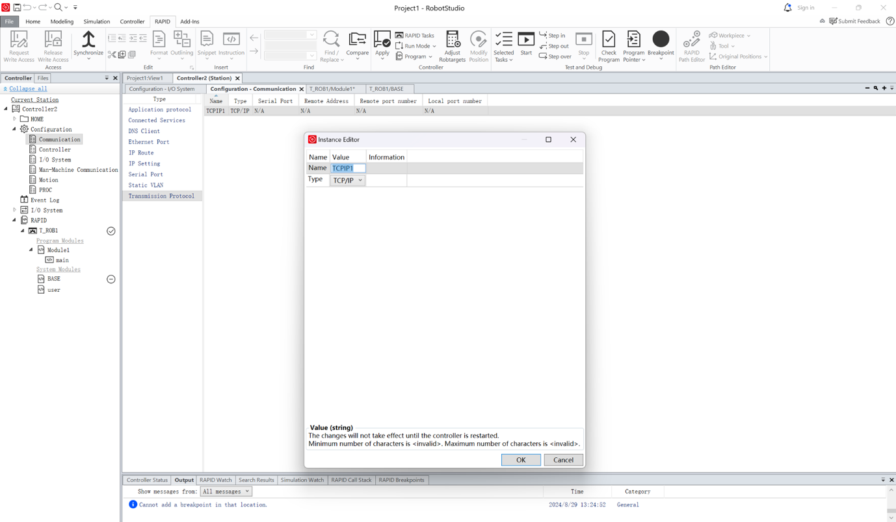

2.2不使用ASCII的报错：

UnpackRawBytes data, 1, signalData;

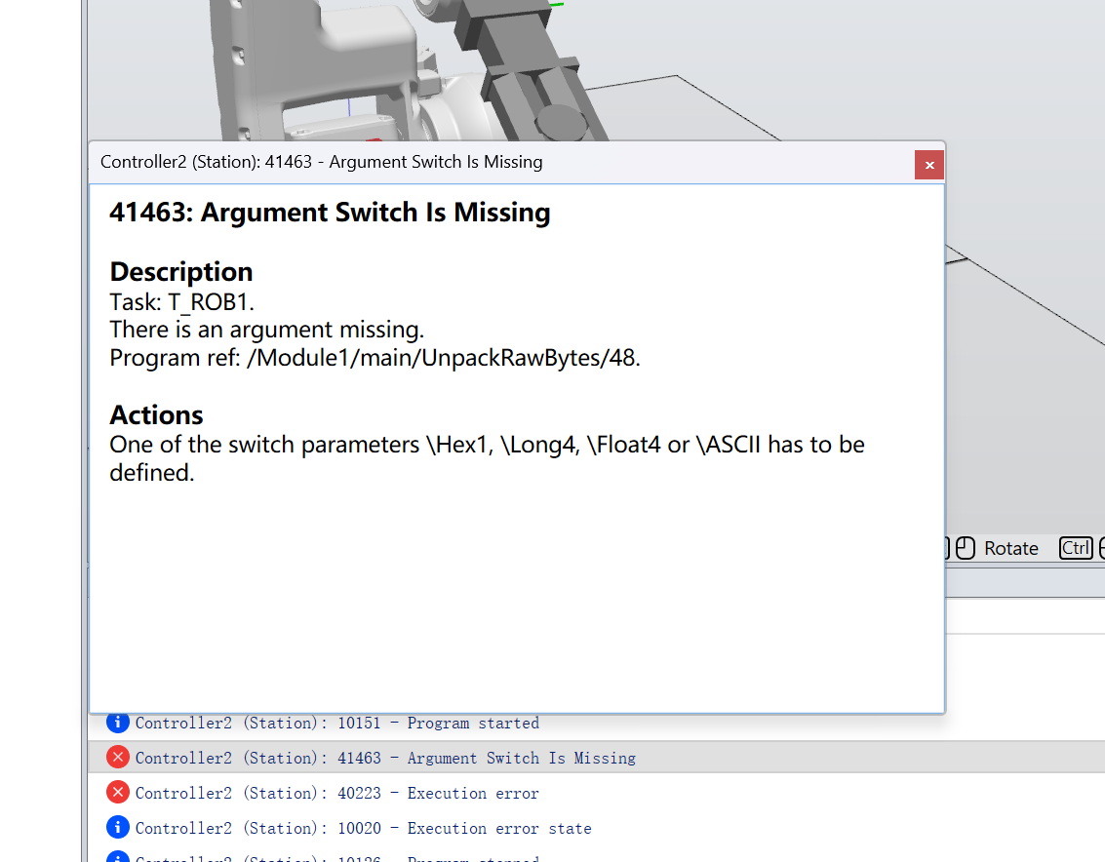

## 2.3使用ASCII但没有末尾数字的报错

UnpackRawBytes data, signalData \ASCII; ! 使用 \ASCII 参数解码字符串

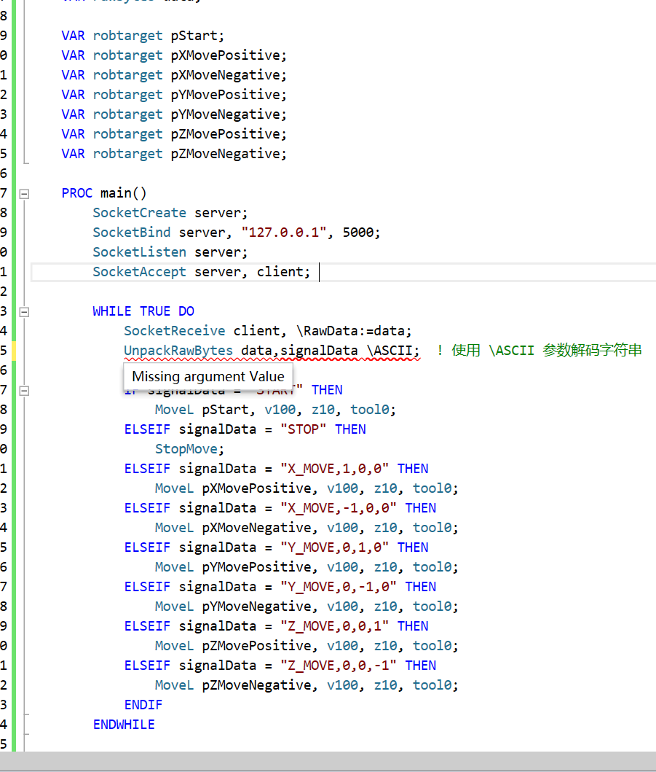

参考文档509之后的内容

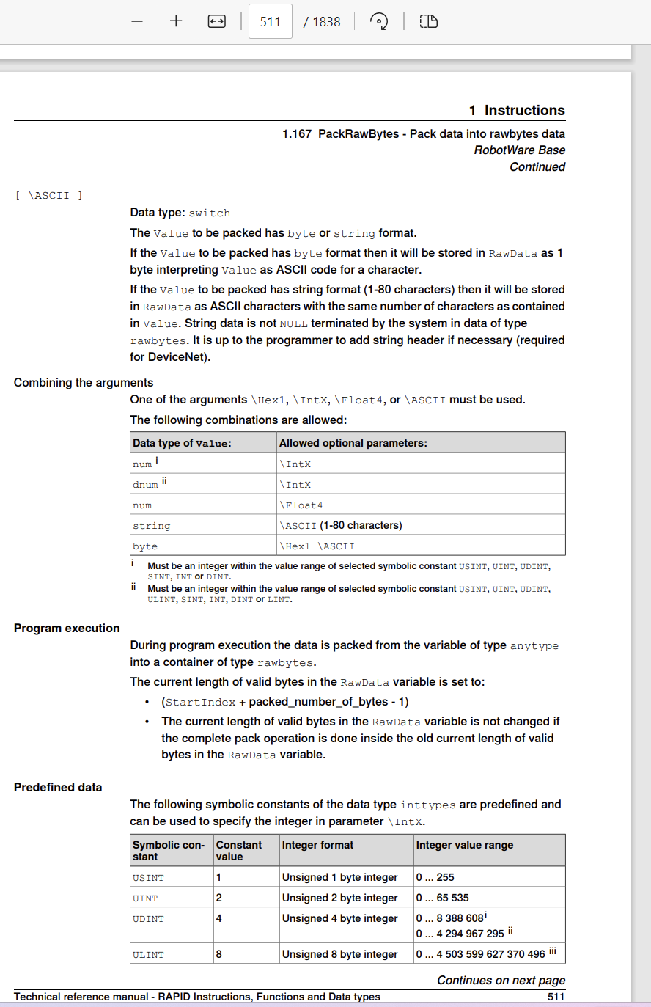

## 2.4 字节数太高

UnpackRawBytes data,1,signalData,\ASCII:=15;

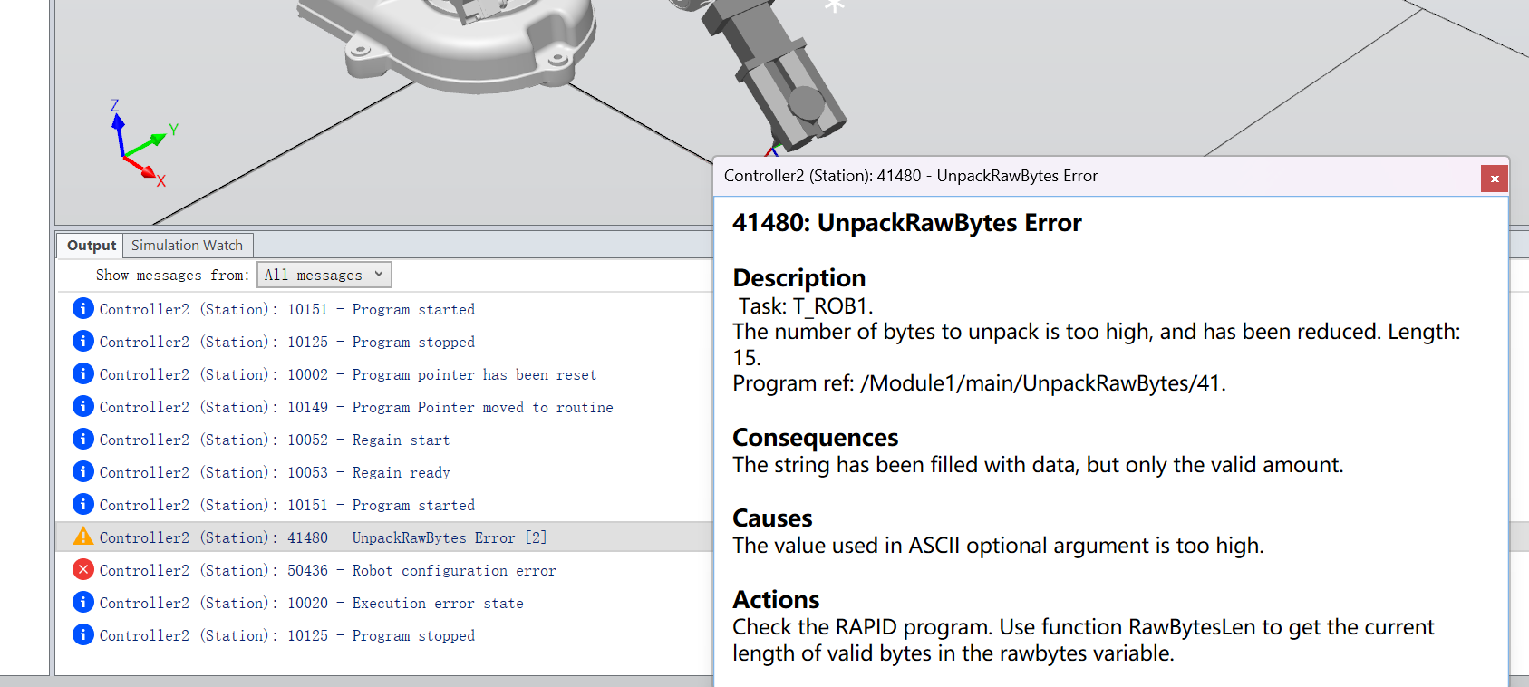

# 3. 链接

文档链接：  
<https://search.abb.com/library/Download.aspx?DocumentID=3HAC050917-001&LanguageCode=en&DocumentPartId=&Action=Launch>

YouTube视频链接：  
<https://www.youtube.com/watch?v=JGJt17c69Bk>

4. Joe老师发的图片



