**Guideline to run the App for code test**

Jiajun Wu

**Quick Demo**

I deployed this App on this website: [**http://8.218.11.33:3000/**](http://8.218.11.33:3000/)

**MySQL Database**

The default database connection parameters are:

Host: 127.0.0.1 User: mylearning Pass: mylearning Database: mylearning

Executing the mylearning.sql using the root user could build the user and database.

If you need to change the parameters, please edit both backend/config.py and mylearning.sql.

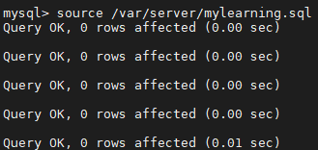

Tips: It is possible that the SQL command fails to create a user due to permission or password policy issues. Please create the user manually and grant the privileges then.

**Permission**

Please ensure the folders backend/static/ and backend/logs/ are writeable because they will be used to store logs, datasets and visualizations.

**Backend**

It is written with Python 3.8.

You may want to install the dependencies:

# cd backend

# pip3 install -r requirements.txt

It may take some time to finish. Then you can start the FastAPI backend:

# python3 main.py

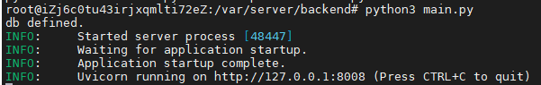

You may leave it running at the background but do not terminate it.

**Frontend**

It is tested with NodeJS latest LTS version: 18.12.1 (includes npm 8.19.2).

Tips: Old version NodeJS and npm may not build the project properly.

<https://github.com/nodesource/distributions/blob/master/README.md#debinstall>

The *node_modules* folder was removed before submission.

So you may want to reinstall the dependencies before the first run:

# cd ..

# cd frontend

# npm install

It may take some time to finish.

Then, you will see the *node_modules* folder was built. It could be started:

# npm start

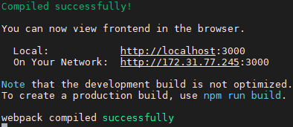

The default URL is <http://localhost:3000/>.

**Database Structure**

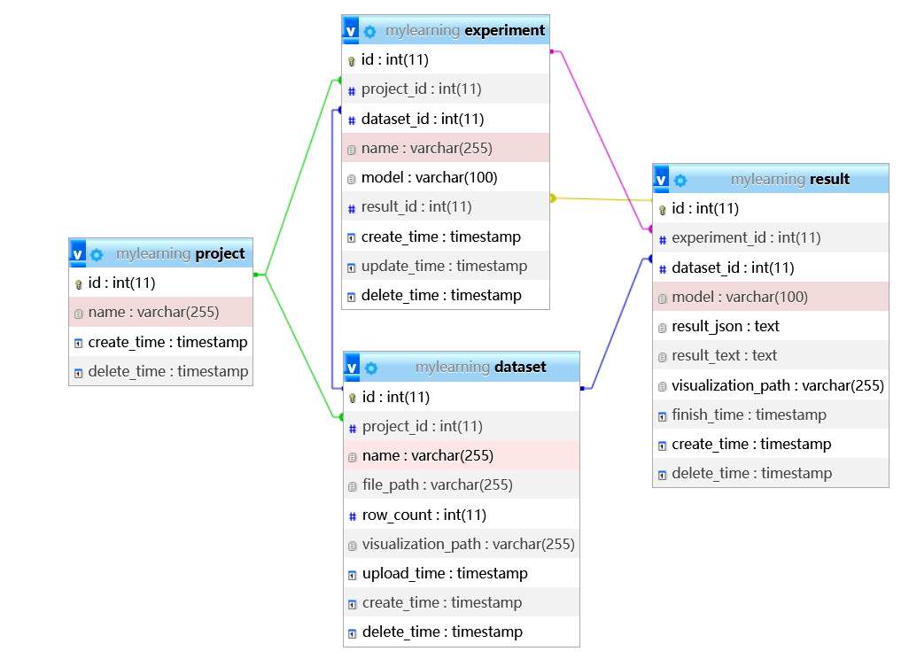

**Screenshots**

