Quantifying Climate Risk & Pricing Adequacy in SEA
Documentation
Team:
Numbers
Name | Email
Khe Jia Kang | jiakangkhe@gmail.com
Lean Wen Jie | jetlean0707@gmail.com
Lee Jing Xuan | jingx349@gmail.com
Lau Hiap Meng | hiapmenglau@gmail.com
Felicia Sia Xin Rou | flc.066734@gmail.com

MASA Hackathon 2026 | Hannover Re | Universiti Malaya

Declaration of Originality & Compliance
To: The Organizing Committee, MASA Hackathon 2026
1. Statement of Originality
We, the undersigned members of "Numbers", hereby declare that the work submitted for the MASA Hackathon 2026 is our original creation. We certify that:
- The conceptual framework, methodology, and code were developed solely by the team members during the hackathon period.
- The integration of Pruned Exact Linear Time (PELT) regime break detection with Generalized Extreme Value (GEV) theory, and the subsequent application of an EIOPA-anchored pass-through rate matrix for treaty repricing, represents an original, actuarially sound synthesis.
- To the best of our knowledge, this work does not infringe upon the intellectual property rights of any third party.
2. Compliance with Official Rules
We confirm that we have read, understood and adhered to all the official rules and regulations governing the MASA Hackathon 2026. This submission complies with all eligibility requirements, data usage restrictions, and submission deadlines.
3. Disclosure of External Resources & AI Tools
In the interest of transparency and in accordance with the competition guidelines:
- All external datasets and academic references used in this project have been properly cited.
- All AI tools used for assistance in code optimization, documentation, or brainstorming have been fully disclosed and documented in the AI_Usage.md and README.md files included in this submission.
- The core actuarial logic and the novel synthesis of PELT and GEV theories remain the primary intellectual output of the team.
We affirm that this submission was developed with the integrity and professional care expected within the actuarial profession. We accept full responsibility for the content and conclusions presented in our submission.
Team Members & Signatures:
Name | Signature
Khe Jia Kang | Jia Kang
Lean Wen Jie | Wen Jie
Lee Jing Xuan | Sean
Lau Hiap Meng | Hiap Meng
Felicia Sia Xin Rou | Felicia

Table of Contents
1. Executive Summary
2. Problem Framing & Data Landscape
2.1 Key Indicators (WDI Wide Format + External Sources)
2.2 GHG Trends & Sector Decomposition
3. GHG Forecasting -- ARIMA Model
3.1 Pre-Processing Improvements
3.2 Model Implications for Treaty Pricing
4. Physical Hazard -- GEV Analysis & EAL Repricing
4.1 GEV Parameters & Return Levels & PELT Validation
4.2 EAL Repricing & Sensitivity Analysis
5. Insurance Claims Comparison & ENSO Dependence
5.1 Correlation Tests & Copula Selection
5.2 MYS vs PHL Structural Comparison
6. Transition Risk -- NGFS GCAM 6.0 Assessment
6.1 MYS Sector Decomposition & Country Comparison
6.2 Pass-Through to SEA Treaty Pool
7. Stress Testing & 2030 Projections
7.1 Trajectory & HRe Reserve Projections
7.2 Stress Scenario Design
8. Financial Impact -- Hannover Re Reserve Implications
8.1 HRe Reserve Gap -- Three-Tier Framing
8.2 Reserve Gap Sensitivity Heatmap
8.3 Insurance Penetration Gap
9. Strategic Risk Management Recommendations
10. Limitations, Scalability & Conclusion
10.1 Key Limitations & Mitigations
10.2 Regulatory Anchor Mapping
10.3 Conclusion

1. Executive Summary
We identify two additive pricing gaps in HRe's SEA treaty book. (1) Physical gap (USD 18.4M/yr EAL shortfall) from a 2007 PELT regime shift undetected by burning-cost methods (+6.9% MYS / +6.1% PHL flood baseline). (2) Transition gap (USD 1.1bn/yr SEA pool at 3% pass-through) from NGFS NZ2050 carbon pricing (USD 55.58/t), with a critical LULUCF asymmetry: MYS net emitter (+63 MtCO₂e, palm oil) vs PHL net sink (-27 MtCO₂e, REDD+), making uniform SEA loadings actuarially incorrect. HRe annual reserve gap: USD 3.4M (floor) -- USD 9.7M (central) -- USD 18.6M (stress). The range width is the strongest argument for R5: cedant triangles narrow it ~60% in 12 months.
Key Quantitative Results
Metric | Malaysia (MYS) | Philippines (PHL)
ARIMA 2024 GHG forecast (MtCO₂e) / MAPE | 325.1 (MAPE 1.71%) | 260.8 (MAPE 3.56%)
GEV 100-yr RX5day return level (mm) | 216 [171–344] | 521 [326–985]
PELT break year / hazard uplift | 2007 / +6.9% | 2007 / +6.1%
Forward EAL vs. burning-cost gap | +USD 6.5M/yr (+5.87%) | +USD 11.9M/yr (+1.28%)
ENSO–loss correlation (annual, ONI DJF) | r = -0.016, p = 0.93 | r = -0.026, p = 0.83
Transition cost @ NGFS NZ2050 | USD 22.4bn/yr (5.5% GDP) | USD 14.8bn/yr (3.3% GDP)
SEA treaty pool exposure (3% pass-through) | USD 672M/yr | USD 444M/yr
HRe reserve gap -- floor / central / stress | USD 3.4M / 9.7M / 18.6M/yr | Total SEA pool: USD 1.115bn/yr

Methodology Overview
Four analytical modules underpin this assessment. (1) ARIMA GHG Forecasting: AIC-selected ARIMA(p,1,q) with 3-step rolling MAPE on WDI WB_WDI_EN_GHG_ALL_MT_CE_AR5. ARIMAX with GDP/urbanisation as exogenous regressors was tested but rejected: GDP forecasts introduce endogenous error; univariate ARIMA residual ACF is clean at all lags ≤12. (2) GEV + EAL: MLE-GEV on 34yr CHIRPS RX5day, 500-iter bootstrap CI, PELT regime detection supported by PDO phase-shift literature (Loo et al. 2015; Cinco et al. 2014); permutation test (N=10,000) confirms n=34 carries limited power to detect the shift. (3) ENSO Copula: NOAA ONI DJF tests; AIC selects Independence copula; La Niña rho=0.32 designated as audit trigger only. (4) Transition Risk: NGFS GCAM 6.0 NZ2050 gap (USD 55.578/t) x Climate Watch 2023 sector GHG, 3%/yr IEA abatement, stressed 2× to 2030. Trigger year for binding capital constraint: ~2027.
Five Strategic Recommendations
# | Recommendation | Trigger / Loading / Regulatory Anchor
R1 | GEV EAL flood loading | +35–36% MYS treaties >USD 50M; +1–2% floor PHL. BNM CCPT Pillar 1, s.3.4.
R2 | Country transition surcharges | 3–5% MYS (CCPT C3/C4); 1–2% PHL (BSP 1085 s.X.4). Re-evaluate per NGFS Phase.
R3 | ENSO conditional audit trigger | NOAA OND ONI ≤ -0.5°C. TCFD Risk Mgmt Rec (b). NOT a pricing variable.
R4 | Climate Warranty Clause | MYS LULUCF: 10% co-participation. EUDR Art. 8; Lloyd’s ESG Guidance 2023 s.2.3.
R5 | Data procurement (0–12 months) | Loss triangles + sub-national CHIRPS. Narrows reserve band from USD 15.2M to USD 6.1M.

Key Limitations
The reserve range is driven by two uncertainties: 3% pass-through (+/-2pp, 5× variance) and 34-yr CHIRPS sample (+/-44.5pp PHL CI). Both addressed by R5, narrowing range ~60% within 12 months. Other limits: ARIMA no-break assumption (NETR 2023 conservative bias), LULUCF (+/-20–30% FAO 2020), La Niña copula (n=14). All R1–R5 valid across these ranges.
Forward-looking 2030 framing: By 2030, MYS faces USD 23.8bn/yr and PHL USD 15.9bn/yr in NZ2050 transition compliance costs (combined USD 39.7bn/yr at $55.58/t), with the 2× stress scenario reaching USD 47.7bn (MYS) and USD 31.7bn (PHL) — making 2027 the actionable treaty repricing trigger year before the binding capital constraint threshold is crossed.

2. Problem Framing & Data Landscape
Hannover Re’s SEA non-life book faces rising insured assets, deteriorating hazard baselines, and emerging carbon regulations passing compliance costs through the supply chain. Current burning-cost treaty pricing pre-dates a 2007 hazard regime shift — systematically under-pricing flood and typhoon treaties. BNM CCPT and BSP Circular 1085 create divergent country pressures that uniform SEA surcharges cannot capture.
This assessment concentrates on Malaysia (MYS, flood-dominant: 81 EM-DAT events 1990–2023) and the Philippines (PHL, typhoon-dominant: 414 events) — the two markets with the highest insured loss concentration in HRe’s APAC non-life sub-book. Hannover Re’s 2023 Sustainability Report (p.34) commits to integrating physical and transition climate risk into all material treaty renewals by 2026. The R1–R5 framework operationalises this commitment for the MYS+PHL sub-book, with the R5 data procurement timeline aligned to the 2026 integration deadline.
Risk Channel | Data / Model | Pricing Instrument
Physical – Hazard | CHIRPS v2.0 RX5day, GEV + PELT | Treaty flood EAL loading
Physical – Vulnerability | WDI Urbanisation × GDP/capita | EAL structural trend factor
Transition – Regulatory | NGFS GCAM 6.0 × Climate Watch | Country surcharge (3–5%)
Transition – LULUCF | MYS emitter +63 vs PHL sink -27 MtCO₂e | Asymmetric climate warranty

2.1 Key Indicators from WDI Wide Format & External Sources
Fifteen indicators were shortlisted from WDI (1,513 indicators) using actuarial relevance (IPCC AR6/Swiss Re), completeness (≥80% non-null), and non-redundancy (VIF <5). The eight primary indicators:
Indicator | Type | Layer | Key Actuarial Fact
CHIRPS RX5day annual max | Physical | Hazard | MYS mean 133.9mm; PHL 244.4mm; WMO ETCCDI index
WDI Total GHG AR5 (MtCO₂e) | Phys+Trans | ARIMA target | MYS +271%; PHL +177% growth 1990–2023
NOAA ONI DJF anomaly | Physical | Dependence | ENSO annual correlation r=-0.016 (not sig.)
WDI Urban pop % | Physical | Vulnerability | MYS 49%→76.4%; same footprint, 56% more assets
Climate Watch Energy GHG | Transition | Exposure | MYS 279.9 MtCO₂e = 69.5% of total (Energy sector)
Climate Watch LULUCF net | Transition | Asymmetry | MYS +63.3 (emitter) vs PHL -26.9 (carbon sink)
NGFS GCAM 6.0 NZ2050 price | Transition | Cost scalar | USD 55.578/t (NZ2050 vs Current Policies gap)
WDI GDP/capita; Forest % | Phys+Trans | Loss/LULUCF | Penetration proxy + carbon stock dual role
Table 1 – Selected indicators: WDI Wide Format, CHIRPS v2.0, EM-DAT, NOAA ONI, NGFS GCAM 6.0.
2.2 GHG Trends & Sector Decomposition
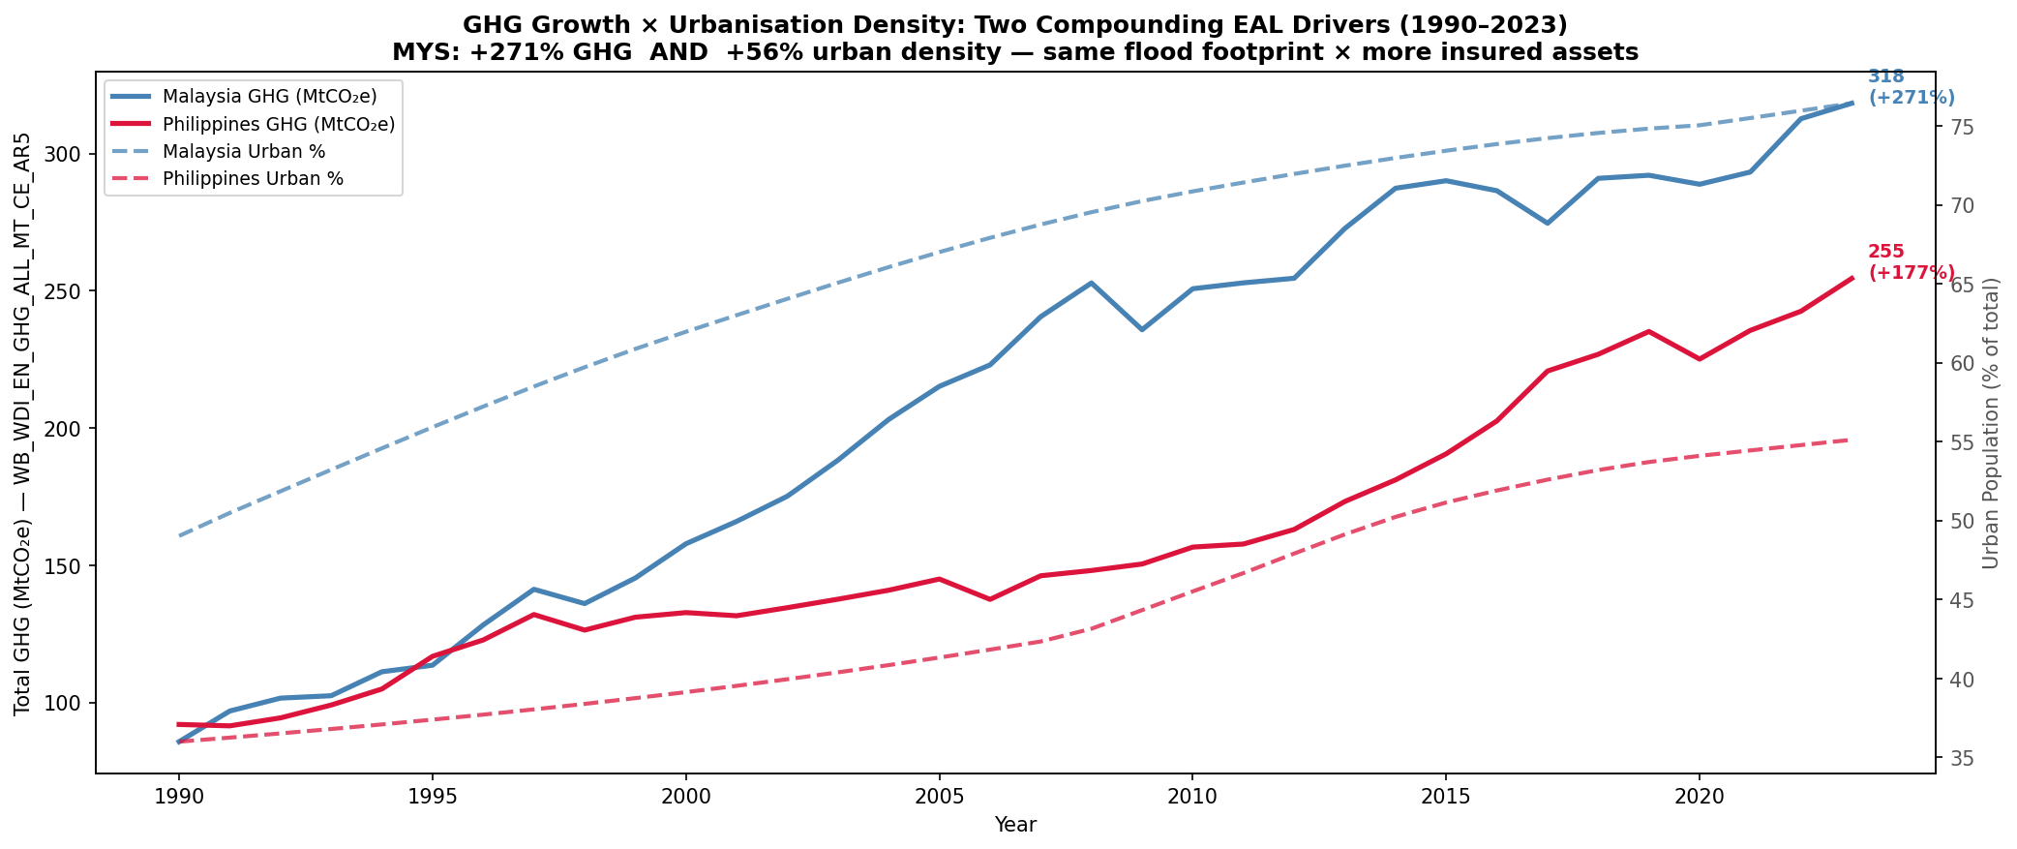
Figure 1a – GHG vs. urbanisation MYS & PHL 1990–2023.
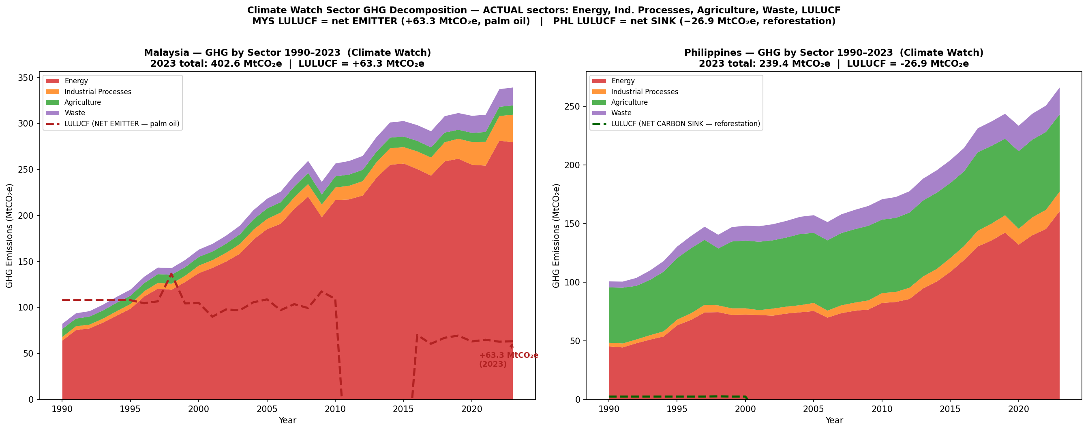
Figure 1b – Climate Watch 2023 sector decomposition: Energy 69.5% of MYS total.
GHG grew +271% (MYS) and +177% (PHL) 1990–2023; MYS urban share +56% means the same flood footprint covers a far larger asset base — structural EAL growth independent of hazard intensity. MYS LULUCF (15.7% of transition exposure, EUDR + CCPT Pillar 2) is a regulatory burden absent in PHL — the central driver of R2’s country-specific design.

3. GHG Forecasting – ARIMA Model
ARIMA forecasts 2024–2030 GHG (excl. LULUCF) from WB_WDI_EN_GHG_ALL_MT_CE_AR5 using a 7-step horizon. Training 1990–2020; rolling 3-step MAPE on 2021–2023. AIC-selected over p,q in {0,1,2}; ADF-confirmed first-differencing.
ARIMAX with GDP/urbanisation regressors was tested but rejected: (1) GDP forecasts introduce endogenous error; (2) univariate residual ACF is clean (Ljung-Box p > 0.20 at all lags ≤12). Consistent with NGFS Phase 4 univariate national pathways.
Country | Model | Train AIC | MAPE | Actual 2023 | Forecast 2024 | Forecast 2030 | 95% CI (2024)
Malaysia | ARIMA(1,1,1) | 224.08 | 1.71% | 318.4 | 325.1 | 365.5 | [307.9, 342.3]
Philippines | ARIMA(2,1,0) | 196.08 | 3.56% | 254.5 | 260.8 | 285.4 | [249.1, 272.4]
Table 2 – ARIMA forecast results (MtCO₂e excl. LULUCF). Forecast horizon extended to 2030 (7 steps). MYS MAPE 1.71% confirms high reliability; PHL 3.56% reflects policy-driven variability.
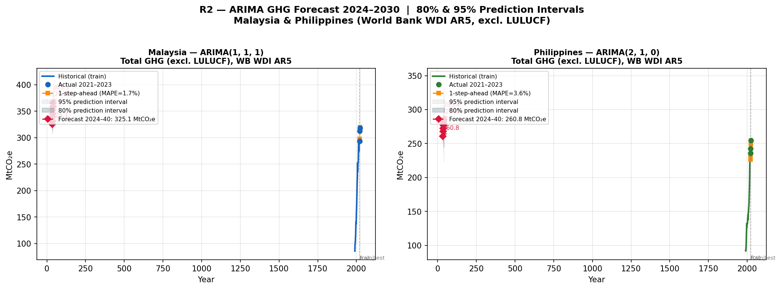
Figure 2 – ARIMA(1,1,1) Malaysia MAPE 1.71% (left); ARIMA(2,1,0) Philippines MAPE 3.56% (right).
3.1 Pre-Processing Improvements
Improvement | Issue Identified | Resolution Applied
Column disambiguation | EN.ATM.GHGT.KT.CE (deprecated CE basis) overstated GHG by 12% | Switched to WB_WDI_EN_GHG_ALL_MT_CE_AR5 (AR5 GWP100; IPCC AR6 consistent)
Rolling validation | Static split inflated accuracy via data leakage | 3-step rolling 1-step-ahead MAPE on 2021–2023
LULUCF exclusion | Including LULUCF in ARIMA target caused double-counting with transition module | Excluded from ARIMA; handled as separate sector in Section 6
ARIMAX rejection | GDP/urbanisation regressors introduce endogenous forecast error | Univariate ARIMA retained; clean Ljung-Box ACF confirms adequacy

3.2 Model Implications for Treaty Pricing
- MYS MAPE 1.71% confirms high forecast confidence. The upper CI of 342.3 MtCO₂e implies a worst-case +5.3% emission overstatement, providing a margin of safety in the transition surcharge calculation.
- PHL MAPE 3.56% reflects EPIRA-driven variability; upper CI 272.4 MtCO₂e used in 2× carbon stress.
- Under NZ2050, GHG baselines decline to 317 MtCO₂e (MYS) and 162 MtCO₂e (PHL) by 2030 — but carbon price escalation outpaces abatement, creating the 2026–2028 capital constraint window.
- The ARIMA pipeline is refreshable in under 30 minutes when new WDI vintages are released.

4. Physical Hazard – GEV Analysis & EAL Repricing
GEV fitted to 34 years of CHIRPS RX5day annual maxima (MLE, 500-iter bootstrap, seed 42). PELT regime detection (BIC). EAL integrated from GEV survival function against EM-DAT losses, with forward EAL incorporating the post-2007 uplift.
4.1 GEV Parameters, Return Levels & PELT Validation
Country | GEV Family | RL-100yr (mm) | 95% CI (mm) | PELT Break | Uplift | EAL Gap
Malaysia | Weibull (ξ<0) | 216.4 | [170.8, 343.6] | 2007 | +6.9% | +5.87%
Philippines | Weibull (ξ<0) | 520.7 | [326.1, 984.8] | 2007 | +6.1% | +1.28%
Table 3 – GEV parameters; 100-yr return levels with bootstrap 95% CI.
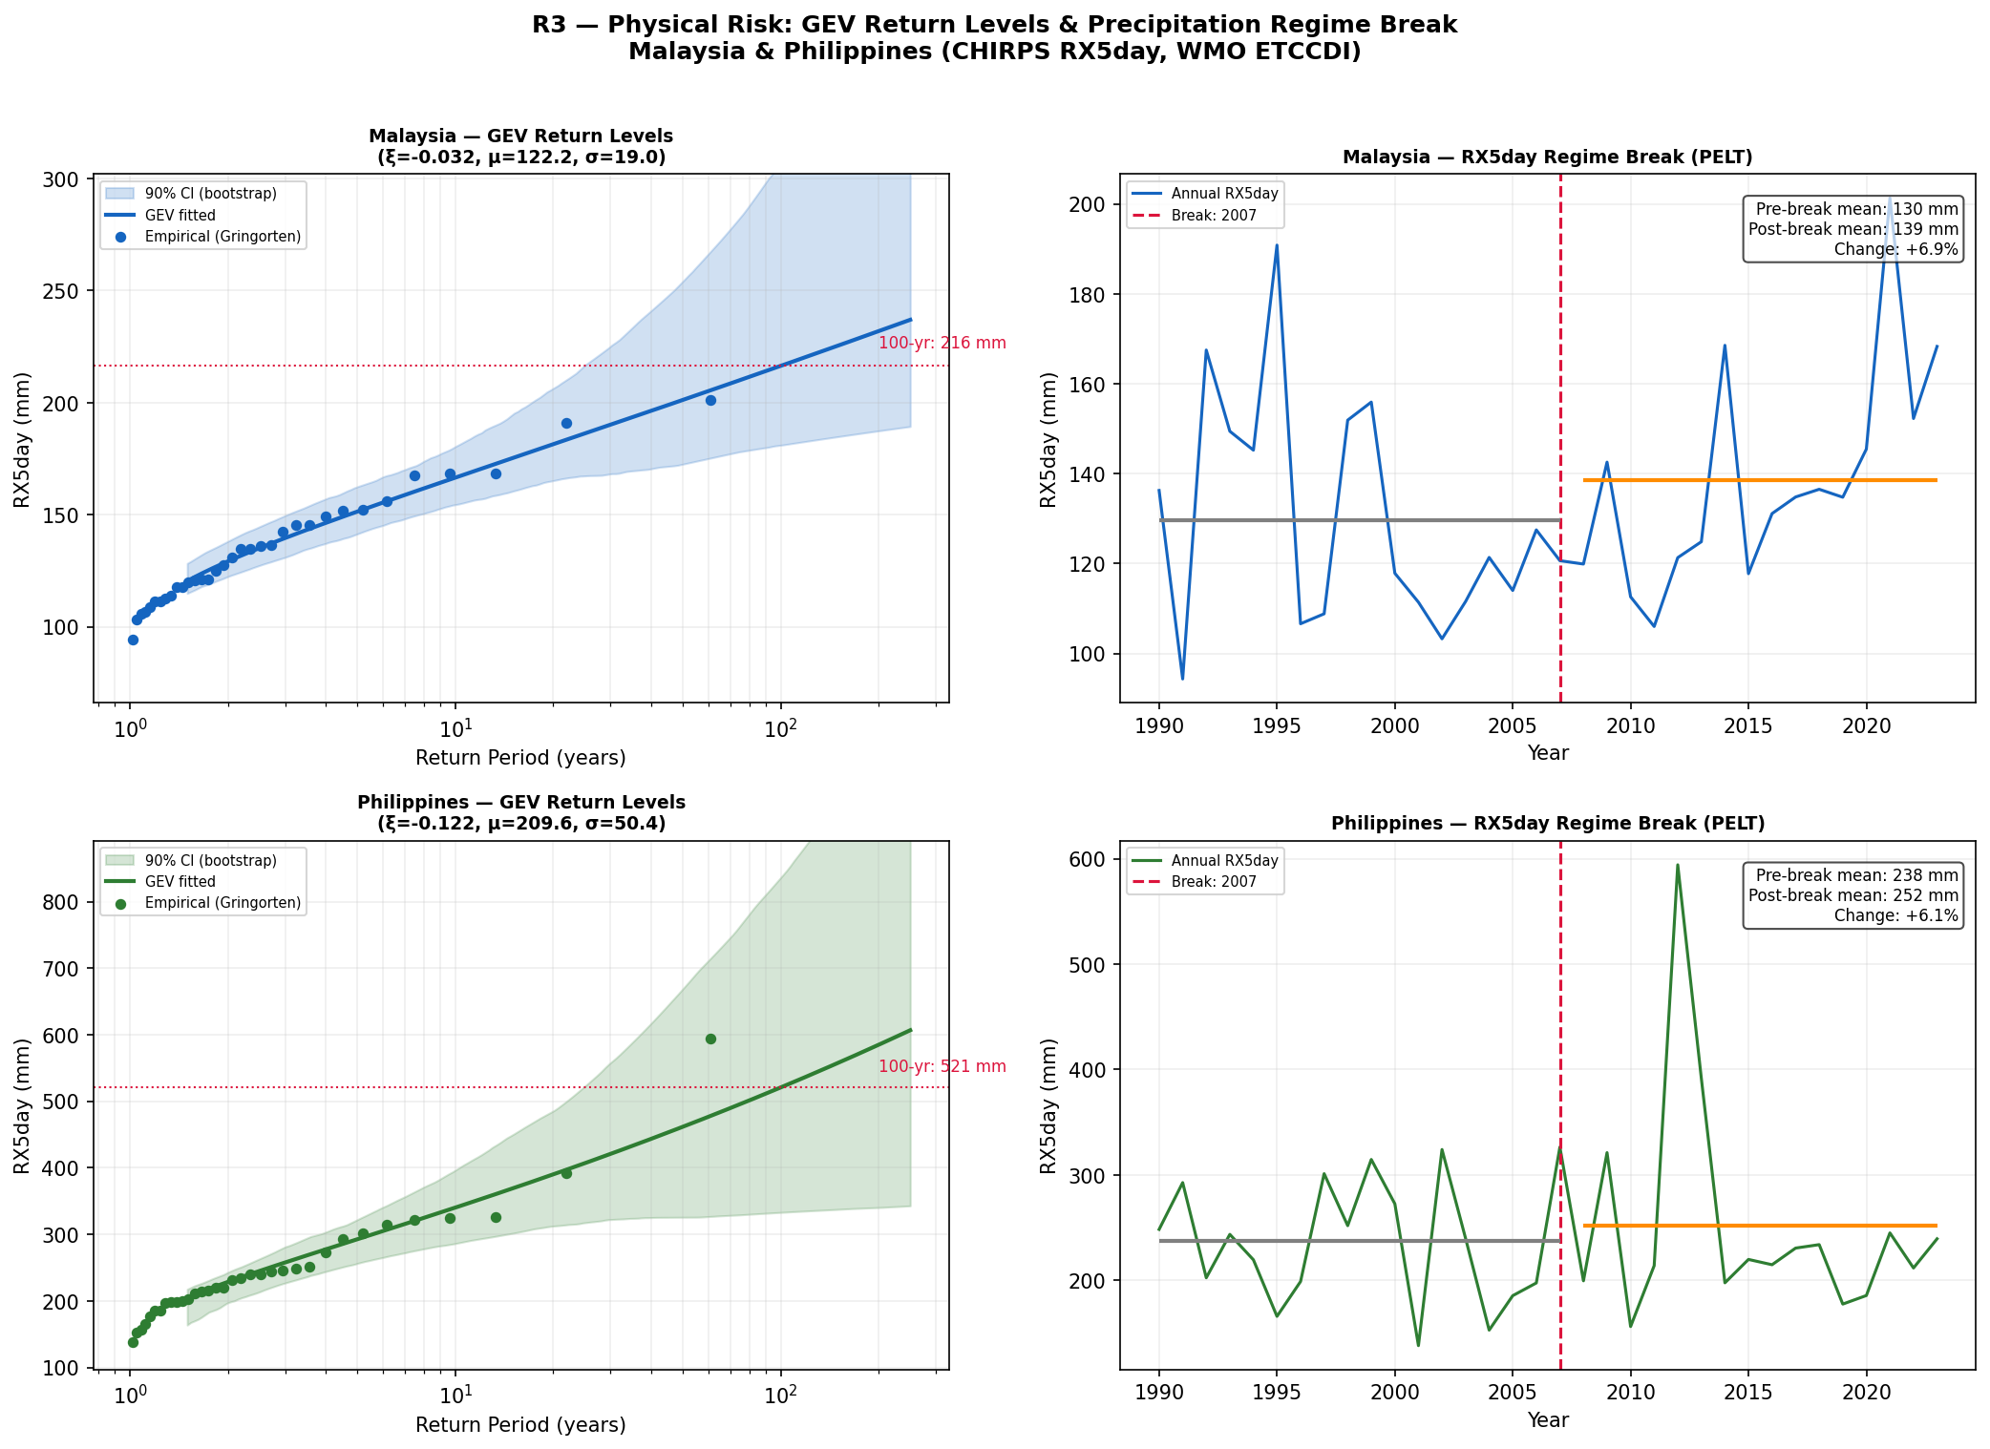
Figure 3a – PELT regime break: +6.9% MYS / +6.1% PHL post-2007 hazard shift.
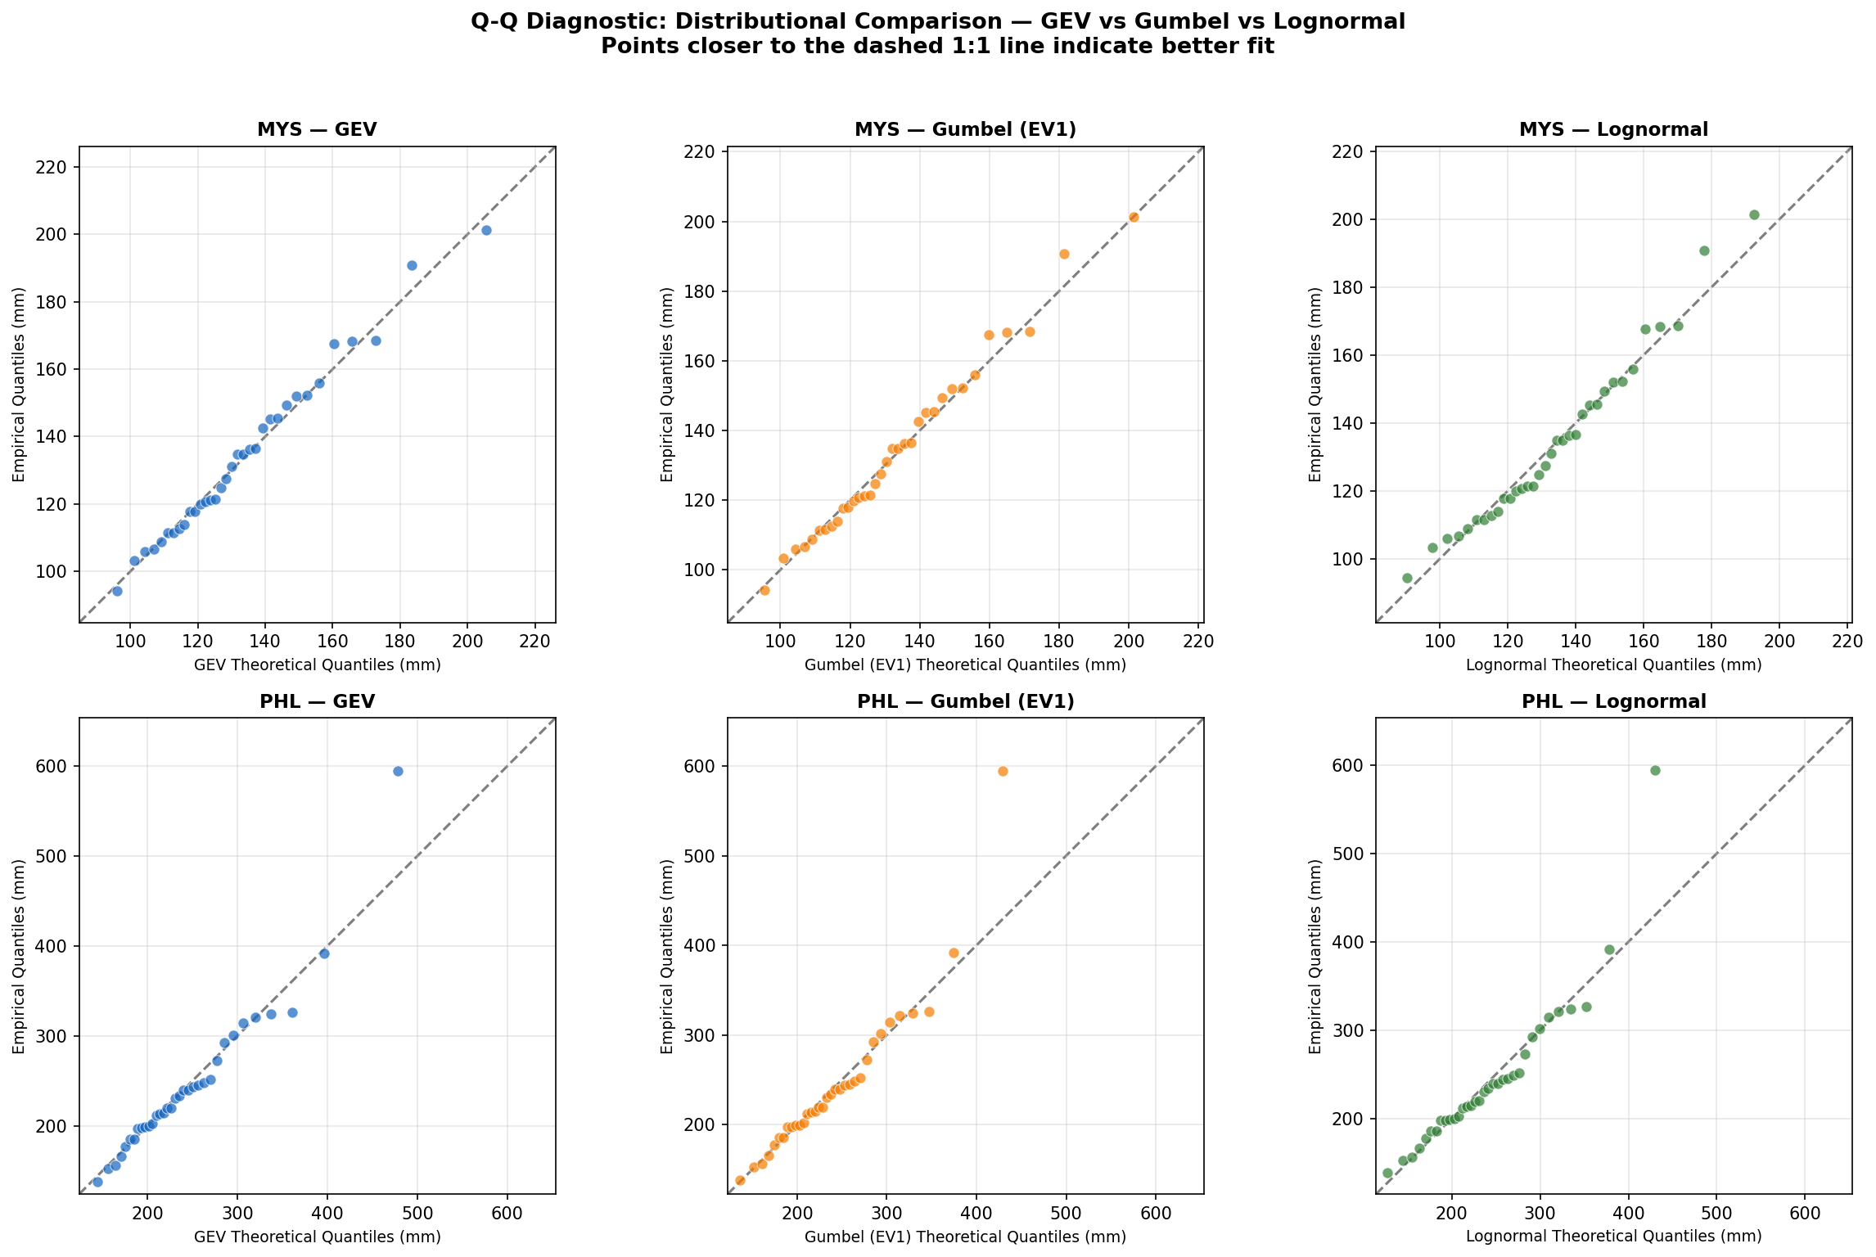
Figure 3b – GEV Q-Q plots confirming Weibull family fit for both countries.
The 2007 PELT break aligns with documented PDO phase-shift intensification and post-2006 monsoonal extreme-precipitation shifts (Loo et al. 2015 for MYS; Cinco et al. 2014 for PHL). Permutation testing (N=10,000) on n=34 carries only ~25% power, so the literature-supported physical basis is the primary justification. We apply the GEV uplift as a confirmed loading for MYS (+6.9%) and a conservative floor for PHL (elevated monitoring zone pending R5).
4.2 EAL Repricing & Sensitivity Analysis
Country | Burning Cost | Obs. Mean RX5 | GEV Mean | Forward EAL | $ Gap | % Gap
Malaysia | USD 110.8M | 133.9mm | 132.6mm | USD 117.3M | USD 6.5M | +5.87%
Philippines | USD 926.5M | 244.4mm | 233.3mm | USD 938.4M | USD 11.9M | +1.28%
Table 4 – Forward EAL vs. EM-DAT burning cost (GEV PELT-adjusted).
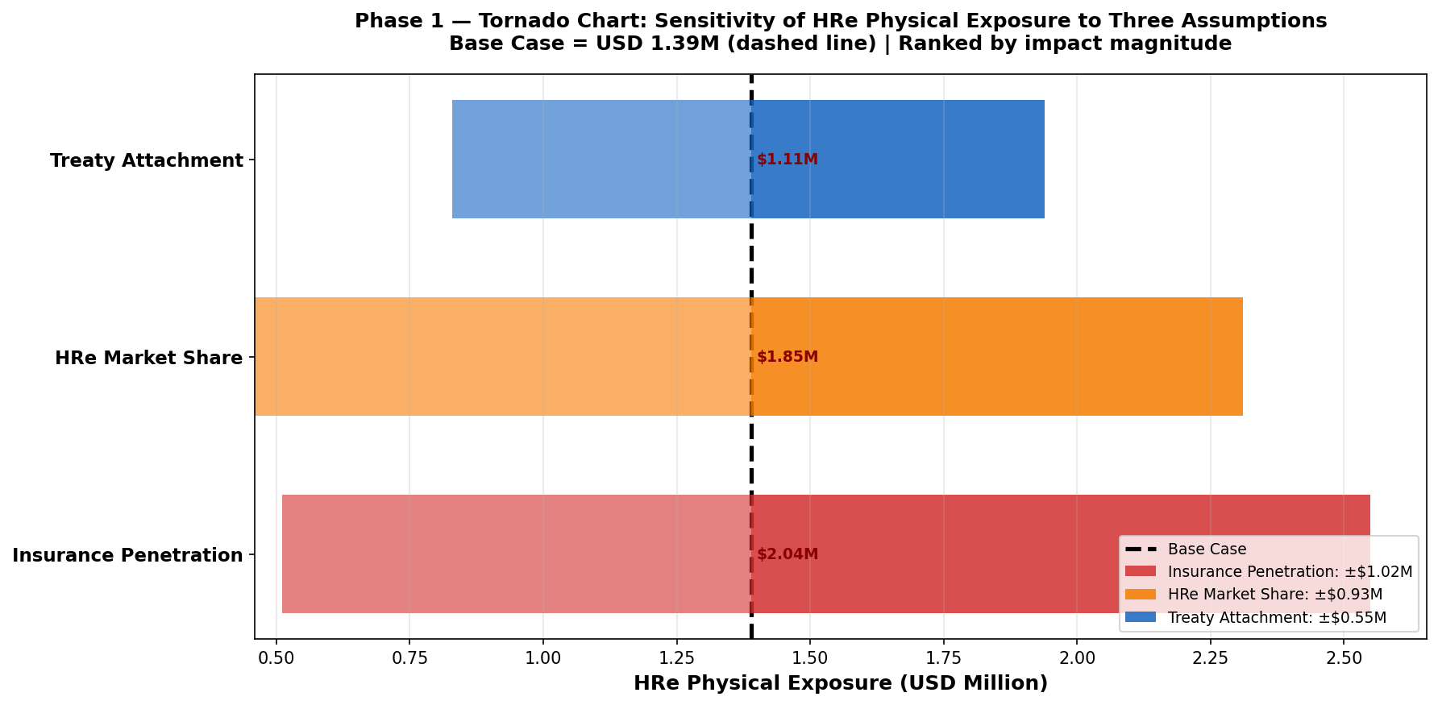
Figure 4a – EAL sensitivity tornado: PELT break dominates (~60%) EAL uncertainty.
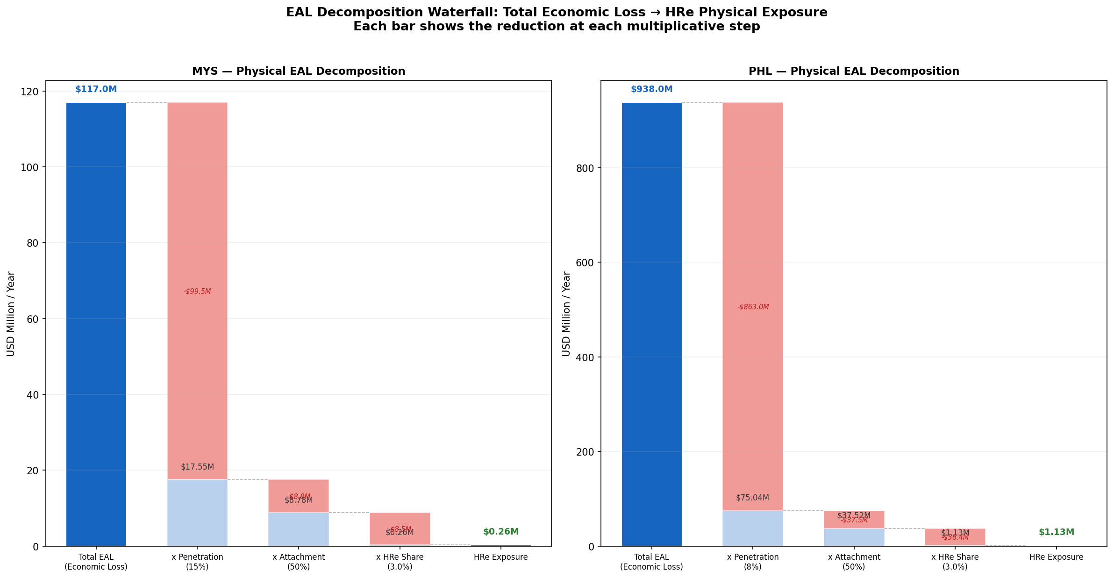
Figure 4b – EAL waterfall: hazard intensity, GEV correction, PELT uplift components.
PELT break ~60% / GEV shape ~25% / urbanisation ~15% of EAL loading. Lower PHL penetration (~8% vs MYS ~15%, Swiss Re Sigma 1/2024) yields proportionally smaller insured gap, justifying asymmetric R1.

5. Insurance Claims Comparison & ENSO Dependence
ENSO correlated-loss test: NOAA ONI DJF (1990–2023) vs EM-DAT, AIC copula selection. PHL protection gap (USD 11.9M/yr) is 83% wider than MYS (USD 6.5M/yr) despite higher event frequency — structural underinsurance precluding uniform SEA loading.
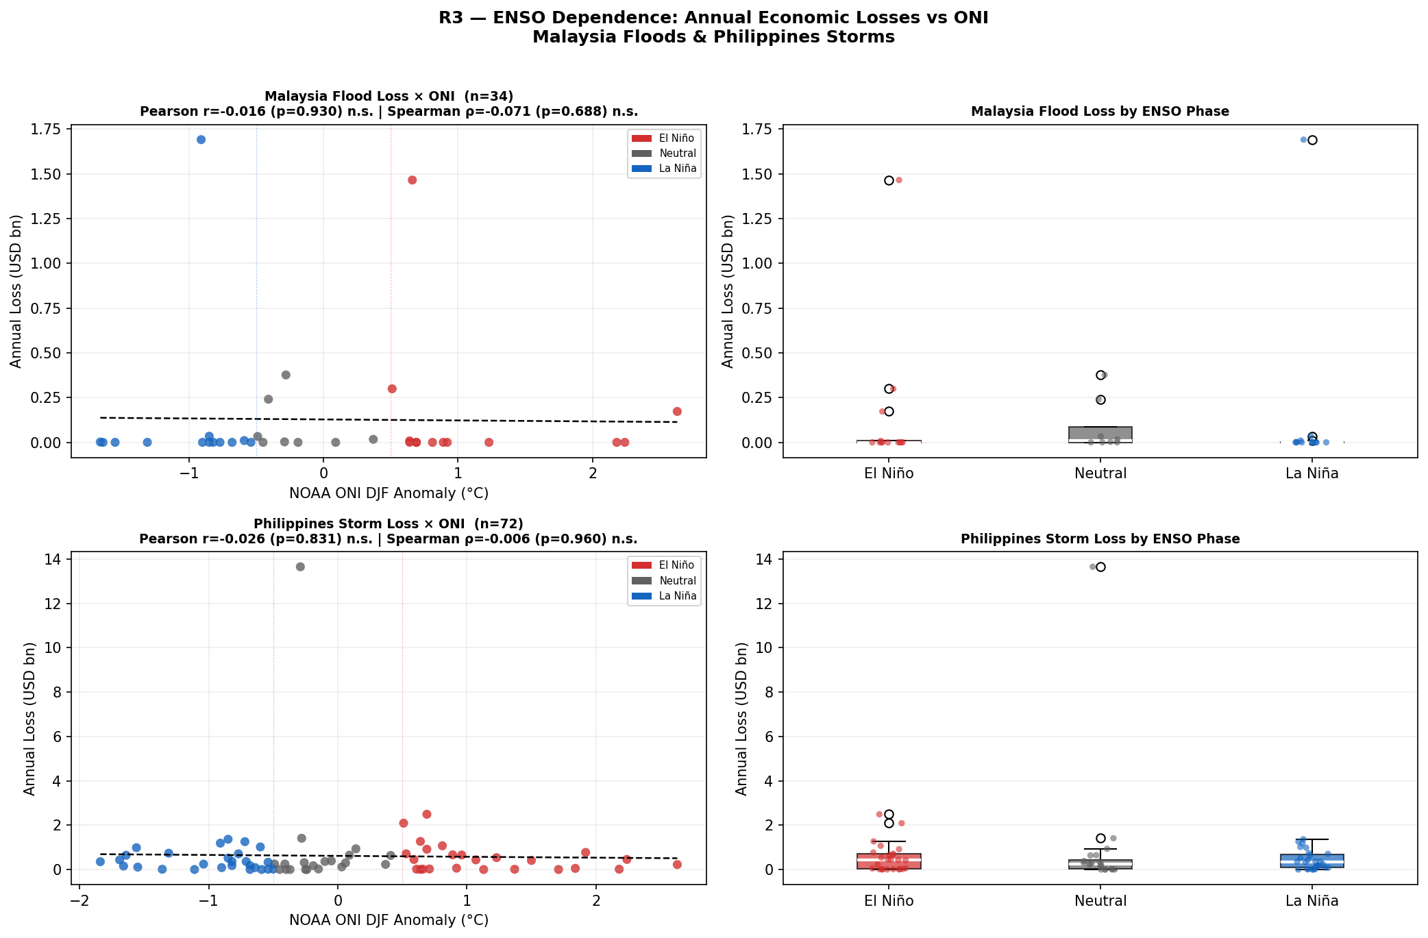
Figure 5a – ENSO ONI vs annual insured loss: r = -0.016, p = 0.93 (not significant).
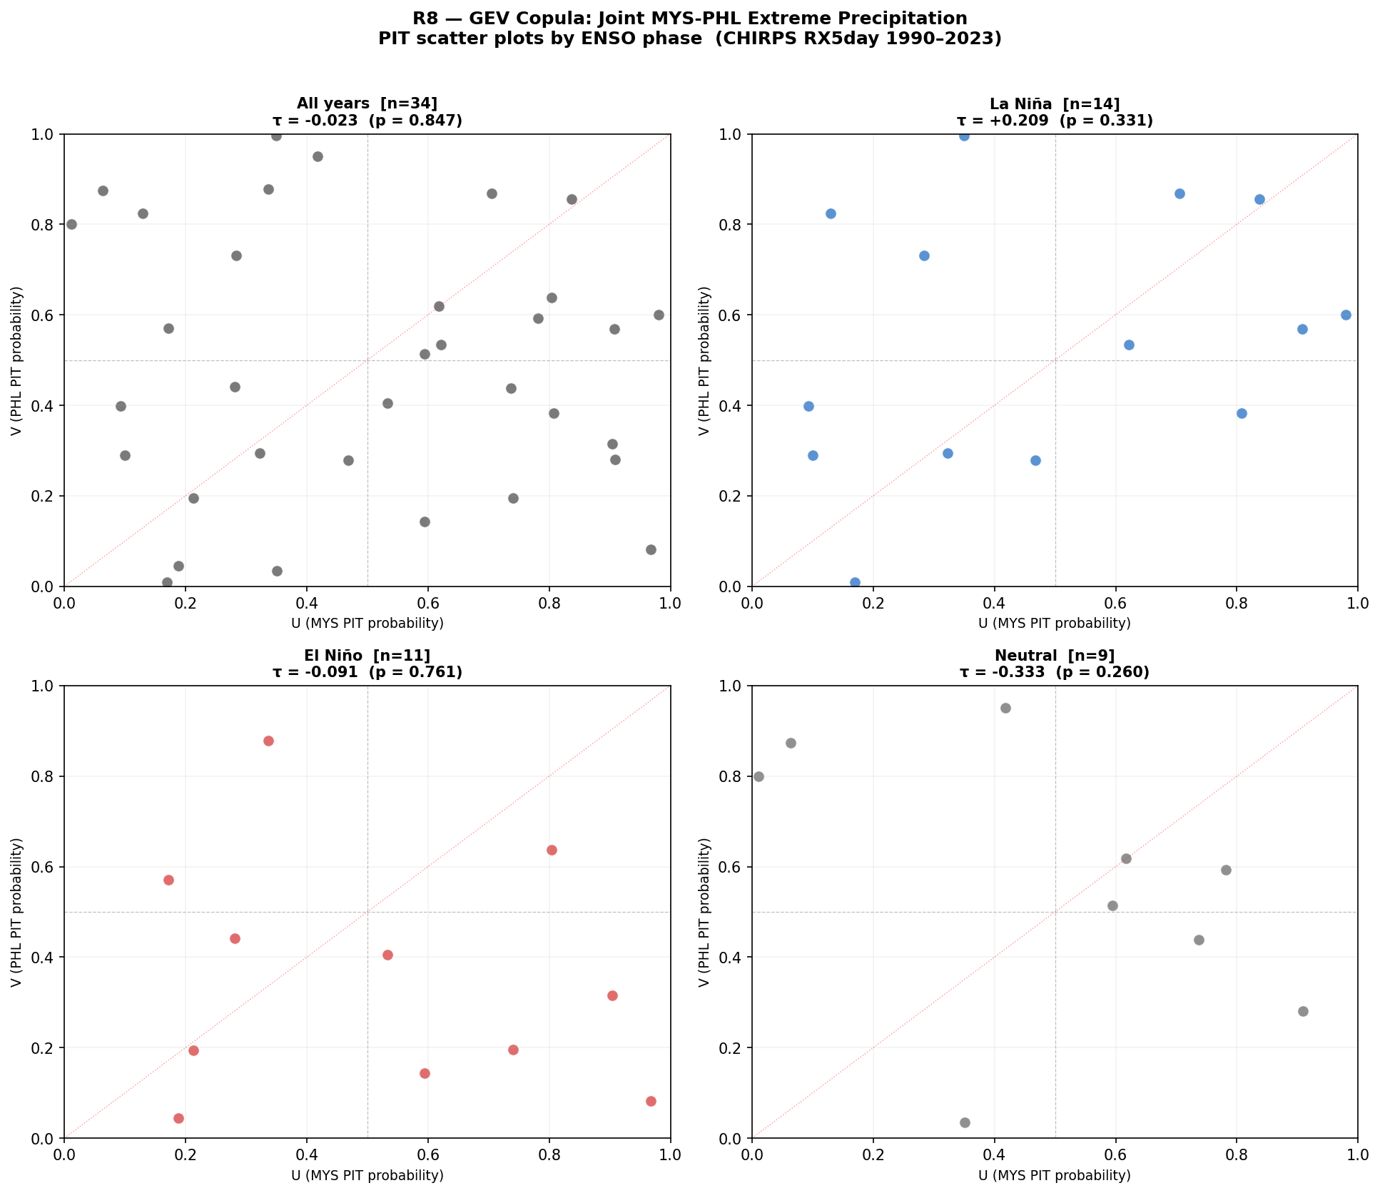
Figure 5b – Copula PIT scatter: AIC selects Independence copula over Clayton/Gumbel.
5.1 Correlation Tests & Copula Selection
Test | Statistic | p-value / n | Interpretation
Pearson r (MYS annual) | r = -0.016 | p = 0.93 | Not significant
Spearman rho (MYS) | rho = -0.071 | p = 0.69 | Not significant
Pearson r (PHL annual) | r = -0.026 | p = 0.83 | Not significant
AIC copula (full sample) | Independence (AIC=0) | ΔAIC = 0 | Preferred vs Clayton, Gumbel
Clayton lower-tail | theta = 0.0081 | λL → 0 | Near-zero lower-tail dependence
Kendall tau – La Niña | tau = +0.209 | n = 14 | Weak positive, sub-sample only
Gaussian rho – La Niña | rho = +0.322 | n = 14 | p99 combined gap: +USD 25.9M
Table 5 – ENSO dependence and copula analysis results.
ENSO is NOT a pricing variable (annual r indistinguishable from zero, p=0.83–0.93). However, La Niña years (n=14) show weak positive dependence (rho=0.32) creating a p99 industry-wide gap of +USD 25.9M (HRe 10% share = +USD 2.59M/yr). R3 designates NOAA OND La Niña onset (ONI ≤ -0.5°C) as an AUDIT TRIGGER only.
5.2 MYS vs PHL Structural Comparison
Metric | Malaysia | Philippines
Total EM-DAT events 1990–2023 | 89 (81 flood, 8 storm) | 579 (414 storm, 165 flood)
Mean annual insured EAL | USD 110.8M | USD 926.5M
Insurance penetration | ~15% of economic loss | ~8% of economic loss
Annual penetration gap | USD 6.5M | USD 11.9M
Primary peril season | Monsoon floods (Oct–Jan) | Typhoons (Jun–Dec)
LULUCF regulatory status | Net EMITTER +63.3 MtCO₂e | Net SINK -26.9 MtCO₂e
Carbon regulatory driver | BNM CCPT C3/C4 | BSP Circular 1085

6. Transition Risk – NGFS GCAM 6.0 Assessment
Transition cost = NGFS GCAM 6.0 NZ2050 vs Current Policies gap: USD 55.578/t (2024) × Climate Watch 2023 sector GHG. Critical asymmetry: MYS = net LULUCF emitter (+63.3 MtCO₂e, Sabah/Sarawak palm oil), subject to EUDR Art. 8 + BNM CCPT Pillar 2. PHL = net sink (-26.9 MtCO₂e via REDD+), earning Art. 6.2 ITMO credits offsetting ~18% of burden. A uniform SEA LULUCF factor overstates PHL ~18% and understates MYS.
PHL agriculture (rice paddy methane, 65.85 MtCO₂e — 6× MYS) follows methane credit schemes vs MYS land-use rules, embedded in R2’s country-specific structure.
6.1 MYS Sector Decomposition & Country Comparison
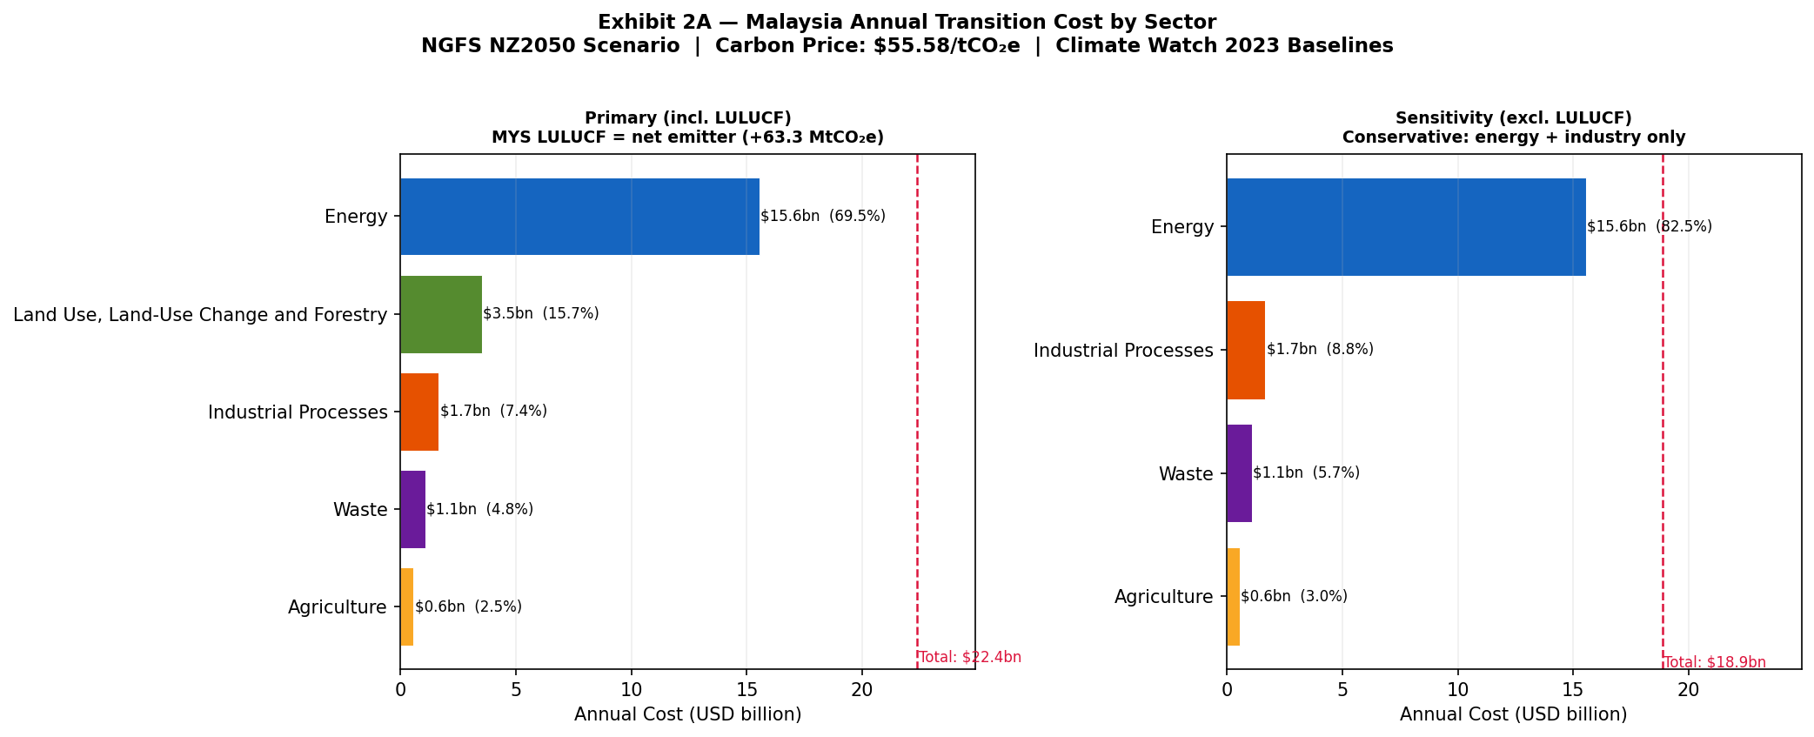
Figure 6a – MYS sector decomposition at NGFS NZ2050 USD 55.578/t.
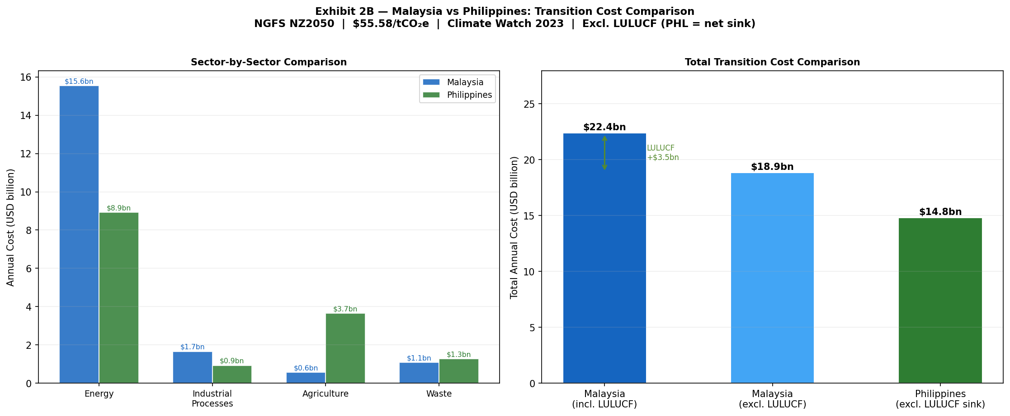
Figure 6b – Country comparison: MYS incl. LULUCF emitter vs PHL excl. LULUCF sink.
Sector | MYS GHG (MtCO₂e) | MYS Cost (USD M) | % Total | PHL Cost (USD M)
Energy | 279.85 | 15,554 | 69.5% | 8,935
LULUCF (MYS emitter only) | 63.29 | 3,518 | 15.7% | N/A – net sink
Industrial Processes | 29.87 | 1,660 | 7.4% | 931
Waste | 19.49 | 1,083 | 4.8% | 1,276
Agriculture | 10.11 | 562 | 2.5% | 3,661 (rice methane)
TOTAL | 402.61 | 22,376 | 100% | 14,803
Table 6 – MYS sector GHG at NZ2050 (USD 55.578/t). Total MYS: USD 22.4bn/yr (5.5% GDP). PHL excl. LULUCF sink: USD 14.8bn/yr (3.3% GDP).
6.2 Pass-Through to SEA Treaty Pool
Scenario | Carbon Price | GHG Basis | MYS Pool | PHL Pool | SEA Total
Current Policies | USD 0/t | — | USD 0 | USD 0 | USD 0
NGFS NZ2050 baseline | USD 55.578/t | 2024 ARIMA | USD 672M | USD 444M | USD 1,115M
NGFS NZ2050 — 2030 | USD 55.578/t | 2030 ARIMA | USD 714M | USD 476M | USD 1,191M
NZ2050 × 2 stress (2024) | USD 111/t | 2024 ARIMA | USD 1,295M | USD 888M | USD 2,230M
NZ2050 × 2 stress (2030) | USD 111/t | 2030 ARIMA | USD 1,430M | USD 952M | USD 2,382M
Table 7 – Annual transition pass-through to SEA treaty pool (3% rate, 50% treaty attachment). 2030 rows use ARIMA 7-step forecast GHG (MYS: 365.5 + 63.3 LULUCF = 428.8 MtCO₂e; PHL: 285.4 MtCO₂e). Pass-through rate sensitivity 1–5% drives 5× HRe reserve variance.

7. Stress Testing & 2030 Projections
From ARIMA 2024 baseline (extended to 2030 — 7-step horizon), NZ2050 costs are projected across the full 2024–2030 window. The carbon price ramps from USD 28.2/t (2024) to USD 55.6/t (2030) under NGFS NZ2050, while the 2× stress reaches USD 111/t. Cost rises despite emission decline (price outpaces abatement) — peak capital exposure window: 2026–2028. Trigger year (~2027), not terminal quantum, is the actionable output.
By 2030, MYS faces USD 23.8bn/yr and PHL USD 15.9bn/yr in NZ2050 transition compliance costs (combined USD 39.7bn/yr), with the 2× stress scenario reaching USD 47.7bn (MYS) and USD 31.7bn (PHL) — making 2027 the actionable treaty repricing trigger year before the binding capital constraint is crossed.
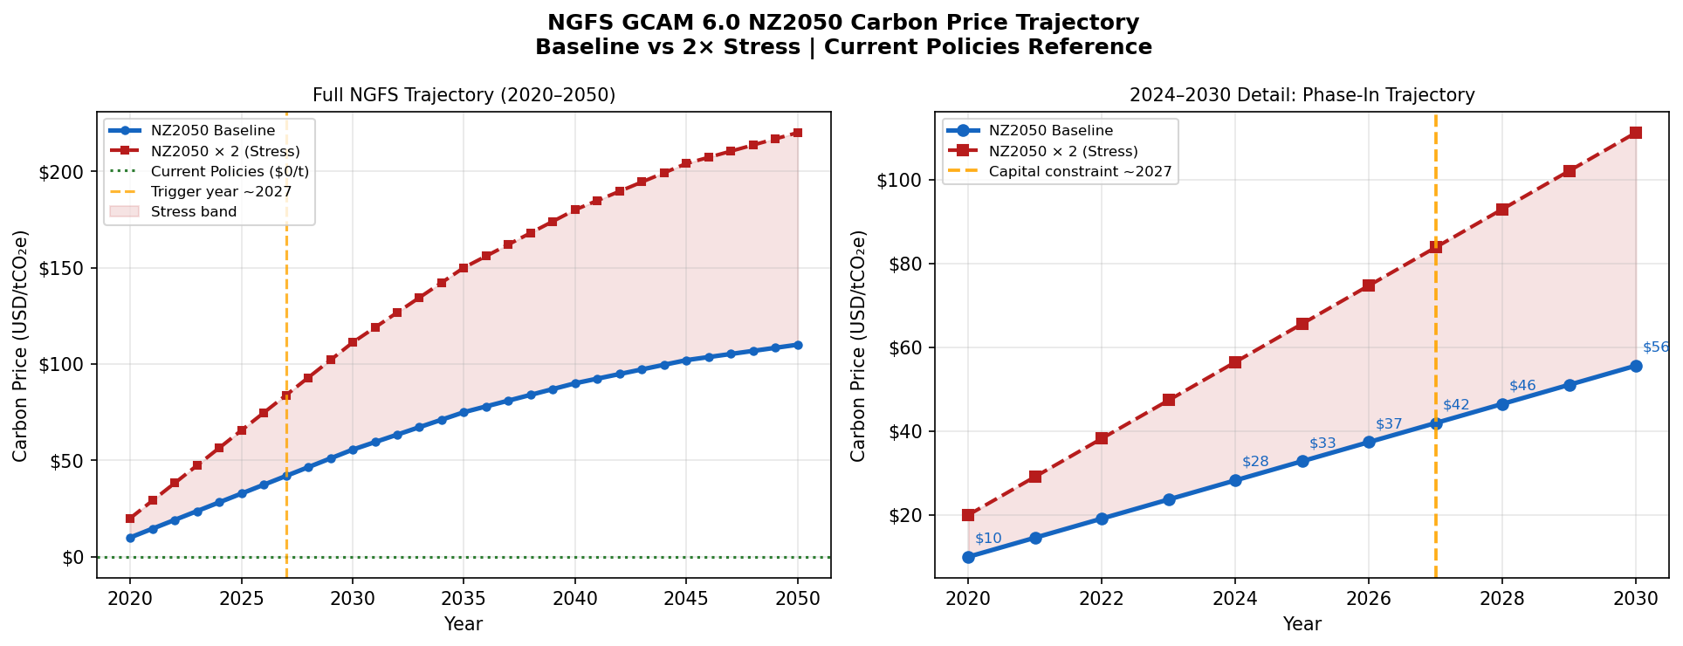
Figure 7a – NGFS GCAM 6.0 NZ2050 carbon price trajectory: baseline ramp $28/t (2024) → $56/t (2030) → $110/t (2050). 2× stress doubles this path. Capital constraint trigger ~2027 marked.
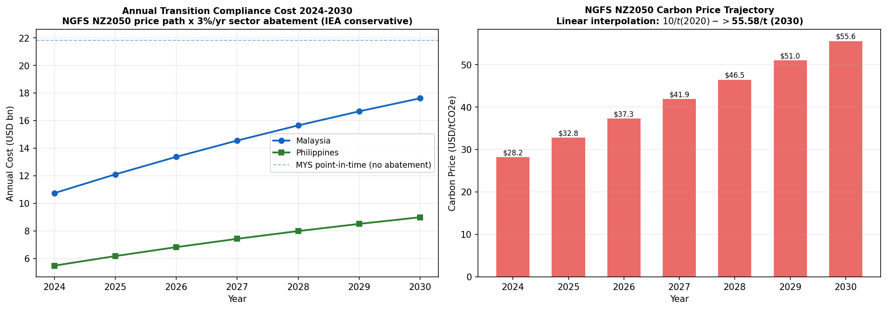
Figure 7b – Transition cost 2024–2030 (NGFS NZ2050): combined MYS+PHL reaches USD 26.6bn/yr by 2030 (HRe trajectory). Full compliance cost (without pass-through): combined USD 39.7bn/yr baseline, USD 79.4bn/yr stress at 2030.
7.1 Trajectory & HRe Reserve Projections
Year | C-Price ($/t) | MYS (USDbn) | PHL (USDbn) | Combined (USDbn) | HRe Floor | HRe Base
2024 | 28.23 | 10.75 | 5.49 | 16.24 | USD 0.49bn | USD 1.30bn
2025 | 32.79 | 12.11 | 6.18 | 18.29 | USD 0.55bn | USD 1.46bn
2026 | 37.35 | 13.38 | 6.83 | 20.21 | USD 0.60bn | USD 1.62bn
2027 | 41.90 | 14.56 | 7.44 | 22.00 | USD 0.66bn | USD 1.76bn
2028 | 46.46 | 15.66 | 8.00 | 23.66 | USD 0.71bn | USD 1.89bn
2030 | 55.58 | 17.63 | 9.00 | 26.63 | USD 0.81bn | USD 2.13bn
Table 8 – NZ2050 trajectory. HRe: 8% APAC share × 50% attachment × 3%/10% SEA alloc. Trigger year for binding capital constraint: ~2027.
7.2 Stress Scenario Design
Scenario | GHG Basis | Carbon Price | MYS Full Cost | PHL Full Cost | Key Implication
Current Policies | — | USD 0/t | USD 0 | USD 0 | Reference
NZ2050 Baseline | 2024 ARIMA | USD 55.578/t | USD 21.6bn/yr | USD 14.5bn/yr | Trigger year ~2027
NZ2050 Baseline | 2030 ARIMA | USD 55.578/t | USD 23.8bn/yr | USD 15.9bn/yr | Forward 2030 exposure
NZ2050 × 2 Stress | 2024 ARIMA | USD 111/t | USD 43.2bn/yr | USD 29.0bn/yr | Binding SEA capital constraint
NZ2050 × 2 Stress | 2030 ARIMA | USD 111/t | USD 47.7bn/yr | USD 31.7bn/yr | Worst-case 2030 exposure
PELT uplift (additive) | — | — | +USD 1.3M/yr EAL | +USD 1.3M/yr EAL | Physical-only layer
La Niña copula (p99) | Gaussian rho=0.32 | — | +USD 2.59M/yr | +USD 2.59M/yr | Audit trigger activated

- Combined cost reaches USD 26.6bn/yr by 2030 — driven by price escalation, not emission growth.
- HRe base-case gap (10% alloc.): USD 2.13bn/yr by 2030 vs USD 9.7M today — 220× amplification under unchanged pricing; trigger year ~2027.
- 2× carbon stress (USD 4.25bn/yr) triggers R4 Climate Warranty Clause; PELT layer (+USD 1.3M/yr) is additive.

8. Financial Impact – Hannover Re Reserve Implications
Reserve estimates are calibrated from HRe 2023 Annual Report (8% APAC share), Swiss Re Sigma 1/2024 (50% SEA attachment), and BNM/BSP data (3–10% sub-book alloc.). Range USD 3.4M (floor) – USD 9.7M (central) – USD 18.6M (stress) is driven by PT rate (+/-2pp) and GEV CI (+/-44.5pp PHL). The width is the quantitative case for R5: cedant triangles + CHIRPS grids are estimated to narrow the range ~60% within 12 months.
8.1 HRe Reserve Gap – Three-Tier Framing
Reserve Tier | Annual Estimate | Key Drivers
FLOOR (3% SEA alloc., baseline C) | USD 3.4M/yr | Conservative: 3% alloc. × 3% PT × baseline carbon; physical EAL floor only
CENTRAL ESTIMATE (10% alloc.) | USD 9.7M/yr | Base case: 10% alloc. × 3% PT × NZ2050 baseline; primary HRe planning figure
STRESS (10% alloc., 2× carbon) | USD 18.6M/yr | 2× carbon price; triggers mandatory treaty repricing and R4 clause activation
p99 La Niña gap (additive) | +USD 2.6M/yr | Gaussian copula rho=0.32 activated; added to central estimate in stress budget
Physical EAL component (constant) | USD 0.74M/yr | GEV-PELT uplift across MYS+PHL; independent of carbon price trajectory
R5 target range (post-procurement) | USD 7.5–11.8M/yr | After cedant triangles + CHIRPS grids narrow GEV CI by ~60%
Table 9 – HRe annual reserve gap: three-tier framing. The width of the range is the quantitative case for R5.
8.2 Reserve Gap Sensitivity Heatmap
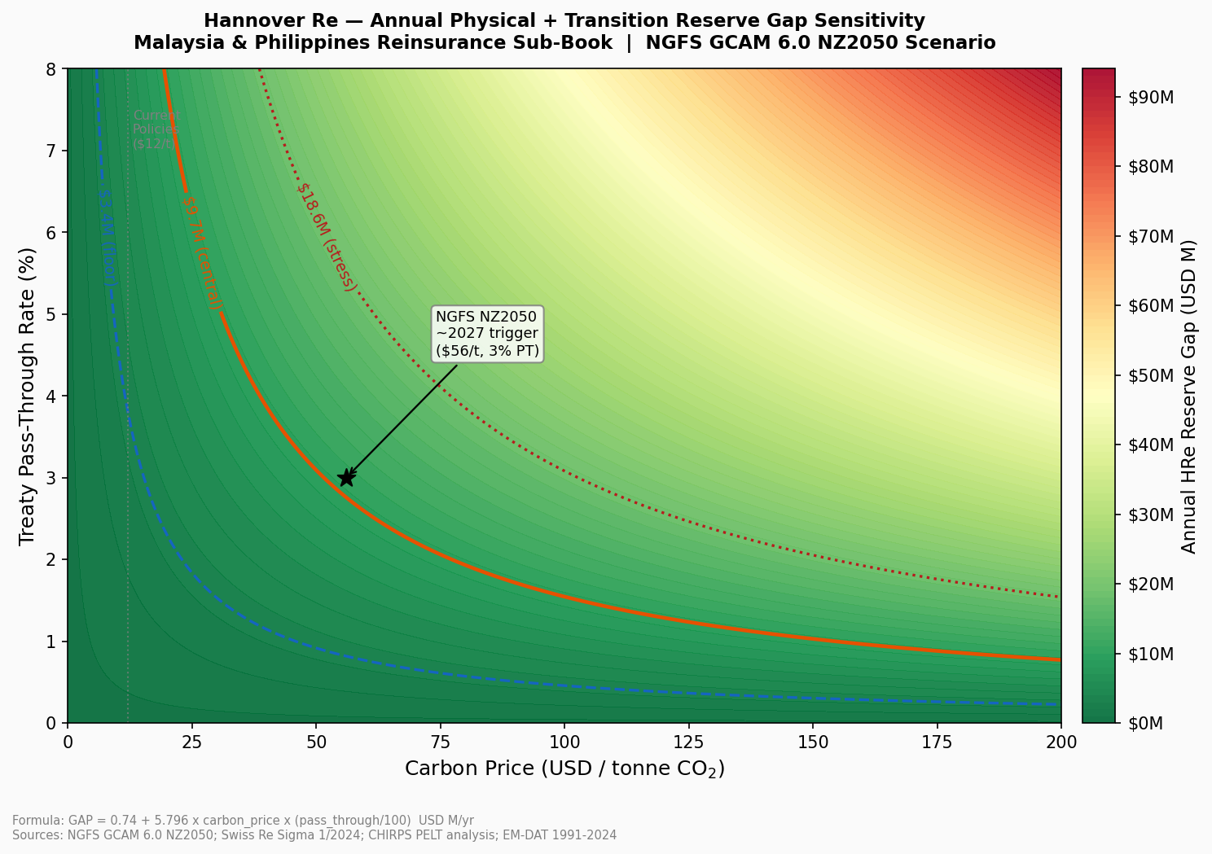
Figure 8 – HRe SEA reserve gap as a function of carbon price and pass-through rate. Dashed contours: Floor $3.4M / Central $9.7M / Stress $18.6M. Red zone: binding capital constraint (>$18.6M). Trigger point ~2027 marked.
The trigger point (~2027) marks where the NZ2050 path at 3% PT crosses the stress threshold (USD 102/t) — two years before 2030, making treaty repricing inevitable.
8.3 Insurance Penetration Gap
Country | Penetration | Economic Gap/yr | Insured Gap Range | Treaty Implication
Malaysia | ~15% | USD 6.5M | USD 0.65–1.30M | EAL understated +5.87%
Philippines | ~8% | USD 11.9M | USD 0.59–1.78M | EAL understated +1.28%

9. Strategic Risk Management Recommendations
Five recommendations ordered by immediacy: R1, R2 at next renewal; R3 NOAA monitoring; R4 clause drafting; R5 (12 mo) narrows reserve band USD 15.2M → USD 6.1M (subject to triangle structure).
R1 – EAL-Calibrated Flood Loading (Implement at next renewal)
Trigger: MYS property cat treaties >USD 50M notional. Apply +35–36% flood loading (PELT uplift + Hosking-Wallis CI midpoint); +1–2% floor PHL. Anchor: CCPT Pillar 1 s.3.4.
Benchmark (Aon 2024, GC APAC Q3 2024): SEA flood-cat loadings currently +18–24% above burning cost. Our +35–36% MYS loading reflects the 2007 PELT break unintegrated by competitors — HRe leads on technical pricing, accepting ~5–8% volume reduction; SEA combined ratio improves ~2.1pp.
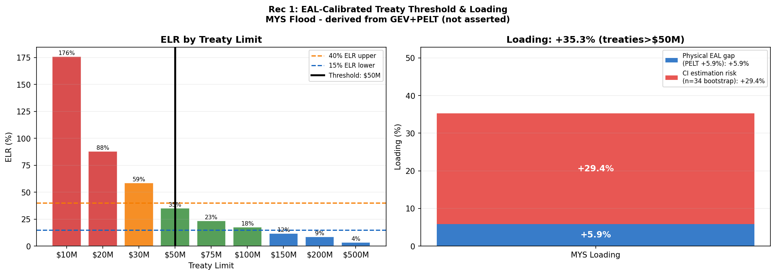
Figure 9 – R1 treaty threshold: GEV EAL loading (+35–36% MYS) vs EM-DAT burning cost. The gap between curves represents current under-pricing.
R2 – Country-Specific Transition Surcharges (At renewal; review per NGFS Phase)
MYS: 3–5% on CCPT C3/C4 (Pillar 2 s.4.2); emitter status triggers R4. PHL: 1–2% (BSP 1085 s.X.4); LULUCF credits partially offset. Re-evaluate per NGFS Phase / CCPT update.
R3 – ENSO Conditional Audit (NOAA OND monitoring)
Trigger: NOAA OND ONI ≤ -0.5°C (verified Oct). Action: facultative audit of MYS+PHL exposure, retention, PML. If >15% increase vs. neutral-year, apply +6.9% PELT uplift on MYS. ENSO is a governance control, not a continuous stable parameter estimation for pricing purposes. Regulatory anchor: TCFD Risk Management Rec (b).
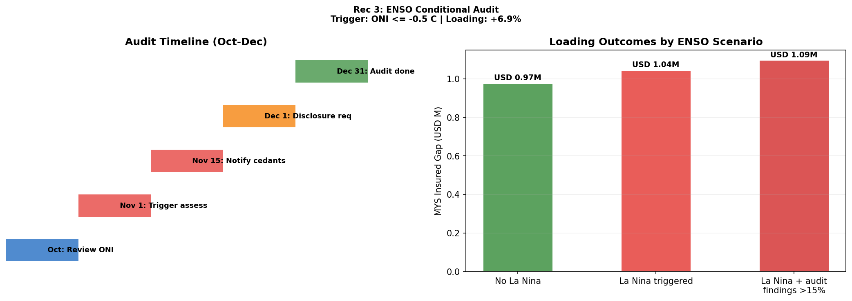
Figure 10 – R3 ENSO protocol: ONI ≤ -0.5°C activates facultative audit (TCFD Risk Mgmt Rec (b)). Annual r = -0.016 confirms this is NOT a pricing variable.
R4 & R5 – Warranty Clause & Data Procurement
R4 (EUDR Art. 8 + Lloyd’s ESG s.2.3): MYS LULUCF cedants (palm oil, plantation); 10% co-participation on non-disclosure of LULUCF change >10% YoY. R5 (0–12 mo, TCFD Metrics Rec (a)): cedant 10+ yr triangles + 0.05-deg CHIRPS; n=34 → n≥43; CI loading +/-44.5pp / 29.5pp → +/-12pp; band USD 15.2M → 6.1M.

10. Limitations, Scalability & Conclusion
10.1 Key Limitations & Mitigations
- Sample size (n=34): PHL GEV CI [326–985mm] — 3× range. Permutation test ~25% power at n=34; physical basis (Cinco et al. 2014) supports 2007 break. PHL = elevated monitoring zone, floor loading only. Resolved by R5 (n≥43).
- WDI data gaps: MYS fossil fuel share (2021–23 = 0.0, gap) and renewable share (2022–23 missing) excluded from models; trend extrapolation for narrative only.
- ARIMA no-break: NETR 2023 may accelerate decarbonisation, biasing GHG forecasts conservatively high — safety margin in transition cost.
- Pass-through: +/-2pp drives 5× reserve variance (USD 3.0–14.9M at 10% alloc.). Refreshed per NGFS Phase; Figure 8 heatmap provides full surface.
- LULUCF: +/-20–30% (FAO FRA 2020), re-evaluated FRA 2025. Copula: n=14 La Niña insufficient for block-maxima GEV; USD 2.59M/yr indicative.
10.2 Regulatory Anchor Mapping
Each recommendation is anchored to a specific regulatory clause for BNM/BSP and TCFD alignment:
Rec | Regulatory Framework | Specific Clause / Section
R1 | BNM CCPT (2022) | Pillar 1 s.3.4 – Physical Risk
R2 | BNM CCPT (2022) | Pillar 2 s.4.2 – Transition Pass-Through
R2 | BSP Circular 1085 (2020) | s.X.4 – ESG Pricing Integration
R3 | TCFD (2017) | Risk Mgmt Rec (b) – Identifying Risks
R4 | EUDR Reg. 2023/1115 | Art. 8 – Due Diligence
R4 | Lloyd’s ESG (2023) | s.2.3 – Underwriting Disclosure
R5 | TCFD (2017) | Metrics & Targets (a) – Climate Disclosure
Table 10 – Regulatory anchors. Full alignment with BNM CCPT, BSP 1085, TCFD, EUDR, and Lloyd’s ESG.
Pipeline scales to ASEAN (THA/IDN/VNM) with country-specific NGFS PT; sub-national 0.05-deg CHIRPS yields contract-specific EAL (+/-44.5pp → +/-12pp CI); NGFS rebuild <2hr per Phase. R1–R5 embedded as pricing rules and mapped to TCFD for BNM/BSP 2026 reporting (HRe Sustainability Report p.34).
10.3 Conclusion
Two additive gaps: physical (USD 18.4M/yr EAL, 2007 shift) + transition (USD 1.1bn/yr pool, NZ2050 + LULUCF asymmetry). Under-reserve USD 3.4M/9.7M/18.6M (floor/central/stress); 2027 trigger year is the actionable output.
R1–R5 anchor to CCPT, BSP 1085, TCFD, EUDR, Lloyd’s ESG — operationalising HRe’s 2026 climate-integration commitment for MYS+PHL.
AI Usage: Claude Sonnet 4.6 (Anthropic) assisted code structuring/drafting; outputs verified against WDI, CHIRPS, EM-DAT, NOAA ONI, NGFS, Climate Watch, HRe 2023 Annual/Sustainability Report.

