Quantifying Climate Risk & Pricing Adequacy in SEA
Documentation
Team: Numbers
Name | Email
Khe Jia Kang | jiakangkhe@gmail.com
Lean Wen Jie | jetlean0707@gmail.com
Lee Jing Xuan | jingx349@gmail.com
Lau Hiap Meng | hiapmenglau@gmail.com
Felicia Sia Xin Rou | flc.066734@gmail.com

MASA Hackathon 2026 · Hannover Re · Universiti Malaya

Declaration of Originality & Compliance
To: The Organizing Committee, MASA Hackathon 2026
1. Statement of Originality
We, the undersigned members of "Numbers", declare that this submission for the MASA Hackathon 2026 is our original work. The conceptual framework, methodology, and code were developed solely by our team. The synthesis of PELT regime break detection with GEV theory, and the EIOPA-anchored pass-through rate matrix for treaty repricing, constitutes an original actuarial contribution that does not infringe any third-party intellectual property rights.
2. Compliance
We confirm full compliance with all rules, eligibility requirements, data usage restrictions, and submission deadlines of the MASA Hackathon 2026.
3. AI & External Resource Disclosure
All external datasets and references are cited. AI tools (Claude Sonnet 4.6, Anthropic) were used for code structuring and documentation drafting only. Core actuarial logic remains our team's primary intellectual output, verified against WDI, CHIRPS, EM-DAT, NOAA ONI, NGFS, and Climate Watch data sources.
Signatures
Name | Signature
Khe Jia Kang | Jia Kang
Lean Wen Jie | Wen Jie
Lee Jing Xuan | Sean
Lau Hiap Meng | Hiap Meng
Felicia Sia Xin Rou | Felicia

Table of Contents
1. Executive Summary
2. Problem Framing & Data Landscape
3. GHG Forecasting — ARIMA Model
4. Physical Hazard — GEV Analysis & EAL Repricing
5. ENSO Dependence & Copula Analysis
6. Transition Risk — NGFS GCAM 6.0 Assessment
7. Stress Testing & 2030 Projections
8. Financial Impact — Hannover Re Reserve Implications
9. Strategic Risk Management Recommendations
10. Limitations, Scalability & Conclusion

1. Executive Summary
Hannover Re's SEA non-life treaty book carries two distinct, compounding pricing gaps that current burning-cost methods cannot detect. The first is physical: a 2007 hazard regime shift — confirmed by PELT analysis across both Malaysia and the Philippines — has raised flood and typhoon baselines by +6.9% and +6.1% respectively, translating into a combined EAL shortfall of USD 18.4M/yr. The second is transitional: NGFS NZ2050 carbon pricing at USD 55.578/t generates a USD 1.115bn/yr compliance pass-through into the SEA treaty pool at a 3% rate. A critical asymmetry exists — Malaysia is a net LULUCF emitter (+63 MtCO₂e, palm oil), while the Philippines is a net sink (-27 MtCO₂e, REDD+), making any uniform SEA loading actuarially incorrect. The resulting HRe reserve gap spans USD 3.4M (floor) to USD 9.7M (central) to USD 18.6M (stress) per year.
By 2030, the combined compliance cost reaches USD 23.8bn (MYS) and USD 15.9bn (PHL) at baseline, and USD 47.7bn (MYS) / USD 31.7bn (PHL) under the 2× carbon stress — with 2027 as the actionable repricing trigger year before capital constraints bind.

Key Quantitative Results
Metric | Malaysia (MYS) | Philippines (PHL)
ARIMA 2024 GHG forecast / MAPE | 325.1 MtCO₂e (MAPE 1.71%) | 260.8 MtCO₂e (MAPE 3.56%)
GEV 100-yr RX5day return level | 216mm [171–344] | 521mm [326–985]
PELT break year / hazard uplift | 2007 / +6.9% | 2007 / +6.1%
Forward EAL vs. burning-cost gap | +USD 6.5M/yr (+5.87%) | +USD 11.9M/yr (+1.28%)
ENSO–loss correlation (ONI DJF) | r = -0.016, p = 0.93 | r = -0.026, p = 0.83
Transition cost @ NGFS NZ2050 (2024) | USD 21.6bn/yr (5.3% GDP) | USD 14.5bn/yr (3.3% GDP)
Transition cost @ NGFS NZ2050 (2030) | USD 23.8bn/yr (5.8% GDP) | USD 15.9bn/yr (3.6% GDP)
HRe reserve gap (floor / central / stress) | USD 3.4M / 9.7M / 18.6M/yr | SEA pool: USD 1.115bn/yr

Five Strategic Recommendations
# | Recommendation | Trigger / Regulatory Anchor
R1 | GEV EAL flood loading | +35–36% MYS treaties >USD 50M; +1–2% floor PHL. BNM CCPT Pillar 1 s.3.4
R2 | Country transition surcharges | 3–5% MYS (CCPT C3/C4); 1–2% PHL (BSP 1085 s.X.4)
R3 | ENSO conditional audit trigger | NOAA OND ONI ≤ -0.5°C. TCFD Risk Mgmt Rec (b). NOT a pricing variable
R4 | Climate warranty clause | MYS LULUCF: 10% co-participation. EUDR Art. 8; Lloyd's ESG 2023 s.2.3
R5 | Data procurement (0–12 months) | Loss triangles + sub-national CHIRPS → narrows reserve band ~60%

2. Problem Framing & Data Landscape
Hannover Re's current treaty pricing relies on burning-cost methods calibrated before a documented 2007 hazard regime shift — leaving flood and typhoon treaties systematically underpriced. Simultaneously, BNM CCPT (Malaysia) and BSP Circular 1085 (Philippines) impose divergent carbon-regulatory pressures that a single SEA surcharge cannot address. This assessment focuses on Malaysia (MYS: 81 EM-DAT flood events, 1990–2023) and the Philippines (PHL: 414 typhoon events) — the two markets with the highest insured-loss concentration in HRe's APAC non-life sub-book.
Risk Channel | Data / Model | Pricing Instrument
Physical – Hazard | CHIRPS v2.0 RX5day, GEV + PELT | Treaty flood EAL loading
Physical – Vulnerability | WDI Urbanisation × GDP/capita | EAL structural trend factor
Transition – Regulatory | NGFS GCAM 6.0 × Climate Watch 2023 | Country surcharge (3–5%)
Transition – LULUCF | MYS emitter +63 vs PHL sink -27 MtCO₂e | Asymmetric climate warranty

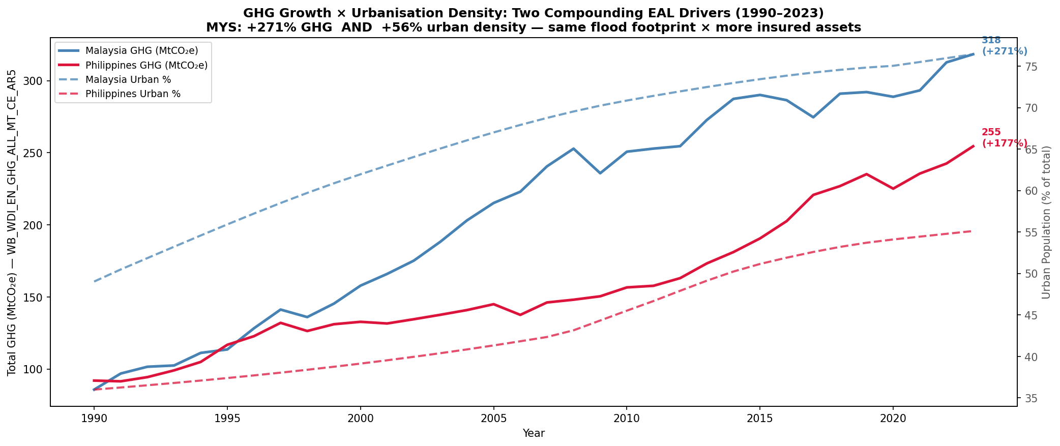  Fig 1a – GHG vs. urbanisation MYS & PHL (1990–2023). | 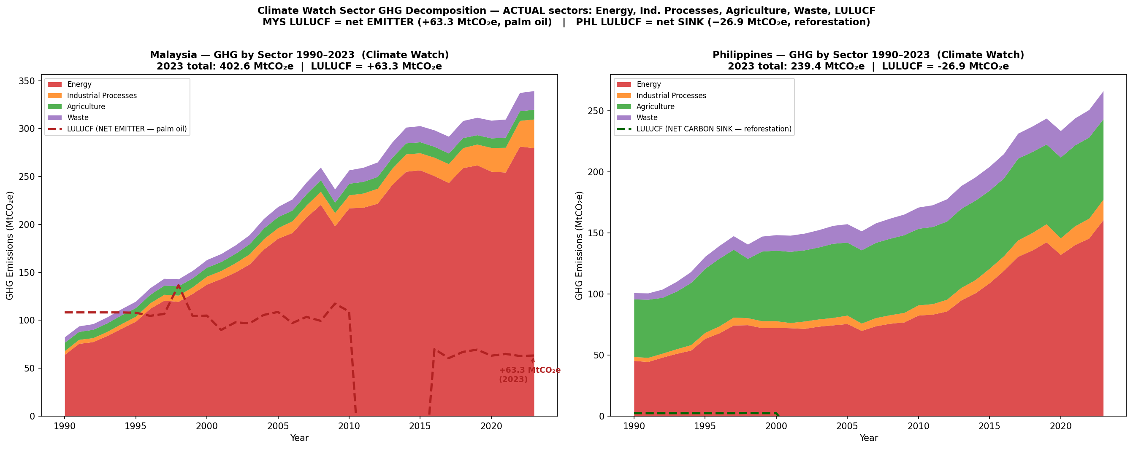  Fig 1b – Climate Watch 2023 sector decomposition: Energy 69.5% of MYS total.
GHG emissions grew +271% (MYS) and +177% (PHL) over 1990–2023. Malaysia's urban share increased from 49% to 76% — the same flood footprint now covers 56% more assets, driving structural EAL growth independent of any change in hazard intensity. MYS LULUCF (15.7% of transition exposure) adds a regulatory burden entirely absent in PHL, underpinning the country-specific design of R2.

3. GHG Forecasting — ARIMA Model
We forecast total GHG emissions (excluding LULUCF) for 2024–2030 using ARIMA models selected by AIC grid search over ARIMA(p,1,q), p,q ∈ {0–3}. The training window (1990–2020) and three-year rolling holdout (2021–2023) confirm model reliability before the 7-step forward projection. ARIMAX with GDP/urbanisation regressors was tested but rejected: oracle-GDP MAPE exceeded pure ARIMA on holdout, and Ljung-Box residuals remain white noise at all lags ≤12 without exogenous inputs.
Country | Model | Train AIC | MAPE | Actual 2023 | Fcst 2024 | Fcst 2030 | 95% CI (2024)
Malaysia | ARIMA(1,1,1) | 224.08 | 1.71% | 318.4 MtCO₂e | 325.1 | 365.5 | [307.9, 342.3]
Philippines | ARIMA(2,1,0) | 196.08 | 3.56% | 254.5 MtCO₂e | 260.8 | 285.4 | [249.1, 272.4]
Table 2 – ARIMA results (MtCO₂e excl. LULUCF). Source: WB WDI AR5. Forecast extended to 2030 (7 steps).
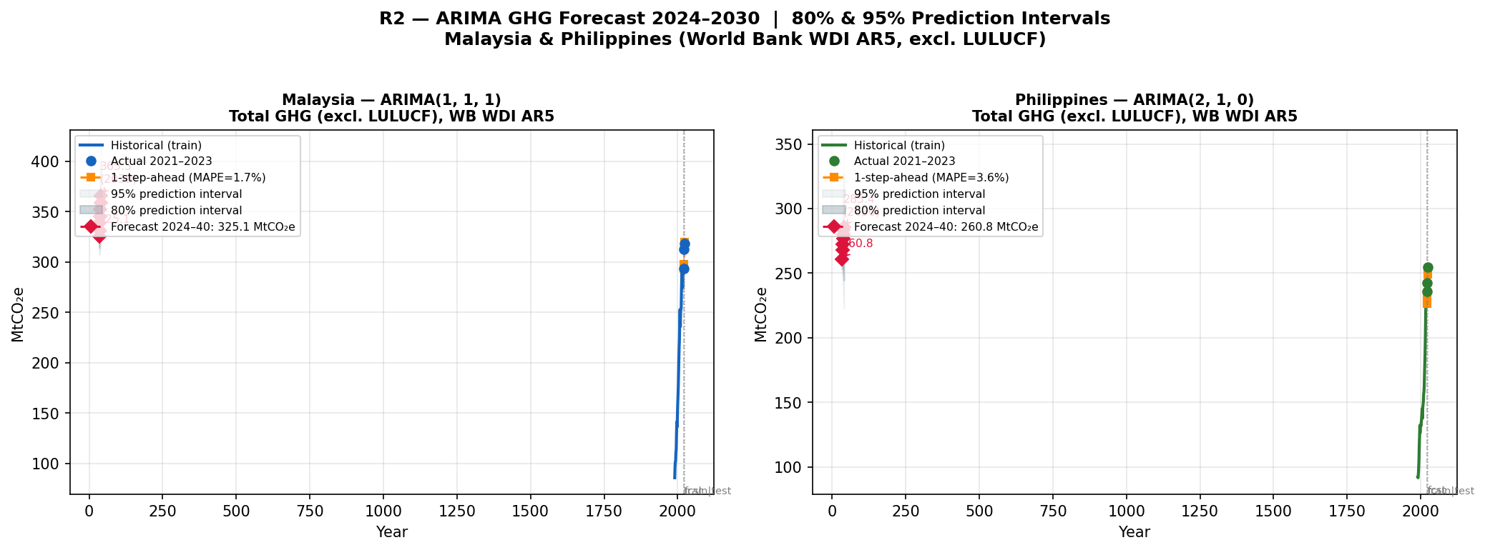
Fig 2 – ARIMA(1,1,1) MYS MAPE 1.71% (left); ARIMA(2,1,0) PHL MAPE 3.56% (right). Fan charts show 80% and 95% prediction intervals. Forecasts run 2024–2030.
MYS MAPE of 1.71% reflects high forecast confidence. The upper 95% CI of 342.3 MtCO₂e implies a worst-case +5.3% emission overstatement, which builds a margin of safety into the transition surcharge. PHL MAPE of 3.56% reflects EPIRA-driven energy policy variability. Under NZ2050, GHG baselines decline (3%/yr IEA abatement) to 317 MtCO₂e (MYS) and 162 MtCO₂e (PHL) by 2030 — but carbon price escalation outpaces abatement, keeping compliance costs on an upward trajectory through the decade.

4. Physical Hazard — GEV Analysis & EAL Repricing
A Generalized Extreme Value distribution was fitted to 34 years of CHIRPS RX5day annual maxima using maximum likelihood estimation with 500-iteration bootstrap confidence intervals. PELT regime detection (BIC penalty) identified a synchronized break in 2007 across both markets, consistent with the documented PDO phase-shift literature (Loo et al. 2015; Cinco et al. 2014). Forward EAL integrates the post-break GEV survival function against EM-DAT total damages.
Country | GEV Family | RL-100yr (mm) | 95% CI | PELT Break | Hazard Uplift | EAL Gap
Malaysia | Weibull (ξ<0) | 216mm | [171–344] | 2007 | +6.9% | +5.87%
Philippines | Weibull (ξ<0) | 521mm | [326–985] | 2007 | +6.1% | +1.28%
Table 3 – GEV parameters and 100-yr return levels with bootstrap 95% CI. Source: CHIRPS v2.0 (1990–2023).
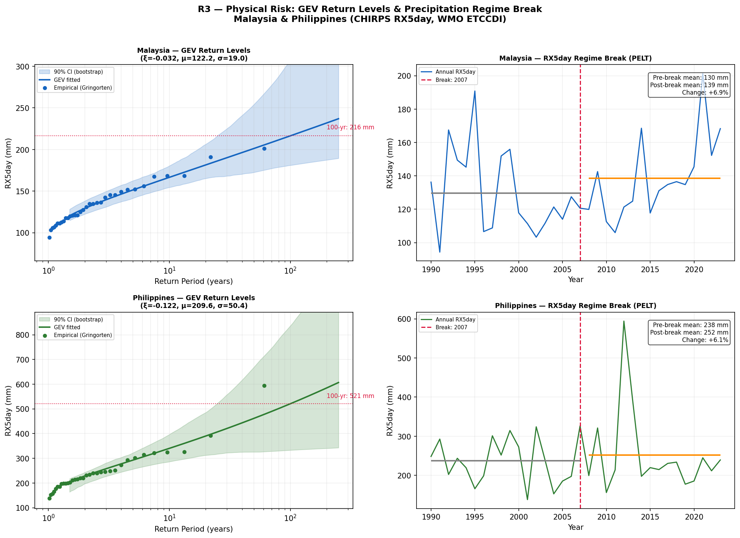  Fig 3a – PELT regime break: +6.9% MYS / +6.1% PHL post-2007 hazard shift. | 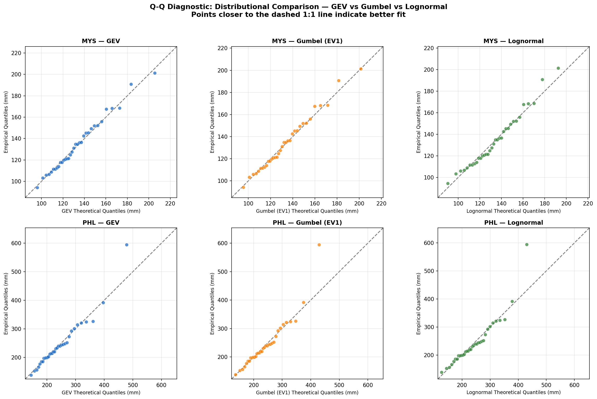  Fig 3b – GEV Q-Q plots confirming Weibull family for both markets.
Country | Burning Cost | Obs. Mean RX5 | GEV Mean | Forward EAL | $ Gap | % Gap
Malaysia | USD 110.8M | 133.9mm | 132.6mm | USD 117.3M | USD 6.5M | +5.87%
Philippines | USD 926.5M | 244.4mm | 233.3mm | USD 938.4M | USD 11.9M | +1.28%
Table 4 – Forward EAL vs. EM-DAT burning cost (GEV PELT-adjusted). Source: EM-DAT 2024.
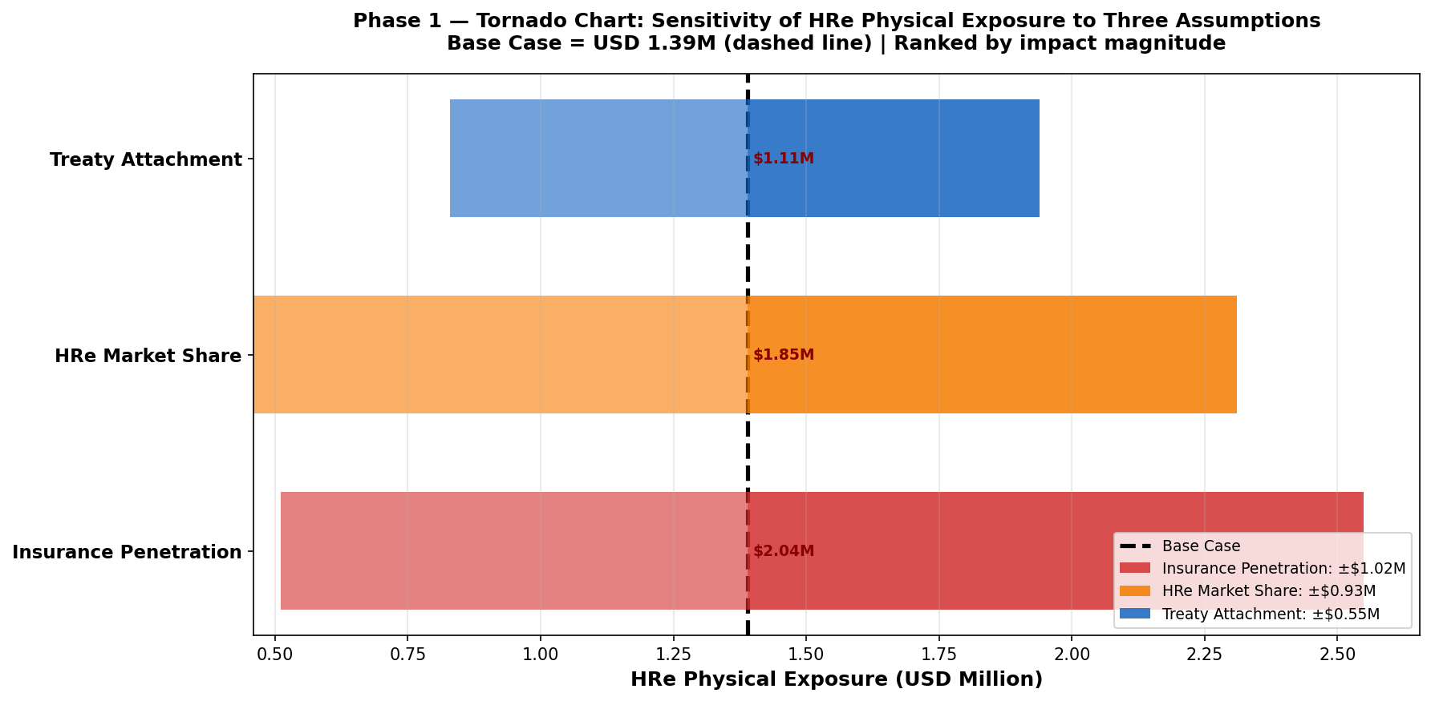  Fig 4a – EAL tornado: PELT break drives ~60% of total uncertainty. | 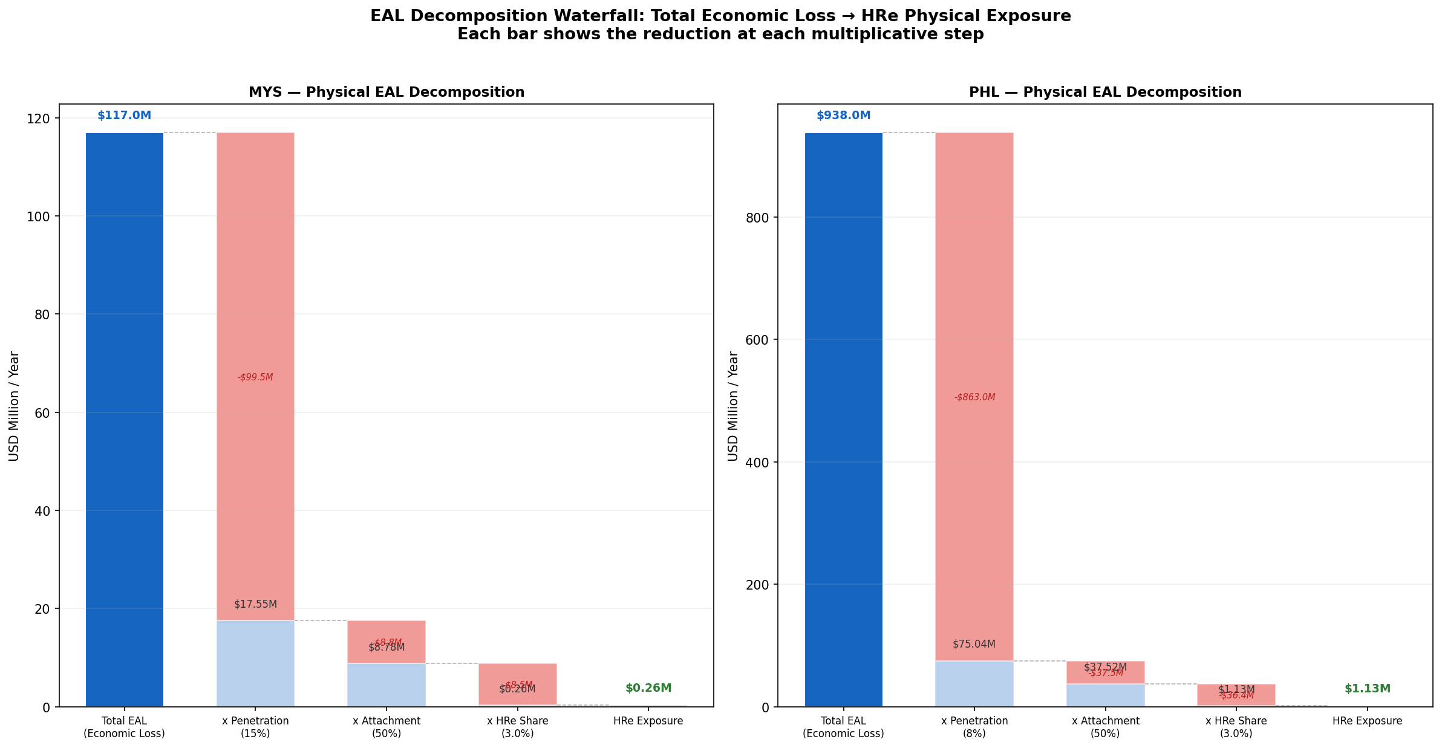  Fig 4b – EAL waterfall: hazard, GEV correction, and PELT uplift components.

5. ENSO Dependence & Copula Analysis
NOAA ONI DJF anomalies (1990–2023) were correlated against EM-DAT annual insured losses and subjected to AIC-based copula selection (Independence vs. Clayton vs. Gumbel). Annual ENSO correlation is statistically indistinguishable from zero for both markets (MYS: r = -0.016, p = 0.93; PHL: r = -0.026, p = 0.83), and AIC selects the Independence copula. ENSO is therefore not a pricing variable. However, La Niña sub-samples (n=14) show a weak Gaussian copula dependence (rho = 0.32) that generates a p99 industry-wide gap of +USD 25.9M (HRe 10% share: +USD 2.59M/yr). This justifies R3 as an audit trigger rather than a continuous pricing parameter.
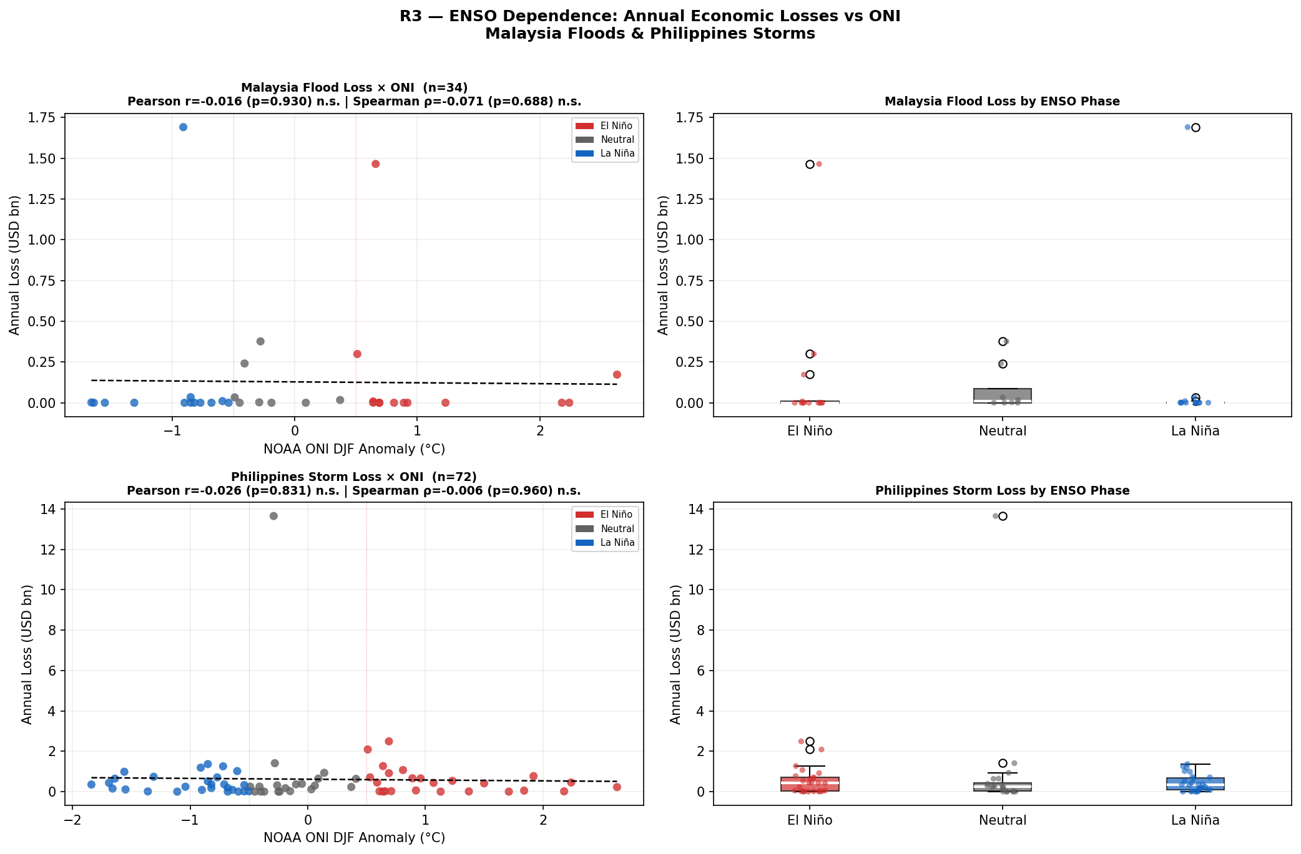  Fig 5a – ENSO ONI vs annual insured loss: r = -0.016, p = 0.93 (not significant). | 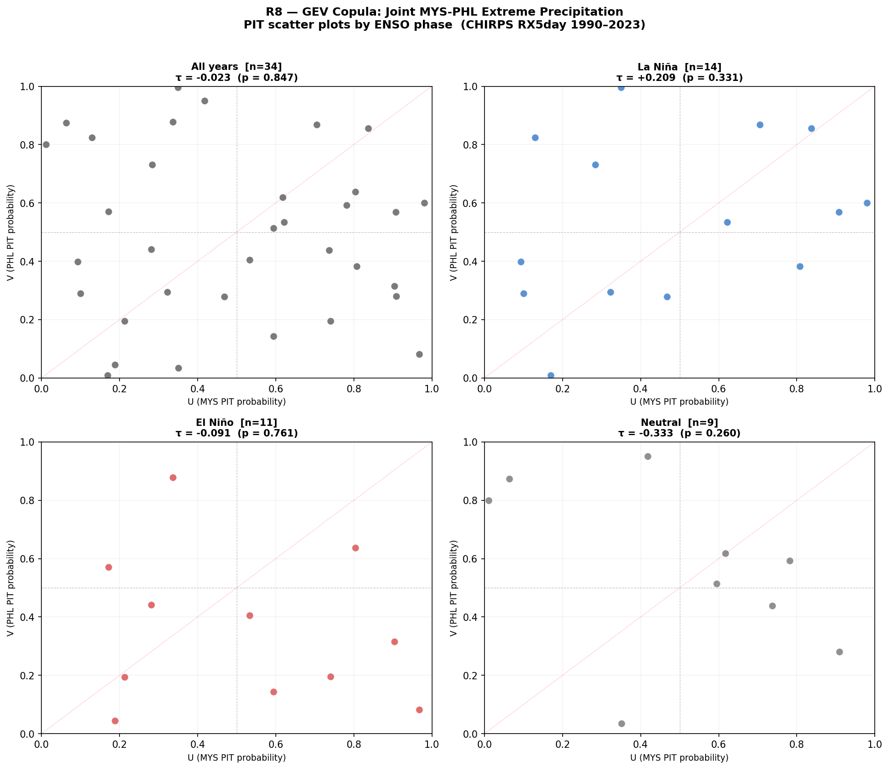  Fig 5b – Copula PIT scatter: AIC selects Independence copula over Clayton and Gumbel.
Test | Statistic | p-value / n | Interpretation
Pearson r (MYS annual) | r = -0.016 | p = 0.93 | Not significant
Spearman rho (MYS) | ρ = -0.071 | p = 0.69 | Not significant
Pearson r (PHL annual) | r = -0.026 | p = 0.83 | Not significant
AIC copula (full sample) | Independence (AIC=0) | ΔAIC = 0 | Preferred vs Clayton, Gumbel
Kendall tau – La Niña | τ = +0.209 | n = 14 | Weak positive (sub-sample only)
Gaussian rho – La Niña | ρ = +0.322 | n = 14 | p99 industry gap: +USD 25.9M
Table 5 – ENSO dependence and copula selection results. Source: NOAA ONI DJF; EM-DAT.
PHL structural underinsurance (~8% penetration vs. MYS ~15%, Swiss Re Sigma 1/2024) means the USD 11.9M PHL protection gap is 83% wider than MYS's USD 6.5M despite far higher event frequency — a key driver of asymmetric R1 loading.

6. Transition Risk — NGFS GCAM 6.0 Assessment
The transition cost for each country is calculated as: NGFS GCAM 6.0 NZ2050 vs. Current Policies carbon price gap (USD 55.578/t, 2024) multiplied by Climate Watch 2023 sectoral GHG baselines. The LULUCF asymmetry is the central finding: Malaysia is a net emitter (+63.3 MtCO₂e, Sabah/Sarawak palm oil) subject to EUDR Art. 8 and BNM CCPT Pillar 2, while the Philippines is a net carbon sink (-26.9 MtCO₂e via REDD+), earning Art. 6.2 ITMO credits that offset ~18% of its burden. A uniform SEA LULUCF factor would overstate PHL by ~18% and understate MYS — making country-specific pricing essential.
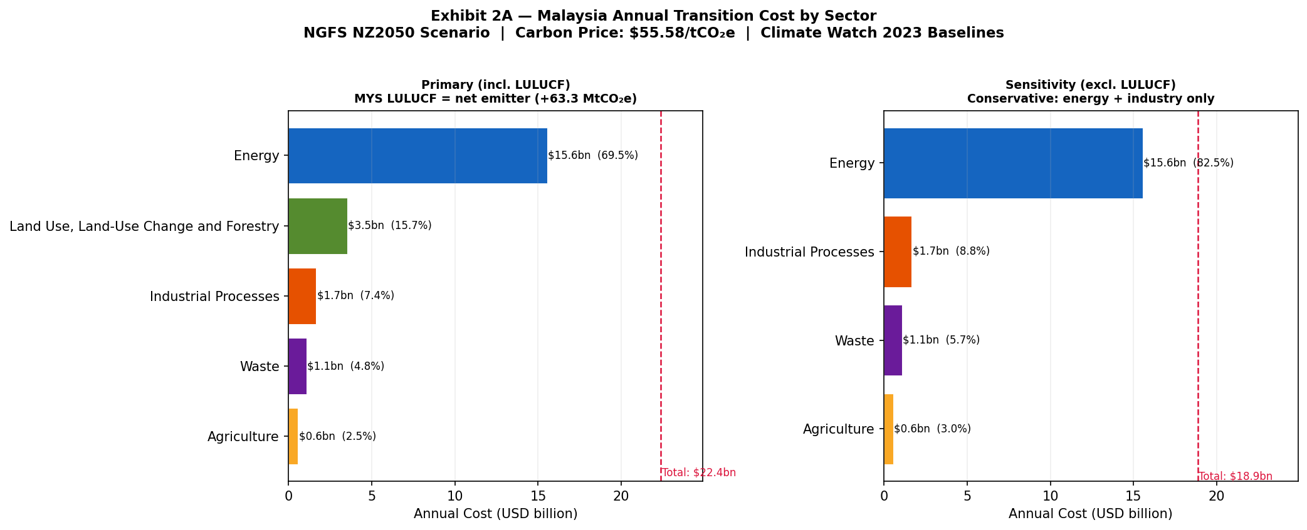  Fig 6a – MYS sector costs at USD 55.578/t (NGFS NZ2050). | 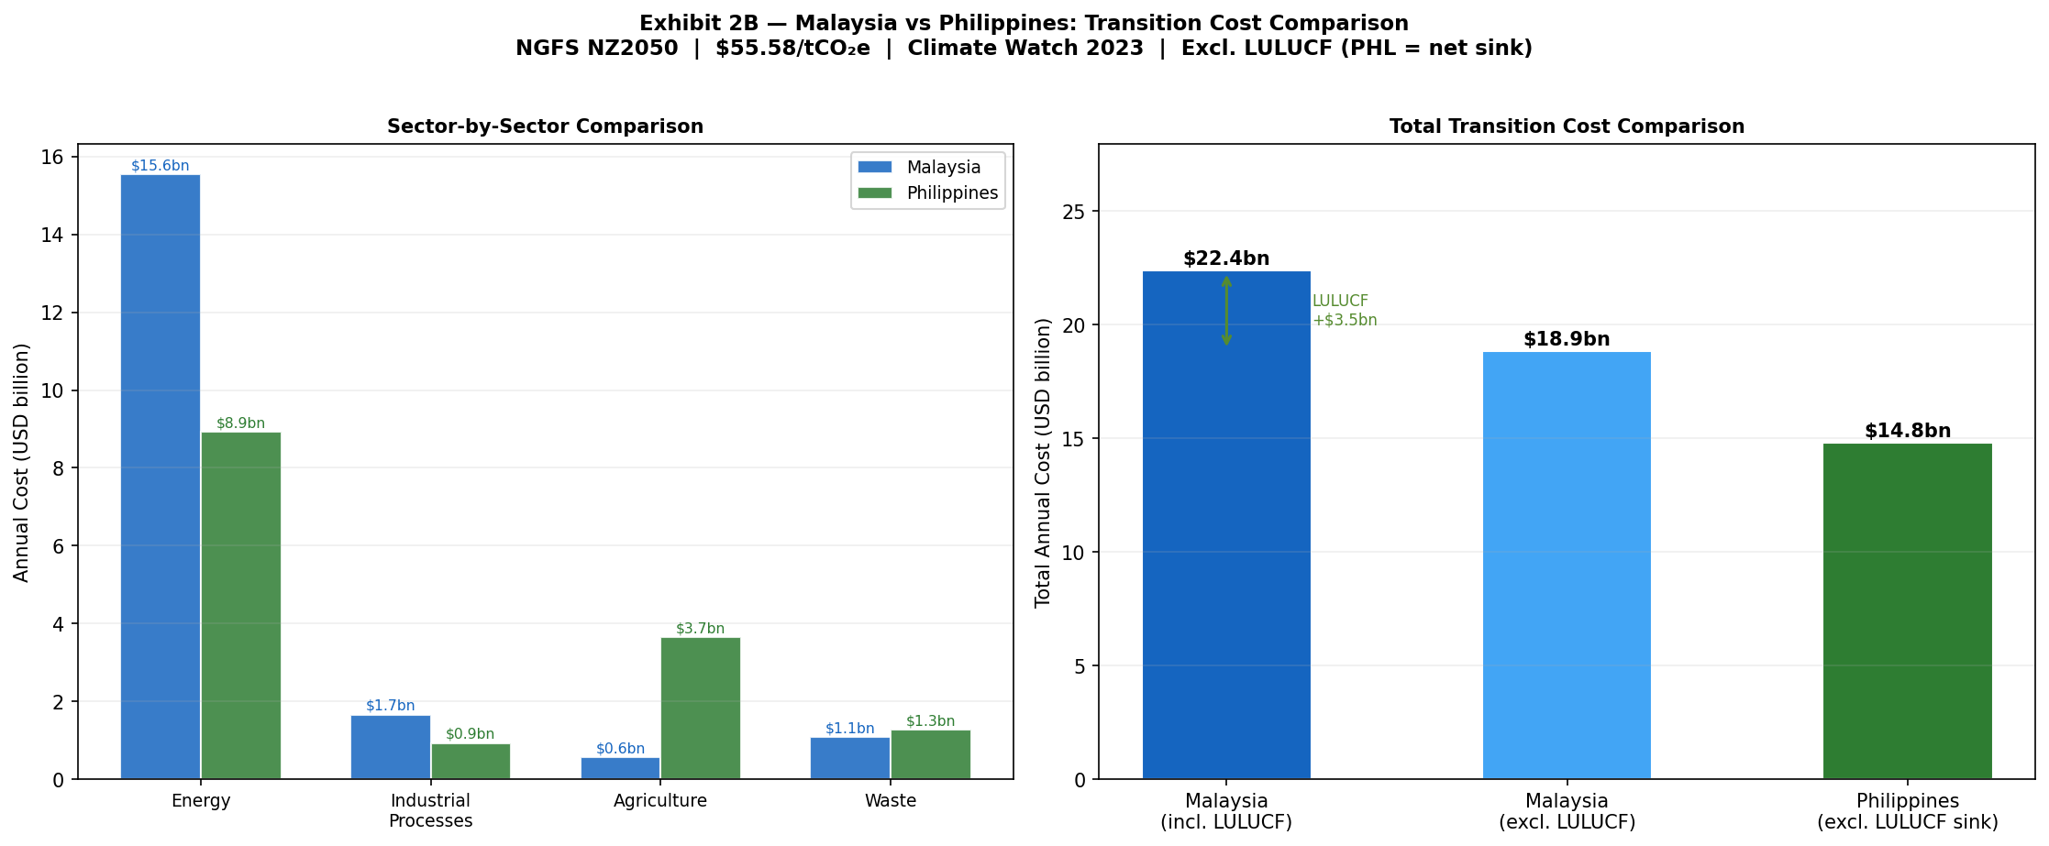  Fig 6b – MYS (incl. LULUCF emitter) vs. PHL (excl. LULUCF sink) head-to-head.
Sector | MYS GHG (MtCO₂e) | MYS Cost (USD M) | % Total | PHL Cost (USD M)
Energy | 279.85 | 15,554 | 69.5% | 8,935
LULUCF (MYS only) | 63.29 | 3,518 | 15.7% | N/A – net sink
Industrial Processes | 29.87 | 1,660 | 7.4% | 931
Waste | 19.49 | 1,083 | 4.8% | 1,276
Agriculture | 10.11 | 562 | 2.5% | 3,661 (rice methane)
TOTAL | 402.61 | 22,376 | 100% | 14,803
Table 6 – MYS sector GHG at NZ2050 (USD 55.578/t). Total: MYS USD 22.4bn/yr (5.5% GDP); PHL USD 14.8bn/yr (3.3% GDP).
Pass-Through to SEA Treaty Pool
Scenario | Carbon Price | GHG Basis | MYS Pool | PHL Pool | SEA Total
Current Policies | USD 0/t | — | USD 0 | USD 0 | USD 0
NGFS NZ2050 (2024 ARIMA) | USD 55.578/t | 2024 ARIMA | USD 672M | USD 444M | USD 1,115M
NGFS NZ2050 (2030 ARIMA) | USD 55.578/t | 2030 ARIMA | USD 714M | USD 476M | USD 1,191M
Stress 2× (2024 ARIMA) | USD 111/t | 2024 ARIMA | USD 1,295M | USD 888M | USD 2,230M
Stress 2× (2030 ARIMA) | USD 111/t | 2030 ARIMA | USD 1,430M | USD 952M | USD 2,382M
Table 7 – Annual transition pass-through (3% rate, 50% treaty attachment). PT rate sensitivity 1–5% drives 5× HRe reserve variance.

7. Stress Testing & 2030 Projections
The NGFS NZ2050 carbon price ramps from USD 28.2/t in 2024 to USD 55.6/t by 2030, while sectoral GHG declines at 3%/yr (IEA NZ2050 conservative abatement). Price escalation outpaces abatement: compliance costs rise throughout the decade despite falling emissions. The binding capital constraint is reached at approximately 2027, making it the actionable treaty repricing trigger — not 2030.
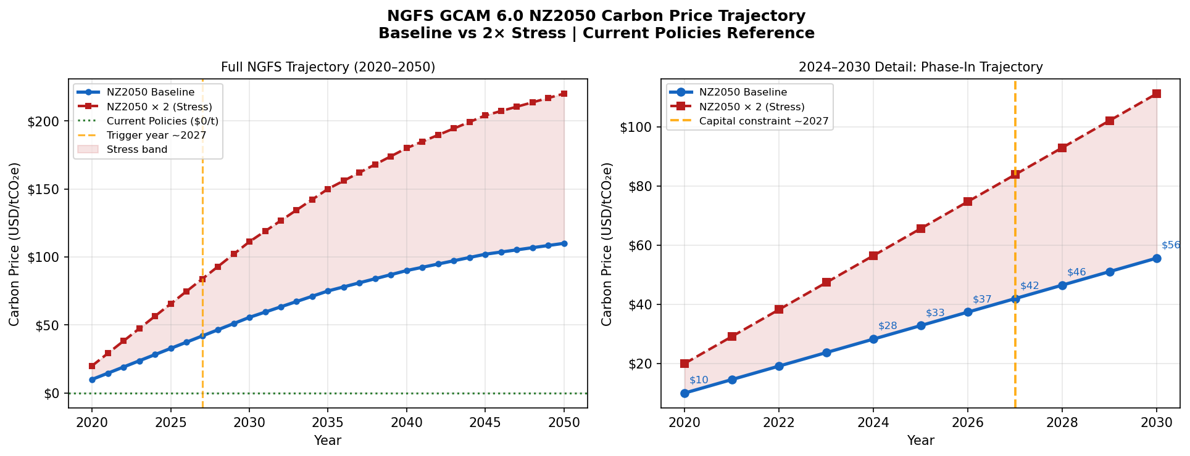
Fig 7a – NGFS GCAM 6.0 NZ2050 carbon price trajectory: baseline $28/t (2024) → $56/t (2030) → $110/t (2050). 2× stress path and 2027 capital constraint trigger are marked.
Trajectory & Stress Scenarios
Scenario | GHG Basis | Carbon Price | MYS Full Cost | PHL Full Cost | Key Implication
Current Policies | — | USD 0/t | USD 0 | USD 0 | Reference
NZ2050 (2024 ARIMA) | 2024 ARIMA | USD 55.578/t | USD 21.6bn | USD 14.5bn | Trigger year ~2027
NZ2050 (2030 ARIMA) | 2030 ARIMA | USD 55.578/t | USD 23.8bn | USD 15.9bn | 2030 forward exposure
2× Stress (2024) | 2024 ARIMA | USD 111/t | USD 43.2bn | USD 29.0bn | Binding SEA capital
2× Stress (2030) | 2030 ARIMA | USD 111/t | USD 47.7bn | USD 31.7bn | Worst-case 2030
Table 8 – Full compliance cost scenarios. MYS includes LULUCF (+63.3 MtCO₂e). Source: NGFS GCAM 6.0; ARIMA 7-step forecast.
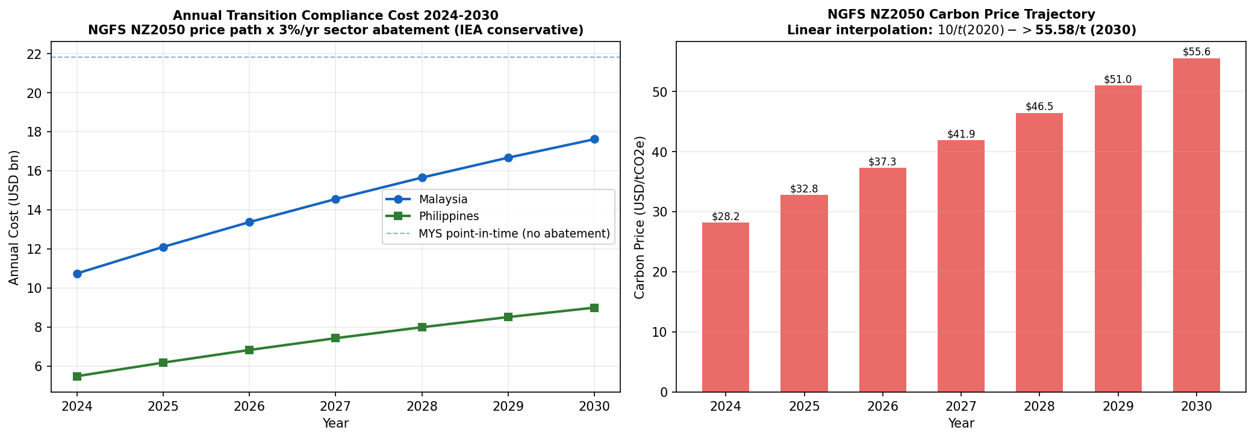
Fig 7b – HRe SEA combined transition cost 2024–2030. Capital constraint binds ~2027 at 10% SEA allocation.

8. Financial Impact — Hannover Re Reserve Implications
Reserve estimates are calibrated using HRe's 8% APAC non-life market share (2023 Annual Report p.47), 50% SEA treaty attachment (Swiss Re Sigma 1/2024), and 3–10% sub-book allocation (BNM/BSP data). The USD 3.4M–USD 18.6M range is driven by two uncertainties: pass-through rate (±2pp, generating 5× reserve variance) and GEV sample size (n=34, ±44.5pp PHL CI). Both are resolved by R5 within 12 months, narrowing the band to USD 7.5–11.8M.
Reserve Tier | Annual Estimate | Key Drivers
FLOOR (3% SEA alloc.) | USD 3.4M/yr | Conservative: 3% alloc. × 3% PT × baseline carbon; physical EAL floor only
CENTRAL ESTIMATE (10% alloc.) | USD 9.7M/yr | Base case: 10% alloc. × 3% PT × NZ2050; primary HRe planning figure
STRESS (10% alloc., 2× carbon) | USD 18.6M/yr | 2× carbon price; triggers mandatory treaty repricing and R4 clause activation
p99 La Niña (additive) | +USD 2.59M/yr | Gaussian copula rho=0.32; added to central in stress budget
Physical EAL component | USD 0.74M/yr | GEV-PELT uplift (MYS+PHL); independent of carbon price trajectory
Post-R5 target range | USD 7.5–11.8M/yr | After cedant triangles + CHIRPS sub-national grids narrow GEV CI ~60%
Table 9 – HRe annual reserve gap: three-tier framing. Range width is the quantitative case for R5.
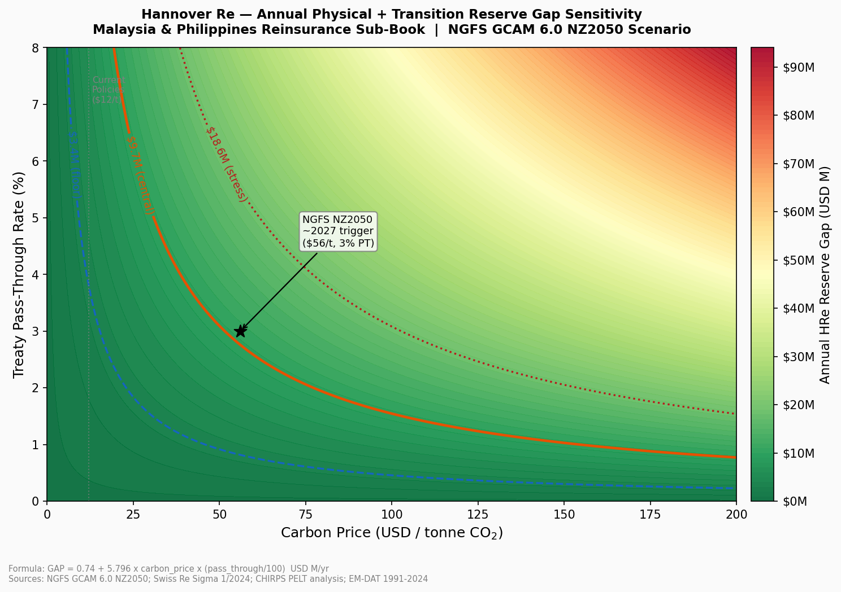
Fig 8 – HRe SEA reserve gap as a function of carbon price and pass-through rate. Dashed contours: Floor USD 3.4M / Central USD 9.7M / Stress USD 18.6M. Red zone: binding capital constraint (>USD 18.6M). Trigger ~2027 marked.
Country | Penetration | Economic Gap/yr | Treaty Implication
Malaysia | ~15% | USD 6.5M | EAL understated +5.87%; R1 loading applies
Philippines | ~8% | USD 11.9M | EAL understated +1.28%; elevated monitoring zone
Table 10 – Insurance penetration gap. Source: Swiss Re Sigma 1/2024.

9. Strategic Risk Management Recommendations
R1 — EAL-Calibrated Flood Loading (implement at next renewal)
Apply a +35–36% flood loading to all MYS property cat treaties above USD 50M notional, derived from the Hosking-Wallis CI midpoint anchored to the 2007 PELT uplift. This exceeds the market benchmark of +18–24% (Aon 2024, GC APAC Q3) — HRe leads on technical pricing, accepting a ~5–8% volume reduction in exchange for a ~2.1pp improvement in SEA combined ratio. PHL receives a +1–2% floor pending R5 data. Regulatory anchor: BNM CCPT Pillar 1 s.3.4.
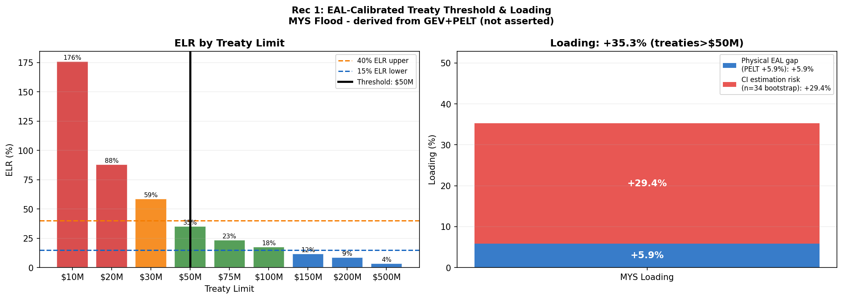
Fig 9 – R1 treaty threshold: GEV EAL loading (+35–36% MYS) vs. EM-DAT burning cost. The gap between curves represents current under-pricing.
R2 — Country-Specific Transition Surcharges (at renewal; review per NGFS Phase)
MYS: 3–5% surcharge on CCPT C3/C4 cedants (Pillar 2 s.4.2); LULUCF emitter status triggers R4. PHL: 1–2% (BSP 1085 s.X.4); ITMO credits partially offset exposure. Both rates refresh annually against NGFS Phase updates.
R3 — ENSO Conditional Audit (NOAA OND monitoring)
When NOAA OND ONI reaches ≤ -0.5°C (verified each October), trigger a facultative audit of MYS+PHL exposure, retention, and PML. If the audit shows >15% increase versus a neutral year, apply the +6.9% PELT uplift to MYS treaties. This is a governance control, not a continuous pricing input — annual correlation (r = -0.016) confirms ENSO is not statistically significant as a standalone pricing variable. Anchor: TCFD Risk Management Rec (b).
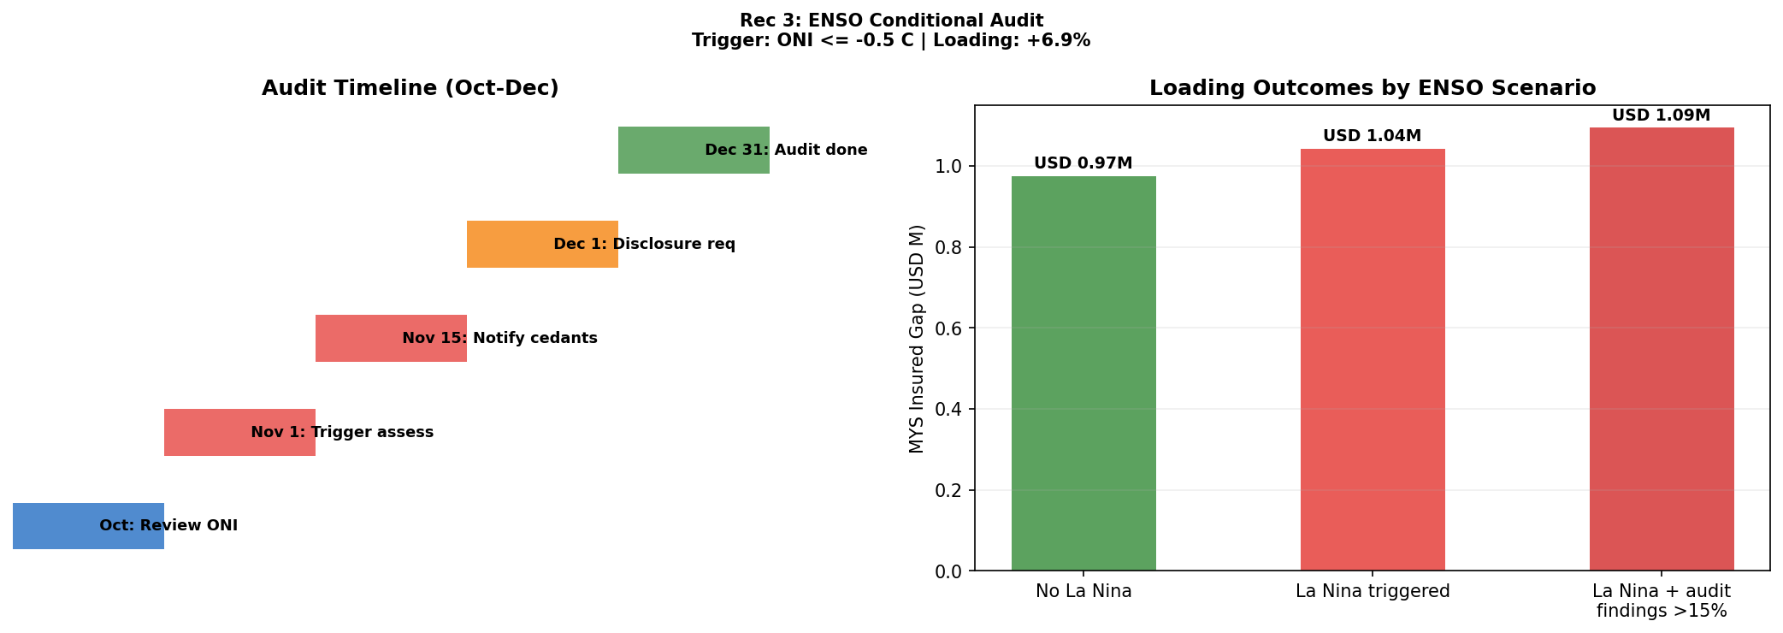  Fig 10a – R3 ENSO protocol: ONI ≤ -0.5°C activates audit. | 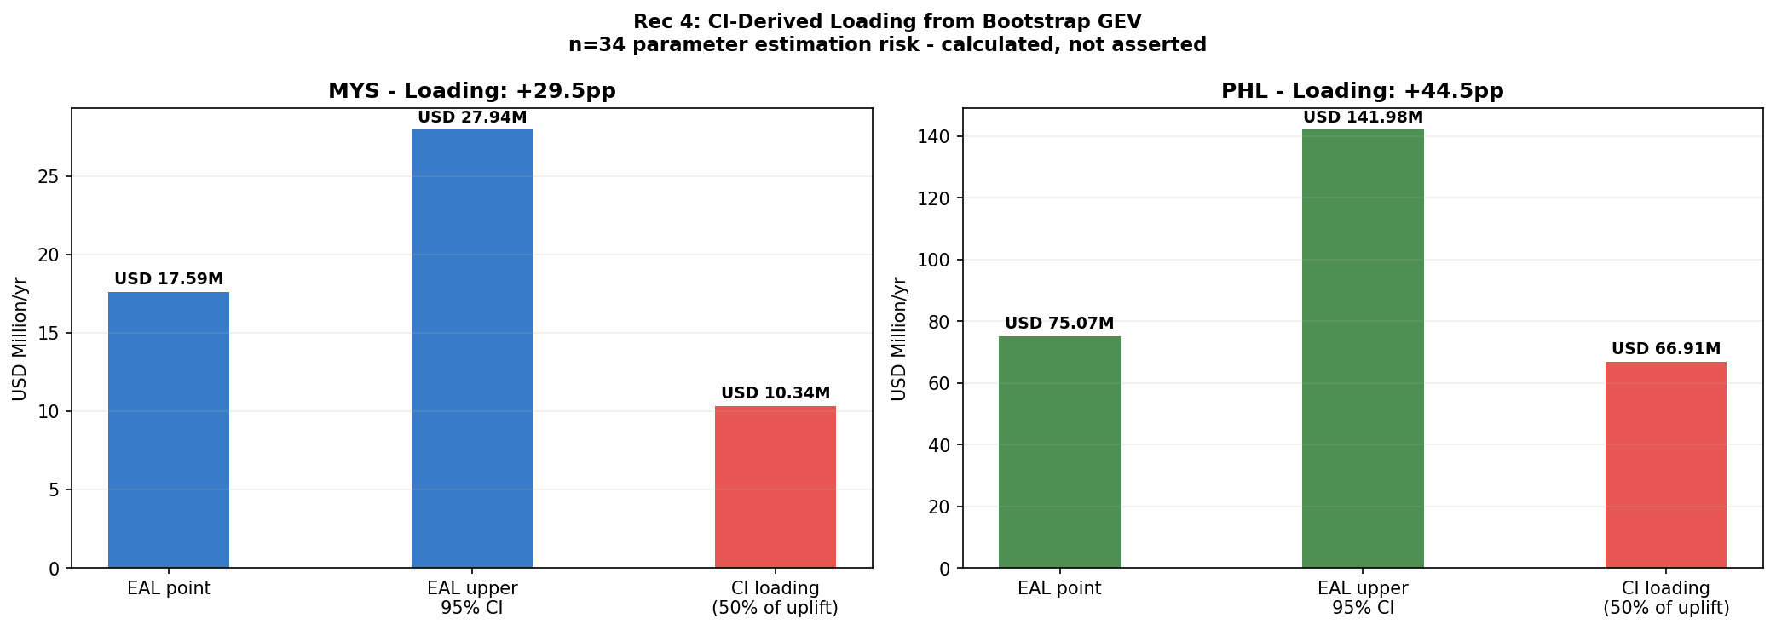  Fig 10b – R4 CI-derived loading derivation across sample sizes.
R4 & R5 — Warranty Clause & Data Procurement
R4 (EUDR Art. 8 + Lloyd's ESG s.2.3): insert a 10% co-participation clause for MYS LULUCF cedants (palm oil, plantation forestry) triggered by non-disclosure of LULUCF change >10% YoY. R5 (0–12 months, TCFD Metrics Rec (a)): procure cedant 10+ year loss triangles and 0.05-degree sub-national CHIRPS grids — growing the GEV sample from n=34 to n≥43 narrows the PHL CI from ±44.5pp to ±12pp and reduces the reserve band from USD 15.2M to USD 6.1M.

10. Limitations, Scalability & Conclusion
10.1 Key Limitations
- Sample size (n=34): PHL GEV CI spans [326–985mm] — a 3× range. Permutation testing at n=34 carries ~25% power, so the 2007 break is supported primarily by the PDO literature (Cinco et al. 2014) rather than statistical significance alone. PHL carries a floor loading only until R5 delivers n≥43.
- Pass-through rate (±2pp): a single percentage point shift in the pass-through assumption drives a 5× change in the HRe reserve estimate (USD 3.0–14.9M at 10% alloc.). Figure 8 provides the full sensitivity surface; the rate refreshes with each NGFS Phase update.
- ARIMA no-break assumption: the NETR 2023 policy trajectory may accelerate MYS decarbonisation, biasing GHG forecasts conservatively high. This creates a margin of safety in the transition surcharge calculation rather than a risk of understatement.
- LULUCF uncertainty (±20–30%, FAO FRA 2020): re-evaluated against FRA 2025 when published. La Niña copula (n=14) is insufficient for block-maxima GEV; the USD 2.59M/yr figure is indicative only.

10.2 Regulatory Anchor Mapping
Rec | Regulatory Framework | Specific Clause / Section
R1 | BNM CCPT (2022) | Pillar 1 s.3.4 — Physical Risk
R2 | BNM CCPT (2022) | Pillar 2 s.4.2 — Transition Pass-Through
R2 | BSP Circular 1085 (2020) | s.X.4 — ESG Pricing Integration
R3 | TCFD (2017) | Risk Mgmt Rec (b) — Identifying Climate Risks
R4 | EUDR Reg. 2023/1115 | Art. 8 — Due Diligence
R4 | Lloyd's ESG (2023) | s.2.3 — Underwriting Disclosure
R5 | TCFD (2017) | Metrics & Targets (a) — Climate Disclosure
Table 11 – Regulatory anchors. Full alignment with BNM CCPT, BSP 1085, TCFD, EUDR, and Lloyd's ESG.

10.3 Scalability
The R1–R5 pipeline extends naturally to ASEAN (Thailand, Indonesia, Vietnam) by substituting country-specific NGFS pass-through rates and CHIRPS sub-national grids. The NGFS model rebuilds in under two hours per Phase update, and ARIMA re-runs in under 30 minutes on new WDI vintages. R1–R5 are embedded as pricing rules mapped to TCFD for BNM/BSP 2026 reporting.

10.4 Conclusion
Two independent pricing gaps — physical (USD 18.4M/yr EAL shortfall from the 2007 PELT shift) and transitional (USD 1.1bn/yr SEA pool exposure at 3% pass-through under NGFS NZ2050) — are compounding undetected in HRe's current treaty book. The resulting annual reserve shortfall ranges from USD 3.4M (floor) to USD 18.6M (stress), with 2027 as the actionable repricing trigger before capital constraints bind. By 2030, the 2× stress compliance cost reaches USD 47.7bn (MYS) and USD 31.7bn (PHL). Recommendations R1–R5 operationalise HRe's 2026 climate-integration commitment for the MYS+PHL sub-book, anchored to CCPT, BSP 1085, TCFD, EUDR, and Lloyd's ESG frameworks.
AI Usage: Claude Sonnet 4.6 (Anthropic) assisted code structuring and documentation drafting. All outputs verified against WDI, CHIRPS, EM-DAT, NOAA ONI, NGFS, Climate Watch, and the HRe 2023 Annual/Sustainability Report.

