**Comic Con Management System Design Updates**

Initial ERD:

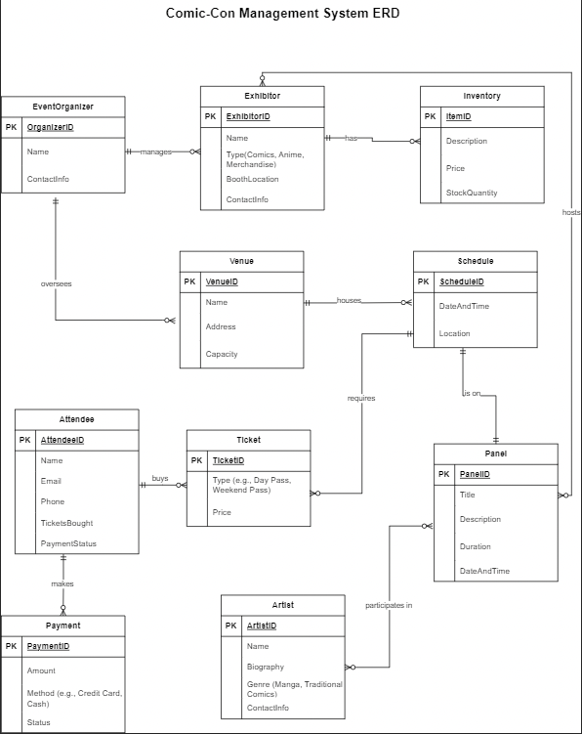

**Issues with the above model:**

1. There were multiple attributes that were redundant and would be storing the same data when implemented.
2. Some attributes made sense at the time but after taking a deeper look, they required rework.
3. General modelling improvements are required with regards to naming convention.
4. There are multiple many to many relationships.

Updated ERD:

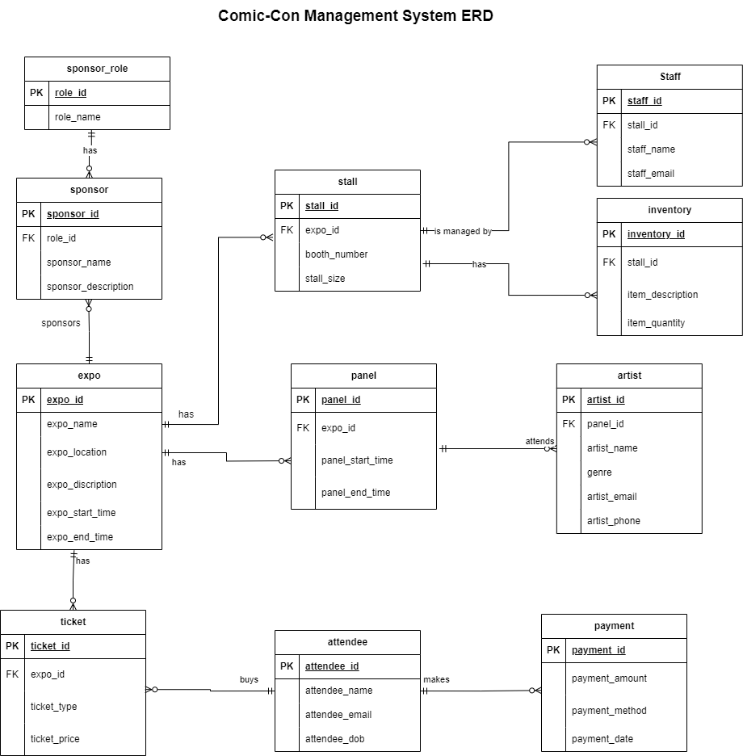

**Updated Model Changes:**

1. Removed redundant attributes.
2. Refactored many to many relations.
3. Reworked attribute logic for most of the entities and replaced them with meaningful ones.
4. Added new entities such as stall and sponsor as well entities associated with it.
5. Added foreign keys to the logically correct entities.
6. Fixed naming convention for some of the attribute