Five test results:

- Init command — Confirms database and tables are created successfully.

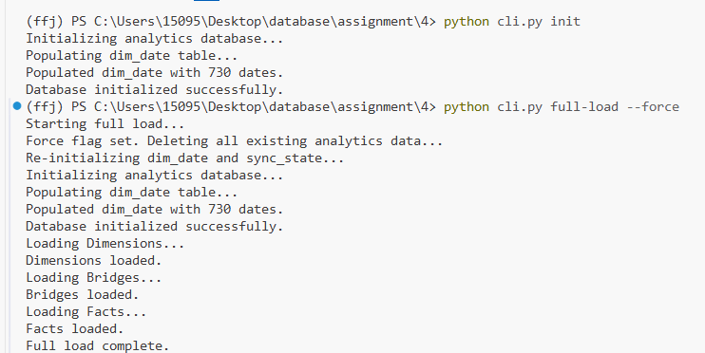

- Full-load command — Verifies all data from Sakila is loaded into SQLite.

- Incremental command (new data) — Checks that new records added in Sakila
appear correctly in SQLite.

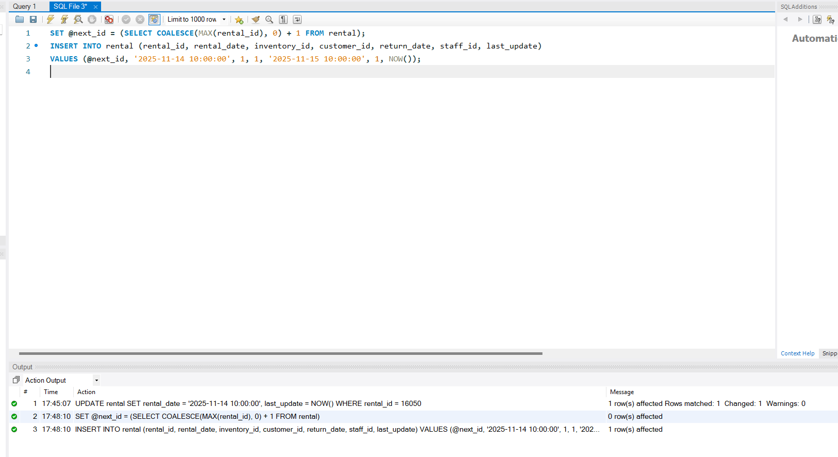

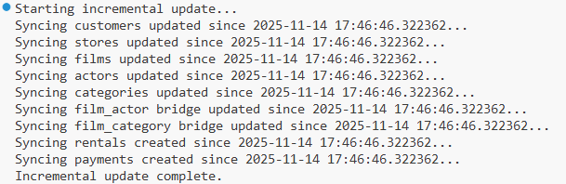
- Incremental command (updates) — Ensures existing rows are updated when source
data changes.
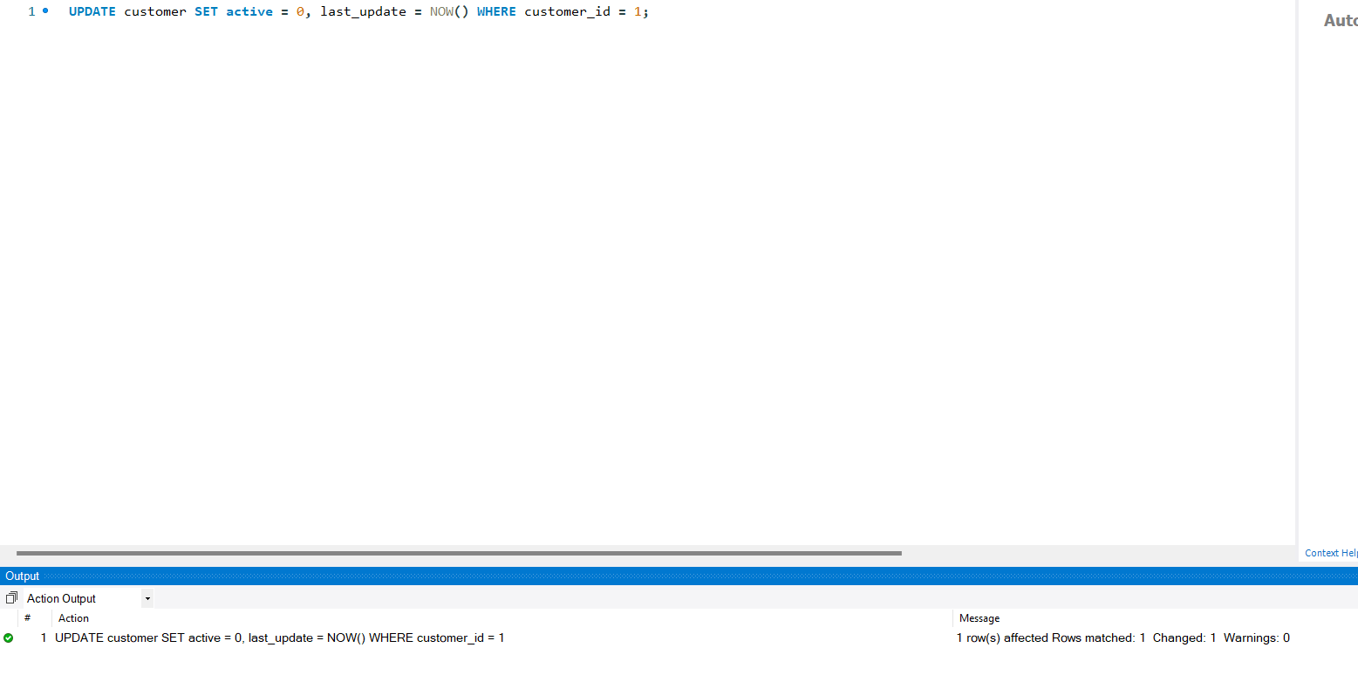
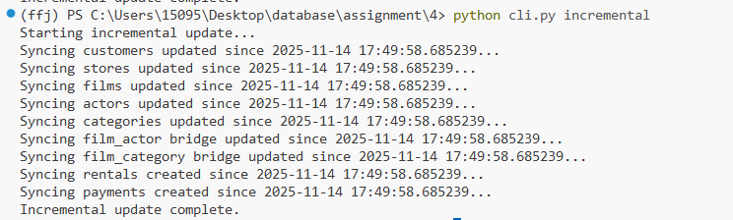
5. Validate command — Confirms data consistency between MySQL and SQLite.

