**Lab assignment**

Jialin Kang

e-mail: [jkang58@jhu.edu](mailto:jkang58@jhu.edu)

Download SSalzbergDNA23andMe.txt file from personal genome project(PGP): personalgenomes.org

Position: chr1:87222711

The variant’s dbSNP identifier is: rs10873824

The allales is : A > G / A > T

The allele frequency of the variation is:

A=0.20686 (25975/125568, TOPMED)

A=0.1950 (15347/78696, PAGE_STUDY)

A=0.2195 (6876/31326, GnomAD) (- 6 less)

A=0.212 (1063/5008, 1000G)

A=0.272 (1220/4480, Estonian)

A=0.275 (1059/3854, ALSPAC)

A=0.270 (1003/3708, TWINSUK)

A=0.26 (155/600, NorthernSweden)

A=0.34 (74/216, Vietnamese)

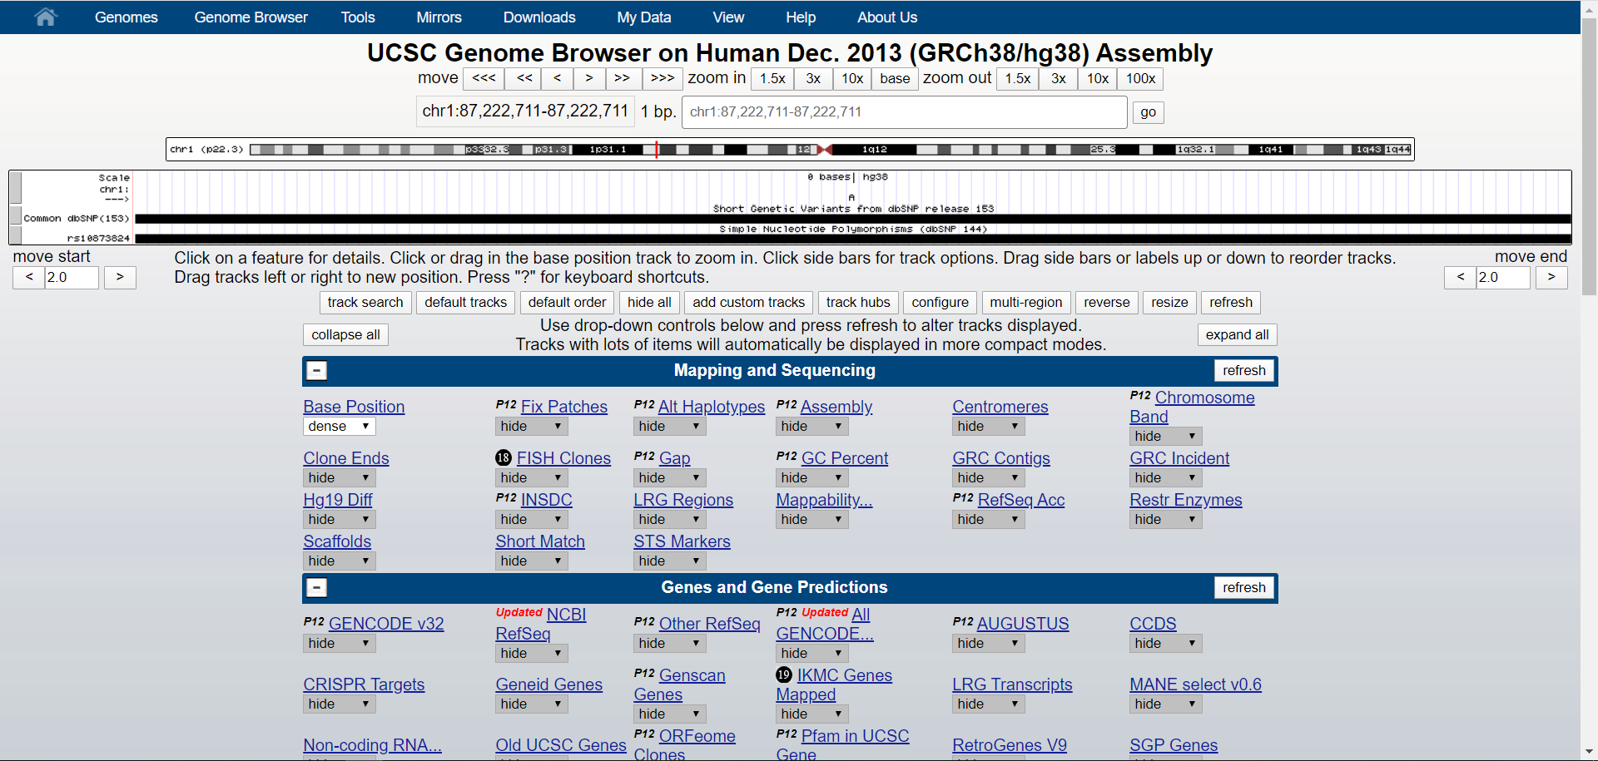

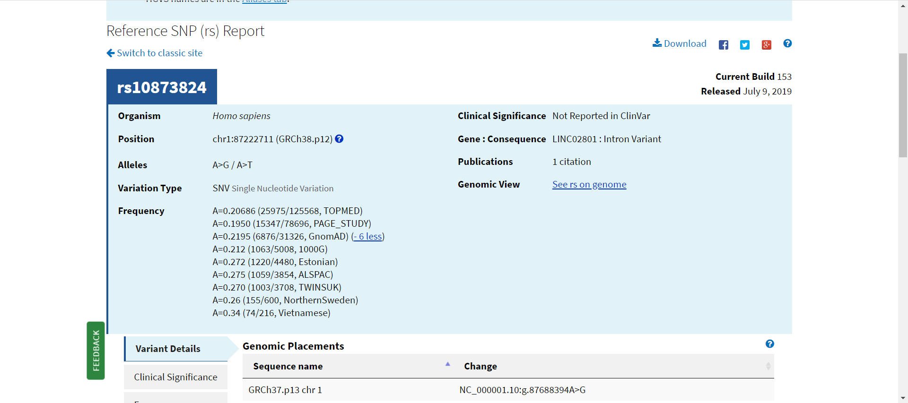

The known clinical relevance paper is:

<https://www.ncbi.nlm.nih.gov/pmc/articles/PMC4011843/pdf/pone.0096374.pdf>

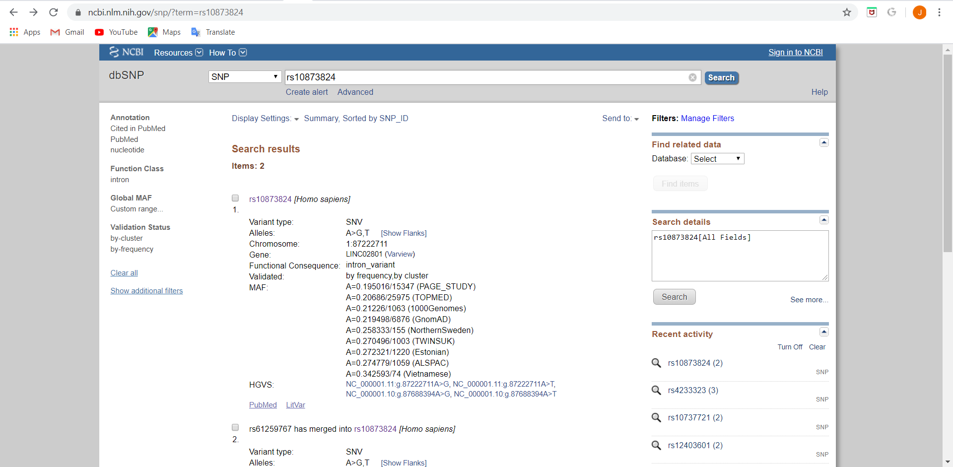

The paper directly investigated the molecular genetic basis of heredity of mathematical ability. The SNPs (rs789859) which I randomly choose shows significant association with the heredity of mathematical ability after Bonferroni correction. And the SNP (rs789859) is located in a region on chromosome 3q29 that has been previously linked to learning difficulties and autism. rs789859 lies 1.3 kbp downstream of LSG1, and 700 bp uostream of FAM43A, mapping within the potential promoter/regulatory region of the latter.