**Assignment 3**

**Jialin kang**

The following is the perceptron algorithm result:

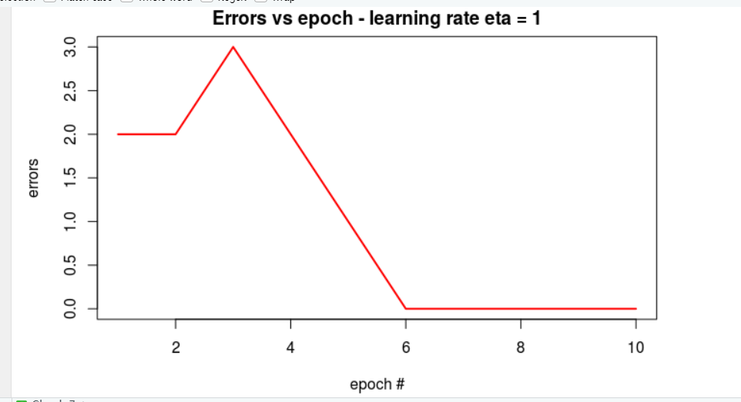and follow is Naïve Bayes classifier result:

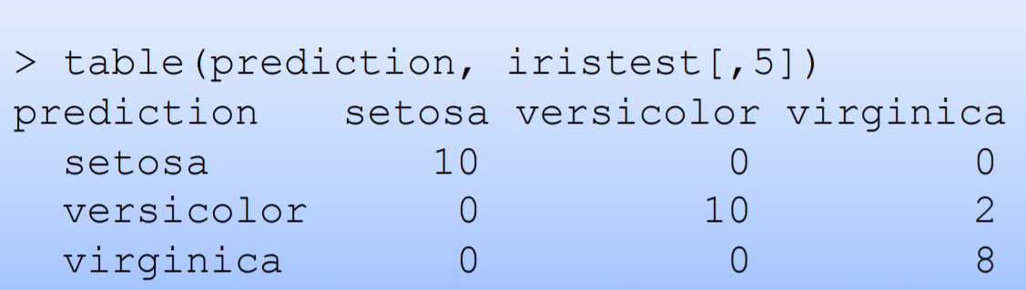

From the result we can know

When echo > 4 perceptron algorithm is better than Naïve Bayes classifier