2.4.3 VGG19

Extremely similar to VGG16, the original VGG19 network has 19 layers and is trained on more than a million images from the ImageNet database. The network can identify 1000 categories with input size of 224\*224. Figure X illustrates the structure of VGG19. It consists of five conventional layers and an output layer.

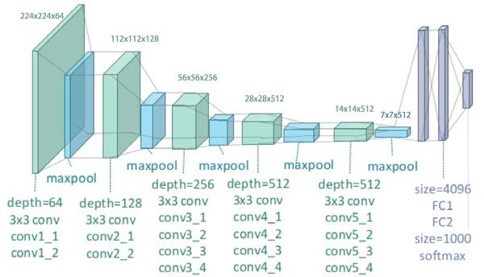

Figure 1 The structure of VGG19

In this paper, we also present a transfer learning solution to migrate the original VGG19 network to a relatively simplified map classifying network. To implement transfer learning, similar to VGG16, we loaded pre-trained weight, added a new output layer, and set the last few layers trainable during the training process.

4.3.3 VGG19

[Parameter setting]

Considering the extreme similarity between VGG16 and VGG19, we constructed the output layers and parameters just like VGG16.

[Experiment results]

Likewise, we investigated training/validation accuracy’s relationship with epochs, and trainable layer number.

Figure X shows the convergence process of VGG19 with 3 trainable layers. After 50 epochs, the accuracy and loss will converge and stay invariable. Considering the convergence speed of the network, we set the 20 epochs for all training instances.

Figure 2 The convergence process of VGG19

To see the trainable layers’ impact on the final accuracy, we conducted a series of experiment with different trainable layers’ number from 3 to 10. Figure X shows the convergence process of VGG19 with 3, 4, 5 trainable layers. Figure X shows the accuracy’s changing trend with the number of trainable layers.

Figure 3 The convergence process of VGG19 with 3, 4, 5 trainable layers.

Figure 4 The changing trend of accuracy with the number of trainable layers

[Discussion]

From Figure 4 we can observe that the accuracy reaches its peak at trainable layers of 4. The highest accuracy is 0.72, which is not ideal compared to the original network. However, with more trainable layers, the accuracy is lower. After 6 trainable layers, the convergent accuracy is 0.25, which is equal to random guessing. More parameters make the optimizer harder to achieve a better solution other than a local one, and we can observe this in Figure 3. For trainable layers of 3, it has a valley in the curve, which means the solution can easily jump out of the local optima. For 4, the accuracy oscillates around 0.65, which means the optimizer is effective. Nevertheless, after 5, especially 6, the accuracy hardly changes.

VGG19 has more parameters than VGG16, therefore, VGG19’s performance of transfer learning is accordingly worse than VGG16.