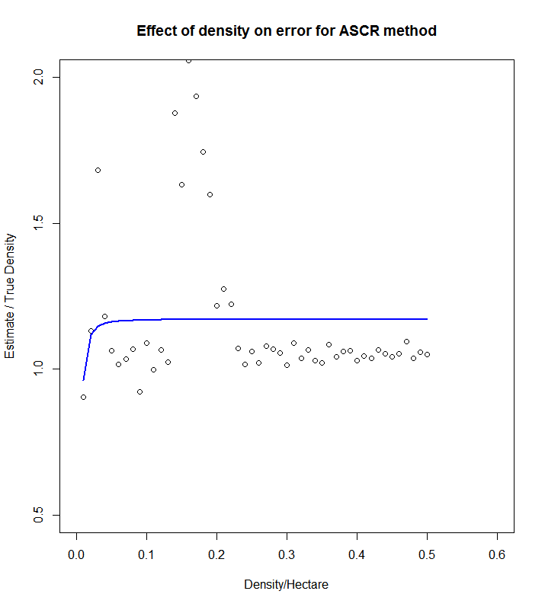

Density:0.01-0.50

Simulations:10