Project Title

Member 1, Member 2
Purpose
The purpose of having a proposal is so you and your teammates can begin thinking about a project and its long-term execution. Knowing how to properly think ahead of its data, experiment, and deliverables are an important skill.

Assignment
Describe your project idea in 1 to 2 pages. You will need to implement advanced algorithms techniques solving some problem and perform an empirical evaluation. Below is an example of headers and a description of what would be included in the proposal You may modify the headers as you see fit, but you cannot modify the content that I am requesting. You may modify this document for your submission.

Big Idea
Mention the big idea and problem that you will be addressing. You can make it up or it can be a real problem, but it has to be a scenario with a problem.

Methodology
What do you propose to solve this issue? Describe your high-level plan on how you plan to approach the project, and your empirical evaluation.
Undergraduates must implement at least two advanced algorithms, one in either category (greedy, divide and conquer, dynamic programming). Both algorithms cannot all be from a single category. Graduates must implement at least three algorithms, each in either category, and cannot all or some be from a single category. They must be advanced algorithms. It can be an algorithm we discussed in class, or another, but it has to be advanced (cannot have been taught in 340).
Your evaluation must include your experiment design with metrics of how you’re planning to evaluate the efficacy of your algorithms AND the problem. Both undergraduates and graduates must have at least three experiments.
Dataset
Describe your dataset. Where are you getting it? Describe the type, size, etc. of the dataset. If you’re not using dataset, then how will you be generating your data? Use tables, graphs or some visual to visually show your data.

Gantt Chart
Include a Gantt chart (or some timeline that shows tasks in time) of the different tasks in the project and which member will oversee it that clearly illustrates what will be accomplished by the mid presentation and final presentation. Please be specific. If it is generic, points will be deducted. I would suggest that for each assignment, everyone works on a key component of it. For example, for the mid report, one team member works on experiment 1, another works on experiment 2, another works on experiment 3. Below is an example.
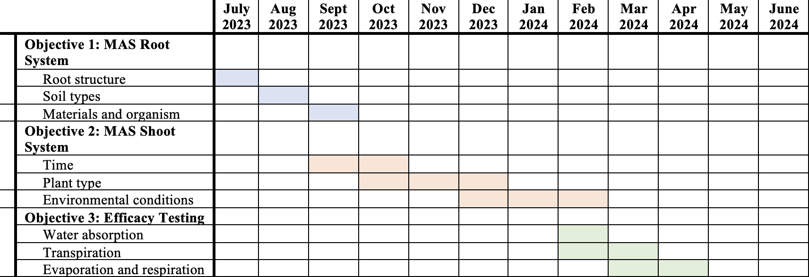

Deliverables
- If you would like detailed feedback, submit your document as a .docx. If you do not want detailed feedback, submit your document as a .pdf.
- Name your document “groupname_UG.pdf/.docx” if you’re an undergraduate group or “groupname_G.pdf/.docx” if you’re a graduate group.
- Only one member from the team needs to submit it. Please do not submit multiples.

Report Rubric
20 points maximum
 |  | 5 | 4 |  | 3 |  | 2 |  | 1 |  | 0
Title |  |  |  |  |  |  |  |  |  | A descriptive title of the project is provided. |  | A generic title or an assignment title is given
Big Idea | Much thought has been put into finding or creating a problem. |  |  |  |  | A thought was given, but I am unable to see the problem. |  |  |  |  |  | No problem was clearly discussed.
Methodology | Three experiments were given and detailed of what they will be testing, the type of data they’ll be using, and the metrics for the problems and the algorithms’ efficacy. |  |  | Three experiments were given but either the description, data, or metrics lack |  | Only two experiments were given with the rest of the requirements |  | Only two experiments were given but some requirements lack |  | Only one experiment was given |  | No experiments were given
Dataset Description | The dataset was properly explained in terms of acquisition and description. |  |  |  |  | The acquisition was described, but the dataset description lacked. |  |  |  | Both acquisition and description lacked |  | No explanation was given.
Gantt Chart |  |  |  | Visually nice chart with clear deliverables for each assignment for each team member. |  | Each team member had an assignment but the Gantt chart is vague. |  |  |  | Too vague of a chart. Not everyone has evenly distributed responsibilities. |  | No chart given.

- 1 point: report not properly named
- 5 points: report is not in paragraph format

Code Rubric
None

