Travel Route Planer
Jiamin Yao, Hangyu Yao, Yan Pang

Big Idea
Traveling is one of the most enjoyable activities, but planning an efficient travel route can often be a complex and time-consuming task, especially when visiting multiple cities across a continent like Europe. Travelers always struggle to identify the most distance-effective, cost-friendly, and time-efficient routes that align with their preferences. Key factors in this decision-making process include the distance between cities, the cost of flights, and the flight duration.
Our project addresses the challenge of optimizing travel routes by developing a tool that leverages advanced algorithms to solve travel route planning across Europe. The tool uses a fixed map of Europe with predefined city coordinates, flight costs, and flight durations stored in a dataset. It automatically generates results for the shortest distance, the lowest flight costs, and the shortest travel time, using different algorithms such as greedy algorithms, divide-and-conquer strategies, and dynamic programming techniques. This comprehensive approach provides travelers with multiple optimized solutions, helping them save time and money while simplifying the complexities of planning multi-city trips.

Methodology

Algorithms

Greedy

Nearest Neighbor(Divide and Conquer)

A*(Dynamic Programming)

High-Level Plan

For this travel problem, we will conduct three stages. In the first stage, we will focus on the shortest distance, in the second stage, we will focus on cost, and in the third stage, we will focus on time. Each stage will include the implementation of three algorithms, and we will conduct an experiment for each stage.

Empirical evaluation
- Experimental Design:
  - Algorithm Implementation:
    - Implement the selected high-level algorithms. Make sure each algorithm is unit-tested and can solve the given problem.
    - Use small-scale data sets for testing to ensure the correctness of the algorithm.
  - Experimental Run:
    - Experimental variation: Changing the number of cities in the TSP (e.g. 10, 20, 50, 100 cities)
    - For each set of experiments, run all algorithms and record the running time, and solution.
    - Make detailed records and comparisons of the algorithm performance under different input sizes and characteristics.
  - Data Collection and Analysis:
    - Summarize the performance data of the algorithms in each experiment and make tables and charts for easy analysis.
    - Compare the quality gap between the solutions of the greedy algorithm and the solutions of dynamic programming or divide-and-conquer methods.
    - Analyze the impact of different problem sizes on algorithm performance.
  - Results Presentation and Discussion:
    - Present the experimental results in the form of charts, focusing on comparing the time complexity, optimality of the solution, and capability of each algorithm.
    - Discuss the advantages and disadvantages of each algorithm and explain what scenarios they are suitable for.
- Evaluation indicators:
  - Time complexity: measure the actual execution time of each algorithm under different input scales to evaluate the efficiency of the algorithm.
  - Evaluate the optimal solution: By considering the availability of the solution and the running time of the algorithm, we can evaluate the optimal solution.
  - Algorithm capability: as the problem size increases, compare the performance of each algorithm.

Dataset
For our project, we are creating a custom dataset with a fixed map image of Europe. The dataset consists of three components: the coordinates of selected cities in Europe map, flight costs, and flight durations between these cities. While the city coordinates are generated through user interaction with the map, the flight cost and flight duration data are synthetic. These data points will be used to solve the travel route planning by optimizing for the shortest distance, the lowest travel cost, or the shortest travel time.

Coordinates
  - Source: Generated based on click points on the Europe map.
  - Data:
City | x-coordinate | y-coordinate | City | x-coordinate | y-coordinate
London | 590 | 219 | Rome | 1849 | 1624
Paris | 839 | 634 | Munich | 1758 | 740
Milan | 1519 | 1130 | Zurich | 1455 | 852
Vienna | 2236 | 729 | Amsterdam | 1094 | 81
Barcelona | 819 | 1689 | Brussels | 1039 | 326
Madrid | 234 | 1819 | Florence | 1726 | 1367
Lyon | 1085 | 1087 | Birmingham | 414 | 62
Berlin | 1940 | 56 | Prague | 2043 | 448
Venice | 1832 | 1134 | Nantes | 448 | 875

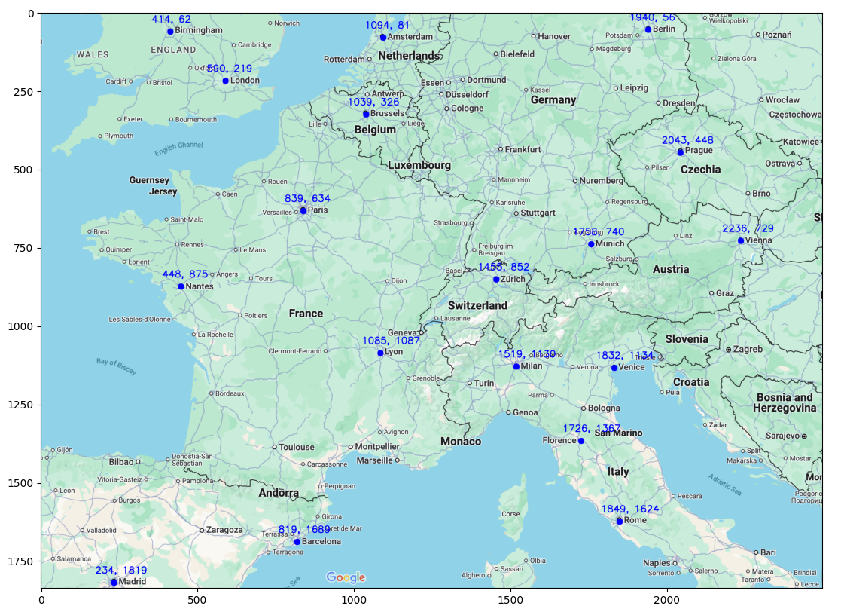

Flight Cost
  - Source: We will use synthetic data(reference from Google Flight).
  - Data:
Cost/$ | London | Paris | Milan | Vienna | Barcelona | Madrid | Lyon | Berlin | Venice | Rome | Munich | Zurich | Amsterdam | Brussels | Florence | Birmingham | Prague | Nantes
London | 0 | 83 | 80 | 137 | 93 | 55 | 91 | 84 | 82 | 85 | 70 | 85 | 71 | 70 | 110 | 219 | 118 | 157
Paris | 61 | 0 | 102 | 109 | 98 | 63 | 90 | 94 | 99 | 109 | 95 | 99 | 82 | 284 | 128 | 78 | 99 | 123
Milan | 56 | 103 | 0 | 89 | 142 | 47 | 133 | 99 | 129 | 72 | 107 | 98 | 73 | 94 | 173 | 115 | 152 | 119
Vienna | 43 | 121 | 102 | 0 | 173 | 97 | 235 | 124 | 92 | 103 | 102 | 441 | 155 | 121 | 156 | 149 | 145 | 121
Barcelona | 65 | 72 | 135 | 86 | 0 | 40 | 55 | 74 | 89 | 72 | 157 | 168 | 116 | 85 | 73 | 79 | 65 | 147
Madrid | 43 | 56 | 40 | 114 | 25 | 0 | 39 | 71 | 60 | 51 | 87 | 52 | 53 | 60 | 84 | 157 | 149 | 59
Lyon | 57 | 84 | 254 | 209 | 118 | 63 | 0 | 52 | 41 | 70 | 144 | 143 | 102 | 115 | 139 | 103 | 105 | 59
Berlin | 74 | 92 | 109 | 194 | 108 | 67 | 141 | 0 | 125 | 150 | 94 | 136 | 132 | 99 | 100 | 112 | 108 | 159
Venice | 69 | 118 | 148 | 62 | 108 | 64 | 144 | 152 | 0 | 84 | 140 | 176 | 154 | 78 | 160 | 107 | 152 | 103
Rome | 89 | 107 | 72 | 132 | 70 | 66 | 148 | 109 | 76 | 0 | 94 | 114 | 122 | 143 | 81 | 127 | 107 | 153
Munich | 74 | 104 | 126 | 194 | 123 | 108 | 153 | 97 | 126 | 114 | 0 | 308 | 161 | 179 | 303 | 135 | 142 | 194
Zurich | 81 | 147 | 256 | 281 | 107 | 91 | 162 | 156 | 140 | 122 | 272 | 0 | 183 | 302 | 257 | 201 | 206 | 230
Amsterdam | 108 | 154 | 131 | 169 | 177 | 108 | 142 | 138 | 213 | 166 | 160 | 191 | 0 | 261 | 315 | 121 | 163 | 210
Brussels | 73 | 60 | 64 | 92 | 116 | 101 | 91 | 95 | 107 | 91 | 154 | 235 | 204 | 0 | 117 | 124 | 82 | 112
Florence | 99 | 127 | 165 | 297 | 182 | 78 | 138 | 159 | 159 | 70 | 123 | 141 | 138 | 94 | 0 | 108 | 142 | 144
Birmingham | 220 | 96 | 155 | 198 | 52 | 162 | 155 | 121 | 156 | 106 | 164 | 189 | 96 | 113 | 235 | 0 | 165 | 230
Prague | 60 | 105 | 107 | 187 | 156 | 128 | 146 | 115 | 115 | 131 | 203 | 156 | 127 | 87 | 173 | 102 | 0 | 136
Nantes | 141 | 157 | 119 | 101 | 111 | 64 | 113 | 108 | 119 | 152 | 167 | 133 | 218 | 143 | 114 | 184 | 133 | 0

Flight Duration
  - Source: We will use synthetic data(reference from Google Flight).
  - Example Data:
Time/min | London | Paris | Milan | Vienna | Barcelona | Madrid | Lyon | Berlin | Venice | Rome | Munich | Zurich | Amsterdam | Brussels | Florence | Birmingham | Prague | Nantes
London | 0 | 85 | 120 | 135 | 130 | 145 | 95 | 115 | 130 | 150 | 115 | 105 | 85 | 75 | 135 | 285 | 110 | 330
Paris | 90 | 0 | 90 | 115 | 105 | 120 | 190 | 105 | 100 | 120 | 90 | 85 | 80 | 55 | 100 | 80 | 100 | 310
Milan | 130 | 95 | 0 | 90 | 95 | 140 | 240 | 100 | 210 | 80 | 70 | 60 | 115 | 95 | 210 | 260 | 170 | 175
Vienna | 140 | 125 | 85 | 0 | 140 | 190 | 110 | 75 | 65 | 95 | 60 | 80 | 115 | 110 | 305 | 245 | 50 | 260
Barcelona | 145 | 120 | 100 | 135 | 0 | 85 | 90 | 165 | 110 | 105 | 125 | 105 | 145 | 130 | 105 | 150 | 150 | 95
Madrid | 145 | 125 | 130 | 180 | 75 | 0 | 110 | 185 | 150 | 145 | 160 | 140 | 160 | 145 | 140 | 265 | 170 | 100
Lyon | 110 | 245 | 60 | 195 | 250 | 120 | 0 | 115 | 75 | 90 | 80 | 210 | 105 | 85 | 250 | 220 | 315 | 80
Berlin | 130 | 110 | 110 | 75 | 155 | 195 | 115 | 0 | 100 | 130 | 70 | 85 | 85 | 95 | 115 | 130 | 210 | 225
Venice | 145 | 115 | 235 | 70 | 120 | 160 | 85 | 100 | 0 | 70 | 65 | 70 | 115 | 105 | 196 | 235 | 85 | 135
Rome | 175 | 130 | 70 | 100 | 110 | 155 | 90 | 130 | 70 | 0 | 95 | 95 | 155 | 140 | 55 | 170 | 110 | 140
Munich | 125 | 105 | 65 | 60 | 125 | 170 | 80 | 70 | 60 | 95 | 0 | 60 | 100 | 85 | 75 | 125 | 50 | 120
Zurich | 110 | 80 | 70 | 70 | 110 | 145 | 205 | 85 | 65 | 90 | 55 | 0 | 100 | 75 | 75 | 110 | 75 | 195
Amsterdam | 80 | 80 | 90 | 100 | 125 | 160 | 100 | 75 | 100 | 135 | 80 | 85 | 0 | 45 | 120 | 75 | 85 | 90
Brussels | 80 | 60 | 85 | 100 | 120 | 150 | 80 | 85 | 95 | 125 | 80 | 70 | 55 | 0 | 105 | 75 | 85 | 190
Florence | 130 | 110 | 185 | 220 | 100 | 150 | 215 | 115 | 180 | 50 | 75 | 80 | 130 | 110 | 0 | 255 | 180 | 120
Birmingham | 270 | 85 | 205 | 230 | 135 | 290 | 235 | 120 | 235 | 165 | 110 | 105 | 80 | 70 | 260 | 0 | 220 | 240
Prague | 140 | 110 | 90 | 55 | 155 | 190 | 190 | 245 | 85 | 110 | 55 | 80 | 95 | 95 | 250 | 215 | 0 | 265
Nantes | 85 | 240 | 205 | 240 | 90 | 100 | 75 | 220 | 120 | 130 | 110 | 205 | 100 | 235 | 110 | 235 | 235 | 0

Gantt Chart

 | Owner | Aug 2024 | Sep 2024 | Oct 2024 | Nov 2024 | Dec 2024
Objective 1: Distance-first route planning
Coordinate databset collection | Jiamin Yao
Implementation of Greedy Algorithm | Jiamin Yao
Implementation of Divide and Conquer | Hangyu Yao
Implementation of dynamic programming | Yan Pang
Objective 2: Cost-first route planning
Flight cost databset collection | Jiamin Yao
Implementation of Greedy Algorithm | Yan Pang
Implementation of Divide and Conquer | Jiamin Yao
Implementation of dynamic programming | Hangyu Yao
Objective 3: Time-first route planning
Flight duration database collection | Jiamin Yao
Implementation of Greedy Algorithm | Hangyu Yao
Implementation of Divide and Conquer | Yan Pang
Implementation of dynamic programming | Jiamin Yao
Objective 4: Powerpoint & Report
Evaluation Metrics | All
Report | All
Powerpoint | All

