Bank Account Management System

* By Jiamin Yuan & Emmy Ea

**bankManagement.db**

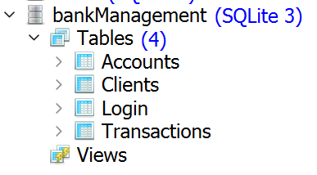

**Accounts Table**

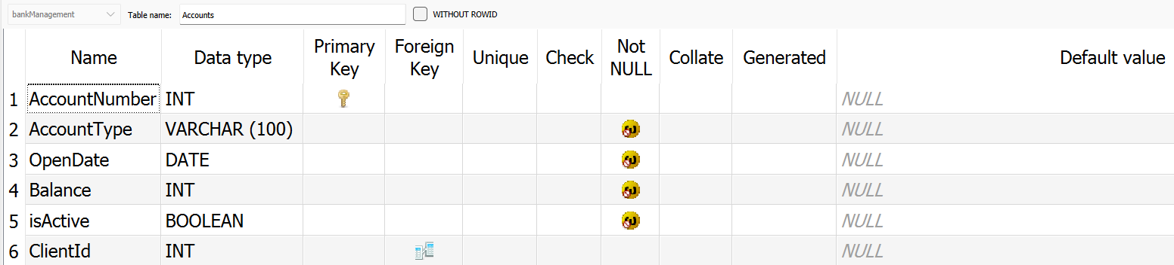

**Clients Table**

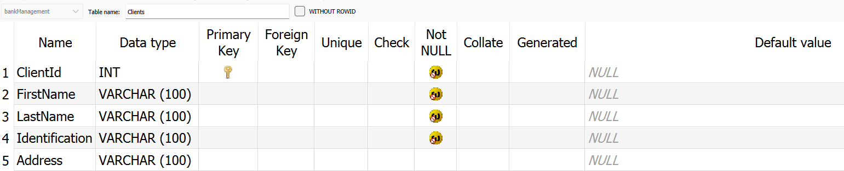

**Login Table**

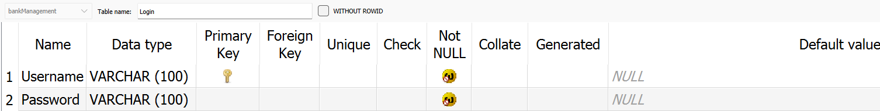

**Transaction Table**

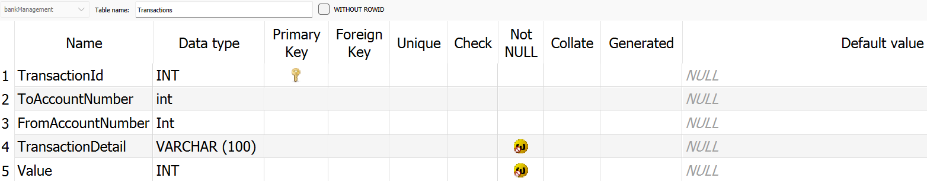

**Log in:**

Failure to login using wrong User and Password

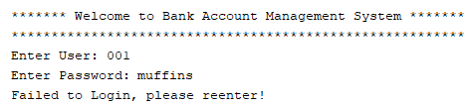

Successful login will lead to menu of options below

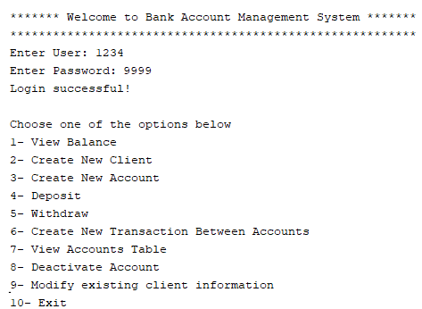

**Main Menu:**

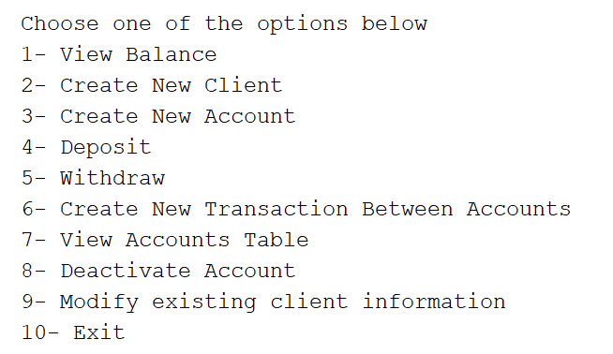

*Option 1 - View Balance*

Displays existing accounts available to choose from. Entering a non-existent account will display a balance of 0 and send the user back to the menu.

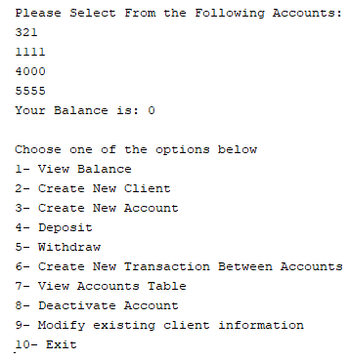

Selecting an existent account will return that account’s balance.

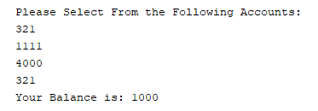

*Option 2 - Create New Client*

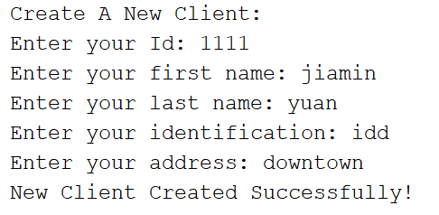

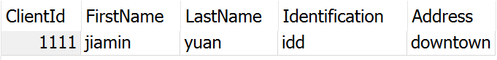

*Option 3 - Create New Account*

User have to select from the existing clients’ id, since client id is a foreign key in account table

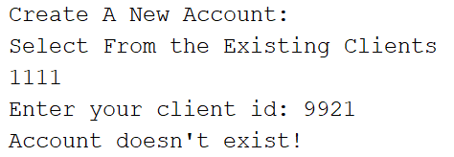

To successfully create an account the user must choose among the existing clients.

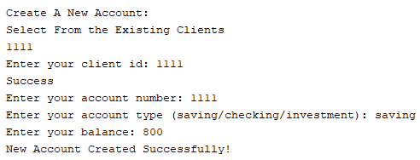

Invalid Account Type:



*Option 4: Deposit*

Failure to enter an existing account.

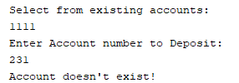

Successful selection of an account will allow users to deposit any desired amount. A total balance is given.

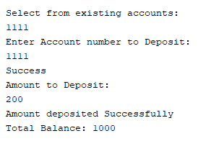

Deposit amount can’t be negative

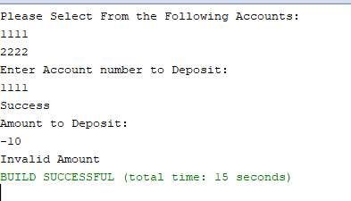

*Option 5: Withdraw*

Failure to enter an existing account.

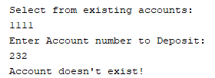

The Withdrawal amount can’t be negative.

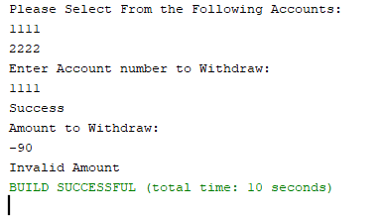

Trying to withdraw more than within an account’s balance.

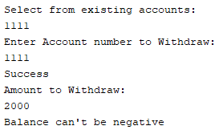

Successful selection of an account will allow users to withdraw any amount that is not over their current balance.

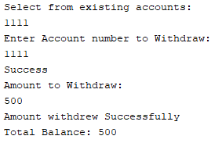

*Option 6: Create New Transaction*

Failure to select an existing account.

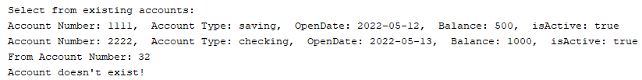

Once two successful accounts are created. A transfer between two accounts is possible.

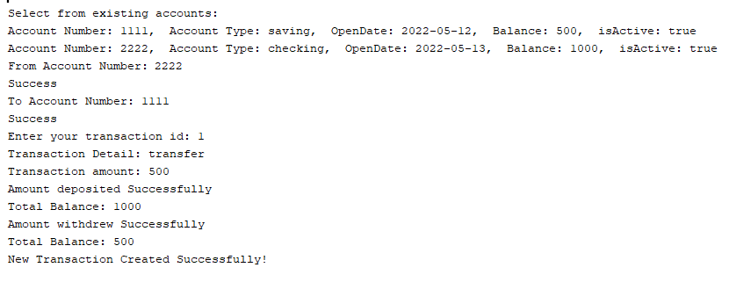

Attempting to create an existing TransactionId.

Error Executing Statement [org.sqlite.SQLiteException: [SQLITE_CONSTRAINT_PRIMARYKEY] A PRIMARY KEY constraint failed (UNIQUE constraint failed: Transactions.TransactionId)]

Error rolling back [java.sql.SQLException: database in auto-commit mode]



*Option 7: View All the Accounts*

Display Accounts Table.



*Option 8 - Deactivated Account*

Accounts with zero balance with be deactivated -> isActive = 0

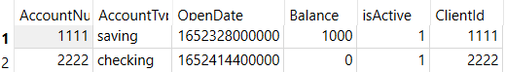



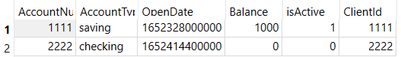

*Option 9 - Modify Existing Client Info*

If clients’ id does not exist.

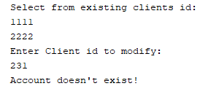

Successful modification.

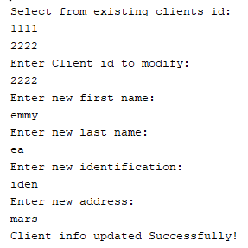

Before

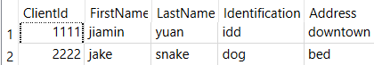

After

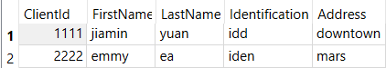

*Option 10- Exit*

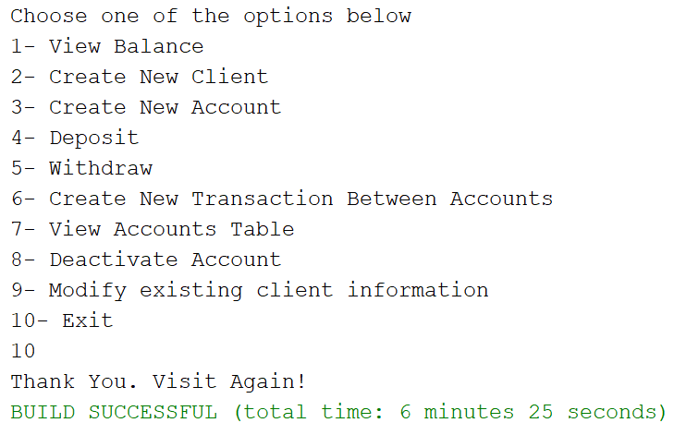

**Internationalization**

Must choose between these two codes in every file.

currentLocale = new Locale("fr", "FR"); currentLocale = new Locale("en", "EN");

