**C Sc 335 Analysis and Design Artifacts for Jukebox**

*Each team complete this form, put it in your project in a folder named* **doc** *and push to Github. This will be part of your Iteration 1 grade*

**1. Team Name:**  __Attitude_________________________

**2. Project (Risk, Pokemon, or Tower Defense): ___Pokemon_______________________**

**3. Team Members**: ___Haotian Yuan____________ __Jiaming Hao___________________

___Xuwei Zhang____________ ___John Xu__________________________

List the most important objects, or an inheritance hierarchy name, and the responsibility of each.

|  |  |
| --- | --- |
| **Candidate Object** | **Responsibility in 1 or 2 sentences** |
| Pokemon | Each object contains elements of a pokemon such as name, aptitude, capturing rate. |
| player | Each object contains all elements of a player such as name, gender, steps, Safari balls… |
| MapGenerate | Contains all maps |
| persistence | Make the game be persistent. |
| game | Trace the process of a game |
| MapElement | Such as grass, water, background… |
| PokemonCollection | The collection of all 15 pokemons |
| Battle scene | The Scene of battle |
| PokemonGenerate | Generate a pokemon |
| Caught | Imitate the process of caught |
| item | All elements of an item |
|  |  |

**3) Sequence Diagram:** Write a UML Sequence Diagram should show the most important scenario you can think of. Your sequence diagram should show most of your candidate objects you listed above and how they communicate with each other.

**Recommended:** *Use the Sequence Diagram editor found at*

<https://www.websequencediagrams.com/>

*Export and Image and copy and paste it here*

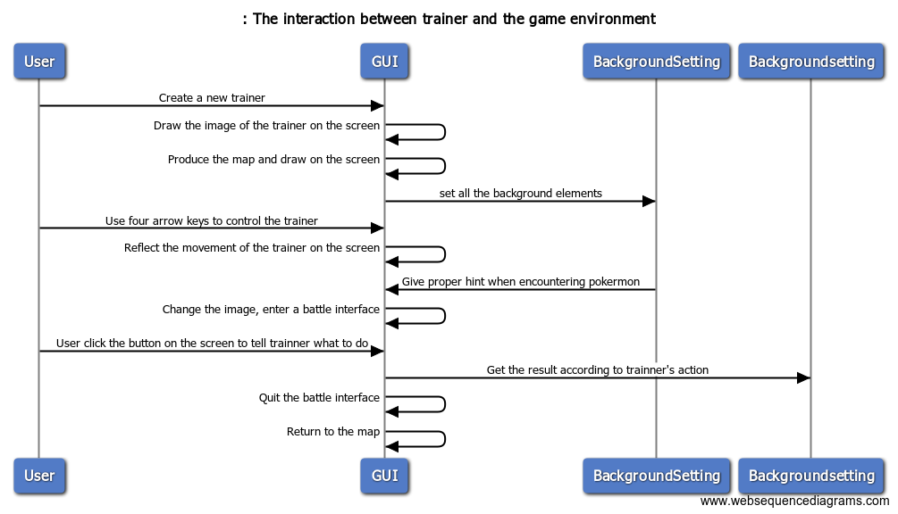

**4) Class Diagram:** Write a UML Class Diagram that shows all of your candidate objects from above. Show any relationships between them the classes such as inheritance or interface implementation. Draw general associations such as dependency or aggregation. Label some to help explain things. Add any multiplicity adornments that seem appropriate. Use notes to explain things if you feel it will help. Each UML class must show the class name. For full credit, each class must have an average of at least one attribute per class. There must be an average of about 1.5 methods per class.

**Optional:**  *Instead of using pencil, paper and scanning to insert an image, use a new Eclipse Project to add classes, methods, and instance variables. No implementation needed. Then use Object Aid UML tool to reverse engineer your code to get the UML class diagram.*

*Installation of Eclipse Plugin in case you don't have it:*

<http://www.objectaid.com/installation>

*Export and Image and copy and paste it here*

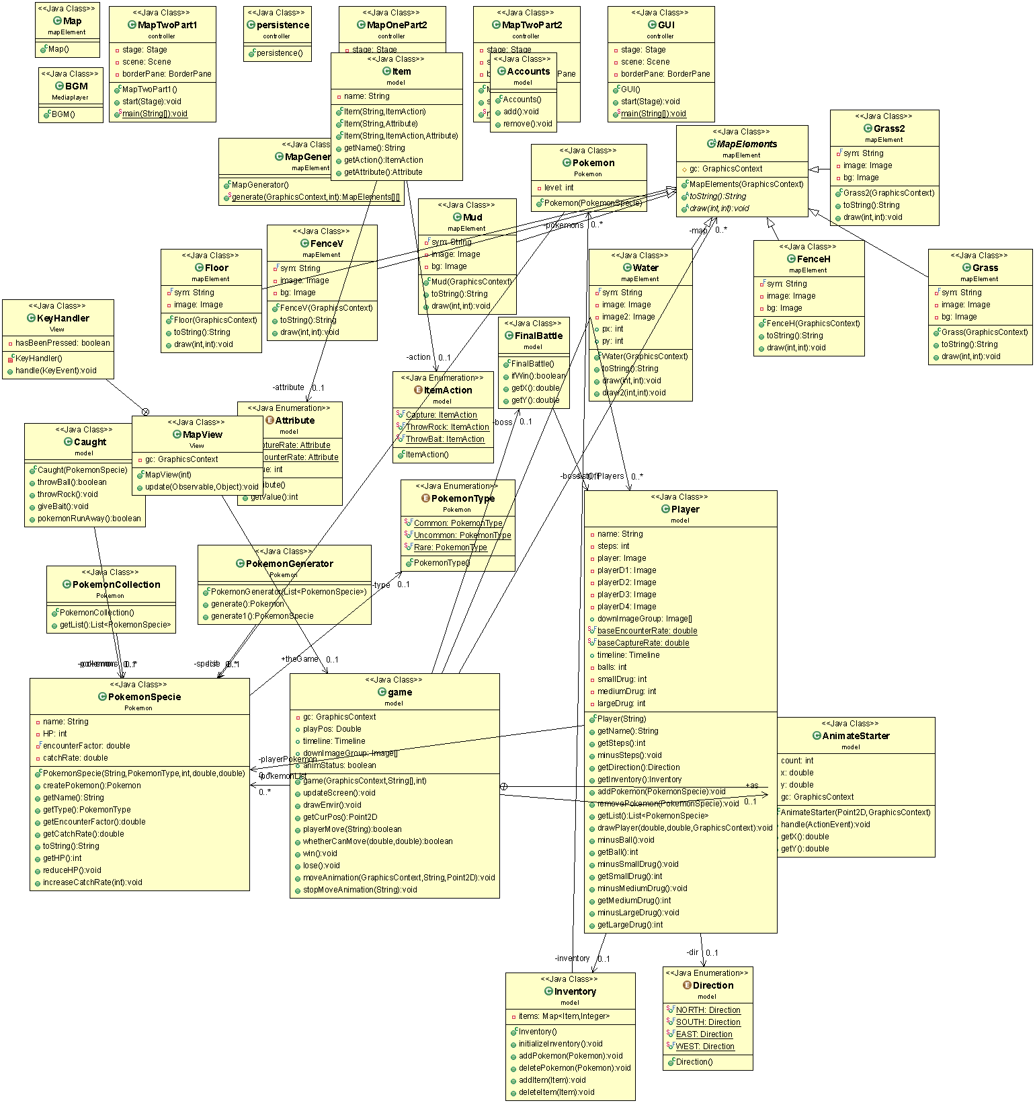

**5) Estimate and Assign Tasks** For each Iteration 1 task, estimate its difficulty using the numbers 1, 2, 3, 5, or 8. These are points that represent the relative complexity of the task. Mark 8 for the most difficult and/or time consuming and 1 for what appears to be the easiest. Indicate which person (s) will complete the task before iteration 1 due date.

|  |  |  |
| --- | --- | --- |
| Points | Who will  complete this? | Task |
| 3 | Haotian | Users can create accounts(set name, gender…), log in and log out. |
| 2 | Jiaming | Logic movement. |
| 2 | Xuwei | Testing |
| 3 | Haotian+John | Pokemon Encounter Rate |
| 3 | Haotian | Pokemon Caught |
| 2 | Haotian | Sound |
| 3 | Haotian | Game logic design |
|  |  |  |
|  |  |  |
| 3 | Two maps  (Haotian + Jiaming)  (Xuwei + John) | Map generation. (more than one view) |
| 5 | Jiaming | Battle scene generation including four options and multiplayer-battles. |
| 2 | Haotian | Server and client. |
| 5 | John | Pokemons’ and trainers’ animation. |
| 3 | Xuwei | Tracing the process of a game (items remaining, HP…), determining if the user wins or loses, then showing appropriate scene. |
| 2 | Everyone deals with the map which he created. | BGM. |
| 3 | John | Persistence. |