Please see the following description for this tracker software.

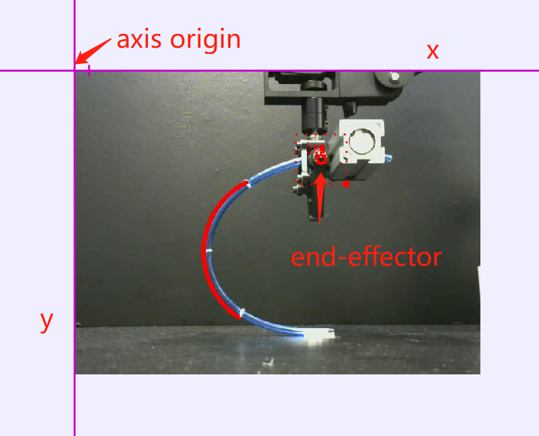

Upper left corner of the picture is the origin and should pay attention to, the unit in the picture should be pixel.

And the direction of the axis shown in the picture is: from left to right gradually becomes larger, from top to bottom gradually becomes lower.

The origin is (0,0), the bottom is (0,-480), far right of origin is (640,0), and lower right point is (640, -480).

Note: the definition of coordinate in this software is different from the general pixel coordinate system.

The following picture is built from this software, and “质量” just means the point mass, please don’t worry about it. And from this picture, it can see that, the unit of y axis is meter (m), so, for the better presentation, I use the Matlab to plot the data again.

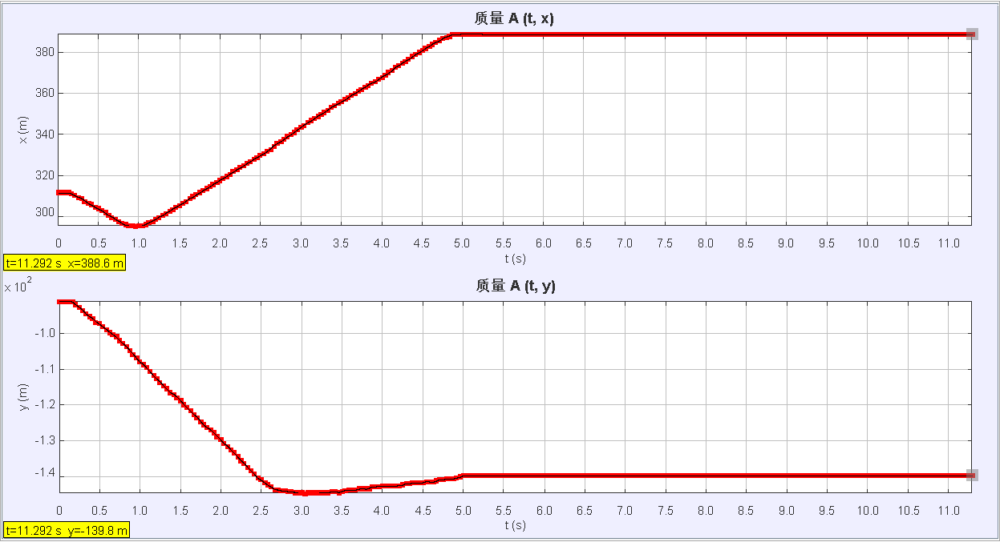

The below picture is made in Matlab, the unit of y axis is pixel,

The x axis is time, unit is second (s), the time length of the video is near 12s.

