**Electricity Bill Calculator**

It is considered that utility bills in Japan, specially the electricity bill is very expensive compared to other countries. Recently, The Japanese Agency for Natural Resources and Energy(ANRE) took an effective decision to reduce the energy cost and collect bills more accurately.

Their plan is to divide all power supply stations into five regions & start an universal power plan for all over the country. They also categorize institution types according to their power plan. There is a certain range to select, in which a consumer categorizes and pay how much per unit(kWh).

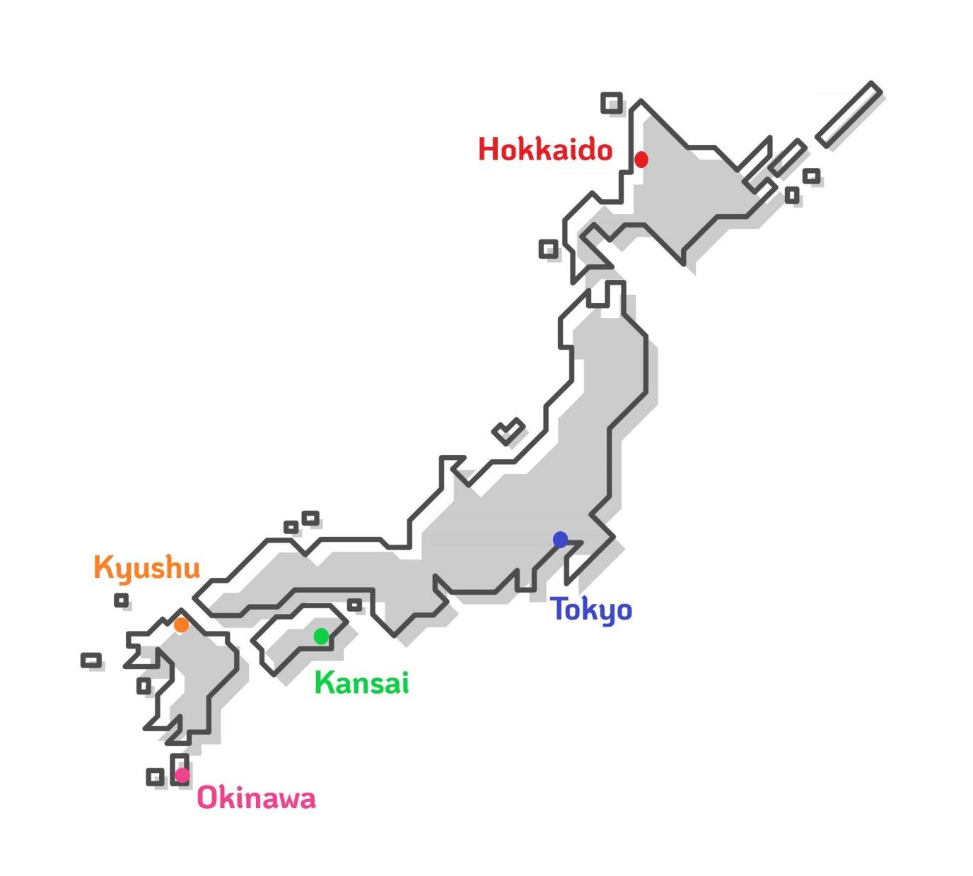

In Japan, the government introduced a new method to inspire people to use renewable energy more. So, it is a new kind of promotional charge called “renewable energy surcharges” with a 1.0005% predefined charge on basic power consumption amount. The government is also offering 2.43% rebate to any amount of electric bills.

**The five regions are:**

| Region Code | Region Name |
| --- | --- |
| 220 | Hokkaido Electric Power Company (HEPCO) |
| 221 | Tokyo Electric Power Company (TEPCO) |
| 222 | Kansai Electric Power Company (KEPCO) |
| 223 | Kyushu Electric Power Company (KYUDEN) |
| 224 | Okinawa Electric Power Company (OKIDEN) |

**Institution Type & Fee:**

| Code | Institution Name | Fee(kWh) |
| --- | --- | --- |
| A | 1DK1R | JPY 1.10 |
| B | 1DK2R | JPY 1.20 |
| C | Industry Level-1 | JPY 1.60 |
| D | Industry Level-2 | JPY 1.80 |
| E | Commercial & Office | JPY 2.00 |
| F | Temporary | JPY 1.50 |

**Energy use charge:(kWh)**

| Consumption | Fee |
| --- | --- |
| 0 - 120kWh | JPY 20.21 |
| 120 - 300kWh | JPY 25.61 |
| >300kWh | JPY 28.59 |

* Renewable Energy Power Promotion Surcharge: 1.0005%

Basic amount * 1.0005%

* Government Rebate: 2.43%

Total charge * 2.43%

The ANRE introduced a UI(Universal Identification) number to identify specific meters properly. The number contains three information-

First 3 digits contain region code: **221 – Tokyo**

Next 5 digits contain meter no.: **12345 – meter number**

Last character contains institution type: **A - 1DK1R**

Each section is separated by “-”

Example:

**221-12345-A**