MARS-NET
Mars Habitat Communication Network

Submitted By

Student Name | Student ID
Shafayat Yeamin Jian | 241-15-679
Shanita Shafi Mugdha | 241-15-511

LAB PROJECT REPORT
This Report Presented in Partial Fulfillment of the course
CSE322: Computer Networks Lab in the Department Computer Science and Engineering Department



DAFFODIL INTERNATIONAL UNIVERSITY
Dhaka, Bangladesh
August 13, 2026

DECLARATION
We hereby declare that this lab project has been done by us under the supervision of Rowzatul Zannat, Lecturer Department of Computer Science and Engineering, Daffodil International University. We also declare that neither this project nor any part of this project has been submitted elsewhere as lab projects.

Submitted To:

Rowzatul Zannat
Lecturer
Department of Computer Science and Engineering
Daffodil International University

Submitted By:

Shafayat Yeamin Jian
ID: 241-15-679
Dept. of CSE, DIU

Shanita Shafi Mugdha
ID: 241-15-511
Dept. of CSE, DIU

COURSE & PROGRAM OUTCOME

The following course have course outcomes as following:

Table 1: Course Outcome Statements
CO’s | Statements
CO1 | Describe and apply the fundamentals of LAN architecture along with basic topology setup using simulation tools.
CO2 | Configure and Analyze network devices and services using Cisco Packet Tracer in various networking topologies.
CO3 | Design, Implement, and Troubleshoot dynamic and static routing protocols NAT, and ACLs in simulated environments to build efficient and secure networks.

Table 2: Mapping of CO, PO, Blooms, KP and CEP
CO | PO | Blooms | KP | CEP
CO1 | PO5 | C3, P1, P2, A2 | K6 | EP1
CO2 | PO2 | C3, P2 | K1-K4 | EP2
CO3 | PO3 | A2, P2 | K5 | EP3

The mapping justification of this table is provided in section 4.3.1, 4.3.2 and 4.3.3.

Table of Contents

Declaration i

Course & Program Outcome ii
- Introduction 1 - 2
  - Introduction 1
  - Motivation 1
  - Problem Statement 1
  - Objectives 1
  - Feasibility Study 2
  - Gap Analysis 2
  - Project Outcome 2
- Network Architecture 3 - 4
  - Requirement Analysis & Design Specification 3 - 4
    - Overview 3
    - Requirements 3
    - Network Topology Diagram 4
    - IP Addressing & Subnetting Table 4
  - Use of Modern Simulation Tools 4
- Implementation and Results 5 - 18
  - Implementation 5 - 12
    - Routing Protocol 5
    - VLAN Configuration 6 - 7
    - NAT Configuration 7
    - ACL Configuration 8 - 10
    - DHCP Server Configuration 10 - 11
    - DNS Server Configuration 11
    - SMTP Server Configuration 12
  - Output 12 - 18
    - Routing Table 12 - 14
    - Virtual Local Area Network (VLAN) 14 - 15
    - NAT Table 15
    - Access Control List (ACL) 16 - 17
    - DHCP Server 17
    - DNS Server 17
    - SMTP Server 18
  - Discussion 18
- Engineering Standards and Mapping 19 - 21
  - Impact on Society, Environment and Sustainability 19
    - Impact on Life 19
    - Impact on Society & Environment 19
    - Ethical Aspects 19
    - Sustainability Plan 19
  - Complex Engineering Problem 20 - 21
    - Mapping of Program Outcome 20
    - Complex Problem Solving 20
    - Complex Engineering Activities 21
- Conclusion 22
  - Summary 22
  - Limitation 22
  - Future Work 22
References 23

Chapter 1

Introduction

This chapter provides an overview of the MARS-Net project, including its objectives, scope, and significance. It sets the foundation by explaining the problem domain and the goals the project aims to achieve.

Introduction
Computer networks are essential for secure communication and resource sharing in modern organizations. A well-designed network improves performance, reliability, and security by connecting different departments and services efficiently. This project designs a secure enterprise network for a hypothetical Mars colony using Cisco Packet Tracer. The network connects the Research, Medical, Habitat, and Security departments using VLANs, EIGRP, OSPF, DHCP, DNS, SMTP, NAT, and ACLs to provide efficient communication and secure access.

Motivation
Modern organizations depend on secure and reliable computer networks. Learning how to design and configure such networks is an important skill for networking professionals. The Mars colony scenario provides a realistic and interesting way to apply networking concepts. It allows different technologies such as VLANs, routing protocols, servers, NAT, and ACLs to work together in one complete network. This project also provides hands-on experience with Cisco Packet Tracer. It improves practical knowledge of enterprise networking and helps develop problem-solving and network design skills that are useful in future careers. Research, Medical, Habitat, and Security departments using VLANs, EIGRP, OSPF, DHCP, DNS, SMTP, NAT, and ACLs to provide efficient communication and secure access.

Problem Statement
The project aims to design a secure and scalable network that enables communication between different departments while protecting sensitive resources through proper routing, network services, and access control.

Objectives
The objectives of this project are:
• To design a secure enterprise network for a Mars colony.
• To divide the Habitat Department into multiple VLANs.
• To configure inter-VLAN communication using Router-on-a-Stick.
• To implement EIGRP for internal routing.
• To connect Mars and Earth using OSPF.
• To configure route redistribution between EIGRP and OSPF.
• To deploy DHCP, DNS, and SMTP servers.
• To implement NAT.
• To secure the network using Extended ACLs.

Feasibility Study
Enterprise networks commonly use technologies such as VLANs, EIGRP, OSPF, DHCP, DNS, NAT, and ACLs to improve performance, security, and network management. Cisco Packet Tracer supports all of these features, making it a suitable platform for designing and testing the proposed Mars colony network. Therefore, implementing this project is both practical and feasible.

Gap Analysis
Many networking projects focus on only one or two technologies. As a result, they do not represent how real enterprise networks operate. They often lack integrated services, security policies, and realistic network design. This project fills that gap by combining multiple enterprise networking technologies into a single secure and scalable network for a Mars colony.

Project Outcome
After completing this project, a secure and fully functional Mars colony network will be available in Cisco Packet Tracer. Different departments will communicate according to the defined security policies, while centralized servers will provide essential network services. The network will support automatic IP address assignment, DNS name resolution, email communication, secure routing, and controlled access between departments. It will also allow communication between Mars and Earth using NAT and OSPF. Overall, the project demonstrates how different networking technologies can be integrated to build a secure, scalable, and reliable enterprise network.

Chapter 2

Network Architecture

This chapter describes the overall system design and architecture of the MARS-Net project. It outlines the major components, their interactions, and the technologies used to build an efficient and scalable project.

Requirement Analysis & Design Specification

Overview
The Mars colony requires a secure and scalable network for communication between departments and access to centralized services. Technologies such as VLANs, dynamic routing, NAT, and ACLs are used to provide efficient communication and network security.

Requirements
The network should provide secure communication between the Research, Medical, Habitat, and Security departments. The Habitat department is divided into four VLANs: Residential, Greenhouse, Robot Maintenance, and Tourist. DHCP, DNS, and SMTP provide essential network services, while EIGRP and OSPF handle routing. NAT enables external connectivity, and Extended ACLs control access between departments.

Network Topology Diagram
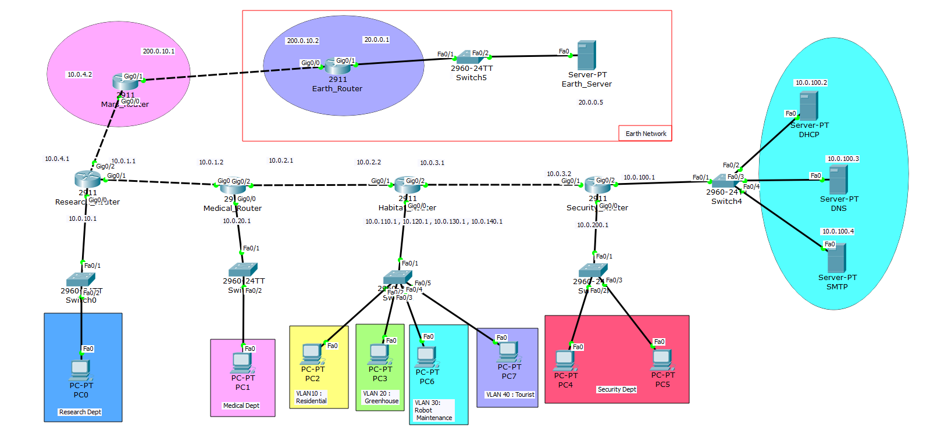
Figure 2.1: Network Diagram

    - IP Addressing & Subnetting Table
Table 2.1: IP Addressing Scheme
Device | Interface | IP Address | Subnet Mask | Connected To
Earth Gateway Router | Gig0/0 | 200.0.10.2 | /30 | Mars Gateway Router
Earth Gateway Router | Gig0/1 | 20.0.0.1 | /24 | Switch5 (Earth LAN)
Earth Server | NIC | 20.0.0.5 | /24 | Switch5
Mars Gateway Router | Gig0/1 | 200.0.10.1 | /30 | Earth Gateway Router
Mars Gateway Router | Gig0/0 | 10.0.4.2 | /30 | Research Router
Research Router | Gig0/0 | 10.0.4.1 | /30 | Mars Gateway Router
Research Router | Gig0/1 | 10.0.1.1 | /30 | Medical Router
Research Router | Fa0/1 | 10.0.10.1 | /24 | Switch0 → PC0
Medical Router | Gig0/1 | 10.0.1.2 | /30 | Research Router
Medical Router | Gig0/2 | 10.0.2.1 | /30 | Habitat Inter-VLAN Router
Medical Router | Fa0/1 | 10.0.20.1 | /24 | Switch1 → PC1
Habitat Inter-VLAN Router | Gig0/1 | 10.0.2.2 | /30 | Medical Router
Habitat Inter-VLAN Router | Gig0/2 | 10.0.3.1 | /30 | Security Router
Habitat Router (VLAN 10 Residential) | Fa0/1.10 | 10.0.110.1 | /24 | Switch2 → PC2
Habitat Router (VLAN 20 Greenhouse) | Fa0/1.20 | 10.0.120.1 | /24 | Switch2 → PC3
Habitat Router (VLAN 30 Robot Maintenance) | Fa0/1.30 | 10.0.130.1 | /24 | Switch2 → PC6
Habitat Router (VLAN 40 Tourist) | Fa0/1.40 | 10.0.140.1 | /24 | Switch2 → PC7
Security Router | Gig0/1 | 10.0.3.2 | /30 | Habitat Inter-VLAN Router
Security Router | Gig0/2 | 10.0.100.1 | /24 | Switch4 (Server Network)
Security Router | Fa0/1 | 10.0.200.1 | /24 | Switch3 → PC4, PC5
DHCP Server | NIC | 10.0.100.2 | /24 | Switch4
DNS Server | NIC | 10.0.100.3 | /24 | Switch4
SMTP Server | NIC | 10.0.100.4 | /24 | Switch4

Use of Modern Simulation Tools
Cisco Packet Tracer was used to design, configure, and test the entire Mars colony network. It provided a virtual environment where routers, switches, servers, and end devices could be connected and configured without requiring physical networking equipment.
The software was used to configure VLANs, Router-on-a-Stick, EIGRP, OSPF, DHCP, DNS, SMTP, NAT, and ACLs. After completing the configuration, different network services were tested to ensure they worked correctly.
Packet Tracer's Simulation Mode was used to observe packet movement between devices and verify the operation of routing protocols, NAT, and ACLs. Diagnostic tools such as Ping (ICMP) and traceroute were used to test connectivity, identify routing paths, and troubleshoot network issues. These features helped verify that all departments could communicate according to the defined network policies and that unauthorized access was successfully blocked.

Chapter 3

Implementation and Results

This chapter details the step-by-step implementation process of the MARS-NET project. It presents the development phases, key features, and the results obtained from testing and evaluation.

Implementation
This chapter describes the implementation of Mars-Net: Mars Habitat Communication Network, including VLANs, trunking, routing protocols, NAT, ACLs, and network services such as DHCP, DNS, and SMTP.

Routing Protocol
EIGRP and OSPF, these two routing protocols were used in the network. EIGRP handles routing within the Mars network (Research Router, Medical Router, Habitat Router, Security Router), while OSPF is used for communication between the Mars and Earth gateway routers.
EIGRP Configuration:
en
config t
router eigrp 10
network 10.0.0.0
no auto-summary
ex

OSPF Configuration:
en
config t
router ospf 1
network 200.0.10.0 0.0.0.255 area 0
network 20.0.0.0 0.0.0.255 area 0
ex

Route Redistribution on Mars Router:
router ospf 1
redistribute eigrp 10 subnets
router eigrp 10
redistribute ospf 1 metric 10000 100 255 1 1500

VLAN Configuration
The Habitat Department was divided into four VLANs to logically separate different areas of the colony. Router-on-a-Stick was used to enable communication between the four Habitat VLANs. Separate router subinterfaces were created for each VLAN, and 802.1Q encapsulation was configured.
Table 3.1: VLAN areas
VLAN ID | VLAN Name | Purpose
10 | Residential | Residential users
20 | Greenhouse | Greenhouse systems
30 | Robot_Maintenance | Robot maintenance systems
40 | Tourist | Tourist users

On Habitat Switch:
en
config t
vlan 10
name Residential
vlan 20
name Greenhouse
vlan 30
name Robot_Maintenance
vlan 40
name Tourist
ex

interface fa0/2
switchport mode access
switchport access vlan 10
ex
interface fa0/3
switchport mode access
switchport access vlan 20
ex
interface fa0/4
switchport mode access
switchport access vlan 30
ex
interface fa0/5
switchport mode access
switchport access vlan 40
ex

Trunk Configuration:
interface fa0/1
switchport mode trunk
switchport trunk allowed vlan 10,20,30,40
no shutdown
Inter-VLAN Routing Configuration on Habitat Router:
en
config t
interface gigabitEthernet0/0.10
encapsulation dot1Q 10
ip address 10.0.110.1 255.255.255.0
exit

interface gigabitEthernet0/0.20
encapsulation dot1Q 20
ip address 10.0.120.1 255.255.255.0
exit

interface gigabitEthernet0/0.30
encapsulation dot1Q 30
ip address 10.0.130.1 255.255.255.0
exit

interface gigabitEthernet0/0.40
encapsulation dot1Q 40
ip address 10.0.140.1 255.255.255.0
exit

NAT Configuration
NAT was implemented on the Mars Gateway Router to allow private Mars networks to communicate with the external Earth network. PAT was used to allow multiple internal devices to share the public IP address of the Mars Gateway Router.
NAT Configuration:
en
config t
interface GigabitEthernet0/0
ip address 10.0.4.2 255.255.255.252
ip nat inside
no shutdown
exit

interface GigabitEthernet0/1
ip address 200.0.10.1 255.255.255.252
ip nat outside
no shutdown
exit

access-list 1 permit 10.0.0.0 0.255.255.255
ip nat inside source list 1 interface GigabitEthernet0/1 overload

ACL Configuration
Extended ACLs were implemented to control communication between departments. The ACL rules were designed according to the security requirements of the Mars colony. For example, the Security Department must be accessible by its own users but should not be accessible from other departments. Other departments were given access only to the networks required for their operations. The ACL policy can be summarized as follows:
Table 3.2:ACL access list
Source Department | Allowed Access
Security | All departments
Tourist | Medical, Residential
Robot Maintenance | Research, Residential
Greenhouse | Residential, Medical
Residential | Medical
Medical | Research, Residential, Greenhouse, Robot Maintenance, Tourist
Research | Medical, Robot Maintenance

On Research Router:
en
configure t
ip access-list extended RESEARCH_ACL
permit ip 10.0.10.0 0.0.0.255 10.0.200.0 0.0.0.255
permit ip 10.0.10.0 0.0.0.255 10.0.20.0 0.0.0.255
permit ip 10.0.10.0 0.0.0.255 10.0.130.0 0.0.0.255
permit ip 10.0.10.0 0.0.0.255 10.0.100.0 0.0.0.255
deny ip 10.0.10.0 0.0.0.255 10.0.0.0 0.255.255.255
permit ip any any
exit
interface GigabitEthernet0/0
ip access-group RESEARCH_ACL in
exit

On Medical Router:
en
config t
ip access-list extended MEDICAL_ACL
permit ip 10.0.20.0 0.0.0.255 10.0.200.0 0.0.0.255
permit ip 10.0.20.0 0.0.0.255 10.0.100.0 0.0.0.255
permit ip 10.0.20.0 0.0.0.255 10.0.10.0 0.0.0.255
permit ip 10.0.20.0 0.0.0.255 10.0.110.0 0.0.0.255
permit ip 10.0.20.0 0.0.0.255 10.0.120.0 0.0.0.255
permit ip 10.0.20.0 0.0.0.255 10.0.140.0 0.0.0.255
deny ip 10.0.20.0 0.0.0.255 10.0.0.0 0.255.255.255
permit ip any any
exit
interface GigabitEthernet0/0
ip access-group MEDICAL_ACL in
exit

On Habitat Router:
en
config t
ip access-list extended RESIDENTIAL_ACL
permit ip 10.0.110.0 0.0.0.255 10.0.200.0 0.0.0.255
permit ip 10.0.110.0 0.0.0.255 10.0.100.0 0.0.0.255
permit ip 10.0.110.0 0.0.0.255 10.0.20.0 0.0.0.255
permit ip 10.0.110.0 0.0.0.255 10.0.140.0 0.0.0.255
deny ip 10.0.110.0 0.0.0.255 10.0.0.0 0.255.255.255
permit ip any any
exit
interface GigabitEthernet0/0.10
ip access-group RESIDENTIAL_ACL in
exit

ip access-list extended GREENHOUSE_ACL
permit ip 10.0.120.0 0.0.0.255 10.0.200.0 0.0.0.255
permit ip 10.0.120.0 0.0.0.255 10.0.100.0 0.0.0.255
permit ip 10.0.120.0 0.0.0.255 10.0.20.0 0.0.0.255
deny ip 10.0.120.0 0.0.0.255 10.0.0.0 0.255.255.255
permit ip any any
exit
interface GigabitEthernet0/0.20
ip access-group GREENHOUSE_ACL in
exit

ip access-list extended ROBOT_MAINT_ACL
permit ip 10.0.130.0 0.0.0.255 10.0.200.0 0.0.0.255
permit ip 10.0.130.0 0.0.0.255 10.0.100.0 0.0.0.255
permit ip 10.0.130.0 0.0.0.255 10.0.10.0 0.0.0.255
deny ip 10.0.130.0 0.0.0.255 10.0.0.0 0.255.255.255
permit ip any any
exit
interface GigabitEthernet0/0.30
ip access-group ROBOT_MAINT_ACL in
exit

ip access-list extended TOURIST_ACL
permit ip 10.0.140.0 0.0.0.255 10.0.200.0 0.0.0.255
permit ip 10.0.140.0 0.0.0.255 10.0.100.0 0.0.0.255
permit ip 10.0.140.0 0.0.0.255 10.0.20.0 0.0.0.255
permit ip 10.0.140.0 0.0.0.255 10.0.110.0 0.0.0.255
deny ip 10.0.140.0 0.0.0.255 10.0.0.0 0.255.255.255
permit ip any any
exit
interface GigabitEthernet0/0.40
ip access-group TOURIST_ACL in
exit

On Security Router:
en
configure t

ip access-list extended SEC_INBOUND
permit icmp any 10.0.200.0 0.0.0.255 echo-reply
permit tcp any 10.0.200.0 0.0.0.255 established
permit udp host 10.0.100.3 10.0.200.0 0.0.0.255 eq domain
deny icmp 10.0.0.0 0.255.255.255 10.0.200.0 0.0.0.255 echo
deny ip 10.0.0.0 0.255.255.255 10.0.200.0 0.0.0.255
permit ip any any
exit
interface GigabitEthernet0/0
ip access-group SEC_INBOUND out
exit

DHCP Server Configuration
A dedicated DHCP server was configured to automatically assign IP addresses to client devices. For all the networks DHCP relay was configured on the router subinterfaces using the IP helper-address command.
On Research Router, Medical Router & Security Router:
en
configure t
interface GigabitEthernet0/0
ip helper-address 10.0.100.2
exit

On Habitat Router:
en
configure t
interface GigabitEthernet0/0
no shutdown
interface GigabitEthernet0/0.10
ip helper-address 10.0.100.2
interface GigabitEthernet0/0.20
ip helper-address 10.0.100.2
interface GigabitEthernet0/0.30
ip helper-address 10.0.100.2
interface GigabitEthernet0/0.40
ip helper-address 10.0.100.2
exit

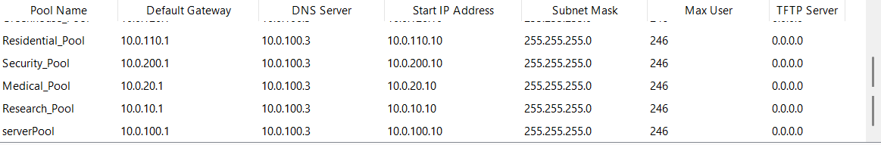
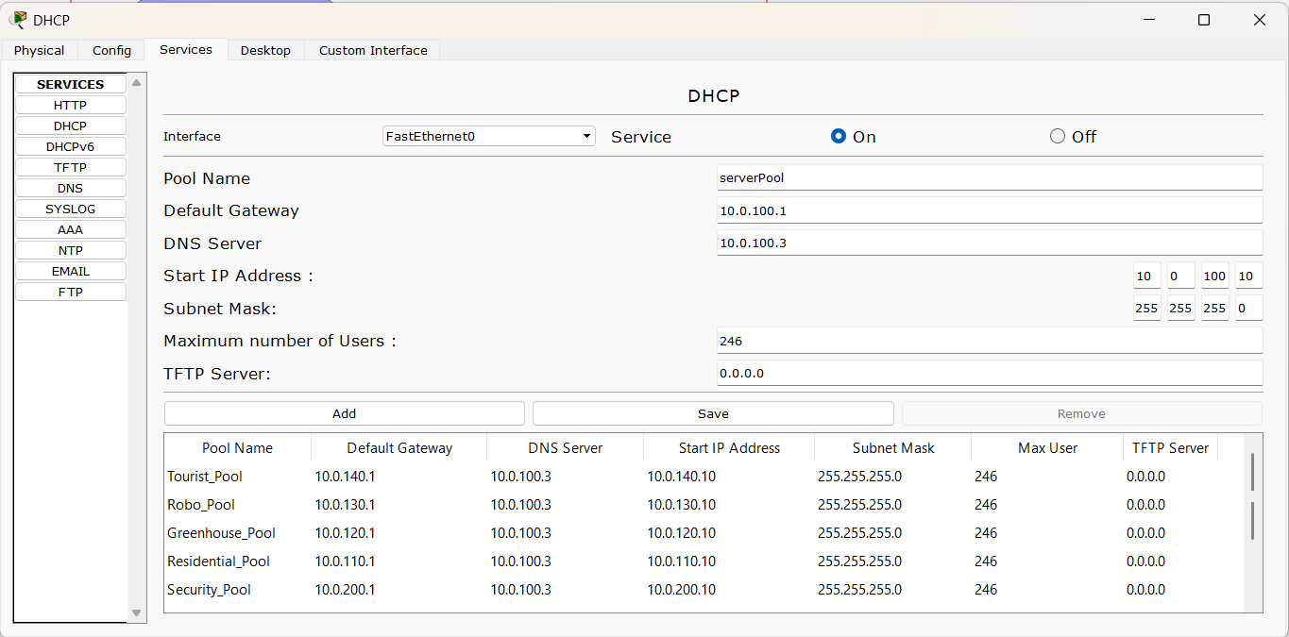
DHCP pool configuration:
Figure 3.1: DHCP pools

DNS Server Configuration
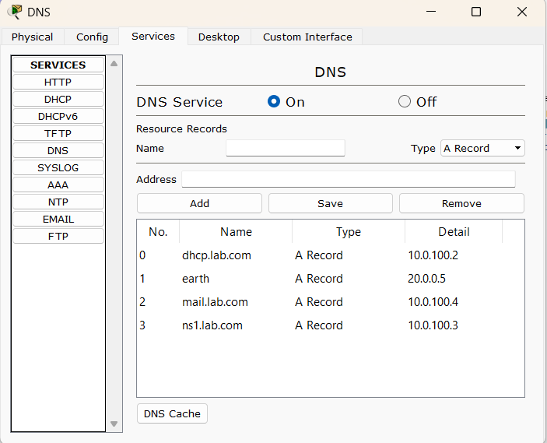
A dedicated DNS server was configured to provide name resolution within the Mars network. Domain names were mapped to the corresponding server or host IP addresses.

Figure 3.2: DNS Configuration

SMTP Server Configuration
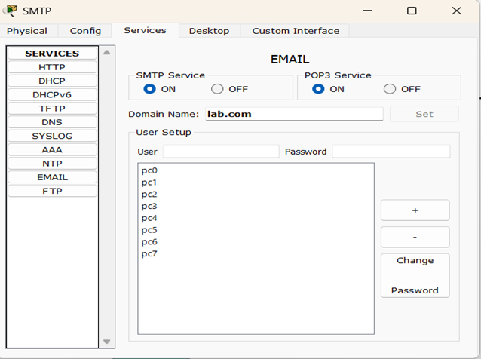
An SMTP mail server was configured to provide email communication between users in different departments. Email accounts were created for the required users, and the SMTP service was enabled.

Figure 3.3: SMTP Configuration

Output
After completing the network configuration, several tests were performed to verify that the network was working correctly. The results confirmed the proper operation of VLANs, routing protocols, network services, NAT, and ACLs.

Routing Table
The routing protocols were tested using routing tables and neighbor information. EIGRP successfully exchanged routes between the internal Mars routers, while OSPF established communication between the Mars and Earth Gateway routers.

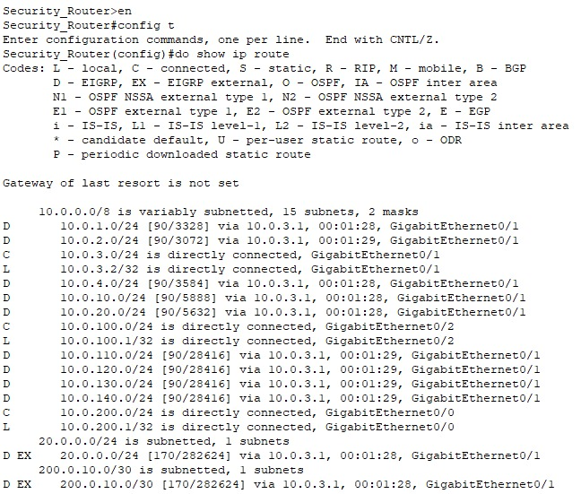
Figure 3.4: Routing Table of Security Router
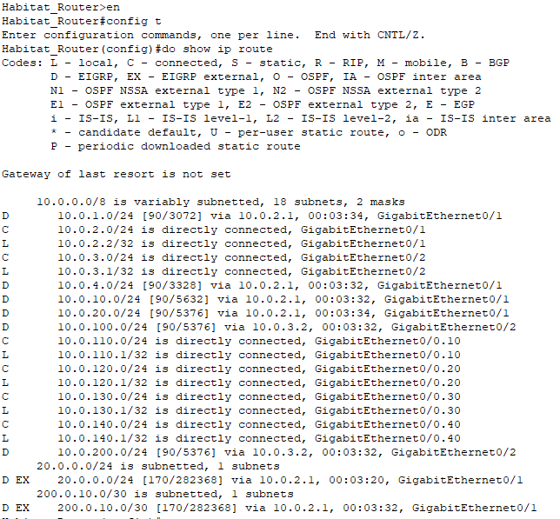
Figure 3.5: Routing Table of Habitat Router
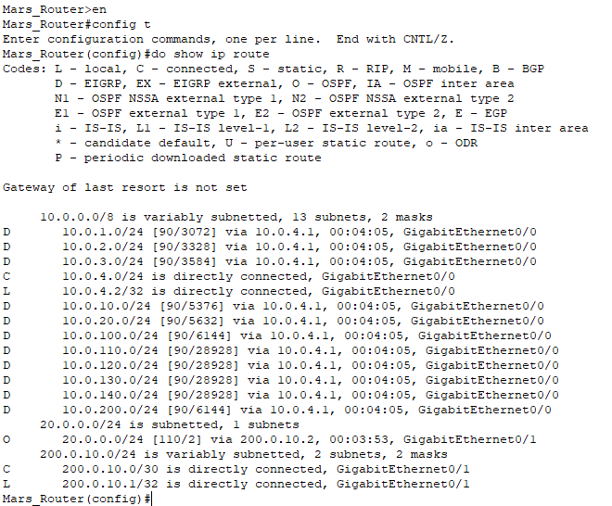
Figure 3.6: Routing Table of Mars Router

Virtual Local Area Network (VLAN)
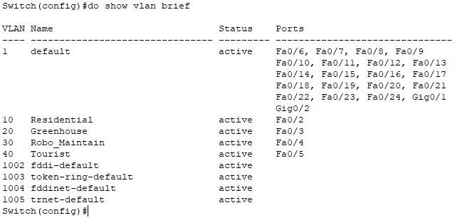
On Habitat Switch:
Figure 3.7: VLAN and Ports

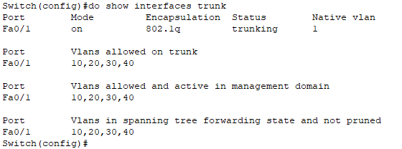
For Trunk:
Figure 3.8: Switch Trunk

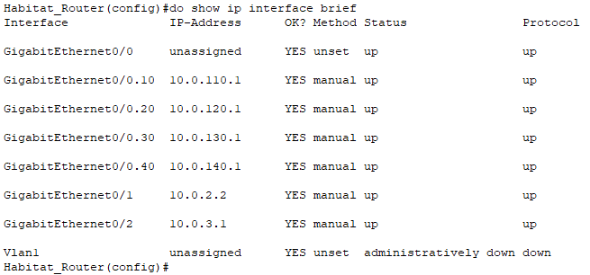
On Habitat Router:
Figure 3.9: VLAN IP interfaces

NAT Table
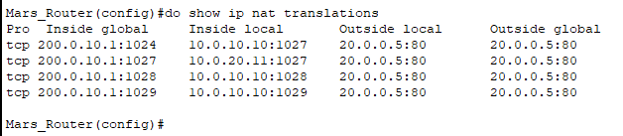
On Mars Router:
Figure 3.10: NAT Table

Access Control List (ACL)
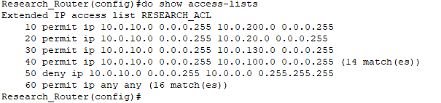
On Research Router:
Figure 3.11: IP Access List of Research Router
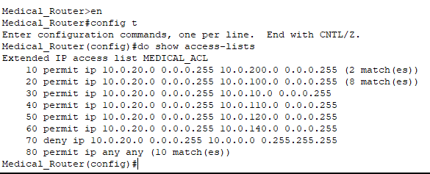
On Medical Router:
Figure 3.12: IP Access List of Medical Router
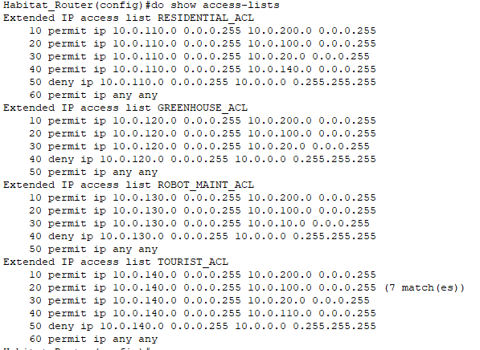
On Habitat Router:
Figure 3.13: IP Access List of Habitat Router
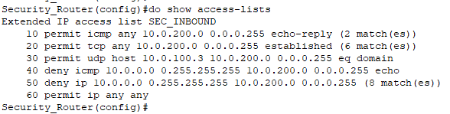
On Security Router:
Figure 3.14: IP Access List of Security Router

DHCP Server
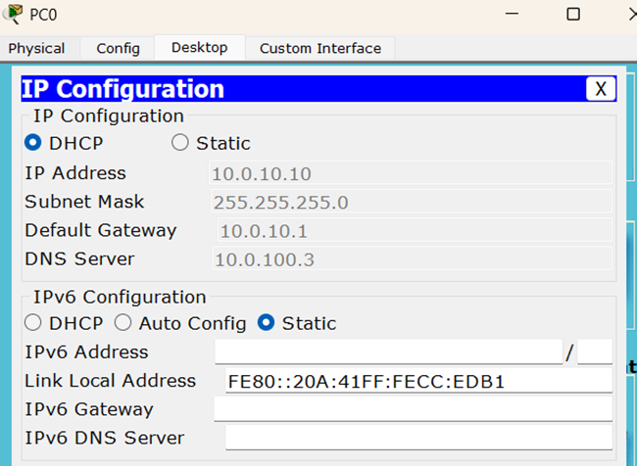
DHCP server is successfully assigning IP on devices.
Figure 3.15: DHCP IP Assignment for PC0

DNS Server
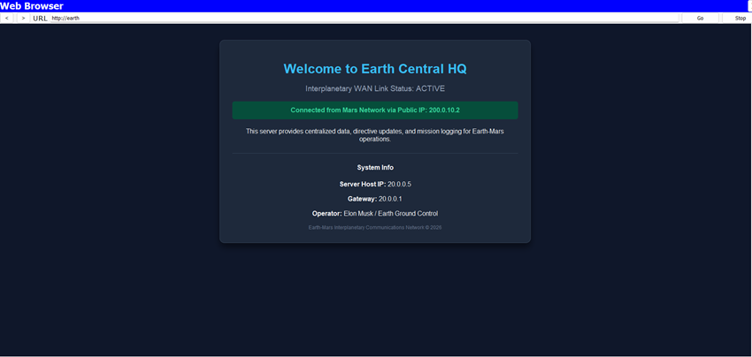
DNS server is successfully working.
Figure 3.16: Accessing Earth Server via DNS from Mars
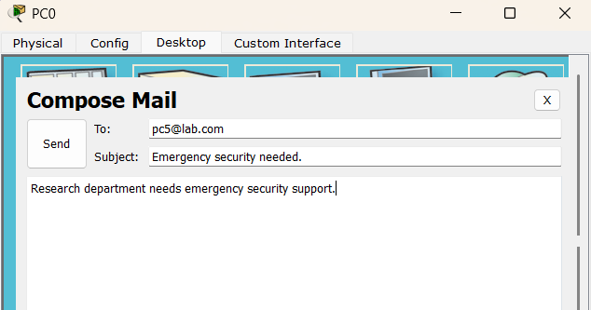
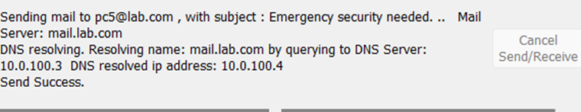

SMTP Server
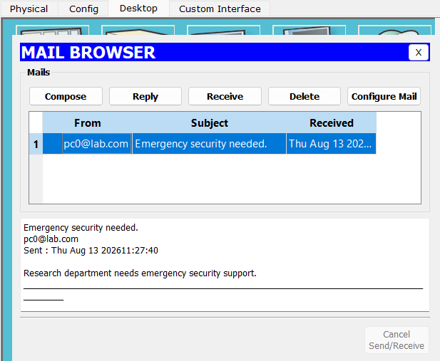
Figure 3.17: Sending email from PC0
Figure 3.18: Receiving Email from Security Dept PC5

Discussion
The implementation and testing results show that the proposed MARS-NET: Mars Habitat Communication Network successfully meets its main requirements. VLANs provided proper network segmentation within the Habitat Department, while EIGRP and OSPF enabled communication between the different network areas. The DHCP, DNS, and SMTP servers successfully provided the required network services. NAT allowed communication between the private Mars network and the external Earth network, while ACLs controlled communication between departments according to the defined security policies. Overall, the combination of these technologies provided a secure, organized, and scalable network structure. The testing results also showed that authorized communication was allowed and restricted traffic was blocked, demonstrating that the network design was functioning according to the project requirements.

Chapter 4

Engineering Standards and Mapping

This chapter discusses the engineering standards followed throughout the project and maps the project activities to the course and program outcomes. It highlights how the project meets academic and professional requirements.

Impact on Society, Environment and Sustainability

Impact on Life
The network can support important services such as Medical, Research, and Security communication. Reliable connectivity can help medical personnel communicate quickly, researchers exchange information, and security personnel coordinate during emergencies. A properly designed network can therefore contribute to safer and more organized operations within the colony.

Impact on Society & Environment
Department-based ACLs mirror how real institutions isolate sensitive units while allowing necessary cross-access. NAT/PAT conserves address space, similar to real-world IPv4 conservation. Dynamic routing (EIGRP/OSPF) lets the network self-adapt to failures without manual reconfiguration, reducing service disruption.

Ethical Aspects
Network security and privacy are important ethical considerations. The ACL policies in this project restrict unauthorized communication between departments and protect sensitive resources. Network administrators should also use network information responsibly, avoid unauthorized access, and ensure that security policies are applied fairly to all users.

Sustainability Plan
The proposed network is designed with future expansion in mind. New departments, VLANs, devices, and services can be added without completely redesigning the existing network. Using dynamic routing protocols such as EIGRP and OSPF also makes the network easier to manage as it grows. Regular monitoring, configuration backups, security updates, and proper documentation would help maintain the network over the long term.

Complex Engineering Problem

Mapping of Program Outcome
In this section, provide a mapping of the problem and provided solution with targeted Program Outcomes (PO’s).
Table 4.1: Justification of Program Outcomes
PO’s | Justification of Mapping
PO1: Engineering Knowledge | The project incorporates modern network modeling and simulation tools, specifically Cisco Packet Tracer, to design, configure, test, and analyze contemporary network topologies and protocols under realistic conditions before physical deployment.
PO2: Problem Analysis | The project requires students to identify and analyze complex networking problems by systematically troubleshooting routing protocols, IP addressing, and security configurations within Cisco Packet Tracer. By examining real-time simulation traffic and routing tables, they apply engineering principles to reach substantiated conclusions regarding network convergence and performance.
PO3: Design/ Development of Solutions | This project involves designing and implementing a scalable network infrastructure using efficient routing protocols (such as OSPF, EIGRP, or RIP), variable-length subnet masking (VLSM), and network security configurations (ACLs and NAT). This directly addresses complex engineering problems and network system design challenges by ensuring reliable, safe, and secure data flow.

Complex Problem Solving
The following table maps the MARS-Net project to the Complex Engineering Problem (CEP) attributes from the CSE322 course outline, with justification for each mapped CO.
Table 4.2: Mapping with complex problem solving
EP1  Depth of Knowledge | EP2  Range of Conflicting Requirements | EP3  Depth of Analysis | EP4  Familiarity  of Issues | EP5  Extent of Applicable Codes | EP6  Extent of Stakeholder Involvement | EP7  Inter-dependence

EP1: This project required the design and implementation of a fully functional network topology from scratch. This involved tackling real-world engineering challenges, such as efficient IP addressing using VLSM, configuring routing protocols for inter-network communication, and securing the system with NAT and ACLs. Working through these roadblocks provided a deeper understanding of how to solve complex network architecture problems.
EP2: Configuring and analyzing network services across varied topologies requires students to balance a range of conflicting requirements, such as performance versus resource constraints. Using Cisco Packet Tracer allows them to systematically test and optimize device configurations to resolve these competing operational demands.
EP3: This project maps to EP3 because troubleshooting complex routing protocols, NAT, and ACLs requires deep analytical investigation of packet flows, routing tables, and security policies to identify and resolve faults. This intensive diagnostic process directly fulfills the "depth of analysis required" to ensure network efficiency and security.

Complex Engineering Activities
The following table maps the project to Complex Engineering Activity (CEA) attributes. CO4 is the primary CO mapped to engineering activities in the CSE322 course outline.
Table 4.3: Mapping with complex engineering activities
EA1  Range of resources | EA2  Level of problem-solving complexity | EA3  Innovation and development of new tools | EA4  Consequences for society and  environment | EA5  Safety and reliability
EA1: The network topology was designed to connect the Research, Medical, Habitat, Security, and Earth networks. VLANs were also designed for Residential, Greenhouse, Robot Maintenance, and Tourist areas.
EA2: Different routing and communication requirements were analyzed to select suitable technologies such as EIGRP, OSPF, NAT, and ACLs.
EA3: The proposed design was implemented in Cisco Packet Tracer by configuring routers, switches, VLANs, servers, routing protocols, NAT, and ACLs. The completed network was tested against the required communication and security policies. Configuration changes were made where necessary to improve reliability, security, and performance.

Chapter 5

Conclusion

This chapter summarizes the outcomes of the MARS-NET project, discusses current limitations, and identifies avenues for future work.

Summary
This project successfully designed and simulated MARS-NET: Mars Habitat Communication Network, a secure enterprise network for a hypothetical Mars colony using Cisco Packet Tracer. The network connects the Research, Medical, Habitat, and Security departments and uses VLANs to separate the different Habitat sections. Technologies including EIGRP, OSPF, DHCP, DNS, SMTP, NAT, and ACLs were implemented to provide routing, network services, external connectivity, and security. Testing was performed using tools such as Ping and Packet Tracer Simulation mode. Overall, the project demonstrates how different networking technologies can work together to create a reliable and secure network for a complex environment.

Limitations
The main limitation of this project is that it was developed and tested using Cisco Packet Tracer,
so it does not represent the performance of a real physical network. The project also uses a simplified
Mars-to-Earth connection. Real interplanetary communication would involve much greater distance,
signal delays, specialized communication systems, and additional reliability requirements.

Future Work
The network can be expanded by adding more departments, routers, servers, and backup connections. Additional security technologies such as firewalls, VPNs, and intrusion detection systems could also be implemented. Future versions could also include redundant links, advanced monitoring, IPv6, and more realistic Mars-to-Earth communication models. These improvements would make the network more scalable, reliable, and closer to a real-world Mars colony infrastructure.

References

[1] Cisco Networking Academy, “Cisco Packet Tracer,” Cisco. Cisco Packet Tracer.
[2] Cisco Systems, “Configuring VLANs,” Cisco Documentation. Cisco VLAN Documentation.
[3] Cisco Systems, “Network Address Translation,” Cisco Documentation. Cisco NAT Documentation.
[4] Cisco Systems, “IP Access Control Lists,” Cisco Documentation. Cisco ACL Documentation.
[5] J. Moy, OSPF Version 2, RFC 2328, Internet Engineering Task Force, 1998. RFC 2328.
[6] J. Klensin, Simple Mail Transfer Protocol, RFC 5321, Internet Engineering Task Force, 2008. RFC 5321.

