实验2 基于ROS机械臂的三维空间目标抓取实验

实验目的
学习编写相关的程序，识别三维空间内的物体，进行抓取。

实验原理
Open3d库是一个3D处理的算法库，可以将深度相机的RGB图像、深度图像以及深度相机的内外参信息进行结合实现深度相机点云信息可视化。

实验步骤
使用Nomachine远程桌面连接工具，通过局域网连接机器人的Jetson Orin Nano主控器。

3.1 编写object_classification.py文件
- 点击系统左侧任务栏的命令行终端图标，新建一个命令行终端,输入指令进行安装相关依赖。
pip3 install transforms3d
- 在终端输入指令进入到grap_3d的scripts目录下：
roscd grap_3d/scripts/
- 接着输入指令，编写程序，将以下的内容，编写到文本当中：
gedit object_classification.py
#!/usr/bin/python3
#coding=utf8

# 机械臂向下识别
# 可以识别长方体，球，圆柱体
import os
import sys
import queue
import signal
import threading
import numpy as np
import math
from math import degrees, radians, atan2, asin, sqrt
import cv2
import rospy
import transforms3d as tfs
import message_filters
from std_srvs.srv import SetBool
from sensor_msgs.msg import Image, CameraInfo
from std_srvs.srv import Trigger, TriggerResponse
from geometry_msgs.msg import Pose

sys.path.append('/home/ubuntu/experiment_ws/src/arm_base/scripts')
sys.path.append('/home/ubuntu/experiment_ws/src/arm_base/utils/arm_pc')
from action_group_controller import ActionGroupController
sys.path.append('/home/ubuntu/experiment_ws/src/kinematics_sim/src/kinematics_sim')
sys.path.append('/home/ubuntu/experiment_ws/src/driver/scripts')
from serial_trans_recv import Board
import kinematics_sim.transform as transform
from kinematics_sim.forward_kinematics import ForwardKinematics
from kinematics_sim.inverse_kinematics import get_ik, set_link, get_link, set_joint_range, get_joint_range
import arm_actiongroups as acgroups

class ObjectClassificationNode:
hand2cam_tf_matrix = [
[0.0, 0.0, 1.0, -0.101],
[-1.0, 0.0, 0.0, 0.011],
[0.0, -1.0, 0.0, 0.045],
[0.0, 0.0, 0.0, 1.0]
]
pick_offset = [0.01, 0.01, 0.0, -0.005, 0.01] # x1, x2, y1, y2, z
'''
x1
y1 center y2
x2

arm
car
'''

def __init__(self, name):
rospy.init_node(name, anonymous=True)
self.moving = False
self.count = 0
self.start = True
self.shapes = None
self.colors = None
self.running = True
self.target_shapes = ''
self.roi = [70, 280, 170, 470]
self.endpoint = None
self.last_position = 0, 0
self.last_object_info_list = []
self.detect_object = ['sphere', 'cuboid', 'cylinder']
signal.signal(signal.SIGINT, self.shutdown)
self.image_queue = queue.Queue(maxsize=1)
# 舵机脉宽范围，中位值，对应的角度范围，中位值
self.joint1_map = [0, 1000, 500, -120, 120, 0]
self.joint2_map = [0, 1000, 500, 30, -210, -90]
self.joint3_map = [0, 1000, 500, 120, -120, 0]
self.joint4_map = [0, 1000, 500, 30, -210, -90]
self.joint5_map = [0, 1000, 500, -120, 120, 0]
self.arm_control = Board()
self.controller = ActionGroupController(board=self.arm_control)
self.current_servo_positions = [500, 500, 500, 500, 500] # 假设的初始位置
rospy.sleep(0.2)
self.goto_default()
# 声明下位机控制的对象，用于调用智能总线舵机控制的函数

# 调用控制的函数，其中 1.5表示运动到目标范角度的时间
# [id,positions] 分别对应的者对应的ID号转到的角度范围
camera = rospy.get_param('~camera_name', 'Gemini') # 获取参数
camera_name = 'camera'
if camera == 'Gemini':
rgb_sub = message_filters.Subscriber('/camera/camera/color/image_raw', Image, queue_size=1)
depth_sub = message_filters.Subscriber('/camera/camera/depth/image_raw', Image, queue_size=1)
info_sub = message_filters.Subscriber('/camera/camera/depth/camera_info', CameraInfo, queue_size=1)

# 同步时间戳, 时间允许有误差在0.03s
sync = message_filters.ApproximateTimeSynchronizer([rgb_sub, depth_sub, info_sub], 3, 0.02)
sync.registerCallback(self.multi_callback) #执行反馈函数

self.image_proc()
# 等比例映射
def angle_transform(self,angle, param, inverse=False):
if inverse:
new_angle = ((angle - param[5]) / (param[4] - param[3])) * (param[1] - param[0]) + param[2]
else:
new_angle = ((angle - param[2]) / (param[1] - param[0])) * (param[4] - param[3]) + param[5]

return new_angle

def pulse2angle(self, pulse):
theta1 = self.angle_transform(pulse[0], self.joint1_map)
theta2 = self.angle_transform(pulse[1], self.joint2_map)
theta3 = self.angle_transform(pulse[2], self.joint3_map)
theta4 = self.angle_transform(pulse[3], self.joint4_map)
theta5 = self.angle_transform(pulse[4], self.joint5_map)
return radians(theta1), radians(theta2), radians(theta3), radians(theta4), radians(theta5)

def set_joint_value_target(self, joint_value):
fk = ForwardKinematics(debug=False) # 不开启打印
# 正运动学解
angle = self.pulse2angle(joint_value)
res = fk.get_fk(angle)
pose = Pose()
print(pose)
if res:
pose.position.x = res[0][0]
pose.position.y = res[0][1]
pose.position.z = res[0][2]
pose.orientation = res[1]
self.endpoint = self.xyz_quat_to_mat([pose.position.x, pose.position.y, pose.position.z],
[pose.orientation.w, pose.orientation.x, pose.orientation.y, pose.orientation.z])
return [True, True, pose]
else:
return [True, False, pose]

def depth_pixel_to_camera(self, pixel_coords, intrinsic_matrix):
fx, fy, cx, cy = intrinsic_matrix[0], intrinsic_matrix[4], intrinsic_matrix[2], intrinsic_matrix[5]
px, py, pz = pixel_coords
x = (px - cx) * pz / fx
y = (py - cy) * pz / fy
z = pz
return np.array([x, y, z])

def set_pose_target(self, msg, resolution_input):
# 逆运动学解，获取最优解
position, pitch = msg, resolution_input,
pitch_range=[-180, 180]
resolution=1

# 确保 position 是一个列表或数组
if not isinstance(position, (list, np.ndarray)):
rospy.logerr('position is not a list or array: {}'.format(position))
return [False, [], [], [], 0]

position = list(position)

all_solutions = get_ik(position, pitch, list(pitch_range), resolution)
if all_solutions != [] and self.current_servo_positions != []:
rpy = []
min_d = 1000*5
optimal_solution = []
for s in all_solutions:
pulse_solutions = transform.angle2pulse(s[0])
try:
for i in pulse_solutions:
d = np.array(i) - self.current_servo_positions
d_abs = np.maximum(d, -d)
min_sum = np.sum(d_abs)
if min_sum < min_d:
min_d = min_sum
for k in range(len(i)):
if i[k] < 0:
i[k] = 0
elif i[k] > 1000:
i[k] = 1000
rpy = s[1]
optimal_solution = i
except BaseException as e:
print('choose solution error', e)

return [True, optimal_solution, self.current_servo_positions, rpy, min_d]
else:
return [True, [], [], [], 0]
def mat_to_xyz_euler(self, mat, degrees=True):
t, r, _, _ = tfs.affines.decompose(mat)
if degrees:
euler = np.degrees(tfs.euler.mat2euler(r))
else:
euler = tfs.euler.mat2euler(r)
return t, euler

def xyz_quat_to_mat(self, xyz, quat):
mat = tfs.quaternions.quat2mat(np.asarray(quat))
mat = tfs.affines.compose(np.squeeze(np.asarray(xyz)), mat, [1, 1, 1])
return mat

def xyz_euler_to_mat(self, xyz, euler, degrees=True):
if degrees:
mat = tfs.euler.euler2mat(math.radians(euler[0]), math.radians(euler[1]), math.radians(euler[2]))
else:
mat = tfs.euler.euler2mat(euler[0], euler[1], euler[2])
mat = tfs.affines.compose(np.squeeze(np.asarray(xyz)), mat, [1, 1, 1])
return mat

def calculate_e_distance(self, point1, point2):
# 计算两个点间的欧式距离
e_distance = int(round(math.sqrt(pow(point1[0] - point2[0], 2) + pow(point1[1] - point2[1], 2))))
return e_distance

def position_change_or_not(self, last_point, current_points, distance):
# 将上一次的某点与当前所有点对比，检测是否有距离符合设定的点，即当作位置没有改变的点

for p in current_points:
if last_point[0][:-1] == p[0][:-1]:
dis = self.calculate_e_distance(last_point[1], p[1])
if dis < distance:
current_points.remove(p)
p[0] = last_point[0]
return False, p, current_points

return True, None, current_points

def position_reorder(self, current_points, last_points, distance=10):
# distance 单位像素
# 对比上一次和当前点的位置，如果位置没有改变，则相应的颜色标签不变，否则从1开始重新安排标签序号
new_points = []
haved_change_points = []
for p in last_points: # 对上一次的所有点和当前点进行位置对比
res, not_change_point, haved_change_points = self.position_change_or_not(p, current_points, distance)
if not res: # 如果没有改变，就将此点记录下来作为重新排序的新点
new_points.extend([not_change_point])
if haved_change_points != [] and new_points != []:
names = np.array(new_points, dtype=object)[:, 0].tolist()
for p in haved_change_points:
index = 0
while True:
new_name = p[0][:-1]
index += 1
new_name += str(index)
if new_name not in names:
p[0] = new_name
new_points.extend([p])
names.append(new_name)
break

return new_points

def shutdown(self, signum, frame):
self.running = False
rospy.loginfo('shutdown')

def goto_default(self):
self.current_servo_positions = [500, 470, 220, 70, 500] # 设置为默认位置
endpoint = self.set_joint_value_target(self.current_servo_positions)
self.arm_control.bus_servo_set_position(duration=1,
positions=[[1, 500],
[2, 470],
[3, 220],
[4, 70],
[5, 500],
[10, 200]])

def move(self, obejct_info):
shape, pose_t = obejct_info[:2]
color, angle = obejct_info[-2:]

rospy.sleep(1)

# 确保 pose_t 是一个列表
if not isinstance(pose_t, (list, np.ndarray)):
pose_t = [pose_t]

if len(pose_t) != 3:
rospy.logerr('pose_t does not contain 3 elements: {}'.format(pose_t))
return

if 'sphere' in shape:
offset_z = -0.03 + self.pick_offset[-1]
else:
offset_z = -0.035 + self.pick_offset[-1]
if pose_t[0] > 0.21:
offset_x = self.pick_offset[0]
else:
offset_x = self.pick_offset[1]
if pose_t[1] > 0:
offset_y = self.pick_offset[2]
else:
offset_y = self.pick_offset[3]
pose_t[0] += offset_x
pose_t[1] += offset_y
pose_t[2] += offset_z

ret1 = self.set_pose_target(pose_t, 85)

if len(ret1[1]) > 0:
self.arm_control.bus_servo_set_position(1.5,
[[1, int(ret1[1][0])],
[2, int(ret1[1][1])],
[3, int(ret1[1][2])],
[4, int(ret1[1][3])],
[5, int(ret1[1][4])]])
rospy.sleep(1.5)
pose_t[2] -= 0.05
ret2 = self.set_pose_target(pose_t, 85)
if angle != 0:
if 'sphere' in shape or ('cylinder' in shape and 'cylinder_horizontal_' not in shape):
angle = 500
else:
angle = angle % 180
angle = angle - 180 if angle > 90 else (angle + 180 if angle < -90 else angle)
if angle == 90:
angle = 0
if ret2[3]:
angle = 500 + int(1000 * (angle + ret2[3][-1]) / 240)
else:
rospy.logerr('ret2[3] is empty or not properly formed')
angle = 500
else:
angle = 500
if len(ret2[1]) > 0:
self.arm_control.bus_servo_set_position(1.5,[[5,angle]])
rospy.sleep(0.5)
self.arm_control.bus_servo_set_position(1.5,
[[1, int(ret1[1][0])],
[2, int(ret1[1][1])],
[3, int(ret1[1][2])],
[4, int(ret1[1][3])],
[5, int(angle)]])
rospy.sleep(1)
if shape == "sphere":
self.arm_control.bus_servo_set_position(1.5,[[10,700]])
else:
self.arm_control.bus_servo_set_position(1.5,[[10,550]])
rospy.sleep(0.6)
if len(ret1[1]) > 0:
self.arm_control.bus_servo_set_position(1,
[[1, int(ret1[1][0])],
[2, int(ret1[1][1])],
[3, int(ret1[1][2])],
[4, int(ret1[1][3])],
[5, int(angle)]])
rospy.sleep(1)
self.arm_control.bus_servo_set_position(1,
[[1, 500],
[2, 500],
[3, 150],
[4, 130],
[5, 500],
[10, 650]])
rospy.sleep(1)
if self.colors is None:
print("shape: ", shape.split("_")[0])
if "sphere" in shape:
self.controller.runAction("target_1")
if "cylinder" in shape:
self.controller.runAction("target_2")
if "cuboid" in shape:
self.controller.runAction("target_3")
else:
color = self.color_comparison(color)
print("color: ", color)
if "red" == color:
self.controller.runAction("target_1")
if "green" == color:
self.controller.runAction("target_2")
if "blue" == color:
self.controller.runAction("target_3")

self.goto_default()
rospy.sleep(2)
self.moving = False

def multi_callback(self, ros_rgb_image, ros_depth_image, depth_camera_info):
if self.image_queue.full():
# 如果队列已满，丢弃最旧的图像
self.image_queue.get()
# 将图像放入队列
self.image_queue.put((ros_rgb_image, ros_depth_image, depth_camera_info))

def cal_position(self, x, y, depth, intrinsic_matrix):
position = self.depth_pixel_to_camera([x, y, depth / 1000], intrinsic_matrix)
position[0] -= 0.01
pose_end = np.matmul(self.hand2cam_tf_matrix, self.xyz_euler_to_mat(position, (0, 0, 0)))
world_pose = np.matmul(self.endpoint, pose_end)
pose_t, pose_r = self.mat_to_xyz_euler(world_pose)
return pose_t

def get_min_distance(self, depth_image):
ih, iw = depth_image.shape[:2]
# 屏蔽掉一些区域，降低识别条件，使识别跟可靠
depth_image[:, :self.roi[2]] = np.array([[1000, ] * self.roi[2]] * ih)
depth_image[:, self.roi[3]:] = np.array([[1000, ] * (iw - self.roi[3])] * ih)
depth_image[self.roi[1]:, :] = np.array([[1000, ] * iw] * (ih - self.roi[1]))
depth_image[:self.roi[0], :] = np.array([[1000, ] * iw] * self.roi[0])
depth = np.copy(depth_image).reshape((-1,))
depth[depth <= 0] = 55555 # 距离为0可能是进入死区，或者颜色问题识别不到，将距离赋一个大值

min_index = np.argmin(depth) # 距离最小的像素
min_y = min_index // iw
min_x = min_index - min_y * iw

min_dist = depth_image[min_y, min_x] # 获取最小距离值
return min_dist

def get_contours(self, depth_image, min_dist):
depth_image = np.where(depth_image > 310, 0, depth_image)
depth_image = np.where(depth_image > min_dist + 40, 0, depth_image) # 将深度值大于最小距离15mm的像素置0
sim_depth_image_sort = np.clip(depth_image, 0, 310).astype(np.float64) / 310 * 255
depth_gray = sim_depth_image_sort.astype(np.uint8)
_, depth_bit = cv2.threshold(depth_gray, 1, 255, cv2.THRESH_BINARY)
contours, hierarchy = cv2.findContours(depth_bit, cv2.RETR_EXTERNAL, cv2.CHAIN_APPROX_NONE)

return contours

def shape_recognition(self, rgb_image, depth_image, depth_color_map, intrinsic_matrix, min_dist):
object_info_list = []
image_height, image_width = depth_image.shape[:2]
if min_dist <= 320:
sphere_index = 0
cuboid_index = 0
cylinder_index = 0
cylinder_horizontal_index = 0
contours = self.get_contours(depth_image, min_dist)
h, w = depth_image.shape[:2]
for obj in contours:
area = cv2.contourArea(obj)
if area/(h*w) < 300/(640*480):
continue

perimeter = cv2.arcLength(obj, True) # 计算轮廓周长
approx = cv2.approxPolyDP(obj, 0.035 * perimeter, True) # 获取轮廓角点坐标

CornerNum = len(approx)
(cx, cy), r = cv2.minEnclosingCircle(obj)
center, (width, height), angle = cv2.minAreaRect(obj)
if angle < -45:
angle += 89
if width > height and width / height > 1.5:
angle = angle + 90
depth = depth_image[int(cy), int(cx)]
position = self.cal_position(cx, cy, depth, intrinsic_matrix)
x, y, w, h = cv2.boundingRect(approx)
mask = np.full((image_height, image_width), 0, dtype=np.uint8)
cv2.drawContours(mask, [obj], -1, (255), cv2.FILLED)
# 计算轮廓区域内像素值的标准差
depth_image_mask = np.where(depth_image == 0, np.nan, depth_image)
depth_std = np.nanstd(np.where(mask == 0, np.nan, depth_image_mask))

objType = None
if depth_std > 3.0 and CornerNum > 4:
sphere_index += 1
angle = 0
objType = 'sphere_' + str(sphere_index)
elif depth_std > 1.5:
cylinder_horizontal_index += 1
objType = "cylinder_horizontal_" + str(cylinder_horizontal_index)
else:
if 4 <= CornerNum <= 6:
hull = cv2.convexHull(obj)
area = cv2.contourArea(hull)
# 计算轮廓的凸包
perimeter = cv2.arcLength(hull, closed=True)

if perimeter / area < 0.07:
cuboid_index += 1
objType = "cuboid_" + str(cuboid_index)
else:
cylinder_index += 1
angle = 0
objType = "cylinder_" + str(cylinder_index)
elif CornerNum > 6:
cylinder_index += 1
angle = 0
objType = "cylinder_" + str(cylinder_index)
if objType is not None:

object_info_list.append([objType, position, depth, [x, y, w, h, center, width, height], rgb_image[int(center[1]), int(center[0])], angle])

cv2.rectangle(depth_color_map, (x, y), (x + w, y + h), (255, 255, 255), 2)

return object_info_list

def color_comparison(self, rgb):
if rgb[0] > rgb[1] and rgb[0] > rgb[2]:
return 'red'
elif rgb[2] > rgb[1] and rgb[2] > rgb[1]:
return 'blue'
elif rgb[1] > rgb[0] and rgb[1] > rgb[2]:
return 'green'
else:
return None

def image_proc(self):
while self.running:
ros_rgb_image, ros_depth_image, depth_camera_info = self.image_queue.get(block=True)
try:
rgb_image = np.ndarray(shape=(ros_rgb_image.height, ros_rgb_image.width, 3), dtype=np.uint8, buffer=ros_rgb_image.data)
depth_image = np.ndarray(shape=(ros_depth_image.height, ros_depth_image.width), dtype=np.uint16, buffer=ros_depth_image.data)
h, w = depth_image.shape[:2]
rgb_h, rgb_w = rgb_image.shape[:2]
rgb_image = rgb_image[int((rgb_h - h)/2):h+int((rgb_h - h)/2), :]
depth_image = depth_image.copy()
min_dist = self.get_min_distance(depth_image)
sim_depth_image = np.clip(depth_image, 0, 380).astype(np.float64) / 380 * 255
depth_color_map = cv2.applyColorMap(sim_depth_image.astype(np.uint8), cv2.COLORMAP_JET)
h, w = rgb_image.shape[:2]
if not self.moving:
object_info_list = self.shape_recognition(rgb_image, depth_image, depth_color_map, depth_camera_info.K, min_dist)
if self.start:
reorder_object_info_list = object_info_list
if object_info_list:
if self.last_object_info_list:
# 对比上一次的物体的位置来重新排序
reorder_object_info_list = self.position_reorder(object_info_list, self.last_object_info_list, 20)
if reorder_object_info_list:

self.target_shapes = reorder_object_info_list[0][0].split('_')[0]

target_index = [i for i, info in enumerate(reorder_object_info_list) if info[0].split('_')[0] == self.target_shapes]

if target_index:
target_index = target_index[0]
obejct_info = reorder_object_info_list[target_index]
x, y, w, h, center, width, height = obejct_info[3]
angle = obejct_info[-1]
cv2.putText(depth_color_map, self.target_shapes, (x + w // 2, y + (h // 2) - 10), cv2.FONT_HERSHEY_COMPLEX, 1.0,
(0, 0, 0), 2, cv2.LINE_AA)
cv2.putText(depth_color_map, self.target_shapes, (x + w // 2, y + (h // 2) - 10), cv2.FONT_HERSHEY_COMPLEX, 1.0,
(255, 255, 255), 1)
cv2.drawContours(depth_color_map, [np.int0(cv2.boxPoints((center, (width, height), angle)))], -1,
(0, 0, 255), 2, cv2.LINE_AA)
position = obejct_info[1]
e_distance = round(math.sqrt(pow(self.last_position[0] - position[0], 2)) + math.sqrt(
pow(self.last_position[1] - position[1], 2)), 5)
if e_distance <= 0.005:
self.count += 1
else:
self.count = 0
if self.count > 5:
self.count = 0
self.target_shapes = None
self.moving = True

threading.Thread(target=self.move, args=(obejct_info,)).start()
self.last_position = position
else:
self.target_shapes = None

self.last_object_info_list = reorder_object_info_list

bgr_image = cv2.cvtColor(rgb_image, cv2.COLOR_RGB2BGR).astype(np.uint8)
cv2.rectangle(bgr_image, (self.roi[2], self.roi[0]), (self.roi[3], self.roi[1]), (0, 255, 255), 1)
result_image = np.concatenate([depth_color_map, bgr_image], axis=1)
cv2.imshow("depth", result_image)
key = cv2.waitKey(1)
if key != -1:
rospy.signal_shutdown('shutdown1')
except Exception as e:
rospy.logerr('callback error:', str(e))

if __name__ == "__main__":
ObjectClassificationNode('object_classification')

- 编写好之后，使用组合按键ctrl+s或者点击右上方的Save按钮保存退出。
- 输入指令，赋予这个python文件可执行的权限：
chmod +x object_classification.py

3.2 编写object_classification.launch文件
当编写好python程序文件之后，就可以通过launch文件进行调用了。
- 在上一小节课程对应的命令行终端下，输入指令，返回上一级目录：
cd ..
- 输入指令，进入到launch目录内：
cd launch
- 输入指令,编写颜色识别的launch文件内容：
gedit object_classification.launch
将以下的代码内容编写到launch文件当中。
<?xml version="1.0"?>
<launch>
<arg name="depth_camera_type" value="Gemini"/>
<include file="$(find orbbec_camera)/launch/gemini.launch"></include>
<node name="object_classification" pkg="grap_3d" type="object_classification.py" output="screen">
<param name="camera_name" value="$(arg depth_camera_type)"/>
</node>
</launch>
- 编写好之后，使用组合按键ctrl+s或者点击右上方的Save按钮保存退出。

3.4效果实现
- 可以在原有的命令行终端里面输入指令，启动本次实验的功能：
roslaunch grap_3d object_classification.launch
- 出现程序的显示窗口，窗口的内容就是通过Open3d工具显示出识别到的物体形状。
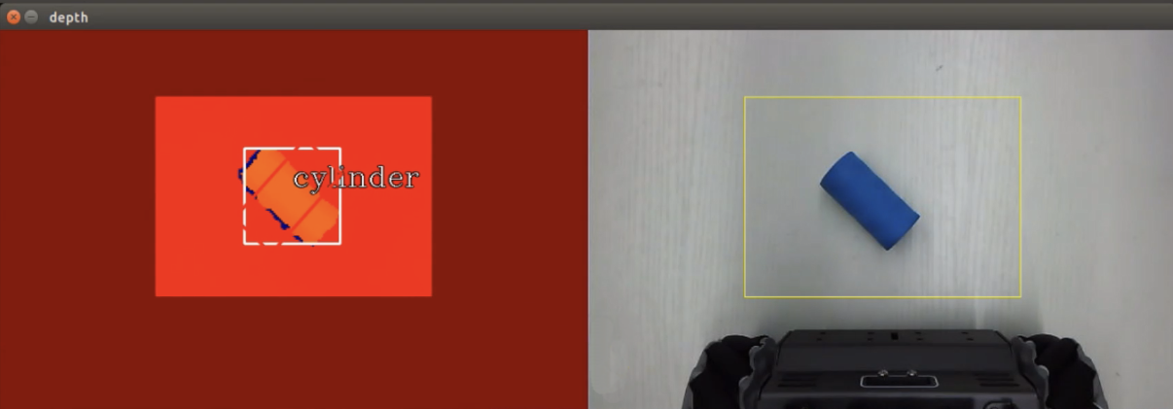
- 识别成功后，机械开始开始夹取物块,放置到机器人旁边对应的颜色收纳盒当中（程序设定的放置位置和本身物块的颜色无关）。
长方体：黄色收纳盒
圆柱体：绿色收纳盒
球体：红色收纳盒
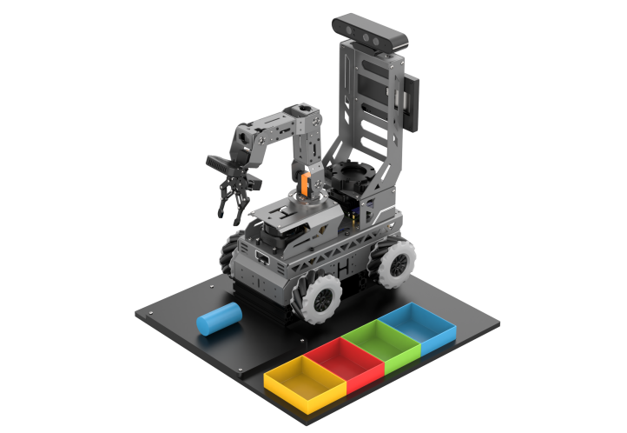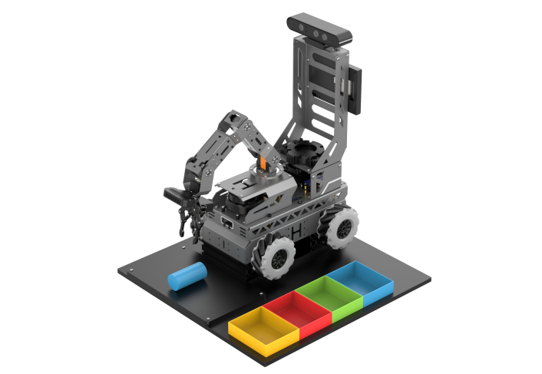
- (2)
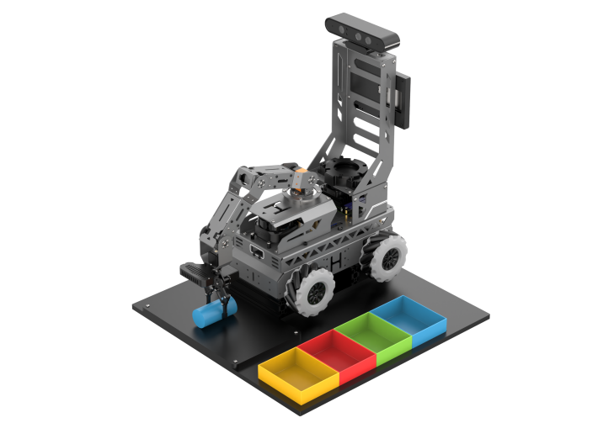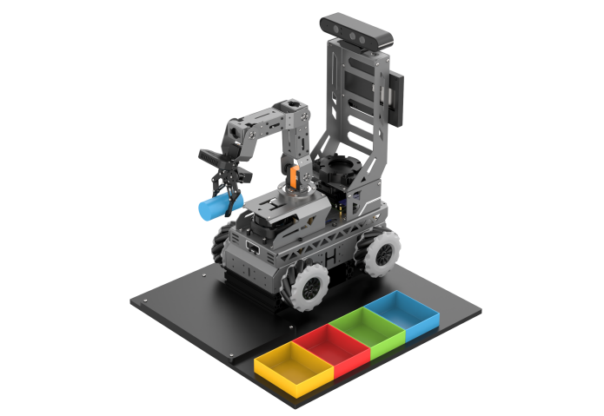
（3） （4）
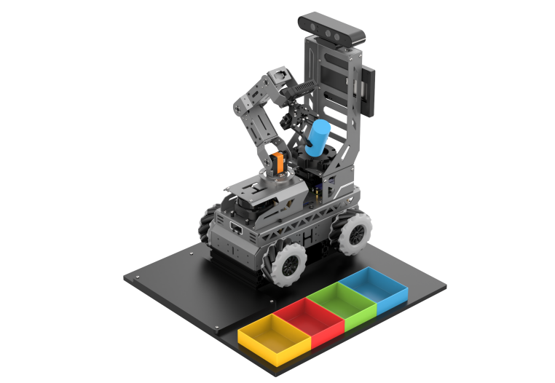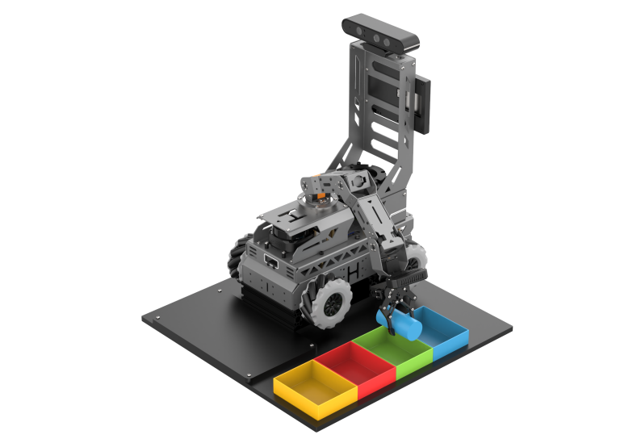
（5） （6）
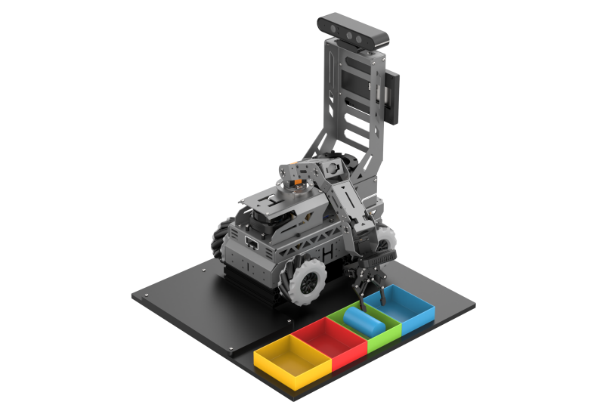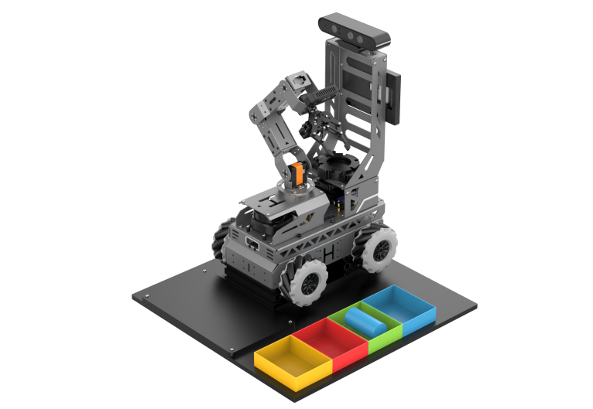
（7） （8）

