**《家教通》需求分析模型--E-R图1.0**

1. 该图为系统总E-R图，描述了系统中涉及到的各个实体及其拥有的属性，和各个实体之间的关系。

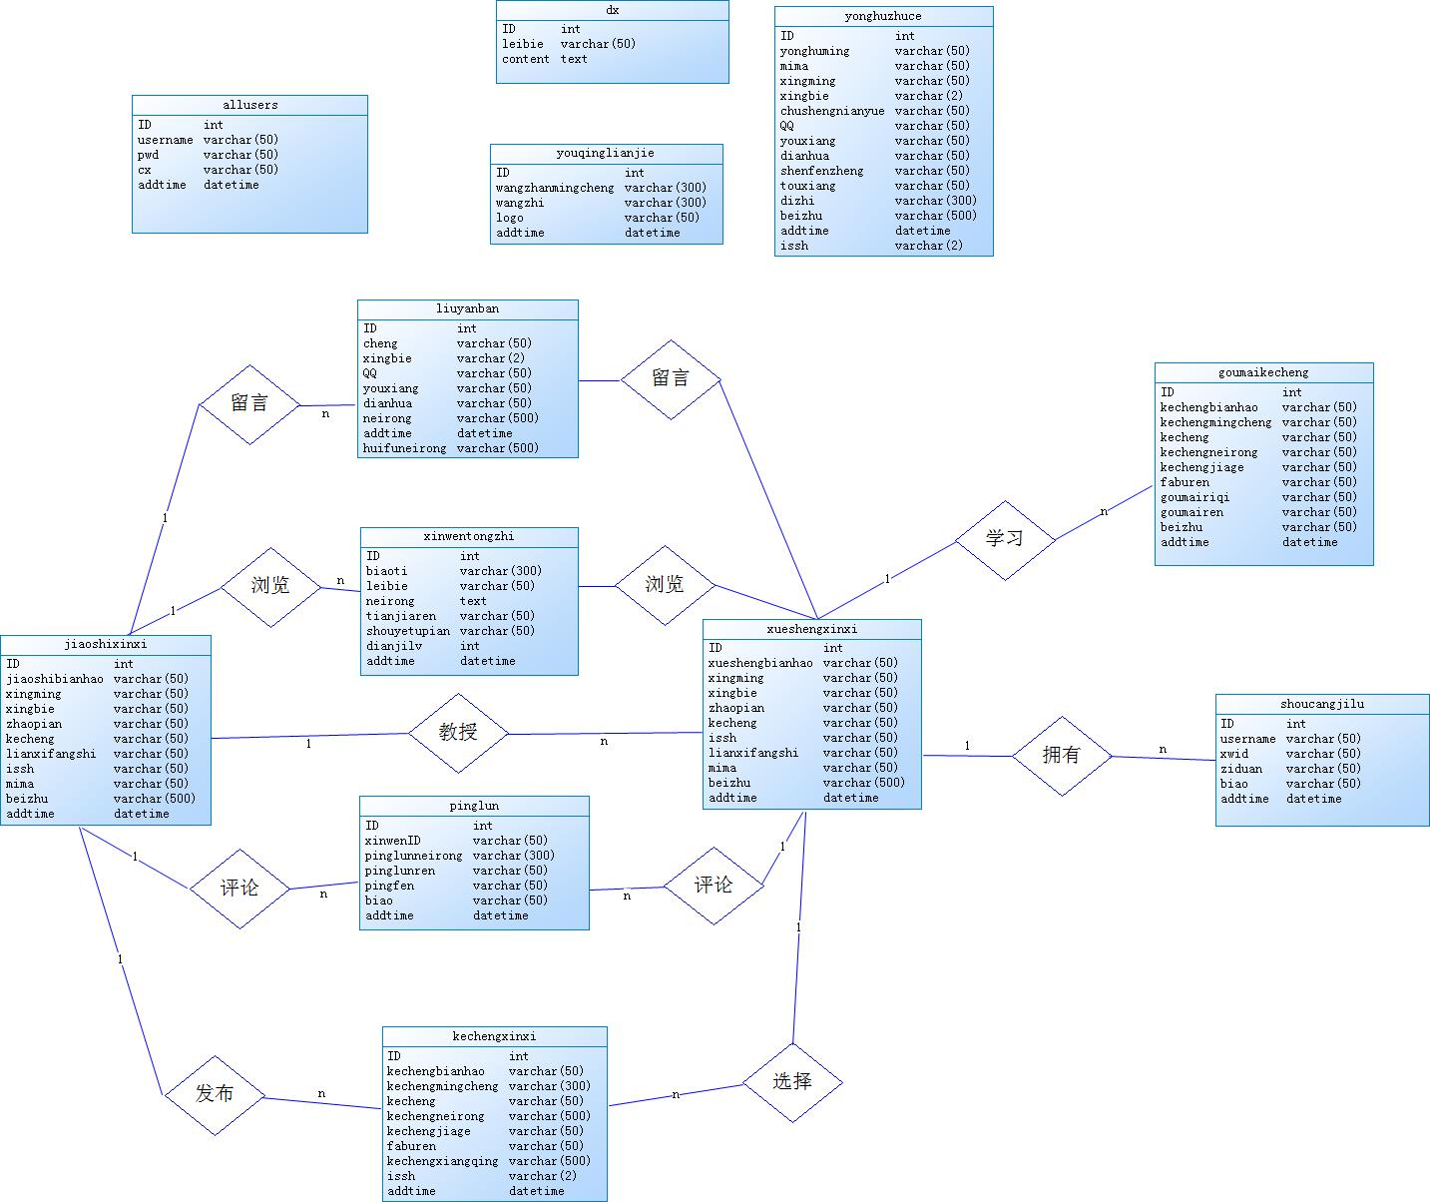

1. **数据表**

系统总E-R图中各表信息如下所示

**2.1 allusers-管理员表**

|  |  |  |  |  |  |  |
| --- | --- | --- | --- | --- | --- | --- |
| 序号 | 字段名称 | 字段类型 | 大小 | 允许为空 | 最大长度 | 备注 |
| 1 | ID | Int | 4 | 自增编号 | 10 |  |
| 2 | username | VarChar | 50 | 是 | 255 |  |
| 3 | pwd | VarChar | 50 | 是 | 255 |  |
| 4 | cx | VarChar | 50 | 是 | 255 | 权限 |
| 5 | addtime | DateTime | 8 | 是 | 23 |  |

**2.2 goumaikecheng-购买课程表**

|  |  |  |  |  |  |  |
| --- | --- | --- | --- | --- | --- | --- |
| 序号 | 字段名称 | 字段类型 | 大小 | 允许为空 | 最大长度 | 备注 |
| 1 | ID | Int | 4 | 自增编号 | 10 |  |
| 2 | kechengbianhao | VarChar | 50 | 是 | 255 |  |
| 3 | kechengmingcheng | VarChar | 50 | 是 | 255 |  |
| 4 | kecheng | VarChar | 50 | 是 | 255 |  |
| 5 | kechengneirong | VarChar | 50 | 是 | 255 |  |
| 6 | kechengjiage | VarChar | 50 | 是 | 255 |  |
| 7 | faburen | VarChar | 50 | 是 | 255 |  |
| 8 | goumairiqi | VarChar | 50 | 是 | 255 |  |
| 9 | goumairen | VarChar | 50 | 是 | 255 |  |
| 10 | beizhu | VarChar | 50 | 是 | 255 |  |
| 11 | addtime | DateTime | 8 | 是 | 23 |  |

**2.3 jiaoshixinxi-教师信息表**

|  |  |  |  |  |  |  |
| --- | --- | --- | --- | --- | --- | --- |
| 序号 | 字段名称 | 字段类型 | 大小 | 允许为空 | 最大长度 | 备注 |
| 1 | ID | Int | 4 | 自增编号 | 10 |  |
| 2 | jiaoshibianhao | VarChar | 50 | 是 | 255 |  |
| 3 | xingming | VarChar | 50 | 是 | 255 |  |
| 4 | xingbie | VarChar | 50 | 是 | 255 |  |
| 5 | zhaopian | VarChar | 50 | 是 | 255 |  |
| 6 | kecheng | VarChar | 50 | 是 | 255 |  |
| 7 | lianxifangshi | VarChar | 50 | 是 | 255 |  |
| 8 | mima | VarChar | 50 | 是 | 255 |  |
| 9 | beizhu | VarChar | 500 | 是 | 255 |  |
| 10 | addtime | DateTime | 8 | 是 | 23 |  |

**2.4 kechengxinxi-课程信息表**

|  |  |  |  |  |  |  |
| --- | --- | --- | --- | --- | --- | --- |
| 序号 | 字段名称 | 字段类型 | 大小 | 允许为空 | 最大长度 | 备注 |
| 1 | ID | Int | 4 | 自增编号 | 10 |  |
| 2 | kechengbianhao | VarChar | 50 | 是 | 255 |  |
| 3 | kechengmingcheng | VarChar | 300 | 是 | 255 |  |
| 4 | kecheng | VarChar | 50 | 是 | 255 |  |
| 5 | kechengneirong | VarChar | 500 | 是 | 255 |  |
| 6 | kechengjiage | VarChar | 50 | 是 | 255 |  |
| 7 | faburen | VarChar | 50 | 是 | 255 |  |
| 8 | kechengxiangqing | VarChar | 500 | 是 | 255 |  |
| 9 | issh | VarChar | 2 | 是 | 255 |  |
| 10 | addtime | DateTime | 8 | 是 | 23 |  |

**2.5 liuyanban-留言信息表**

|  |  |  |  |  |  |  |
| --- | --- | --- | --- | --- | --- | --- |
| 序号 | 字段名称 | 字段类型 | 大小 | 允许为空 | 最大长度 | 备注 |
| 1 | ID | Int | 4 | 自增编号 | 10 |  |
| 2 | cheng | VarChar | 50 | 是 | 255 |  |
| 3 | xingbie | VarChar | 2 | 是 | 255 |  |
| 4 | QQ | VarChar | 50 | 是 | 255 |  |
| 5 | youxiang | VarChar | 50 | 是 | 255 |  |
| 6 | dianhua | VarChar | 50 | 是 | 255 |  |
| 7 | neirong | VarChar | 500 | 是 | 255 |  |
| 8 | addtime | DateTime | 8 | 是 | 23 |  |
| 9 | huifuneirong | VarChar | 500 | 是 | 255 |  |

**2.6 pinglun-评论表**

|  |  |  |  |  |  |  |
| --- | --- | --- | --- | --- | --- | --- |
| 序号 | 字段名称 | 字段类型 | 大小 | 允许为空 | 最大长度 | 备注 |
| 1 | ID | Int | 4 | 自增编号 | 10 |  |
| 2 | xinwenID | VarChar | 50 | 是 | 255 |  |
| 3 | pinglunneirong | VarChar | 300 | 是 | 255 |  |
| 4 | pinglunren | VarChar | 50 | 是 | 255 |  |
| 5 | pingfen | VarChar | 50 | 是 | 255 |  |
| 6 | biao | VarChar | 50 | 是 | 255 |  |
| 7 | addtime | DateTime | 8 | 是 | 23 |  |

**2.7 shoucangjilu-收藏列表**

|  |  |  |  |  |  |  |
| --- | --- | --- | --- | --- | --- | --- |
| 序号 | 字段名称 | 字段类型 | 大小 | 允许为空 | 最大长度 | 备注 |
| 1 | ID | Int | 4 | 自增编号 | 10 |  |
| 2 | username | VarChar | 50 | 是 | 255 |  |
| 3 | xwid | VarChar | 50 | 是 | 255 |  |
| 4 | ziduan | VarChar | 50 | 是 | 255 |  |
| 5 | biao | VarChar | 50 | 是 | 255 |  |
| 6 | addtime | DateTime | 8 | 是 | 23 |  |

**2.8 xinwentongzhi-新闻通知表**

|  |  |  |  |  |  |  |
| --- | --- | --- | --- | --- | --- | --- |
| 序号 | 字段名称 | 字段类型 | 大小 | 允许为空 | 最大长度 | 备注 |
| 1 | ID | Int | 4 | 自增编号 | 10 |  |
| 2 | biaoti | VarChar | 300 | 是 | 255 |  |
| 3 | leibie | VarChar | 50 | 是 | 255 |  |
| 4 | neirong | Text | 16 | 是 | 255 |  |
| 5 | tianjiaren | VarChar | 50 | 是 | 255 |  |
| 6 | shouyetupian | VarChar | 50 | 是 | 255 |  |
| 7 | dianjilv | Int | 4 | 是 | 10 |  |
| 8 | addtime | DateTime | 8 | 是 | 23 |  |

**2.9 xueshengxinxi-学生信息表**

|  |  |  |  |  |  |  |
| --- | --- | --- | --- | --- | --- | --- |
| 序号 | 字段名称 | 字段类型 | 大小 | 允许为空 | 最大长度 | 备注 |
| 1 | ID | Int | 4 | 自增编号 | 10 |  |
| 2 | xueshengbianhao | VarChar | 50 | 是 | 255 |  |
| 3 | xingming | VarChar | 50 | 是 | 255 |  |
| 4 | xingbie | VarChar | 50 | 是 | 255 |  |
| 5 | zhaopian | VarChar | 50 | 是 | 255 |  |
| 6 | kecheng | VarChar | 50 | 是 | 255 |  |
| 7 | lianxifangshi | VarChar | 50 | 是 | 255 |  |
| 8 | mima | VarChar | 50 | 是 | 255 |  |
| 9 | beizhu | VarChar | 500 | 是 | 255 |  |
| 10 | addtime | DateTime | 8 | 是 | 23 |  |

**2.10 yonghuzhuce-用户注册表**

|  |  |  |  |  |  |  |
| --- | --- | --- | --- | --- | --- | --- |
| 序号 | 字段名称 | 字段类型 | 大小 | 允许为空 | 最大长度 | 备注 |
| 1 | ID | Int | 4 | 自增编号 | 10 |  |
| 2 | yonghuming | VarChar | 50 | 是 | 255 |  |
| 3 | mima | VarChar | 50 | 是 | 255 |  |
| 4 | xingming | VarChar | 50 | 是 | 255 |  |
| 5 | xingbie | VarChar | 50 | 是 | 255 |  |
| 6 | chushengriqi | VarChar | 50 | 是 | 255 |  |
| 7 | QQ | VarChar | 50 | 是 | 255 |  |
| 8 | youxiang | VarChar | 50 | 是 | 255 |  |
| 9 | dianhua | VarChar | 50 | 是 | 255 |  |
| 10 | shenfenzheng | VarChar | 50 | 是 | 255 |  |
| 11 | touxiang | VarChar | 50 | 是 | 255 |  |
| 12 | dizhi | VarChar | 200 | 是 | 255 |  |
| 13 | beizhu | VarChar | 500 | 是 | 255 |  |
| 14 | addtime | datetime | 8 | 是 | 255 |  |
| 15 | issh | VarChar | 50 | 是 | 255 |  |