This README contains the guides to run the code.

* It is important that you keep the folders with the names set in the repository and place it in the “My Drive”. The hierarchy is the following one:
  + DL_2021_Final_Project_Group4
    - Data
      * [...]
    - Results
      * [...]
    - README
    - Final_project.ipynb
* Then open the ipynb with the collaboratory and if run everything like in the labs.

**Troubleshooting**

If the path is not correct then click here after running the following code:

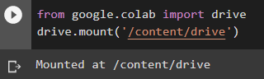

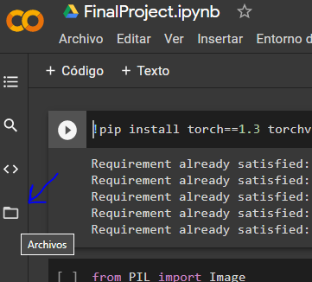

Then find the folder and copy the path and replace it in the code shown below::

